HANDS ON: STRATEGIES TO IMPROVE THE ACCESS OF CHILDREN TO VISUAL EVALUATION
Hélio Pancotti Barreiros, MD, Brazil.
E-mail: hpbarreiros@uol.com.br
Phone: 55-21-9-98669-9874/55-21-2742-2996
Statement of the problem: It is important to access the visual acuity of children before the age of six or seven, when the connections of the central neural pathways related to vision enter into another stage of development. If one finds a decrease in vision before this age, it is easier to conduct the necessary corrections. After these, the strategies for improving the acuity become less effective. But most of the scales that are used to access such ability, like Snellen, Landolt, etc, are of difficult understanding for them because they are in the early years of education. So, it might be useful to have a scale easier of comprehension for children. Methodology & Theoretical Orientation: The Hands from Evaldo (Mãos de Evaldo) were designed by a Brazilian university professor, Evaldo de Mendonça Campos (1915-2003), who draw a hand with only four fingers which size and form are related to the visual scales available (Figure 1&2). The examiner is going to turn the picture to different positions and is going to ask the child to reproduce the hand of the picture with its own hand. Findings: Children in preschool age can understand and perform the test in a manner easier than it would do with other scales. Conclusion and Significance: This test is easy to perform, cheap to acquire, maybe easier and cheaper than the others, and should be used for screening of children at the critical visual period.

Image 1: Picture of the 0,1 Hand
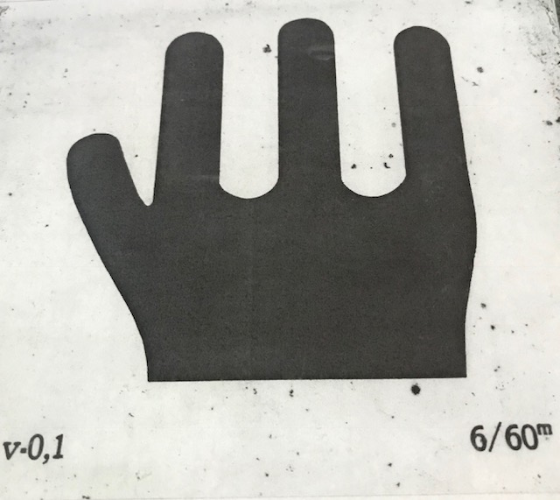

Image 2: Picture of the 0,6 Hand
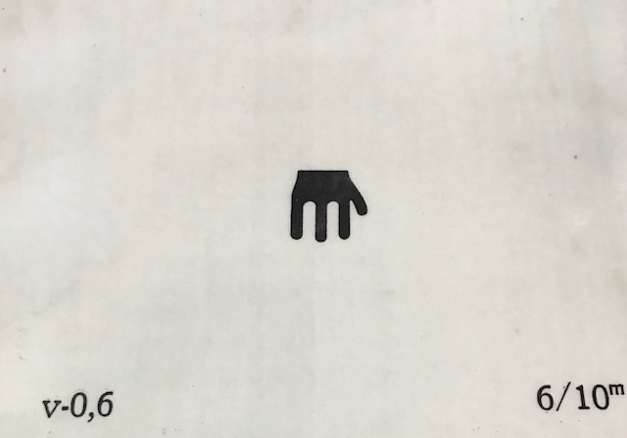
Recent Publications:
- Khan, T. “Is There a Critical Period for Amblyopia Therapy? Results of a Study on Older Anisometropic Amblyopes.” Journal of Clinical and Diagnostic Research : JCDR 9.8 (2015): NC01–NC04.
- Hussaindeen, J R & Rakshit, A & Negiloni, K. (2015). Amblyopia: what else beyond patching and critical period?. Sci J Med Vis Res Found. 132-134
- Powell C, Hatt SR. Vision screening for amblyopia in childhood. Cochrane Database of Systematic Reviews 2009, Issue 3. Art. No.: CD005020.
- Carlton J, Karnon J, Czoski-Murray C, Smith KJ, Marr J. The clinical effectiveness and cost-effectiveness of screening programmes for amblyopia and strabismus in children up to the age of 4-5 years: a systematic review and economic evaluation. Health Technol Assess. 2008 Jun;12(25):iii, xi-194.
- Wong, Agnes et al. New concepts on visual cortical plasticity: Multiple critical periods and implications for amblyopia. Journal of American Association for Pediatric Ophthalmology and Strabismus {JAAPOS} , Volume 17 , Issue 1 , e40.

Biography: Hélio Pancotti Barreiros has completed his first post graduate studies in ophthalmology in 1998 at Serra dos Órgãos University, and the second in 2009 at Fluminense Federal University. After passing a selecting exam in 2007, he has entered the public service in Teresópolis, RJ, where he has had the task of providing ocular care for the poor. After exam once again, he has been previous medicine teacher at Serra dos Órgãos University for five years, but later on he has left this position to dedicate more attention to the care of the unfortunate.

