A Case of Bilateral Adie’s Tonic Pupil on a 5 year-old male patient
Roland Martin B. Abaya, MD, Leonides Karlo C. Melendres III, MD, Department of Ophthalmology, East Avenue Medical Center, Philippines

Abstract

We describe the case of a 5 year-old male patient with an unremarkable perinatal, birth and postnatal history, who came in due to photophobia of 2 weeks duration with no other associated symptoms, no history of trauma, and no previous use of correction glasses. Only a history of fever, cough and colds was noted 5 days prior to onset of ocular symptoms. He was initially diagnosed with bilateral Adie’s Tonic pupil. There is ~1mm anisocoria, with pupillary dilatation on both eyes (8-9mm in size) (See Figure 1). Both pupils are minimally reactive to light, non-responsive to diluted Pilocarpine 0.1% but hyperresponsive to Pilocarpine 1%, constricting up to 2mm (See Figure 2). Subsequent laboratory testing revealed unremarkable blood test, chest radiograph and tuberculin test results. Further imaging showed an unremarkable MRI of the brain and orbits. Seventy percent of patients with Adie’s pupil are female, and it was found to present unilaterally in 80% of the cases, although the second pupil has a 4% increased risk to be involved per year. To date, there has been no documented case of a bilateral Adie’s tonic pupil in the country, as well as cases, occurring on very young males. Our case of a bilateral Adie’s tonic pupil on a 5 year-old male patient, which is rare and possibly the first one in children to be reported locally, emphasizes the urgency of ruling out possible etiologic causes with more grave consequences, hence, the need for prompt laboratory testing and imaging. In our case, though post-infectious etiology of a tonic pupil remains poorly understood, it is still a possibility especially on pediatric patients w/ a history of viral infection. This was reached simply after all other conditions have already been ruled out.
Image
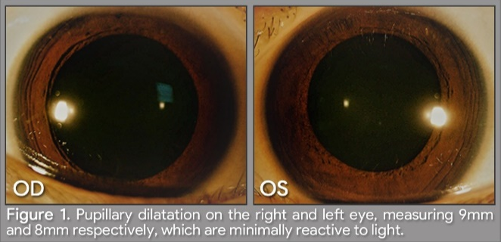

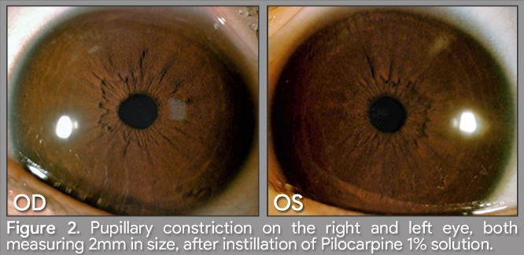

Recent Publications
- American Academy of Ophthalmology (2017) Basic Clinical and Science Course 2016-2017, Neuro-Ophthalmology.
- Bremner F, Smith S (2007) Bilateral tonic pupils: Holmes–Adie syndrome or generalised neuropathy?.
- Ford P, Barnes P, Usmani O (2007) Chronic cough and Holmes-Adie syndrome.
- Imran J, Johnson M (2013) A Rare Presentation of Neurosyphilis Mimicking a Unilateral Adie’s Tonic Pupil.
- Kimber J, Mitchell D, Mathias C (1998) Chronic cough in the Holmes-Adie syndrome: association in five cases with autonomic dysfunction.

 Biography
Roland Martin Abaya is currently a resident in training at the East Avenue Medical Center DOH Eye Center, the national eye referral center under the Department of Health in the Philippines. As a public health graduate and advocate from the University of the Philippines, he aspires to be a Pediatric Ophthalmologist with a heart to serve and provide quality eye care to children in the underserved communities in the country.
Email: rm.abaya@icloud.com, rm16abaya@gmail.com

Notes/Comments:

