
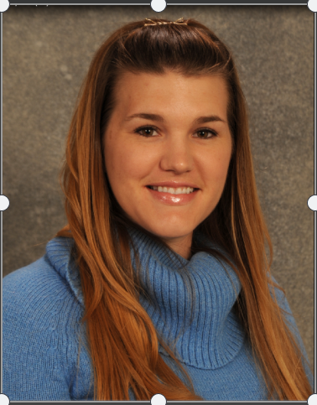

Title: High Risk Infants remain selenium deficient despite recommended dosing.
Name: Susan Marshall, MS, RD, CSPCC, CSP, CNSC

Children’s Hospital Colorado, C0 80045, USA

Objectives:
Selenium (Se) is an essential trace mineral important in neonatal development that contributes to oxidative stress. Se deficiency in preterm infants is associated with late onset sepsis, bronchopulmonary dysplasia, and poor neurodevelopmental outcomes. It is unclear if American Society for Parenteral and Enteral Nutrition Se recommendations are sufficient. We evaluated if ASPEN recommended Se dosing (2 mcg/kg/d) is sufficient in high-risk infants.
Methods:
We retrospectively reviewed Se levels from January 2017 to August 2019. Infants were included if they received total or partial TPN for ≥4 weeks. Normal Se status was defined as 45-90 ng/mL. Se deficient infants received Se dosing at 5-7 mcg/kg/d and were re-evaluated after 4 weeks. Results are reported as mean ± SD.
Results:
Selenium levels were assessed for 39 infants, average GA 29.8 ± 5.36 weeks and average birth weight 1499 ± 837 g. At first Se assessment, 78% of infants were deficient, with a mean Se level of 40.95 ± 12 ng/mL. After 4 weeks of higher Se dosing, 35% of infants remained deficient, with a mean of 54.04 ± 14 ng/mL. By t-test, fewer infants were Se deficient on higher dosing (p <0.0003).
Conclusion:
Infants on prolonged TPN > 4 weeks are at high risk for Se deficiency. Se dosing at 2 mcg/kg/day is insufficient for a majority of high-risk babies. Higher Se dosing improved the percentage of Se sufficient infants, but a third remained deficient. Future studies are needed to prospectively determine if higher Se in TPN prevents Se deficiency.

Biography

Susan Marshall is a Registered Dietitian in the Neonatal ICU at Children’s Hospital Colorado. She is a board certified specialist in Pediatric Nutrition, Pediatric Critical Care, and is a Certified Nutrition Support Clinician. She is integrally involved in quality improvement initiatives for high risk and critically ill infants and serves as a subject matter expert for the Pediatric Specialist in Critical Care board exam. Her clinical interests include improving growth and outcomes for infants with pulmonary hypoplasia and congenital diaphragmatic hernia, in addition to other neonatal disease states.

