Title: The Journey to High Reliability
Kelly Kelleher, MD¹, Gwen Jones, RN, BSN, CPN¹, Katie Barchi, RN, MSN¹, Ryan S. Bode, MD²
¹ Phoenix Children’s Hospital, Phoenix, Arizona; ² Nationwide Children's Hospital, Columbus, Ohio

Abstract

High reliability organizations have common traits including: preoccupation with failure, sensitivity to operations, reluctance to simplify, deference to expertise and commitment to resilience. Using these traits as key drivers, we aimed to develop a high reliability unit (HRU) – a clinical microsystem with targeted outcomes related to patient safety, resource utilization and patient experience.

A medical-surgical unit was identified for a pilot program to create an HRU clinical microsystem in November of 2015. A Medical Director, Nurse Manager and Quality Consultant led the project and a key driver diagram was developed (Image 1). Process and outcome metrics were developed for each goal including: decreased hospital acquired conditions and serious safety events, improved resource utilization and enhanced patient, family and provider experiences. Multidisciplinary daily management rounds were instituted with a focus on identifying and prioritizing discharges and timeliness of discharge orders. Unit digiboards as well a monthly newsletter were utilized to promote transparency and accountability to the defined goals.

HRU outcome dashboard is shown in Image 2. Serious safety events on the unit remained at zero. Severe peripheral IV infiltration rates decreased by 27%. Interventions targeted at throughput resulted in a 10% improvement in patients discharged by 1400. Diagnosis specific clinical pathways were created which resulted in improved length of stay and direct cost compared to baseline institutional and PHIS (Pediatric Health Information System) data. Overall patient and employee satisfaction improved from institutional and national benchmark.

Using high reliability principles, an HRU was developed with demonstrated improvement in the targeted aims related to patient safety, throughput efficiency, length of stay, cost and patient and employee experience. Factors to success included the triad leadership model and the creation of a microsystem with unit level accountability and defined metrics. Next steps include sustained improvement and expansion to additional units.

Image 1
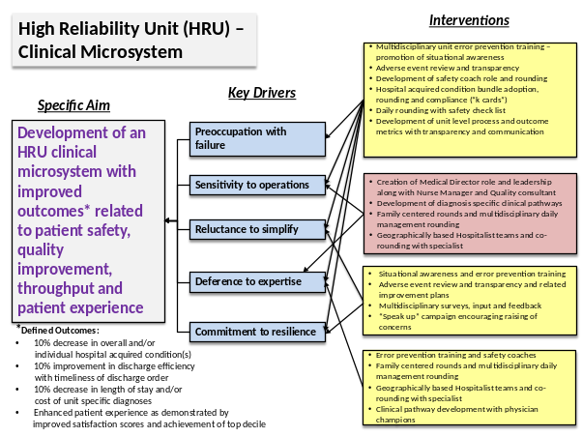

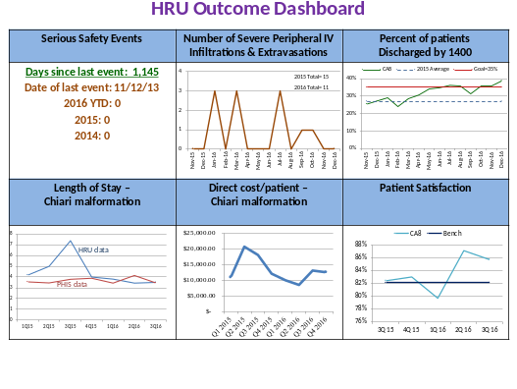

Image 2

Recent Publications (minimum 5)
- Fisher ES, Staiger DO, Bynum JPW, Gottlieb DJ. Creating accountable care organizations: the extended hospital medical staff. Health Aff (Millwood).2007;26(1):w44–w57.
- Kara A, Johnson CS, Nicley A, Niemeier MR, Hui SL, Redesigning Inpatient Care. J. Hosp. Med 2015;12;773-779. doi:10.1002/jhm.2432
- Landrigan CP, Parry GJ, Bones CB, Hackbarth AD, Goldmann DA, Sharek PJ. Temporal trends in rates of patient harm resulting from medical care. N Engl J Med.2010;363(22):2124–2134.
- O’Leary KJ, Killarney A, Hansen LO, et al Effect of patient-centred bedside rounds on hospitalised patients’ decision control, activation and satisfaction with care BMJ Qual Saf 2016;25:921-928.
- O'Leary KJ, Wayne DB, Landler MP, et al. Impact of localizing physicians to hospital units on nurse–physician communication and agreement on the plan of care. J Gen Intern Med.2009;24(11):1223–1227.
- Stein J, Payne C, Methvin A, Bonsall JM, Chadwick L, Clark D, Castle BW, Tong D, Dressler DD, Reorganizing a Hospital Ward. J. Hosp. Med 2015;1;36-40. doi:10.1002/jhm.2284

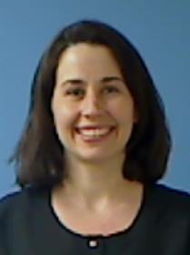 Katie Barchi, RN, MSN, CPN
Katie Barchi is a Registered Nurse with more than 14 years of pediatric experience in the hospital and community health environments. She graduated from Arizona State University in 2004 and later completed her Master’s degree. Katie has worked at Phoenix Children’s hospital for over 10 years. She is a Certified Pediatric Nurse and a member of the American Nurses Association. She currently works in Quality and Patient Safety with a focus on improving the culture of safety within the organization. She is active in work related to hospital acquired conditions and staff education related to error prevention and high reliability.
Email: kbarchi@phoenixchildrens.com

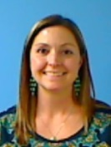Gwen Jones, RN, BSN, CPN
Gwen Jones graduated from the University of Arizona with a Bachelor of Nursing degree. She began her career at Phoenix Children’s Hospital in 2000 and has since worked as a bedside nurse, Clinical Supervisor and Manager. Gwen currently manages a 48 bed acute care Neurosurgical/Abdominal Organ Transplant unit at Phoenix Children’s Hospital. She is a Certified Pediatric Nurse and a member of the 2017 American Organization of Nurse Executives (AONE) Nurse Manager Fellowship program.
Email: gjones1@phoenixchildrens.com

Kelly Kelleher, MD

Dr. Kelly Kelleher is a Pediatric Hospitalist and is board certified with the American Academy of Pediatrics. Dr. Kelleher is originally from Montana. She attended Carroll College in Helena, Montana and earned a Bachelor of Arts in Chemistry and Mathematics. She attended medical school at Creighton University in Omaha, Nebraska. Dr. Kelleher is also the Medical Director for an acute care Neurosurgical/Abdominal Organ Transplant unit. Dr. Kelleher currently serves as the Creighton University SOM Phoenix Campus pediatric clerkship director. She is also active in resident education including conference participation, curriculum committee involvement, and a faculty advisor participant.
Email: kkelleher@phoenixchildrens.com

 Ryan S. Bode, MD
Dr. Bode currently works at Nationwide Children’s Hospital as the Chief of Hospital Pediatrics. He completed his pediatric residency training and was a Chief Resident at Phoenix Children’s Hospital where he then remained as faculty for 12 years. In Phoenix, he served as Associate Program Director of the Residency Program, Chief of the Hospitalist Division and Medical Director of Patient Safety and Quality. He is also a member of the American Academy of Pediatrics PREP Hospital Medicine Self-Assessment Advisory Board as they develop initial PREP content for Pediatric Hospitalists. His research interests focus on comparative effectiveness and the use of clinical pathways to improve outcomes and decrease unnecessary care variation.
Email: Ryan.Bode@nationwidechildrens.org

Notes/Comments:

