Neurocognitive dysfunction in Rasopathies

Ramachandran Muthiah
Morning star hospital, Marthandam, Kanyakumari District, India
Abstract
RASopathies are resulting from germline mutations of the protooncogene HRAS and affect SHP2, SOS1, RAS, RAF and MEK proteins. Dr. White says. a group of related disorders including Costello syndrome, Noonan syndrome (NS), cardiofaciocutaneous (CFC) syndrome, and neurofibromatosis 1 (NF1), caused by abnormal functioning of the Ras‐mitogen‐activated protein kinase (RAS/MapK) pathway that controls cell proliferation, differentiation, survival and its dysregulation causes clinically overlapping genetic disorders, called as ‘Rasopathies’. In this pathway, Ras, a GTPase, transmits extracellular signaling from receptor tyrosine kinases to two serine/threonine kinases (Raf and MEK) and, finally, to the activation of MAPKs. Rasopathies are developmental disorders characterised by postnatal growth retardation with delayed skeletal maturation, psychomotor retardation, cutis laxa, and acanthosis nigricans. In 2009, gain-of-function missence mutation in SHOC2, C4a> G(Ps2g), identified in NS-like syndrome with loose anagen hair, severe intellectual disability, hypernasal voice and skin abnormalities.The splicing efficiency of activating HRAS mutations can determine the rasopathy phenotype. Gene correction of these germline mutations to restore normal protein functions is anticipated as a new therapeutic option. Neurocognitive involement is a common feature of rasopathies. Isoprenylation involves the enzyme farnesyl transferase (FTase) transferring a farnesyl group from farnesyl pyrophosphate (FPP) to the pre-Ras protein. Pathway modulators or small molecule inhibitors such as statins causes significant improvement in verbal and nonverbal memory, visual attention & efficacy by inhibiting the posttranscriptional lipid modification of RAS. RAF-1 inhibition by C-type Natriuretic Peptide (CNP) improved bone growth in preclinical animal models and it is a potential targeted therapeutic drug to improve the stature of patients affected with disruption of the RAS/MEK/ERK pathway. PAR therapy (potassium ascorbate with ribose) combines the antioxidant action of vitamin C with stabilizing intracellular effects of potassium and causes improvement of skin and appendage lesions, better evolution of psychomotor development, no Progression of heart hypertrophy, nor tumor development.

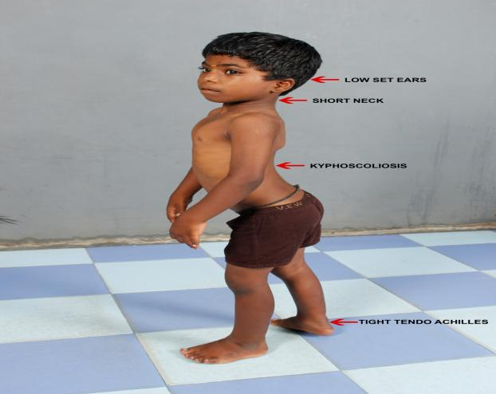

9 years old boy
low-set ears, short neck, kyphoscoliosis, tight tendoachilles

Publications
- Muthiah, R. (2021) Isolated Acute Rheumatic Pancreatitis—A Case Report. Case Reports in Clinical Medicine, 10, 52-77
- Muthiah, R. (2019) Infective Endocarditis in Tetralogy of Fallot Complicating Brain Abscess—A Case Report. Case Reports in Clinical Medicine, 8, 105-126
- Muthiah, R. (2018) Native Aortic Valve Endocarditis—A Case Report. Case Reports in Clinical Medicine, 7, 483-504.
- Muthiah, R. (2018) Tropical Coronary Artery Disease and Arrhythmogenic Potentials—The Changing Pattern towards Endomyocardial Fibrosis—An Analysis. Case Reports in Clinical Medicine, 7, 397-429
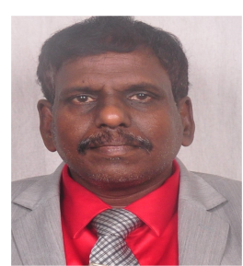
5.Muthiah, R. (2018) Isolated Patent Ductus Arteriosus in an Elderly Female, Aged 65 Years—A Case Report. Case Reports in Clinical Medicine, 7, 352-379.

Biography
Ramachandran Muthiah, Consultant Physician & Cardiologist, Zion hospital, Azhagiamandapam and Morning star hospital, Marthandam, Kanyakumari District, India. Born on 10/5/1966.. Mother Swornam belongs to keezhkulam village and Father Muthiah belongs to Enayam thoppu and both were farmers. School education at Aanan vilai and Concordia higher secondary school Pootteti. Medical education from Tirunelveli and Madurai medical colleges under Madurai Kamaraj (MBBS), Dr.MGR medical university at Chennai (MD,DM). Got married with an Agricultural scientist Rajula shanthy in 1992 and having one son R.Jeremy and now living with an orphan girl R.Russulsy. Mental hospital transfer at Chennai, jailed at Balaramapuram with break of backbone by kerala police. Rural health services at Keelachekkarakudi, Aryappapuram primary health centres and ESI hospital, Singanallur at Coimbatore. Teaching faculty at Coimbatore, Madras and Thoothukudi Govt medical colleges. Published papers in Cardiosource, American College of Cardiology Foundation, Case Reports in Clinical Medicine (SCIRP) and Journal of saudi heart association.
Name/Address: Ramachandran Muthiah
Palaninta vilai, keezhkulam-629193, kanyakumari district, Tamil nadu state, India
(landline-+914651 203014,
mobile +91 7598755201)
Category: Oral
Passport No:P8925619

