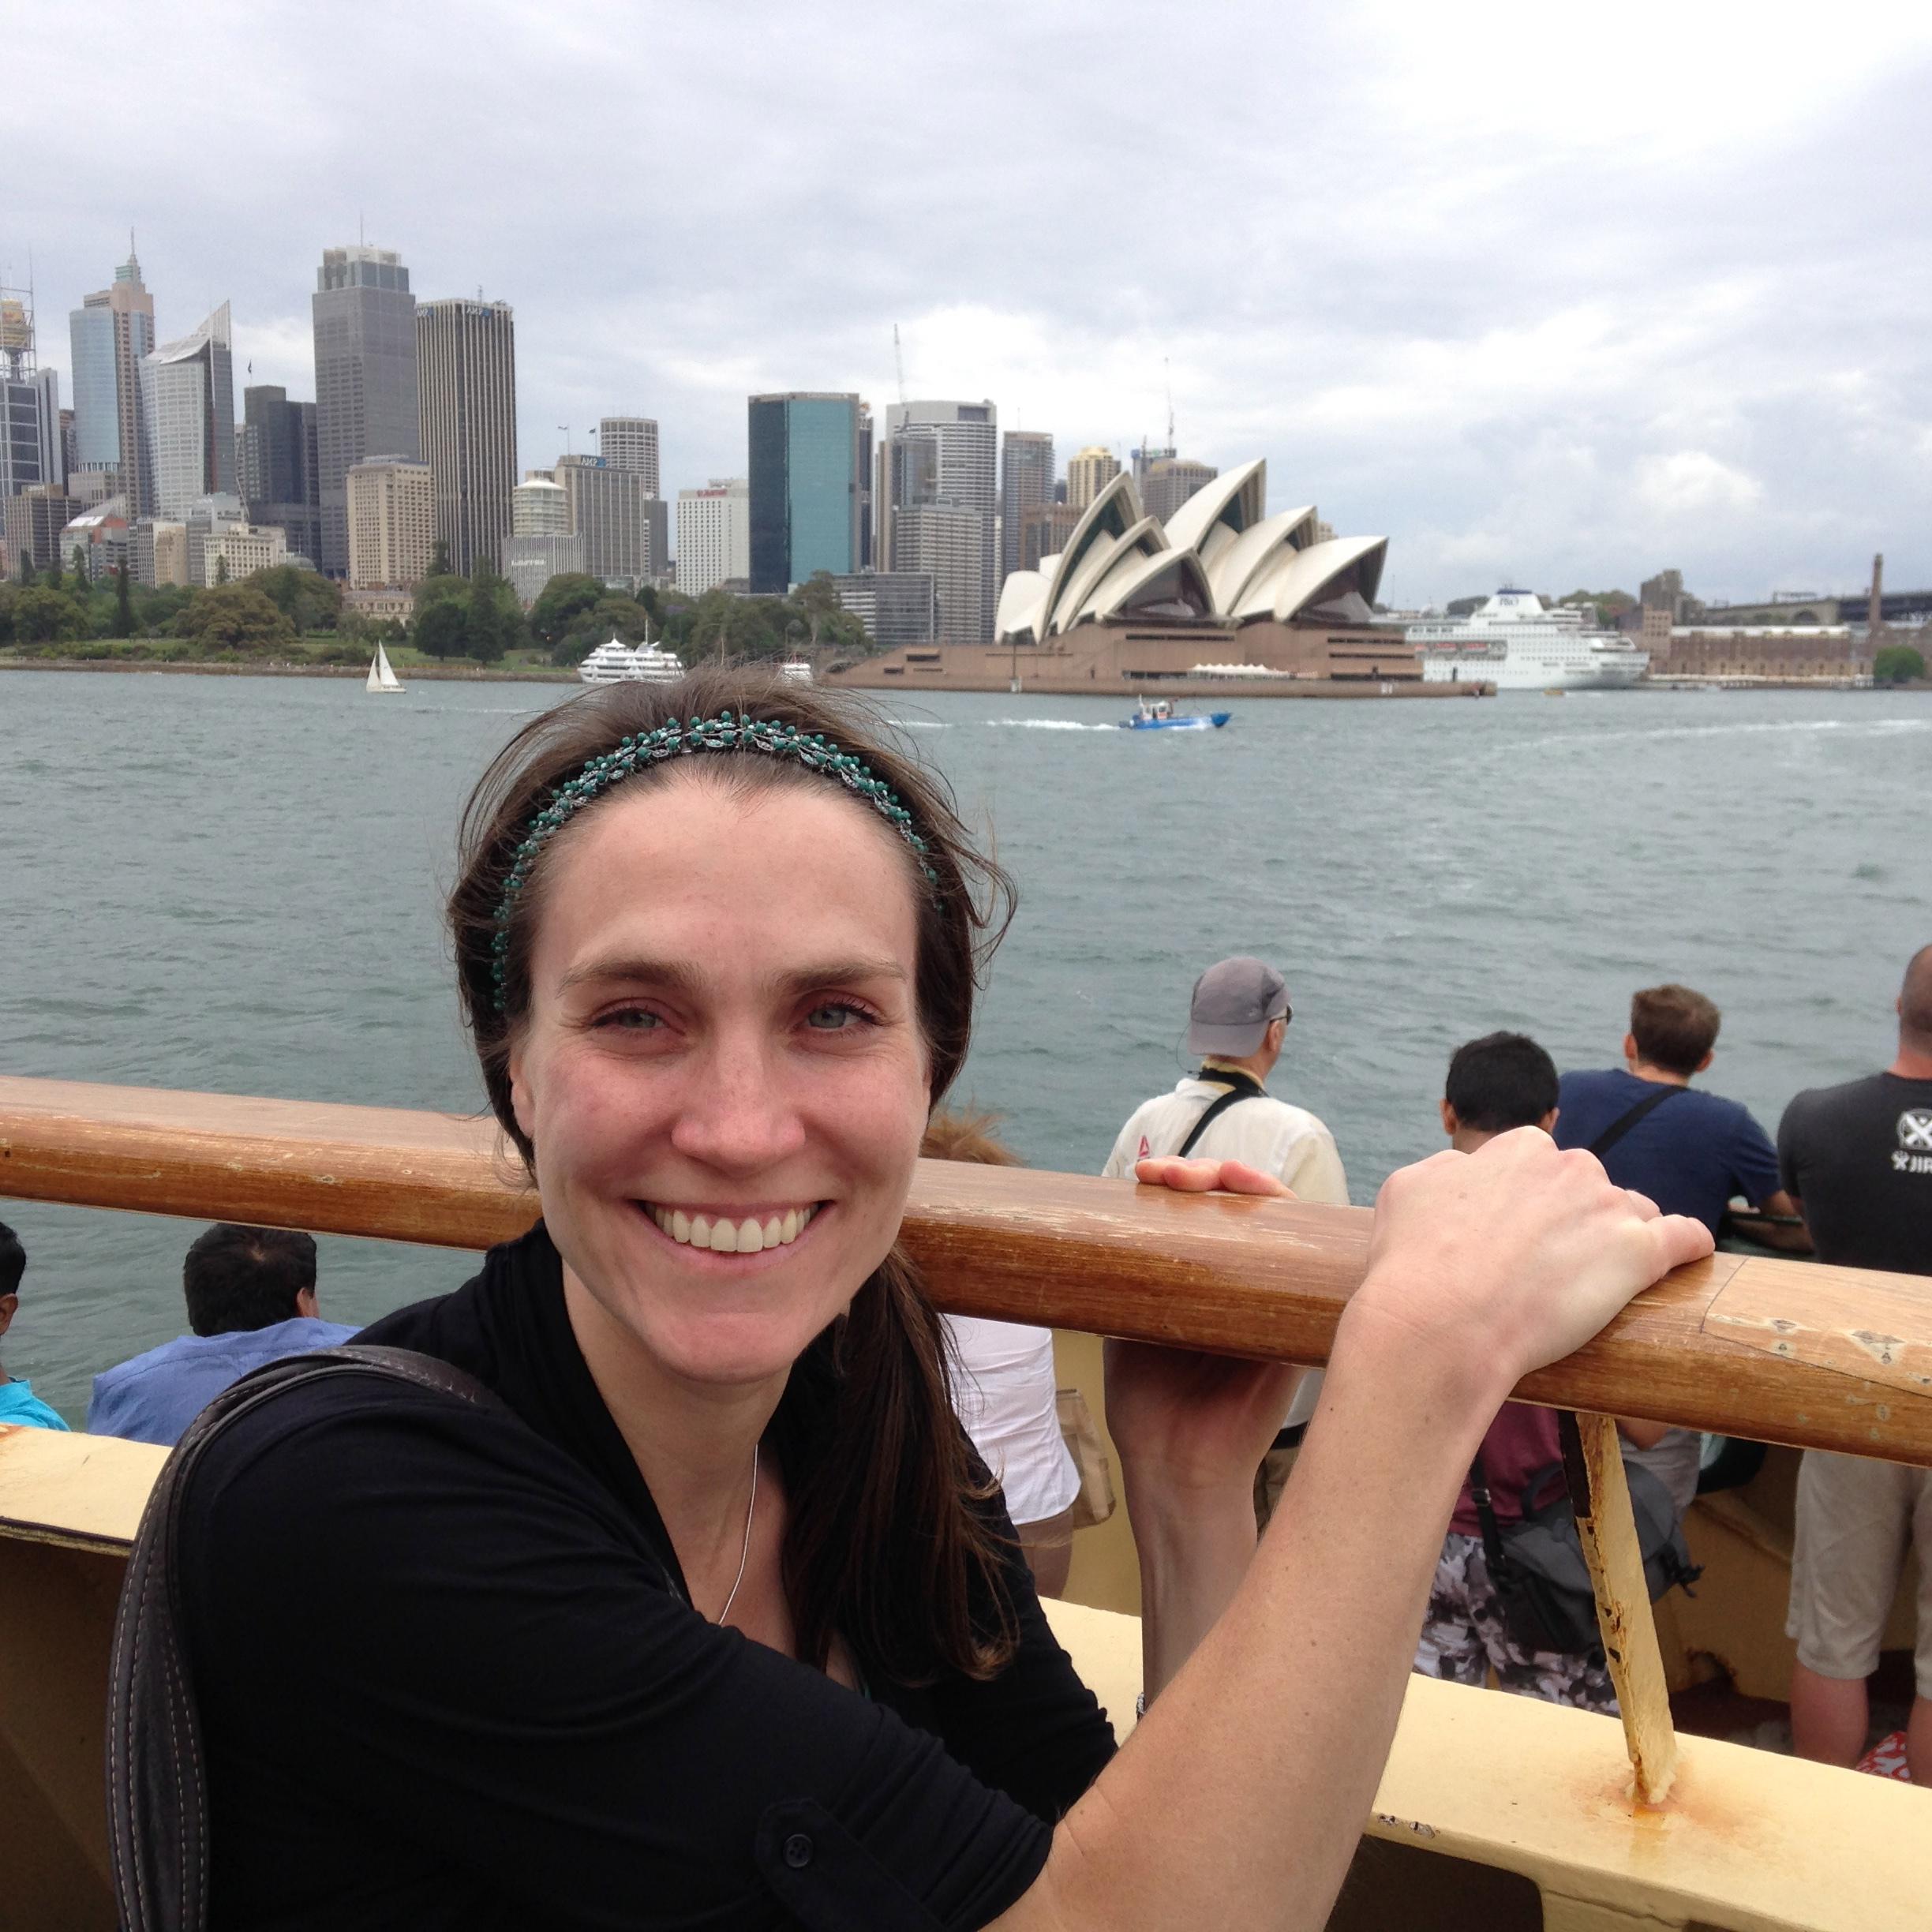
Congenital Myopathy with Cap-like Structures and Nemaline Rods: Case Report and Literature Review
Name: Shalea Piteau, MD, MSc
Queen’s University, Kingston ON, Canada
Abstract
BACKGROUND: Cap myopathy is a rare congenital myopathy characterized by cap structures located at the periphery of the muscle fiber. Cap structures consist of disarranged thin filaments with enlarged Z discs. The clinical presentation and natural history of cap myopathy is variable and overlaps with other congenital myopathies.
METHODS: We describe a case of cap myopathy in a 10 year old boy and contrast it with 20 other cases reported in the literature.
RESULTS: Our patient presented at birth with hypotonia and weakness, and subsequently developed respiratory failure in infancy. He is ambulatory but has increasing fatigue requiring a wheelchair by mid-afternoon. His muscle biopsy at 3 months showed a nemaline myopathy and secondary fiber type disproportion with Type 1 hypotrophy and predominance. A repeat muscle biopsy at 6 years showed numerous peripherally located cap-like structures containing nemaline rods and exhibited a spectrum of Z-disk and myofibrillary abnormalities. Molecular genetic testing was performed for NEB, TPM2, TPM3, ACTA1, TNNT1, SEPN1, SMN1, DMPK, FSHMD1A, and mtDNA. A known pathogenic mutation, c.1152+1G>A, and a previously unreported variant, c.1782+4_1782+5delAG, were detected in NEB.
CONCLUSION: Our patient has a more severe phenotype than the majority of reported cases in the literature and is the first patient with cap myopathy to have a mutation in NEB. Our case supports the identification of cap myopathy as a congenital myopathy with significant overlapping features with nemaline myopathies and further elucidates the phenotype of this disease.
Biography
Shalea Piteau is a Consultant Pediatrician at Quinte Health Care in Belleville Ontario and an Assistant Professor at Queen’s University. She went to Queen’s University and graduated with a Bachelor of Science Honors Degree, and then she did a Masters of Science in Physiology at the University of British Columbia (UBC). Shalea went to Medical School at UBC and then she completed a Residency in Pediatrics at Queen’s University. During her residency, she was awarded the Physicians Services Incorporated Resident Research Award ($2000) and the Best Resident Research in the Department of Pediatrics in 2010.
Presenting author details
Full name: Shalea Piteau
Contact number: 613-969-7400, ext 2272
Twitter account: @shaleapiteau
Linked In account: Shalea Piteau
Session name/ number: ?
Category: Oral presentation

