Google Plus Banner Size 1200*300
Facebook Banner Size 851*315
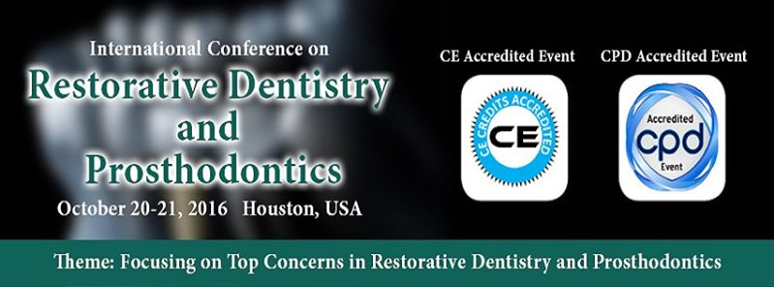

Change Event Photo

Dental & Oral Health Conferences
May 28, 2016 ·
Track 12: Cosmetic Dentistry
======================
Cosmetic dentistry focuses on improving the appearance of a person's teeth, mouth and smile. Cosmetic dentistry provides elective or desired treatments or services. Cosmetic dentistry treatments currently in use include #Inlays/Onlays, Composite Bonding, Teeth Whitening, Dental Veneers, Dental Implants, Smile Makeover, Full mouth reconstruction. Veneers are made of ceramic or resin materials. A dental inlay or onlay is bigge...
See More

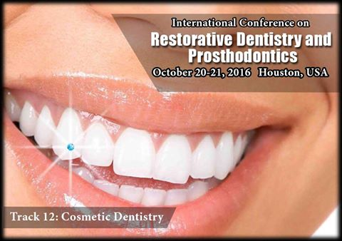



Dental & Oral Health Conferences
May 28, 2016 ·
Track 11: Tools and Techniques in Dentistry
==================================
Dentistry has seen massive improvements with respect to advancement from the traditional techniques to the digital world that has widened the scope of dental treatments and procedures. Dentists can now offer patients advanced choices like Laser “dentistry”, #Esthetic “dentistry”, Digital dentistry and Implant dentistry. Digital dentistry tools and techniques used at present include the Laser applications, Dental implants and #occlusalanalysis, Forensic dentistry, #Dental_radiography/informatics, Robotic and digital dentistry and Imaging techniques for the craniofacial hard and soft tissues.

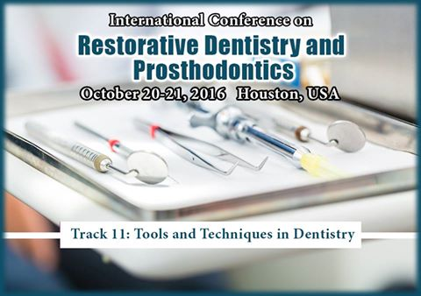

Dental & Oral Health Conferences
May 28, 2016 ·
Track 10: Advanced Surgeries and Complex Cases
========================================
Oral and maxillofacial surgery is the specialty of dentistry that includes the diagnosis and surgical and related treatment of diseases, injuries, and defects involving both the functional and esthetic aspects of the hard and soft tissues of the head, mouth, teeth, gums, jaws and neck. Oral and maxillofacial surgeons are dental specialists who treat conditions, defects, injuries, and esthetic aspects of the mouth, teeth, jaws, and face

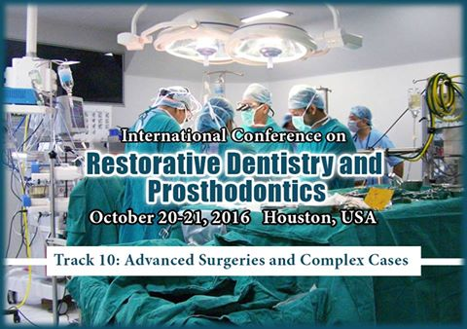

Dental & Oral Health Conferences
May 28, 2016 ·
Track 9: Treatment Modalities
========================
An Akers' clasp is the classic direct retainer for removable partial dentures. Amalgam is an alloy of mercury with various metals used for dental fillings.#Centric relation is the mandibular jaw position in which the head of the#condyle is situated as far anteriorly and superiorly as it possibly can within the #mandibular_fossa/glenoid fossa. #Crown lengthening is a surgical procedure performed by a dentist to expose a ...
See More

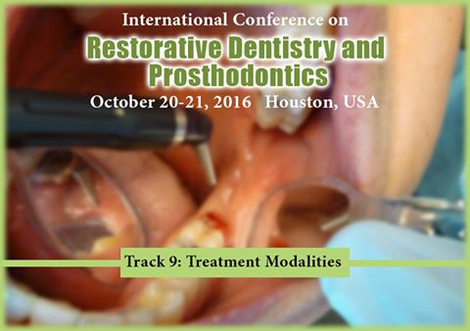

Dental & Oral Health Conferences
May 28, 2016 ·
Track 8: Restorative Implants
========================
A restorative #implant is the study, diagnosis and integrated management of diseases of the teeth and their supporting structures and the#rehabilitation of the dentition to functional and aesthetic requirements of the individual. Restorative dentistry encompasses the dental specialties of#endodontics, periodontics and #prosthodontics and its foundation is based upon how these interact in cases requiring multifaceted care. In the UK restorative dentistry is legally recognized as a specialty under EU directive, with voices from the British Society for Restorative Dentistry and the Association of Consultants & Specialists in Restorative Dentistry

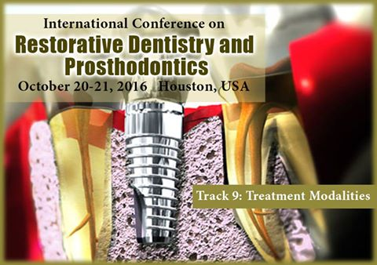

Dental & Oral Health Conferences
May 28, 2016 ·
Track 7: Dental Surgery
===================
Gingivectomy is the removal of gum tissue (gingiva) by surgery. These dentists specialize in treating gums and the other structures that support teeth. #Osseous surgery is a type of surgery that reshapes the bone that holds one or more teeth in place. Osseous surgery reshapes the bone to get rid of the defects. #Gingival flap surgery is a type of gum procedure. The gums are separated from the teeth and folded back temporarily. This allows a dentist to reach the root of the tooth and the bone. In an#apicoectomy, the root tip, or apex, is removed along with the infected tissue. A filling is then placed to seal the end of the root. A #pulpectomy is required when the entire pulp is involved. During this treatment, the diseased pulp tissue is completely removed from both the crown and root.

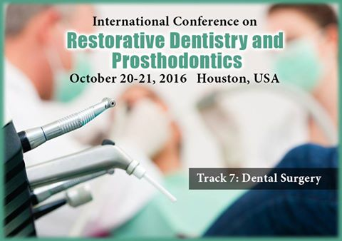

Dental & Oral Health Conferences
May 28, 2016 ·
Track 6: Periodontal & Prosthodontal Disease
====================================
Gingivitis is the mildest form of periodontal disease. It is caused by bacteria in plaque, which produce substances that can harm the gums. Gingivitis is quite common. Almost 3 out of 4 adults over age 35 have some evidence of this condition. If you have #periodontitis, your gums become detached from your teeth. Spaces called pockets form between the teeth and gums. Aggressive periodontitis gets...
See More

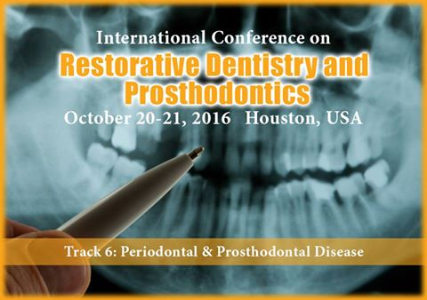

Dental & Oral Health Conferences
May 28, 2016 ·
Track 5: Orthodontics
=================
Orthodontics is a specialty field of dentistry that diagnoses, prevents and treats irregularities of the teeth and face. Treatment can correct an irregular or "bad" bite, also known as a #malocclusion. The #Invisalignmethod is gaining an increasing interest as an alternative treatment option in adult patient in multidisciplinary complex cases to simplify the treatment plan. #Orthodontic implants have become a reliable method in orthodontic practice for providing temporary additional anchorage.

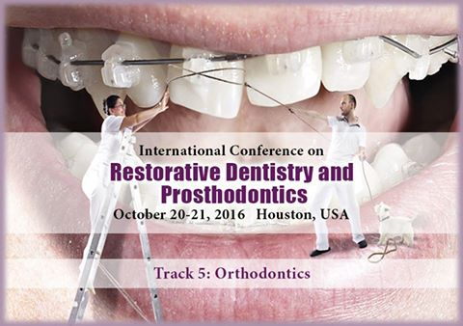

Dental & Oral Health Conferences
May 28, 2016 ·
Track 4: Prosthodontics
===================
Prosthodontists are experts in the restoration and replacement of teeth - they make smiles look beautiful and function the way they should.#Maxillofacial prosthetics, Implant-based prostheses, Management of temporo-mandibular disorders, #Dentures, Crowns, bridges, and full or partial dentures are just some of the procedures that can help you regain your smile and improve your appearance and self-confidence. Another option is dental #implants, a more permanent solution that has improved greatly over the last ten years, thanks to the pioneering techniques of Prosthodontists.

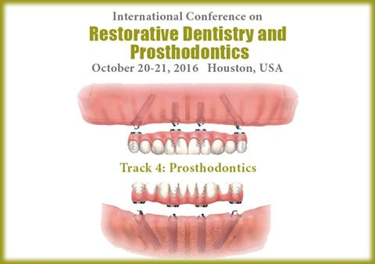

Dental & Oral Health Conferences
May 28, 2016 ·
Track 3: Periodontology
===================
Periodontal diseases are among the most common diseases affecting humans at the Upcoming dental conferences. Dental biofilm is a contributor to the etiology of most periodontal diseases. Scaling and root planning,#Gum graft and #Peri_Implantitis are the few methods which used for the treatment of Periodontal Diseases.

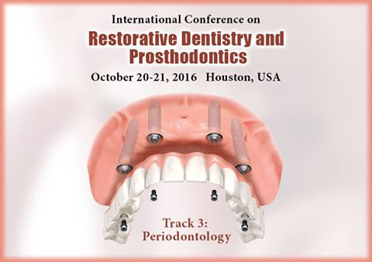

Dental & Oral Health Conferences
May 28, 2016 ·
Track 2: Restorative Dentistry
☻☻☻☻☻☻☻☻☻☻☻☻☻
#Tooth restorations are the various ways your dentist can replace missing teeth or repair missing parts of the tooth structure which is most commonly discussed topic at the Upcoming #dental conferences. Tooth structure can be missing due to decay, deterioration of a previously placed restoration, or fracture of a tooth. Examples of restorations include the #Dental_Fillings, Dental #Crowns, #Cosmetic #Dentures, Bridges and #Implants.

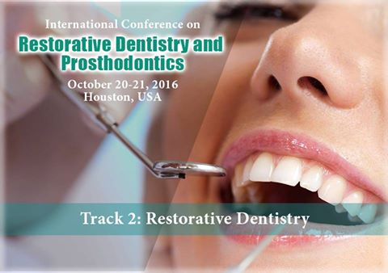

Track 1: Oral Microbiology and Pathology
=================================
Oral microbiology is a complex ecological system where upto 700 species of microorganisms that have been identified .Some of the predominant groups present in the mouth include #Streptococcus, Neisseria, Villanelle ,#Actinomyces and other obligate anaerobes . These organisms maintain a#mutualistic relationship with the host by preventing pathogenic species from adhering to the #mucosal surface. #Oral...
See More

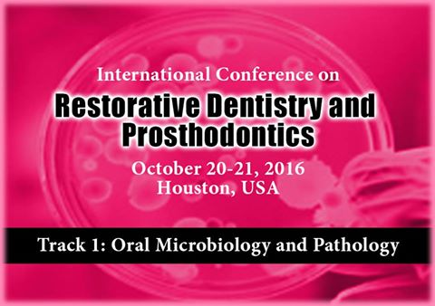

International Conference on Restorative Dentistry

OCT20
International Conference on Restorative Dentistry and Prosthodontics

Speaker
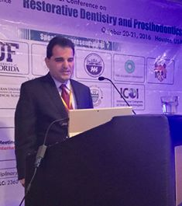

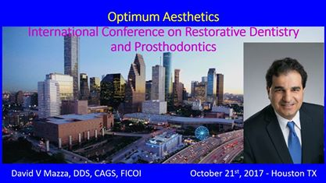

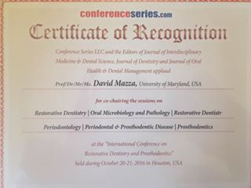



David Mazza-DDs added 4 new photos.
October 21, 2016 · Houston, TX, United States ·
Presenting "Optimum Aesthetics" at International Conference on Restorative Dentistry and Prosthodontics

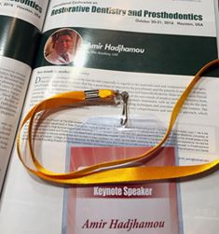

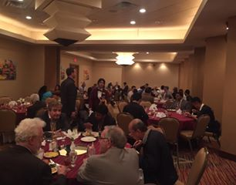

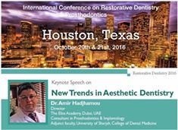

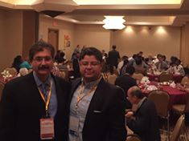

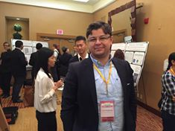

Amir Hamou added 5 new photos.
October 21, 2016 · Houston, TX, United States ·
Speaking at the international Conference on Restorative Dentistry & Prosthodontics at Houston, USA
Dr.Amir Hadjhamou

Restorative Dentistry 2016

#WatchShareListenInspire #RestorativeDentistry2016 Join the Experts 6 Keynote Speakers One special session by Gary Takacs Thriving practice Show Grab the opp...
YOUTUBE.COM

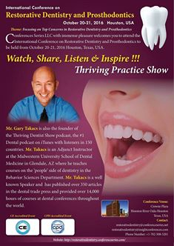

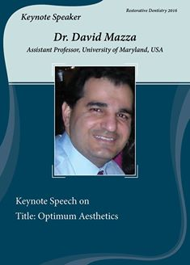

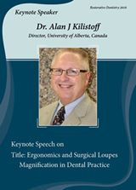

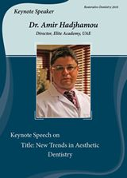

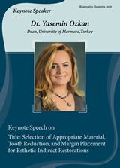
+3

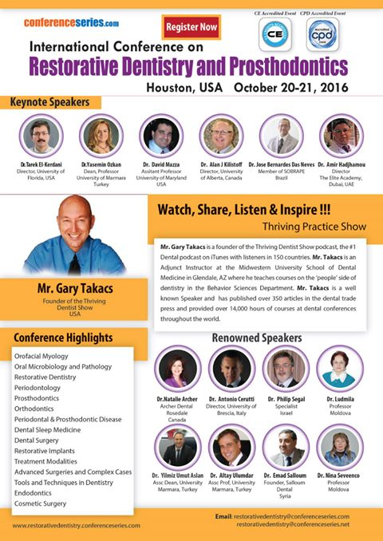

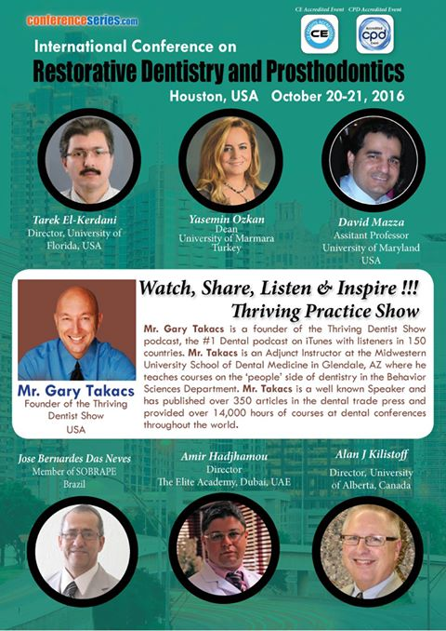

Dental & Oral Health Conferences with Gary Takacs.
July 30, 2016 ·
You are the chosen one !!
******************************
Grab a opportunity to meet scientific leaders across the globe
Mr Gary Takacs Thriving Practice Show at International Conference on Restorative Dentistry and Prosthodontics...
See More

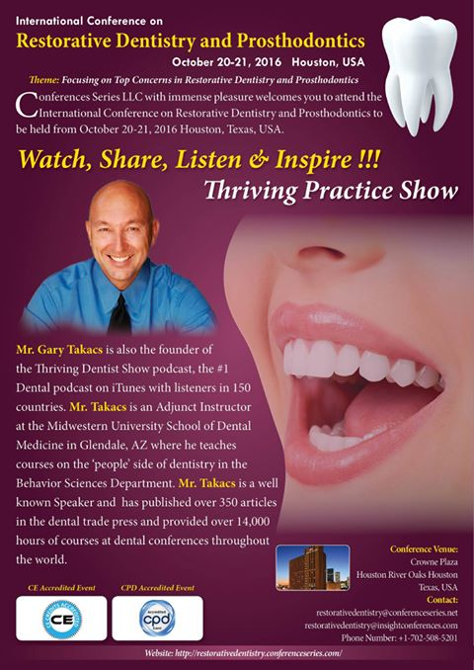

Dental & Oral Health Conferences
July 16, 2016 ·
Worldwide scientific leaders are gathering ?
Distinguished Speakers
Proficiency Gathering at Restorative Dentistry 2016, Houston, USA
Contact us: restorativedentistry@conferenceseries.net...
See More

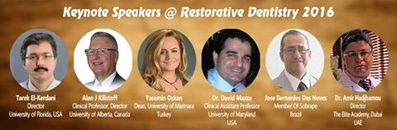

Dental & Oral Health Conferences is with Amir Hamou.
June 10, 2016 ·

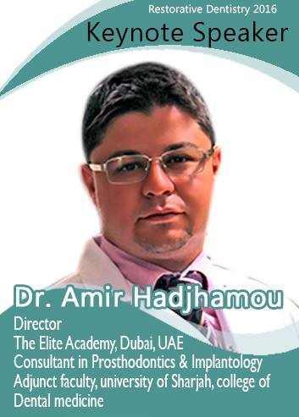

1 Share

Dental & Oral Health Conferences
June 4, 2016 ·

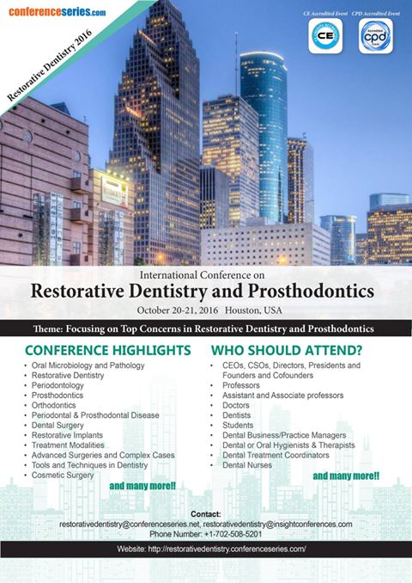

1 Share

Dental & Oral Health Conferences
June 4, 2016 ·



Dental & Oral Health Conferences
June 4, 2016 ·

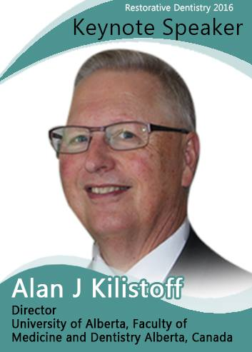

Dental & Oral Health Conferences
June 4, 2016 ·

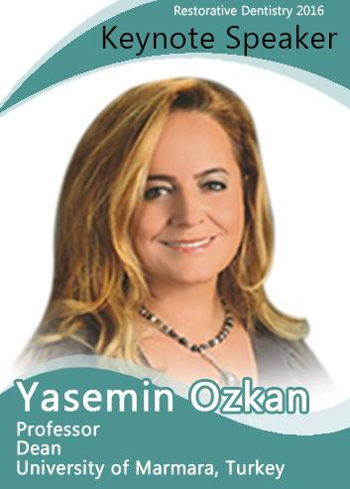

Dental & Oral Health Conferences
June 4, 2016 ·

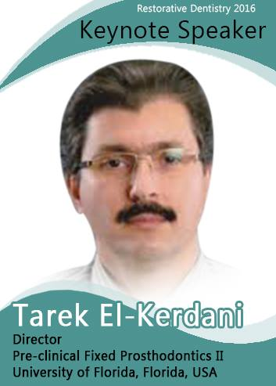

Dental & Oral Health Conferences
May 28, 2016 ·
#Alan J Kilistoff Keynote Speaker for Restorative Dentistry 2016
==============================================
Dr. Alan Kilistoff is currently Clinical Professor at the University of Alberta, Canada. He graduated from the University of British Columbia, Canada, in 1976 with a DMD, and practiced in a private clinic for 28 years. He started teaching at the University of British Columbia in 2000, moved to the University of Saskatchewan in 2005, and is currently teaching at the University of Alberta. In 2009 he received a Master of Education Technology from the University of British Columbia.

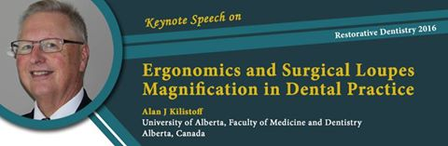

Dental & Oral Health Conferences
May 28, 2016 ·
#Tarek El-Kerdani Keynote Speaker for Restorative Dentistry 2016
================================================
El-Kerdani joined the faculty of the UF College of Dentistry in 2010. A Diplomate of the American Board of Prosthodontics, El-Kerdani earned his dental degree in 1985 and certificate in restorative dentistry in 1989, both from Cairo University in Cairo, Egypt. In 1994 he received a certificate in prosthodontics and in 1996 his master’s in dentistry from the Indiana University School of Dentistry (IUSD) in Indianapolis. He taught at IUSD, University of Detroit Mercy School of Dentistry in Detroit, and Misr International University in Cairo before joining UF.

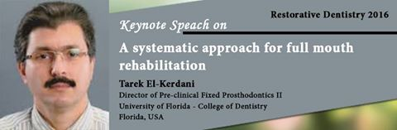

Dental & Oral Health Conferences
May 28, 2016 ·
#YaseminOzkan
=============
She currently works Dean and Chief of Prosthodontic Departments in Marmara University, Faculty of Dentistry, Department of #Prosthodontics. She has various published more than 60 papers in reputed journals and has been serving as an editorial board member of repute.
To know more about Yasemin Ozkan...
See More

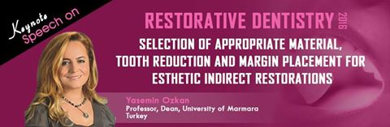

Analytics Report : Reached 2400 People invited only 19320

