Aberrant expression of histone homocysteinylation: Implications for neural tube defects
Qin Zhang， Beijing Municipal Key Laboratory of Child Development and Nutriomics，Capital Institute of Pediatrics, Beijing, China.
Baoling Bai， Beijing Municipal Key Laboratory of Child Development and Nutriomics，Capital Institute of Pediatrics, Beijing, China.

Abstract

Neural tube defects (NTDs) are serious congenital malformations. Excessive maternal homocysteine (Hcy) increases the risk of NTDs, while its mechanism remains elusive. In this study, we evaluated the role of histone homocysteinylation in neural tube closure (NTC). A total of 39 histone homocysteinylation sites were identified in samples from human embryonic brain tissue using mass spectrometry. Elevated levels of histone KHcy and H3K79Hcy were detected at increased cellular Hcy levels in human fetal brains. Using ChIP-seq and RNA-seq assays, we demonstrated that an increase in H3K79Hcy level down-regulated the expression of selected NTC-related genes including Cecr2, Smarca4, and Dnmt3b. In human NTD brain tissues, decrease in expression of Cecr2, Smarca4, and Dnmt3b was also detected along with high levels of Hcy and H3K79Hcy. Our results suggest that higher levels of Hcy contribute to the onset of NTDs through up-regulation of histone H3K79Hcy, leading to abnormal expression of selected NTC-related genes.
Image
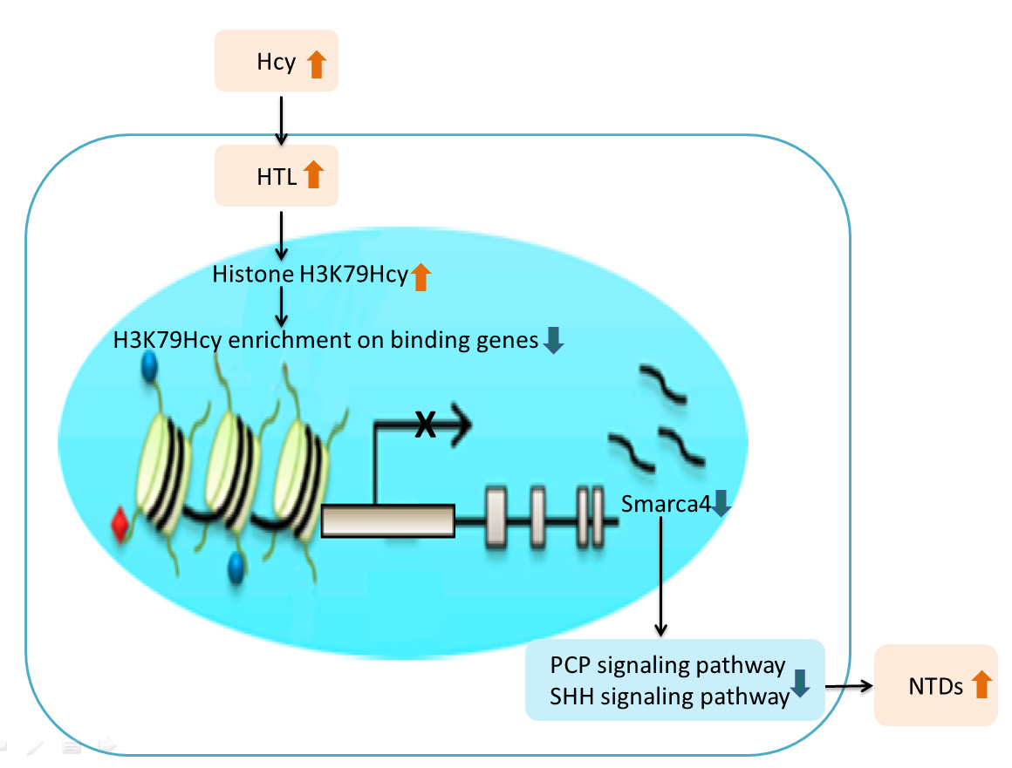
Recent Publications (minimum 5)
- Chen S#, Zhang Q#, Bai B, Ouyang S, Bao Y, Li H*, Zhang T*. MARK2/Par1b Insufficiency Attenuates DVL Gene Transcription via Histone Deacetylation in Lumbosacral Spina Bifida. Mol Neurobiol. 2016 Oct 6.
- Huili Li#, Baoling Bai#, Qin Zhang, Yihua Bao, Jin Guo, Shuyuan Chen, Chunyue Miao, Xiaozhen Liu, Ting Zhang*. Ectopic cross-talk between thyroid and retinoic acid signaling: A possible etiology for spinal neural tube defects, Gene (2016), 573: 254-260.
- Baoling Bai#, Qin Zhang, Xiao zhen Liu, Chunyue Miao, Shao fang Shan gguan, Yihua Bao, Jin Guo, Li Wang ,Ting Zhang,* Huili Li*. Different epigenetic alterations are associated with abnormal IGF2/Igf2 upregulation in neural tube defects. Plos one (2014), 9, e113308.
- Qin Zhang#, Peng Xue, Huili Li, Fuquan Yang* and Ting Zhang*, Histone modification mapping in human brain reveals aberrant expression of histone H3 lysine 79 dimethylation in neural tube defects, Neurobiology of disease. 2013 Jun;54:404-13. doi: 10.1016 .

 Biography (150 word limit)
QinZhang worked in capital institution of pediatrics. Her work focus on the role of histone modifications in nural tube defects, especially the application of mass spectrometry in histone modification idendification and validation. Her current work is concerned with the role of histone homocysteinylation in nural tube defects.
Email: maureenzq@hotmail.com

