When / How to manage meconium related ileus ?

- Always it needs enterostomy?
Eun jeong Jang, M.D., So Hyun Nam, M.D., Ph.D.
Department of Surgery, Dong-A University College of Medicine, Dong-A University Hospital, Busan, Korea

Abstract (300 word limit)

Introduction) Meconium related ileus (MRI) is one of cause for neonatal intestinal obstruction, especially in premature baby. It is associated with cystic fibrosis, but it is very rare in East Asia. MRI can present not only bowel perforation but also persistent abdominal distension with feeding intolerance. We introduced the surgical options of MRI and reviewed the surgical outcome. Material and Method) We retrospectively reviewed the medical records for 45 infants who underwent the operation for MRI from March, 2010 to August 2017 in Haeundae Paik hospital and Dong-A university medical center by single surgeon. We excluded the congenital anomalies and NEC in this study. Results) 45 infants (M:F=23:22) underwent the operation at 20.9 ± 20.6 days after birth. All except 3 were premature baby. Mean gestational age was 28.7 weeks ± 3.9 days and birth weight was 1,235 ± 777.1 g. 13 patients showed the free air on the X-ray and 27 patients showed severe abdominal distension despite of aggressive gastrograffin enema. 4 patients showed fixed bowel loop on the X-ray. The weight at operation was mean 1482.1 ± 779.8 g and bedside operation was done for 31 babies, and the operating time was 71.42 ± 27.2 minutes. Enterostomy was performed in 35 patients. We extracted thick meconium fully via appendix orifice, and then only did appendectomy for 7 patients. 2 patients underwent side to side anastomosis. We could extract meconium via enterotomy and repaired the enterotomy immediately. 2 patients (4.4%) had underlying Hirschsprung’s Disease. 12 patients (26.6%) died from sepsis, respiratory failure, and liver failure. They could start feeding around 7 days regardless of operation method, and the time to full enteral feeding was mean 36.34 ± 34.24 days. Conclusion) Still mortality is high in extremely low birth weight infants. Decompression via appendectomy and primary anastomosis could be another surgical option.
Image
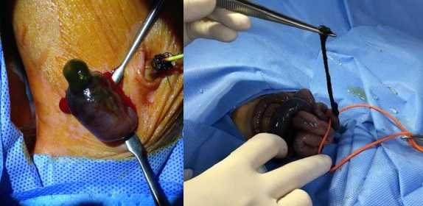
Fig 1. Enterostomy
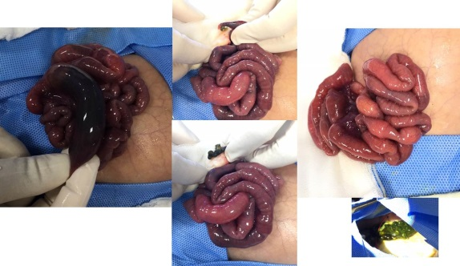
Fig 2. Decompression via appendix
Recent Publications (minimum 5)
- Copeland DR, St. Peter SD, Sharp SW yet al. (2009) Diminishing role of contrast enema in simple meconium ileus. J Pediatr Surg 44:2130-2132.
- Keckler SJ, St. Peter SD, Spilde TL et al. (2008) Current significance of meconium plug syndrome. J Pediatr Surg 43:896-898.
- Carlyle BE, Borowitz DS, Glick PL. (2012) A review of pathophysiology and management of fetuses and neonates with meconium ileus for the pediatric surgeon. J Pediatr Surg 47:772-781.
- Shinohara T, Tsuda M, Koyama N. (2007) Management of meconium-related ileus in very low-birthweight infants. Pediatr Int 49:641-644.
- Kim HY, Kim SH, Cho YH et al. (2015) Meconium-related ileus in very low birth weight and extremely low birth weight infants: immediate and one-year postoperative outcomes. Ann Surg Treat Res 89:151-157

 Biography (150 word limit)
So Hyun Nam is pediatric surgeon in South Korea. I have been working a member of Korean Pediatric Surgeons Society for 11 years. I am an associate professor in Dong-A University College of Medicine. I’m interested in intestinal rehabilitation program and neonatal surgery especially for premature baby. Long term parenteral nutritional support for motility disorder and short bowel syndrome is always my concern.
Email: namsh@dau.ac.kr

Notes/Comments:

