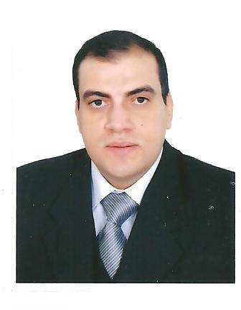
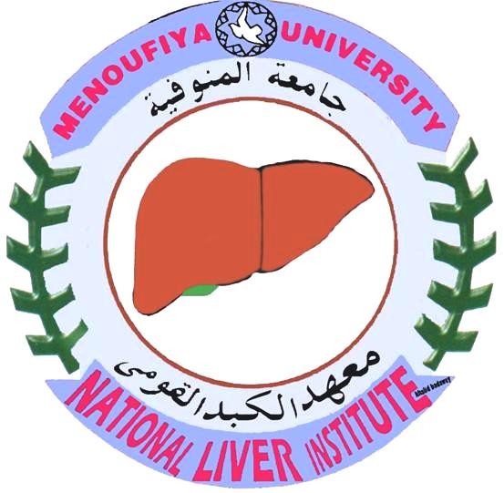

Paste your Logo here
Prof. Dr. Yasser K. Rashed

Post-Dilatation application of Mitomycin-C in children with esophageal strictures.
¹Mohamed El-Guindi and ¹Yasser K. Rashed
Pediatric Hepatology Department - National Liver Institute, Menoufiya University- Egypt.

ABSTRACT:
Background: The esophagus is the major site in risk for strictures in the upper gastrointestinal (GI) tract. Narrowing of the alimentary tract in children almost caused by a benign disorder (e.g., peptic or caustic). Endoscopic management of alimentary strictures based on the ability to gain access to the narrowed segment non-surgically. Clinical responses to the topical application of Mitomycin-C in reducing scar formation had been reported. Aim: To evaluate the methodology, efficacy, and side effects of mitomycin-C application in the treatment of esophageal strictures. Patients and method: This study included 30 children. Upper GI endoscopy was done until reaching the stenotic area, esophageal dilatation was done, and then re-endoscope the patient and Mitomycin C applied topically under direct vision. Results: The response to mitomycin application was excellent (both clinical and endoscopically) in 28 patients (93.3%), and good (endoscopically only) in 2 patients (6.7%). Mitomycin application resulted in no complications in both studied group. Conclusion: Esophageal dilatation followed by local mitomycin - C application may be a useful strategy in esophageal strictures especially those refractory to repeated endoscopic dilatation.

Biography

Prof. Dr. Yasser K. Rashed
- Permanent Associate Professor / Consultant of pediatrics, pediatric Hepatology, Gastroenterology and GI endoscopy. National Liver Institute – Menoufiya University, Egypt.

- Consultant of Pediatrics, pediatric Hepatology, Gastroenterology and GI Endoscopy - Dubai Hospital – UAE.

      - Medical Doctorate, Pediatric Hepatology Menoufiya University, Egypt.
      - Master degree of Pediatric Hepatology Menoufiya University, Egypt.
      - Master degree of Pediatrics Menoufiya University, Egypt.

- Published many articles in the field of pediatrics, pediatric hepatology, gastroenterology, nutrition and GI endoscopy

