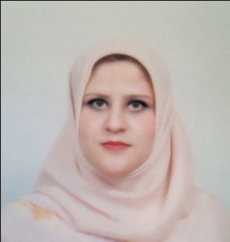
Dr. Shereen M Hamadneh
Assistant Professor, Department of Maternal Child Health, Princess Salma Faculty of Nursing, Al-albayt University, Mafraq, Jordan.

Dr. Shereen Hamadneh has completed her PhD from School of Nursing and Midwifery, at Edith Cowan University (ECU), Australia. She also worked as adjunct research fellow in Nursing and Midwifery Research centre at ECU, Western Australia. Currently, Dr. Hamadneh working as an Assistant Professor, Department of Maternal Child Health, Faculty of Nursing, Al-albayt University, Jordan. Dr. Shereen developed education package to improving infant care practice in Jordan and reduce risk of sudden unexpected infant death, this project was the first of its kind in Jordan addressing SIDS. She has published number of papers in reputed journals and presented in many international conferences in regard developing infant care practices. Dr. Hamadneh run number of voluntary activities and charities in Jordan helps improve infant care practice and enhance health care awareness. In 2016 she won the first place of Arab award on pediatric medical research. Main area of interest is about mother and infant health care, quality assurance, air pollution and environmental health.

Presenting author details
Full name: Shereen Mahmoud Hamed Hamadneh
Contact number: Cellular: +962797050079; +962-796326457
Twitter account: @HamadnehShereen
Email: Shereen_Hamadneh@yahoo.com
Linked In account: https://www.linkedin.com/profile/view?id=146833316
Session name/ number:
Category: (Oral presentation/workshop/Symposium)
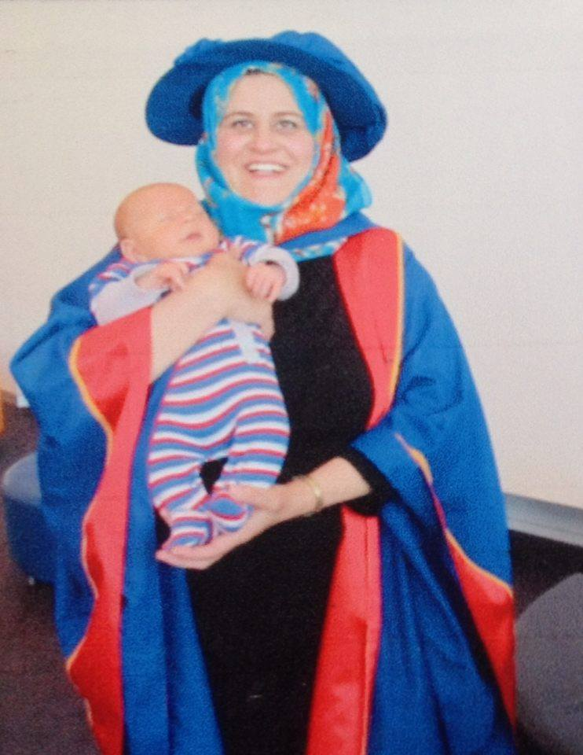

Influencing parental education among Maternal-Infant healthcare providers working in remote rural

Shereen M Hamadneh
Department of Maternal Child Health, Princess Salma Faculty of Nursing, Al-Albayt University, Mafraq, Jordan
Happy Baby and Happy Family NGO, Jordan

Abstract
Background: In Jordan, high-risk infant care practices lead to sudden and unexpected deaths. Parents seem to be unaware of these associated risk factors, which appear to be common among families living in remote areas, including Bedouins and refugees. Educating families and changing their high-risk practices can enhance infant survival.
Aim: The aim of this study was to determine whether providing an education campaign on safe infant care would encourage maternal-infant health providers working in remote areas to revise their family education and training practices regarding this topic.
Method: The study evaluated the impact of the campaign on a sample of 100 maternal-infant healthcare providers working in remote areas in Jordan. A standardized pre- and post-survey study was conducted, which addressed how confident healthcare providers were about their current knowledge regarding recommended infant practices care. It also explored how often they access to professional resources to update their knowledge, and the regularity of parents’ education.
Results: Unlike in-city healthcare providers, it was difficult to target those working in remote rural areas, therefore, volunteers passing education messages was the most suitable strategy for this intervention. The ISC resulted on increasing infant healthcare providers’ knowledge of recommended infant care practices, with a significant improvement in accessing appropriate professional information resources. Healthcare provider's Feeling more confident about the recommended knowledge showed remarkable enhancement on advice to families regarding safe infant care practices.
The knowledge that was gained from the process of developing and implementing the SIC campaign in rural areas has the potential value of providing a stimulus for spread in other similar locations in developing countries. Especially with the current war situation, that led to increasing numbers of refugees and Bedouins, who leaving their homes and going to live in remote and isolated areas.
Conclusions: Healthcare providers working in rural and remote areas were identified as an effective education and training group on health promotion programs of their local community. Reinforcement is recommended for continued professional development. Stakeholders need to create policies and procedures for the enhancement of the role of healthcare providers as educators of parents and families in remote areas.

Keywords: infant care practices, health promotion, rural areas, learning strategies, Bedouins, refugees.

