A Computational Model with Theoretical Nuclear Physics Methods for Molecular Mechanisms in Inflammatory Cardiomyopathy and Developmental Problems
João Marcos Brandet, Centro Universitário Filadélfia - UniFil, Brazil

Abstract
Statement of the Problem: Myocarditis is an inflammation of the myocardium with necrosis of the cardiac myocyte cells. Biopsy-proven myocarditis typically demonstrates myocardial inflammatory infiltrate with lymphocytes, neutrophils, eosinophils, giant cells, granulomas, or a mixture. The purpose of this study is to develop a computational model with theoretical nuclear physics methods for molecular mechanisms in inflammatory cardiomyopathy and developmental problems. Methodology & Theoretical Orientation: The simulation experiments were done on Matlab6.5 under the same condition as the physiological experiments. The molecular docking was conducted with the tool AutoDock Vina (version 1.1.2), as implemented in the MolAr (Molecular Architecture) software. ConSurf was used for the evolutionary conservation analysis. The key docking complexes were evaluated by molecular dynamics (MD) simulation using the GROMOSA7 all-atom force field and performed using GROMACS 5.1 software. The other programs used in this research were: ACD/ChemSketch, Swiss-PdbViewer, ABCpred, BepiPred-2.0, ElliPro, DEseq, GOseq, FunRich, Cytoscape, BiNGO, PepSurf, PyMol, ICM-Browser, Visual Molecular Dynamics (VMD), Cell Illustrator, C-ImmSim, Simmune, GENESIS, Spartan, MacroModel, SYBYL, and Jaguar. Findings: This study suggests that the chemokine receptor CCR3 is defined as a Th2 immunomodulatory profile and the chemokine receptor CCR4 is selectively expressed by T helper 2 (TH2) cells and Treg cells, thus being linked to the production of regulatory cytokines such as IL-10. The high frequency of CD8+T lymphocytes that produce granzyme/perforin suggests the participation in the cytotoxic activity, with an aggravation of tissue destruction in the cardiac muscles. The presence of conformational changes in sCD14, TNF-a, sTNF-R1 and sTNF-R2 favor immune-inflammatory activation in cardiac tissue. TNF-a induces myocyte necrosis through a cytotoxic mechanism related to complement pathway, induction of NO synthetase and local hyperproduction of free radicals damaging the heart and nervous tissues. Conclusion & Significance: Understanding pathological mechanisms should help developing therapeutic tools to treat the inflammatory cardiomyopathy and developmental problems.

Image
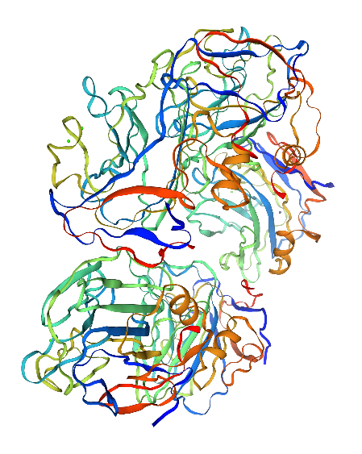
Figure: Human C-Reactive Protein in complex with Zinc
Recent Publications
- Angelini A, Crosato M, Boffa GM, et al. (2002) Active versus borderline myocarditis: clinicopathological correlates and prognostic implications. Heart 87:210–215.
- Calabrese F, Thiene G (2003) Myocarditis and inflammatory cardiomyopathy: microbiological andmolecular biological aspects. Cardiovasc Res 60:11–25.
- Calabrese F, Rigo E, Milanesi O, et al. (2002) Molecular diagnosis of myocarditis and dilated cardiomyopathy in children. Clinico-pathologic features and prognostic implications. Diagn Mol Pathol 11:212–221.
- Chimenti C, Calabrese F, Thiene G, et al. (2001) Inflammatory left ventricular microaneurysms as a cause of apparently idiopathic ventricular tachyarrhythmias. Circulation 104:168–173.
- Kuhl U, Pauschinger M, Noutsias M, et al. (2005) High prevalence of viral genomes and multiple viral infections in the myocardium of adults with “idiopathic” left ventricular dysfunction. Circulation 111:887–893.


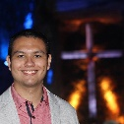
Biography
João Marcos Brandet has experience in Morphology, Immunology, Biophysics and Physiology, focusing on Human Anatomy, Physiology, Cellular and Molecular Immunology, acting on the following subjects: Human Neuroanatomy, Neurophysiology and Neuroimmunology. Brandet studied Human Neuroanatomy and Thoracic Oncology at University of Michigan, Mechanical Ventilation for COVID-19 at Harvard University, Psychology and Pedagogy at Ulyanovsk State University and Human Anatomy at Hong Kong Polytechnic University. Brandet studied Advanced Neurobiology at Peking University, Medical Neuroscience at Duke University, Quantum Mechanics at University of Colorado and Computational Neuroscience at University of Washington. João Marcos completed Specialization in Fundamentals of Immunology at Rice University; Specialization in School Health for Children and Adolescents at University of Colorado; Specialization in Anatomy at University of Michigan; Specialization in Epidemiology in Public Health Practice at Johns Hopkins University; Specialization in Newborn Baby Care at University of Colorado; Specialization in Neuroscience and Neuroimaging at Johns Hopkins University.
Email: jmbrandet@edu.unifil.br

Notes/Comments:
Presenting author details
Full name: João Marcos Brandet
Contact number: +55 43 98411-7430
Mail id: jmbrandet@edu.unifil.br
Category: Oral presentation

