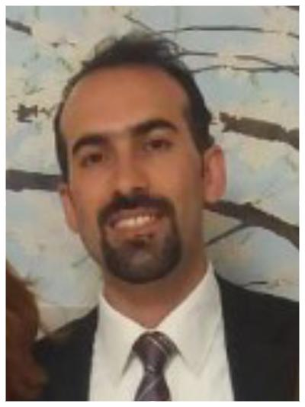
Title: A rare reason of sudden cardiac arrest in children: Cardiac rhabdomyoma

Name: İrfan Oğuz Şahin
Ondokuz Mayıs University Faculty of Medicine, PC 55270, TURKEY

Sudden cardiac arrest (SCA) is a rare but devastating condition. The most common cause of out-hospital SCA is ventricular tachycardia (VT). Major causes of VT in children are congenital heart diseases, cardiomyopathies, myocarditis, channelopathies, electrolyte imbalances. We present a case of benign cardiac tumor of which the first symptom was SCA.
Sixteen year-old previously healthy male had a SCA after he worked at farm. He was resuscitated for 10 minutes and admitted to pediatric intensive care. After initial stabilization, patient was evaluated for possible cardiac diseases. Electrocardiography and echocardiography was found normal. 24 hour Holter monitoring showed lots of ventricular ectopic beats and two nonsustained left-sided VTs (Figure 1). Magnetic resonance (MR) imaging showed a mass on left ventricle apex (Figure 2). Mass (2.5x1.5x1 cm) was resected surgically from the left ventricle (Figure 3). Holter tests after surgery were completely normal and resection of mass was seemed to be effective for elimination of VT. Histopathologic diagnosis was rhabdomyoma.
Primary cardiac tumors are rare with an incidence of 0.2%. They are mostly asymptomatic but may result to cyanosis, respiratory distress, heart failure. Although the mechanism has not been well characterized, cardiac tumors can lead to distinct electrocardiographic changes, VT and SCA. Data regarding arrhytmias associated with cardiac tumors are limited with small series. Management strategies include antiarrhytmics, cardioverter defibrillator and surgery but which is optimal remains unclear. We conclude that clinicians should keep benign cardiac tumor in mind as a cause of SCA and VT in children.

Biography

İrfan Oğuz Şahin has completed his MD at the age of 24 years from Atatürk University. He had completed pediatrics education and pediatric cardiology education. He is the director of “Division of Pediatric Cardiology, Ondokuz Mayıs University”. He has published more than 15 papers in reputed journals.

Presenting author details
Full name: İrfan Oğuz Şahin
Contact number: +905058948942
Twitter account: -
Linked In account: İrfan Oguz Sahin
Category: (Oral presentation)

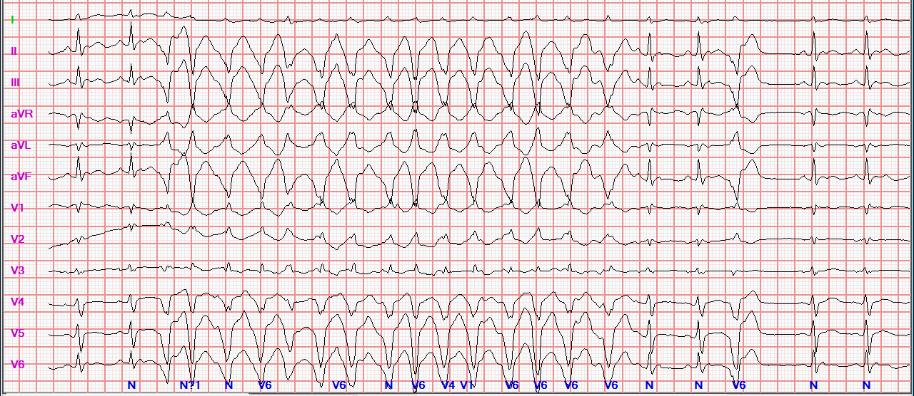
Figure 1: Ventricular ectopic beats and ventricular tachycardia on 24 hour Holter monitoring

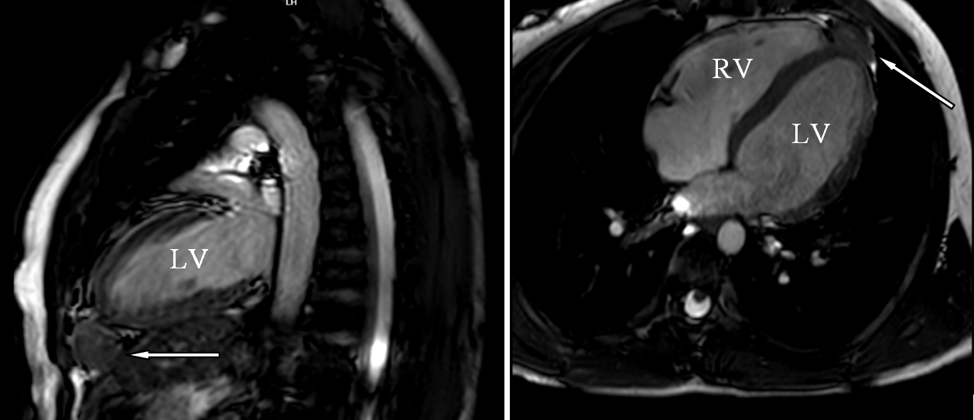
Figure 2: Bulging mass image under apical portion of left ventricle (white arrow)

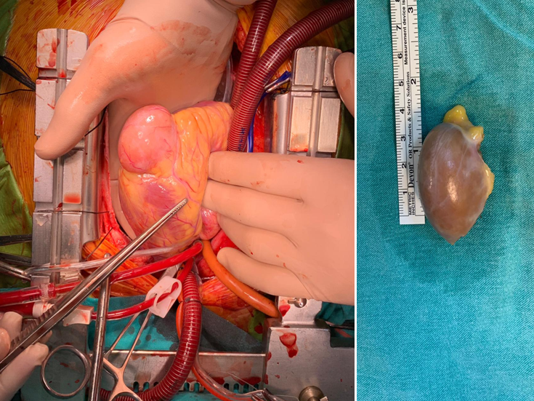
Figure 3: Pictures of mass before and after resection at operation room.
LV
LV
LV
RV
LV

