HPV E6/E7 mRNA Suppression in CaSki Cells with Cyclin-dependent Kinase Inhibitors
Anthony J. Leonardi¹, Joshua Chen¹, Naomi Melamed¹, Jennifer Rhitenia¹, Abigail Whittaker¹
¹University of London, St. George’s Hospital Medical School, UK

Abstract

Background: The major risk factor for Cervical Intraepithelial Neoplasia (CIN) and subsequently cervical cancer, is persistent infection with Human Papilloma Virus (HPV). At the precancerous, proliferative stage, HPV infected cells produce and shed virus and transform in a process pathologically described as Cervical Intraepithelial Neoplasia (CIN). In addition to creating a precancerous state, chronic HPV infection and viral shedding can cause autoinfection in an individual and infectious spread between individuals, therefore pharmacologically targeting the mechanism of virus production and cell transformation would benefit infected individuals and the population alike. Cyclin Dependent Kinases (CDKs) are implicated in the transformation process from precancer to cancer, and novel CDK inhibitors are being developed and used in clinical trials for varying CDK driven malignancies, including those driven by HPV. Aim: We aim to determine whether dinaciclib, a CDK 1, 2, 5, and 9 inhibitor, is capable of reducing virus oncogene E6/E7 production in HPV infected cells, and whether the level of suppression is comparable to the level induced by the CDK 1, 2, and 4 inhibitor, Flavopiridol. Methods: CaSki cells were seeded at 104 cells/well and cultured in a 24-well plate in DMEM Media. Following a 24 hour incubation period, media was removed and new media containing either DMSO, Dinaciclib, or Flavopiridol was supplied to the cells at 2 µM, 10 µM, or 100 µM, each in triplicate. Following 24 hours incubation at 37 °C and 5% CO2, cells were harvested via trypsinization for RNA analysis (Sybr Green). E6/7 RNA levels were normalized with housekeeping (GAPDH) RNA Levels. Results: There is a significant reduction (P<.01) in the expression of E6/E7 mRNA with a 10 uM treatment of Dinaciclib compared to Flavopiridol. Conclusion: Dinaciclib may be used to suppress HPV viral shedding and reduce autoinfection in patients with chronic HPV infection. Advantageously, dinaciclib suppresses HPV at lower doses that flavopiridol.
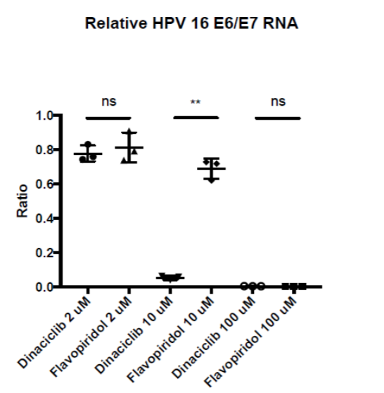
Figure 1. The ratio of HPV 16 E6/E7 RNA to vehicle control (DMSO) following a 24 hour incubation with 2 μΜ, 10 μΜ, or 100 μΜ of dinaciclib or flavopiridol.
Recent Publications
- Plummer M (2016) Global burden of cancers attributable to infections in 2012: a synthetic analysis. Lancet Global Health. 4:e609–16.
- Woodman C (2007) The natural history of cervical HPV infection: unresolved issues. Nature Reviews Cancer. 7:11–22.
- Ajiro M (2018) CDK9 Inhibitor FIT-039 Suppresses Viral Oncogenes E6 and E7 and Has a Therapeutic Effect on HPV-Induced Neoplasia. Clinical Cancer Research. 24(18):4518-4528.
- Schang L (2002) Cyclin-dependent kinases as cellular targets for antiviral drugs. Journal of Antimicrobial Chemotherapy. 50(6):779-92.
- Ghasemy F (2018) High-throughput testing in head and neck squamous cell carcinoma identifies agents with preferential activity in human papillomavirus-positive or negative cell lines. 9(40):26064-26071.

Biography
Anthony Leonardi, Ph.D. is a medical student at the University of London, St George’s Hospital Medical School. His previous work was in the Surgery Branch of the U.S. National Cancer Institute on T cell differentiation in the context of immunization and adoptive immunotherapy by use of Chimeric Antigen Receptor T cells (CAR-T) and Tumor Infiltrating Lymphocytes (TILs), with a special focus on both the AKT pathway and non-apoptotic signaling of CD95.
Email: aleona10@gmail.com

