

A 32-year old female diagnosed with Primary Adrenal Hemangiopericytoma: The first reported case

Luis Antonio R. Balajadia, MDª, Michael Jonathan S. Latayan, MD, FPUA, FPCS^{b}

ªSection of Urology, Department of Surgery, Southern Philippines Medical Center, JP Laurel Ave, Davao City
^{b} Training Officer, Section of Urology, Department of Surgery, Southern Philippines Medical Center, JP Laurel Ave, Davao City

ABSTRACT

Hemangiopericytomas are rare tumors originating from pericytes in the wall of capillaries. It is a type of soft tissue sarcoma which commonly involves the lower extremities, pelvic retroperitoneum, and head and neck. The age of initial diagnosis of HPC is 40.3 years-old (range 16-86) usually presenting as a painless mass. A 32-year old female presented with a 5 year history of slowly-growing right flank mass. She denied any history of hematuria, dizziness, headaches or hypertensive episodes. Physical examination findings showed a bulging right flank and an approximately 15 x 15 cm, palpable, nontender mass on bimanual examination. CT-scan with IV contrast was requested and revealed a large suprarenal mass, right. She underwent adrenalectomy with en-bloc nephrectomy, right with uneventful post-operative course. Histopathology of the specimen was read as hemangiopericytoma. Further testing by Flourescence In-Situ Hybridization confirmed the diagnosis. Metastatic work-up was done and was negative. Hence, this is the first reported case of primary adrenal hemangiopericytoma. Surgical removal is the mainstay of treatment of hemangiopericytomas. Radiotherapy and chemotherapy have no role in the management of the disease. The lesson learned from this case is that behind every mask there is a face, and behind that, a story. What seemed to be a simple and ordinary as an adrenal mass turned out to be as special and unique as a hemangiopericytoma.

Keywords: hemangiopericytoma, adrenal tumor, urologic malignancy, pericytes, case report

Objectives
- To present a case of primary adrenal hemangiopericytoma
- To discuss the clinical course of hemangiopericytomas
- To relate the features of hemangiopericytoma to our patient

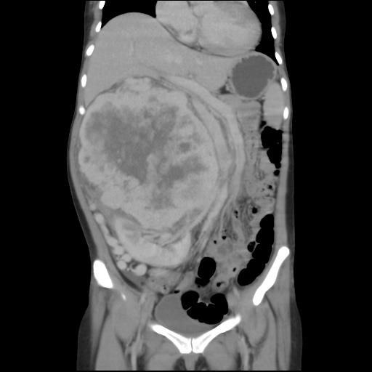
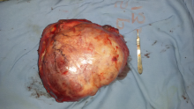
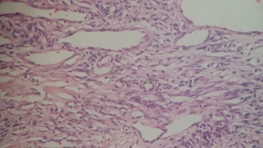
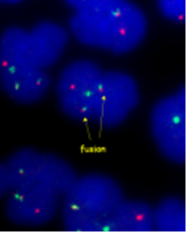
2010
2011
2013
Initial symptom of bulge on right flank
2014
Slowly-growing mass
No pain
No headaches
No hypertensive episodes

No consult nor medications
Loss of appetite and weight loss
Consult at OPD
2016
Underwent adrenalectomy, right with en-bloc nephrectomy
Histopath result:
Hemangiopericytoma
Confimatory Testing using FISH
Follow-up
2015

INTRODUCTION

I

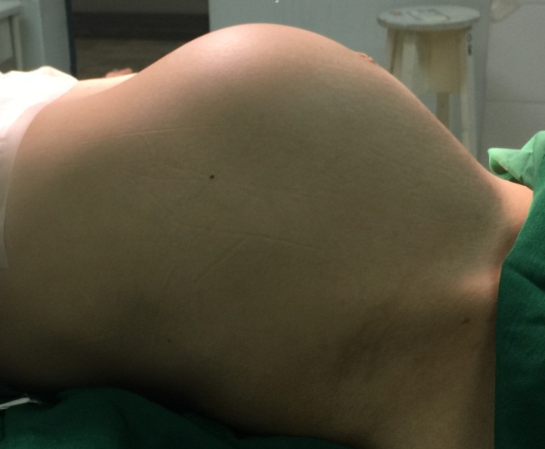
nitially described in 1942 by Stout and Murray, hemangiopericytomas (HPC) are rare tumors derived from capillary pericytes. Common locations include the lower extremities, pelvis and the head and neck. ⁽¹⁾ In world literature as of 2009, 42 cases of hemangiopericytomas were reported but they involve only the kidney. ⁽²⁾ To date, this is the first reported case of a primary hemangiopericytoma of the adrenal gland.

We present a case of a 32 year-old female with a slowly-growing right flank mass for 5 years who was diagnosed and treated at Southern Philippines Medical Center, Davao City, Philippines.

CASE REPORT

Our patient is a 32 year-old female, married, a housewife, non-smoker and non-alcoholic beverage drinker with no history of hypertension, diabetes or previous surgery. Her symptoms started 5 years prior to consult when she noticed a bulge on her right flank upon doing household chores. She denied any history of dizziness, headaches or hypertensive episodes. The mass was slowly-growing for several years but no consult was done and no medications taken. She tolerated the condition until 3 months prior to consult, the patient experienced loss of appetite and weight loss which prompted consult at the Outpatient Department. She was seen awake, conscious, coherent with BP of 110/70, HR of 70, RR of 16 and Temperature of 36.7⁰C. Physical examination findings showed a bulging right flank mass extending anteriorly, approximately 15 x 15 cm palpable, nontende on bimanual examination (Figure 1 and 2).
Figure 1. Bulging mass at right flank (side view)

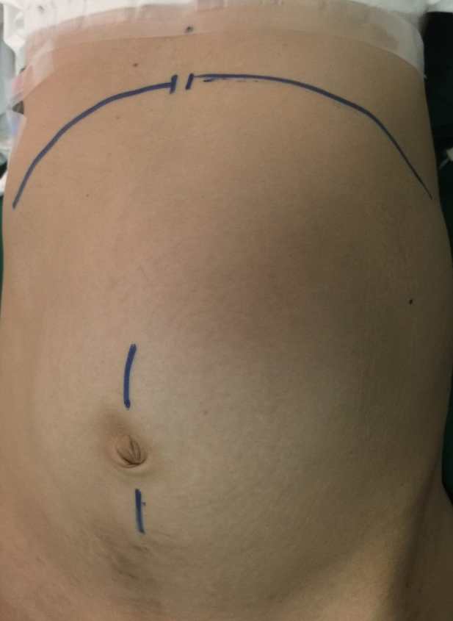
Figure 2. Bulging mass at right flank (front view)

CT-scan of the whole abdomen with IV contrast (Figure 3) showed a huge mass on the right suprarenal space measuring 18 x 16 x 16 cm with compression of the inferior vena cava and pancreas to the left side.
Figure 3. CT-scan

Urine metanephrine, serum metaphrine and cortisol were at normal levels. 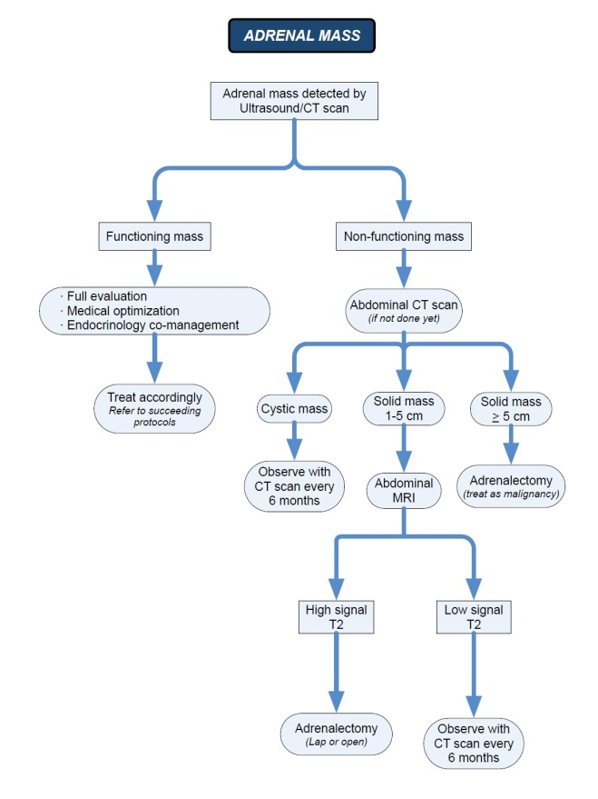
Figure 4. Management algorithm for adrenal mass (NKTI Clinical Practice Guidelines 2011-2012)
Due to the location of the disease entity, our differential diagnoses of flank masses include a renal, adrenal and retroperitoneal origin. Renal cause is ruled out due to the absence of hematuria and flank pain. Next step is to differentiate if it is a functioning or non-functioning adrenal mass. The three most common functioning adrenal diseases are pheochromocytoma, Cushing’s syndrome and Conn’s syndrome. Pheochromocytoma is ruled out because of the absence of headaches and tachychardia. Cushing’s syndrome is ruled out due to the absence of Cushingoid features such as central obesity and buffalo hump. Conn’s syndrome is also ruled out because there was no history of persistent hypertension or muscle weakness. We were then left with a non-functioning adrenal mass versus a retroperitoneal mass, both of which require surgical excision.

With a consideration of a non-functioning mass greater than 5 cms (Figure 4), the patient was scheduled for adrenalectomy with en-bloc nephrectomy, right via trans-abdominal approach. Intra-operatively, the mass was adherent to the IVC and venorraphy was done. (Figure 5 and 6). 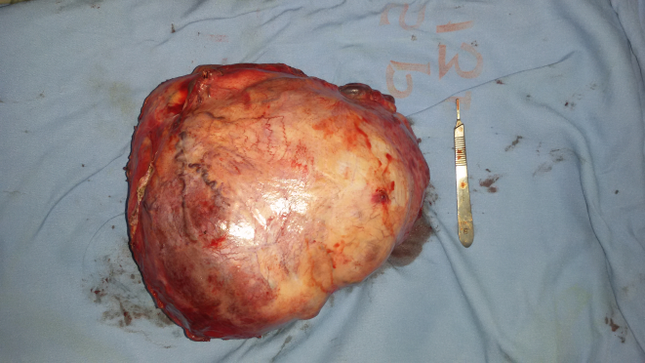
Figure 5. Adrenal mass

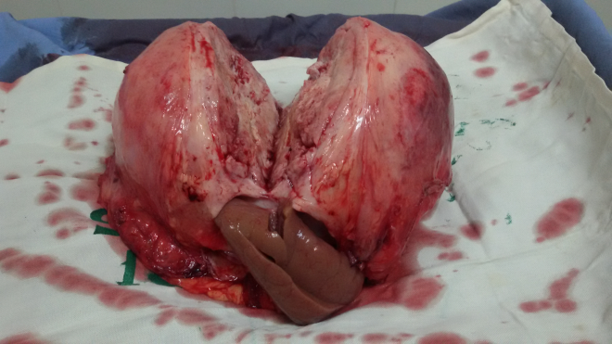
Figure 6. Adrenal mass with right kidney

A total of 6 units of blood was transfused peri-operatively. Post-operatively, the patient progressed without complications and was discharged on the 7th post-op day. Follow-up was done 3 months post-op with the patient having no subjective complaints and a well-coaptated incision scar. The abdomen was flat with no masses nor tenderness on palpation. Metastatic work-up was done at 6 months post-op which included CT-scans of the head, chest and abdomen which were all normal.

Hematoxy-eosin staining revealed sheets of atypical pericytes with numerous thin-walled ramifying vessels. There is very scanty intervening connective tissue. (Figure 7).

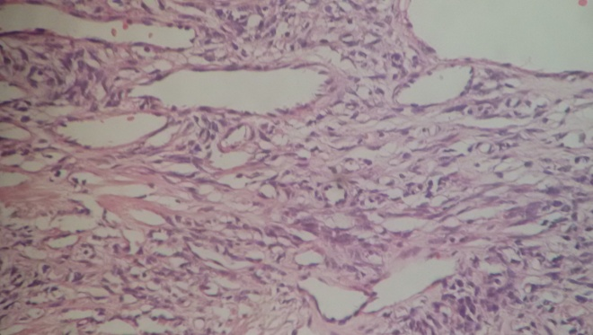
Figure 7. Atypical pericytes with thin-walled ramifying vessels.

Flourescence in situ hybridization (FISH) done at the National Kidney and Transplant Institute revealed 20 out of 50 informative cells (40%, cut off: 1.5%) had a translocation of chromosome 12 and chromosome 19, which is confirmatory for HPC (Figure 8)
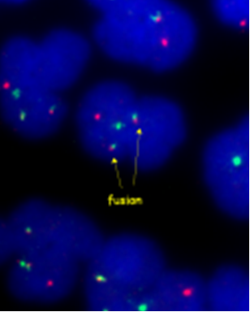
Figure 8. Fusion of DNA probes (orange: chromosome 12, blue-green: chromosome 19) signifies the translocation t(12;19).

DISCUSSION

Hemangiopericytomas are rare vascular tumors and can be found anywhere vascular capillaries are found. These tumors are commonly located in the musculature of the lower extremities, retroperitoneum, pelvis, head, neck and lungs. ^{(3,4)} In 2013, Filho et. al. reported a case of hemangiopericytoma of the kidney and was treated with nephrectomy.⁽⁵⁾ Moreover, Pistolesi et. al. presented a case of meningeal hemangiopericytoma metastatic to the adrenal gland.⁽⁶⁾ This is the first published case report regarding primary hemangiopericytoma of the adrenal gland.
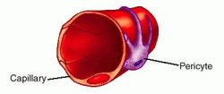
IN REVIEW

Pericytes are contractile cells that wrap around endothelial cells of capillaries and venules all throughout the body. Also known as Rouget cells or mural cells, they regulate blood flow with their finger-like projections. In the brain, they are an integral part of the blood brain barrier.

The age of initial diagnosis of HPC is 40.3 years-old (range 16-86). There is a slight difference in male and female patients, with the predominance of females (17 vs 16). ⁽⁶⁾ Two distinct clinical entities have been described: the adult type and the infantile type, which has a favorable prognosis. In the adult type, as in our case, the reported 10-year-survival rate was 70%. ⁽⁷⁾

Symptoms of HPC are unspecific. In 66% of cases, the presentation is a painless abdominal tumor, ⁽⁸⁾ similar to our patient. Other symptoms are hematuria (if with infiltration to the kidney), hypoglycemia and arterial hypertension. Hypoglycemia is attributed to the extensive metabolism of glucose within the tumor, ⁽⁹⁾ while hypertension is a result of renin production. ⁽¹⁰⁾

 | RCC w/ sarcomatoid features | Leiomyosarcoma | MPNST | PNET | Synovial Sarcoma | HPC
Vimentin | + | + | + | + | + | +
CD99 | - | +/- | +/- | + | + | -
Bcl2 | - | +/- | +/- | +/- | + | +/-
EMA | + | - | +/- | - | + | -
CK | + | - | +/- | - | +/- | -
E-Cadherin | + | - | - | - | +/- | -
CD34 | - | +/- | - | + | - | +
S-100 | - | +/- | + | - | - | -
Desmin | - | + | + | - | +/- | -
SMA | - | + | - | - | - | +/-
RCCA | + | - | - | - | - | -
Caldesmon | - | + | - | - | - | -
Inhibin | +/- | - | - | - | - | -
Despite technical advances in the field of imaging, no characteristic signs of HPC have been described on ultrasonography, CT or MRI that might aid in the differential diagnosis. These studies usually depict a large mass, which may grow insidiously to a diameter of 25 cm, but with no pathognomonic features. ⁽⁸⁾

Macroscopically, most tumors are well circumscribed lesions or a thin capsule, associated to complex network of vessels and, with small satellite nodules around the main mass. Only the minority is adhered to neighbouring tissues. ⁽⁵⁾ Tumor size reported in the literature range between 2 and 25cm. ⁽¹²⁾ In our case, the gross size of the tumor 17 x 22 x 9 cm, but in contrast, was very adherent to the inferior vena cava and posterior retroperitoneum.

Table 1. RCC (Renal Cell Carcinoma), MPNST (Malignant Peripheral Nerve Sheath Tumor), PNET (Primitive Neuroectodermal Tumor), HPC (Hemangiopericytoma)

The combination of histological and immunochemical patterns may provide a diagnosis of HPC and exclusion of differential diagnoses. (Table 1)

However, immunohistochemistry is of limited help in the identification of neoplastic pericytes and hence in the direct recognition of HPC ⁽⁷⁾. Thus, cytogenetic analysis using Flourenscence in situ Hybridization is confirmatory. A study of 163 sarcomas by Jhanwar et. al. ⁽¹³⁾ showed that hemangiopericytomas have a translocation of position 13 of chromosome 12 to position 13 of chromosome 19, [t(12;19) (q13;q13)]. Our specimen showed 40% (cutoff: 1.5%) of informative cell had a t(12;19) abnormality, which confirmed the diagnosis of HPC.

Surgical removal is still the mainstay of the treatment of HPC, and should be as radical as possible in order to avoid incomplete resection and recurrence, which can be as high as 37.5% ⁽¹²⁾ Ideally, a repeat CT-scan must be done every 6 months after surgery for 2 years then annually thereafter to document any recurrence, For large tumors, preoperative embolization can be done and has been reported in 2 cases. ^{(14,15)} There is no role of radiotherapy and chemotherapy in the treatment of HPC. In seven patients radiotherapy followed surgery, but only one was alive at 11 years, while the other six survived for a mean of 32 months. ^{(16,17)} Actinomycin D, nitrogen mustard, cyclophosphamide, vincristine, adriamycin, chlorambucil, fluoromethalone and methotrexate were used but produced no favorable results in terms of sustained objective response of metastatic tumors. ⁽¹⁸⁾

In summary, we were presented with a case of a huge non-functioning adrenal mass but with the help of the CT-scan with IV contrast, we were able to anticipate its adherence to surrounding organs such as the great vessels (Inferior vena cava and aorta). This aided us in pre-operatively by securing 6 units of blood for expected blood loss and intra-operatively by careful dissection around the mass. The limitation in this situation is the unavailability of the immunohistochemistry in our institution. However, the National Kidney and Transplant Institute assisted us in confirmatory testing.

CONCLUSION

Hemangiopericytomas are rare tumors involving the capillaries and can occur anywhere in the body. Typical presentation would be painless growth, as in our patient.
Since HPC’s present with a vague clinical picture and no pathognomonic features even with advances in image modalities, the diagnosis can only be confirmed after surgery thru a combination of histopathology, immunohistochemistry or cytogenetic analysis.

Surgery is treatment of choice for HPC’s. Adjuvant radiotherapy and chemotherapy have been used but showed no survival benefit.

LESSON LEARNED

The lesson learned from this case is that behind every mask there is a face, and behind that, a story. In the perioperative period, we there thinking that the biopsy would just be another adrenal adenoma or carcinoma. To our surprise, the patient gave us a histologic result of an unfamiliar diagnosis. What seemed to be a simple and ordinary as an adrenal mass turned out to be as special and unique as a hemangiopericytoma.

References

- Enzinger FM, Weiss SW. Soft tissue tumors, 3rd edition, Mosby, New York 1995
- Bilici A, Ustaalioglu BB, et al. Metastatic Renal Hemangiopericytoma: A Rare Case Report. Arch Oncol.2009;17 (1-2)
- Spitz FR, Bouvet M, Pisters PW, Pollock RE, Feig BW: Hemangiopericytoma: a 20-year single-institution experience.
Ann Surg Oncol 1998, 5:350-355.
- Goldman SM, Davidson AJ, Neal J: Retroperitoneal and pelvic hemangiopericytomas: clinical, radiologic, and pathologic correlation. Radiology 1988, 168:13-17
- José Eduardo Vetorazzo Filho, Leandro Augusto Costa Bahia,et al. Renal Hemangiopericytoma: A case report and literature review 2013
- Sabina Pistolesi, Gabriella Fontanin, et. al. Meningeal Hemangiopericytoma metastatic to the adrenal gland with multiple metastatis to bones and lungs: A case report. Tumori, 90: 147-150, 2004
- Berard M. Malignant Hemangiopericytoma. Orphanet Encyclopedia. April 2004
- Argyropoulos A, Liakatas I, Lykourinas M. Renal haemangiopericytoma: thecharacteristics of a rare tumour. BJU Int. 2005;95(7):943-7. Review
- Paullada JJ, Lisci-Garmilla A, GonzalesAngulo A et al. Hemangiopericytoma associated with hypoglycemia. Metabolic and electron microscopic studies of a case. Am J Med 1968; 44: 990–9
- Robertson PW, Klidjian A, Hurding LK, Walters G, Lee MR, Robb-Smith AH. Hypertension due to a renin-secreting renal tumor.Am J Med1967;43: 963–76
- Brescia A, Pinto F, Gardi M, Maria Vecchio F, Bassi PF. Renal Hemangiopericytoma: case report and review of the literature. Urology. 2008;71(4):755.e9-12
- Rohan Ramakrishna, Robert Rostomily, et al., Hemangiopericytoma: Radical resection remains the cornerstone of therapy. Journal of Clinical Neuroscience. 2013
- Jhanwar SC, et.al. Summary of Genetic alterations and gene amplifications of 163 sarcomas at MSKCC (1987-1993). Clinical Gene Analysis and Manipulation. 1996. Page 214
- Asa SL, Bedard YC, Buckspan MB, Klotz PG, Bein J, Steinhardt MI. Spontaneous hypoglycemia associated with hemangiopericytoma of the kidney. J Urol 1981;125: 864–7
- Siniluoto TMJ, Paivansalo MJ, Hellstrom PA, Leinonen ASS, Kyllonen APJ. Hemangiopericytoma of the kidney: a case with preoperative ethanol embolization. J Urol 1988; 140: 137–8
- Farrow GM, Harrison EG Jr, Utz DC, Remine WH. Sarcomas and sarcomatoid and mixed malignant tumors of the kidney in adults. Cancer 1968; 22: 545–50
- Lee HC, Kay S. Hemangiopericytoma. report of a case involving the kidney with an 11-year follow-up. Ann Surg 1962; 156: 125–8
- McMaster MJ, Soule EH, Ivins JC. Hemangiopericytoma. A clinicopathologic study and long-term followup of 60 patients. Cancer 1975; 36: 2232–44

