Origin Of Universe
Dipendra Neupane

Abstract:, There are different principles and thoughts about origin of the universe. Of them some are very popular. After a long research and study a new result has found out about the origin of universe. According to this theory, before the origin of our universe there was only black space. i.e. there was a black colored vacant space made from Dian. Dian, the basis of Universe, is density less and motionless. Darkness of the universe is the result of 4 elements: Pito, Anto, Blata and Glyasi. These 4 elements can't react with Dian but can react with each other. Dian can react with any product that results after the reaction of these 4 elements. Dian, Pito, Anto, Blata and Glaci seem to be the fundamental elements of universe. After million and billions of years with the reaction between elements of black space, dark hole are formed and from that dark hole, universe is originated. According to these 3 processes the origin of universe can be clarify. 1. Collision between two Dark Holes: There is condition of collision between the Dark Holes formed in Black Spaces due to unlimited density, movement and gravity there is a condition of collision and they collide with each other. Due to this collision there is an explosion black spaces and expands far-far away in huge area. After that due to the chemical reaction for hundreds of year again that elements starts to unite and turns to surface (body) and hence stars and planets are formed. 2. Dark Hole Explosion: In some points dark hole cannot control elements in itself and from the center it starts to expand or move against from the center. This state lasts for very short time like seconds or minutes and explodes itself. And due to this explosion the elements scatters and form stars and planets in certain time period. 3. Dark Hole Ignition: when there is pressure in Dark hole due to its unlimited density and movement, unlimited energy is formed. Before dark hole changes to state of white hole, due to this continuous chemical reaction and unlimited pressure, the energy produced in it starts to be active and due to this there is production of heat and light and the pressure of dark hole starts to be still. After millions of year the pressure in it starts to decrease and it converts to fire ball and forms a star.

Index Terms—Black Spaces, Dark Holes, Dark holes properties, Expansion of Universe, Attraction, Repulsion

- Introduction:-
With the beginning of Human Age numerous studies, investigations and inventions have been made till now. In case of origin of universe also, many theories were made. Some of them are as follows:
1) Big Bang Theory:- According to this theory the universe was originated and expanded after a big explosion. Thirteen billion years ago all the atoms, elements, sub-elements and dusts were in the same place. The whole universe seemed like a dot. It had infinite density and temperature. No existing scientific laws can work in such stage of universe. There was no space and time. Suddenly an explosion (big bang) happened. The temperature during the explosion is hundreds billions degree Celsius. The less than one second interval after the explosion is called blank time. During blank time the temperature dropped in a fastest rate and reduced to ten billion degree. In this stage all the matters in the universe were mobile in gluon plasma state. The process continued for three hundred thousand years which is known as dark time. During dark time proton and neutron were formed. Protons and neutrons combined in different amount to form Hydrogen and Helium due to which different stars were formed. The same process continued to form planets and satellites to form existing universe.
2) String Theory:- According to this theory the smallest form of any element is an atom which is composed of sub-atomic particles. The sub-atomic particles are formed from quarks. Quarks are also made from strings. Strings are in vibrating stage and change the shapes continuously. String is the tiniest basic component of the universe. According to string theory, before the big bang there were two large membranes in vibrating state which behave like two parallel universes. Once a time arrived and two membranes collided to form a universe. Such process can happen and there're chances of big bang in future too.
3) Multi verse theory:- This is an imaginative theory only and has no any evidences till now. According to this theory there can be another universe like this which can have same state like our universe or have just a reverse state.
(II) Main Body
Black Space
According to this theory, Before the origin of this universe there was only a black space i.e. there was a black colored vacant space made from Dian. Dian, the basis of Universe, is density less and motionless.
Darkness of the universe is the result of 4 elements: Pito, Anto, Blata and Glyasi. These 4 elements can't react with Dian but can react with each other. Dian can react with any product that results after the reaction of these 4 elements. Dian, Pito, Anto, Blata and Glaci seem to be the fundamental elements of universe.
A) Dian: - It is one of the important element among 5 elements of this universe. It is density less and remains motionless unless any influence happens but when any pressure is created then it shows movement and gravitation.
B) Pito: - It remains in dynamic state with the speed more than that of light. It provides the speed to any matter with which it reacts. For example, Pito combines with Ton to form Photon due to which its speed reduces to 300,000 km per second. But Pito cannot combine with Dian.
Pito +A,B,C,D=Speed
Pito + Dian = 0

C) Anto: - It reacts with any element in rest or motion, except density, and privies them density.
Anto + Pito = Mass
Anto + A,B,C,D = Mass
Anto +Dian =0

D) Blata: - It combines with Anto to create positive characteristics and density. On reaction with Pito it goes to dynamic state.
Blata + Anto = Mass + Positive character
Pito +Blata = Speed

E) Glaci: On reaction with Pito it creates negative characteristics and one reaction with Anto the density is created.
Glaci + Pito = Speed + Negative character
Glaci + Anto + Mass
Glaci + Dian = 0

In this way on collideion of these 5 elements motion, density, attractive force, repulsive force and gravity develop in black space. When these elements attach with each other pressure and density is created. With million years of collideion and motion the size, density and gravitational force of matter goes on increasing and it develops as a black hole. This process keeps going on for billion and trillions years and large black hole builds up.

In this way after the formation of number of large dark holes three stages appear:
1) Collideion between two dark holes
2) Dark space explosion
3) Dark hole burning
1) Collideion between two dark holes: - Because of infinite density, motion and gravitational force the dark holes formed in black space collide with each other. Due to this collide ion, explosion occurs and the particles move away to the large area. After the 100 years of chemical reaction these particles start to merge and convert to mass. With reference to density and the effect of gravitational force they merge and gain the shape and area. In this way small and large masses form. The formed masses start to remain in group. Those masses in which active energy develop as stars and those with semi-active energy develop as planets and satellites. The place where two dark holes collide still possess the centric energy so the formed masses revolve around it making it as center. During the explosion a wave develops which is used as orbit for revolving.

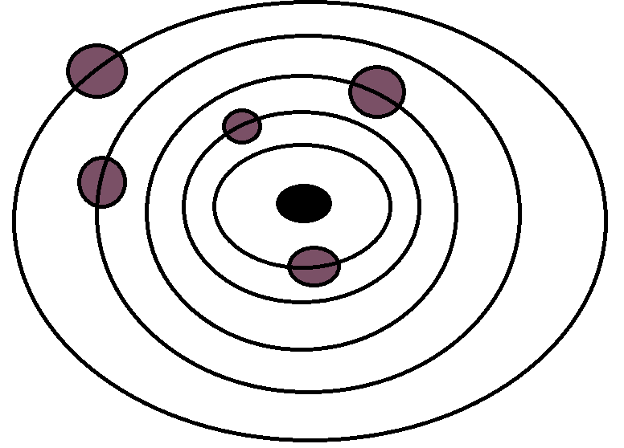

2) Dark hole explosion :- The dark holes in black space pull different elements, formed from chemical reaction, towards their center and get compressed. After million years of process they have infinite density and motion so that infinite pressure develops and the state of zero resistance arrives. The dark hole which reaches to the state of zero resistance cannot hold any element on it and starts to repel them. It happens for few seconds or minutes only then the dark hole explodes. Now the same process occurs. The particles moved away from the explosion start to group and form other small and large masses. The mass in which still have the active energy develop as star and mass with semi-active energy develop as planet or satellite. Since the centric position still holds the energy so the formed masses revolve around making it as center.
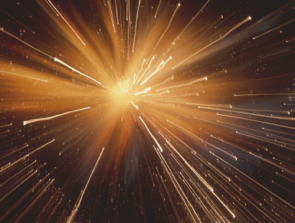

3) Dark hole burning: - Because of infinite density and motion the infinite energy emerges in dark hole. Before reaching to the stage of white hole the energy is activated in dark hole in the form of light and heat due to which the pressure of dark hole starts to remain stationary. Million years later the pressure reduces to great extent and the dark hole converts to fire sphere which we call star. The stars formed in this way are comparatively big, intensely bright and do not revolve around other object. Rather they revolve around own axis in a slow pace. The intensely bright large stars in the existing universe which are revolving in a slower pace around own axis were formed through this process. After one era such stars can develop as big planets, or explode to form separate galaxy or solar system.
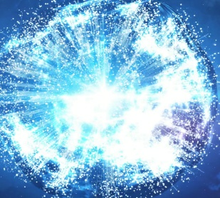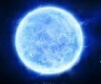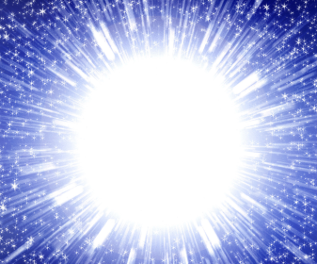
In this way our universe was formed. The Milky Way Galaxy and other similar medium size galaxies are formed from dark hole explosion and revolve around Absepa dark hole or it's influential area. The galaxies formed by collideion between two dark holes are large in size and can be two or more in number, and revolve around dark hole influential mass or area which form during explosion. This process continues in the universe so the universe expands continuously. A galaxy can be destroyed due to the effect of black hole but universe cannot extinct. Also the black hole which in gulfs the galaxy can collide with another black whole and pass through the same process mentioned above to form new larger galaxies. The same process goes on.
( III ) Expansion of Universe
Many theories are there about expansion of Universe. Some theories connect universe with its extinction and according to some theories universe expands due to formation of new mass between two masses. Some theories also say that universe is expanding with the velocity more than that of light.
It's true that the universe is expanding but the reason of expansion is quite different. When two dark holes in a black space collide with each other or dark hole explodes then it affects Dian and a kind of wave develops. This brings Dian in motion and the inherent masses in it gain higher velocity than their normal velocity. Now all the masses go away from each other. This process can last for thousand years depending upon the pressure or effect on Dian. As the effect goes on decreasing the expansion also slows down and eventually stops.
The initial direction in which the universe expands, after thousand years two dark holes collide with each other or the dark hole explodes in the opposite direction. Then our universe starts to move in the original position and we feel the universe contraction. This is the continuous process in the universe because of which some planets or galaxies collide with each other and destroy but there's never the chance of distraction of the whole universe.
( IV ) Extinction of Universe
Universe formed from a process and that continues but never ends. Universe never destroys completely. The reaction of five elements Dian, Pito, Anto, Blata and Glaci is the basis of Universe formation so till these elements exist the universe also exists. Black hole or any cause may destroy or form the galaxy, star, planet or satellite. The process of formation of new things and destruction of old things continues but the universe never extinct. But as expected 95% dark space in the universe starts to decrease to form new dark holes, galaxies, planets and satellites, and the universe becomes larger and larger in size.

( V ) Dark Hole Properties
Dark holes are in the form of tornado or let's say the dark hole is the tornado formed from basic elements Pito, Anto, Blata and Glaci, and has its own properties. It has infinite density and speed. Because of its high gravity no any object which comes in its field can escape from it, even the light too. But the effect of black hole is not same and can be divided in 4 parts.
1) Central region: - The central region of dark hole has maximum pressure, density and gravitation. It is also known as CI (centrally affected area) or the bottom of dark hole. Any object that dark hole engulf arrives in this region, reduces to a dust particle and converts to the elements formed from initial reaction of Pito, Anto, Blata and Glaci. Those masses which do not come in contact with dark hole are in continuous reaction with Pito, Anto, Blata and Glaci of the universe so universe expands continuously till the end.
2) Directly influenced region: - It lies outside the central region and also known as DI (directly affected area) where the pressure, density, gravitation and speed is less than that of central region but the area is large. It continuously moves towards the central region and breaks any mass or element which come in contact to the basic elements. Moving away from the center its size and area increases but the gravitational force decreases and after a fixed distance the gravitational force becomes very less and its speed of rotation too.
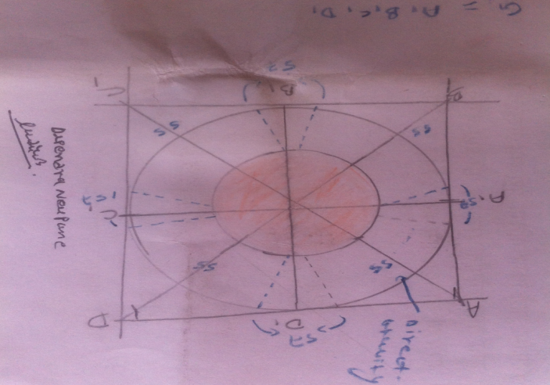
3) Less affected area or semi active region:- It covers the directly affected region (DI area) and known as LI (Less affected area). Here the pressure, density, gravitational force and speed of rotation are negligibly less but the area is very large. It bears the black holic effect not the black holic quality. The existing stars, planets, satellites and masses are situated in this region of their respective black holes.
The central part of all the galaxies, planets and satellites which are formed from collision between to dark holes or the explosion of dark hole still bear the central energy so they revolve that central part and the other masses present in directly central region and affected region merge to the dark hole because of infinite gravitation. So the size and capacity of dark hole increases. Making it as a center the other masses in the lea affected region and semi active region revolve.
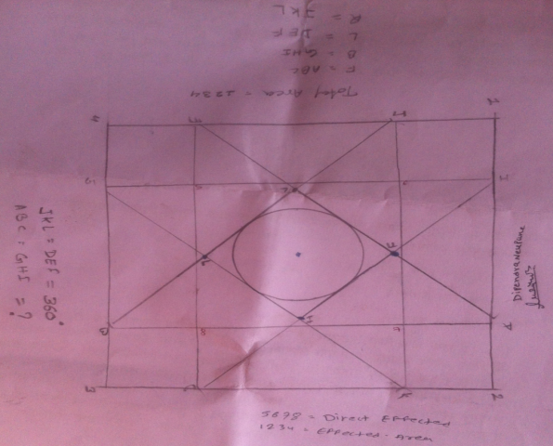
4) Wave region:- WI (Wave region) is the outermost affected area of dark hole. Here is no any significant effect of dark hole and only the wave generated from dark hole influence or wave produced in Dian that is affected due to the presence of dark hole can be detected. Its area is thousand times greater than less affected region and semi active region. There are certain loop holes in lea affected region or semi active region or wave region of dark hole where the gravitational force is large.
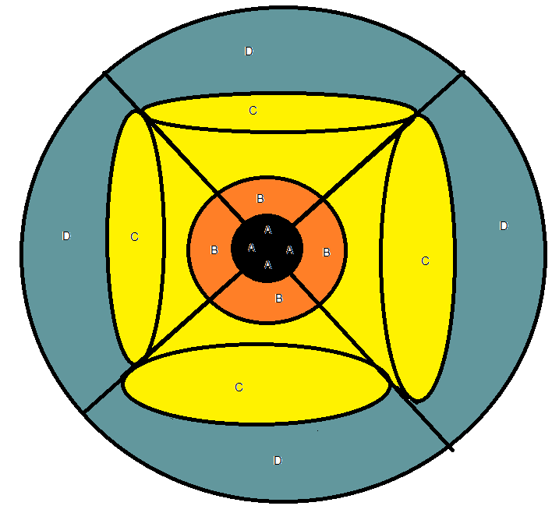
Figure 1: Dark hole properties
A Black Color = CI Area
B Orange Color = DI Area
C Yellow Color = LI Area
D Sky blue Color = WI Area
( VI ) Loop Hole
In one super massive dark hole or in dark hole properties there are four galaxies which remain in four different C = LI Area and revolve the dark hole. Because of the effect of black hole stars, planets and satellites remain in dynamic state. Only if any star, planet and satellite are in wave region of dark hole then it revolves in its own axis but doesn't revolve around any mass. If any star, planet or satellite is not in dark hole influential region then it remains stationary. Dark hole contains loop holes which have gravitational force equivalent to that of central region. During revolution, hose stars, planets or satellites which get trapped in the loop hole region enter to dark hole and vanish. When the Central affected region of dark hole goes on increasing or it becomes powerful then its direct affected region and starts to get pushed back a little. As the Directly Affected Region goes on increasing its effect also appears in Less Affected Region. As a result size of Less Affected Region and starts to go back, and Wave Affected Region (WI) also spreads in very large region.

( VI ) Penumbra Region:-

A dark hole has four regions in which right, left and bottom regions are known as Shadow Region or Penumbra Region. This region cannot be studied using simple telescope because due to dark hole spinning speed and high gravitational force the light or wave coming in this region is attracted or feebly reflected by Shadow Region. To study this region reflected light receiver or wave receiver needs to be invented so that it can be used to study the light or wave coming from other galaxies. The other galaxies in a sense that the light or the wave generated from the stars present in Parathion Region reflect from other galaxies and mix with light or wave of these other galaxies so they can be separated and studied.
( VII )Types of Dark Hole

With this principle Dark Holes are of 2 types:
1) D Type Dark Hole: - This is the prime dark hole which can be smaller or larger in size. It forms from reaction between Pito, Anto, Blata and Glaci of this universe. It has high gravitational force, high orbital speed, and high pressure. Also the shape and the acidity are also increasing in a faster rate. By time it transforms into any of the 3 stages mentioned above and then form galaxies, stars, planets, satellites or other masses.
2) N Type Dark Hole: - This type of dark hole forms from collision between two dark holes or due to dark hole explosion. Like other stars, planets and satellites they revolve a super massive dark hole. It has very high gravity and pressure as compared to stars, planets and satellites. Such type of dark holes can't form other masses but can destroy them. By time they merge to super massive black hole. Number of N Type Dark Holes can be found in Milky way Galaxy too.

( VIII ) Inter Dark Hole Effect

The inter dark hole effect is defined as the effect of one dark hole to other in between two or more dark holes. Often such effect is directly seen in Wave Affected Region (WI) and Less Affected Region (LI).
Dark Holes bear attractive and repulsive character. When similar types of dark holes come closer to each other then following two cases appear:
1) Attraction:- Similar or equal state or same pole condition
2) Repulsion:- Opposite or in equal state or opposite pole condition

1) Attraction:- There is high attractive property in Dark Hole which attracts mass, object or matter towards itself. If two dark holes are in same state or facing each other in same pole then they attract each other. In this state the masses in the periphery merge in these two dark holes and by time those two dark holes also merge to form a big dark hole. The smaller dark hole fuses to larger dark hole. Two dark holes of equal shape and capacity collide with each and destroy themselves and billion years later new structures like stars, masses, planets and satellites start to form.
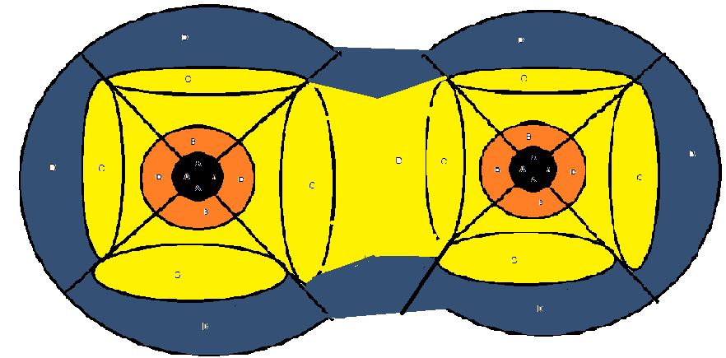

Figure 2: Attraction
2) Repulsion:- Dark holes also have repulsive property. The repulsion can occur only in between to dark holes of same size and capacity when they approach towards each other from opposite poles or when they are in unequal state. After repulsion the two black holes move up to million light years apart. This effect can last up to thousand years. While getting repelled some stars, planets or satellites in Less Affected Region can enter to Directly Affected Region of dark hole and vanish. The repulsion can also occur between two dark holes of unequal size and capacity in which small dark hole gets repelled more than the bigger one. During such type of repulsion the small dark holes can be repelled up to million light years and take billion years to come to normal state. In this case also some stars, planets or satellites in Less Affected Region can enter to Directly Affected Region of dark hole and vanish. The small sized dark hole is most affected than larger one.
Figure 3: Repulsion

Space and Mass Revolution
Various theories have been proposed about ‘Space and Mass Revolution’. According to Newtonian principle smaller masses are attracted by the gravitational force of huge masses and fall towards them but due to high velocity and distance are unable to reach to the surface of larger masses and revolve around them. So, all masses in this universe revolve around the masses with larger mass and higher density. ‘Theory of Relativity’ of Albert Einstein is the universally accepted principle till now which connects space and time.
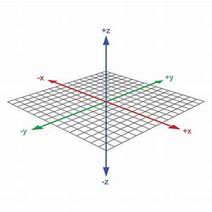
Fig: 01
If any mass comes to time and space, a curvature builds up and affects the both. The mass with high density creates more curvature in space time. Similarly there’s less curvature with lightly dense mass.
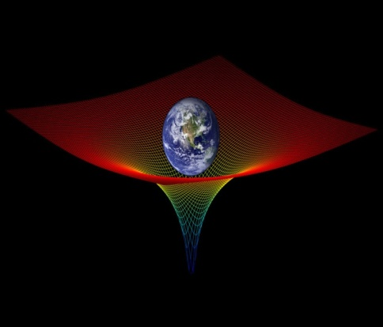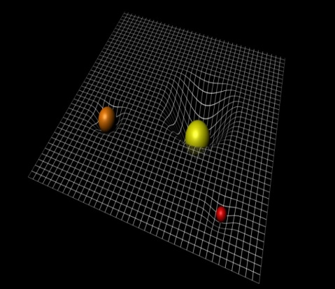
Fig 2
The curvature causes small masses to revolve around heavenly masses as per its size. Curvature affects the time also.
But the outcomes of this new investigation are found different. Mass and density of an object have no influence on space. So presence of any mass doesn’t affect space and time and, hence no creation of curvature. The effect is only perceived when there’s gravitational effect on space. But presence of mass in the space can break the line of space and time. If that happened then the presence of space & time must be vanished in the locus made by mass but that doesn’t occur. With this research it’s concluded that there’s gravitational force only, but not the effect. For example, if two persons of mass 10 kg and 50 kg in Earth are taken to the space where there’s no effect of gravity i.e. outside the region where there’s no effect of black hole placed at the center of Milky Way galaxy, then their weight becomes zero. But within a gravitational field they how some weight. So the experiment must be done in no gravitational zone.
This theory divides the space in 3 parts as below:
- Mass Affected Space
- Indirectly Affected Space
- Free Space
1) Mass Affected Space:- It’s the space covered by the object plus the space where the gravity of that object can be experienced. For example, mass affected space of Earth is the region covered by the earth and the region directly or indirectly affected by its gravity. This space size depends upon density and force of gravity of the mass.

u'?lTto c;/ :k]; Indirectly Affected Space
Mass Affected Space

Mass + Gravitational Region = Mass Affected region

2) Indirectly Affected Space:-It covers space occupied by the mass, it’s gravitational field and wave region. The region affected by other masses which are affected by the central mass also belongs to this. For example the indirectly affected area of Milky Way galaxy is the total region affected by central black hole and masses revolving around it. In the picture below we can see dark hole properties with its indirectly affected area.

 Black = Black Hole
Blue = Black Hole Affected Area
Other 4 Mass = Galaxy and affected area

Mass + Gravitational Field + Mass Affected Area = Indirectly Affected Area
3) Free Space:- It’s the region where there’s no effect of mass, dark hole and black hole except gravity. This is why it’s also termed as null region or passive region. In this region elements viz. Dian, Pito, Anto, Blata and Glaci, and other elements formed from chemical composition of them are present. No any physical laws work in this region.
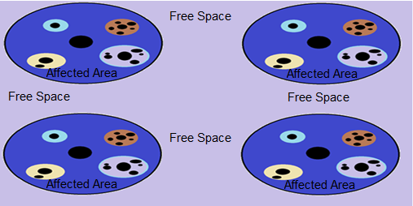
4 Circle’s blue area = Black hole affected area and Galaxies
Lite brown area = Free space

Mass Revolution
To know about mass revolution it’s needed to understand dark hole properties. Dark hole is a whirlpool formed by the interaction between the Pito, Anto, Blata and Glaci. It has 4 regions viz. central region, directly influenced region, less affected area or semi active region and wave region. All the mass in the universe are spaced in less affected area or semi active region of their respective dark holes. These masses gain motion due to gravitational force of dark hole. According to this principle masses are of two types: main mass and additional mass. Main mass revolves around the dark hole directly but the additional mass revolves around main mass i.e. around the dark hole indirectly. When a mass falls in the dark hole or black hole affect region another whirlpool is created with reference to density and gravity. It can also be called as sub-whirlpool. Small masses when fall in it start to revolve around other bigger masses. Millions and billions of such sub-whirlpools can develop in a dark space. Any mass or sub-mass gets its motion, speed and an orbit because of the pressure and speed of whirlpool and sub-whirlpool it belongs. If any mass falls outside the dark hole properties it remains free and still.
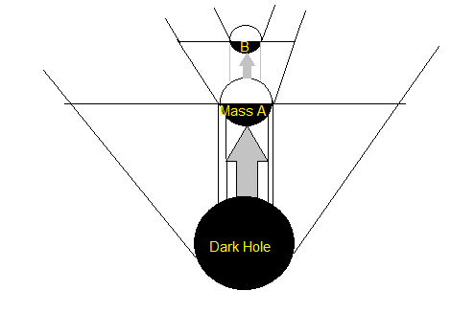
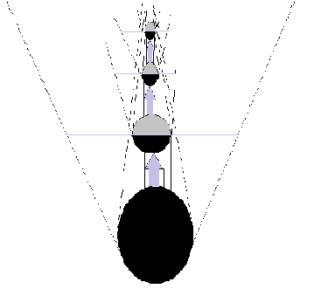
Investigation Method
For this research and investigation multiple studies and tests were carried out but I am presenting here the methods that can be done in laboratory.
At first numerous studies were carried out to search 5 elements viz. Dian, Pito, Anto, Blata and Glaci. Following conclusions are made:
- To bring any element in motion external influence or pressure is needed. Else one such dynamic element must exist which brings other matter interacting with it into motion. A simple test has been done to test it. Light and round objects were placed at some distance to each other on plane vacuum test pan. Then a similar kind of object was brought into motion by external influence and passed between them. Result was that it brought other objects, which came in contact with it, into motion. All other objects remained in motion till that object remained in motion. This proves that if any object remains in motion then there must exist one element which provides that object a motion. That element is proven as Tito.
- Any element requires a base. For the above test too plane vacuum test pan was taken as base. Base is still and has gravitational effect and hence attracts other matters towards it. Such type of base element cannot be tested in Earth as Earth has force of gravity. The experiment must be carried out in such lab where there’s gravitational force but not force of gravity. Such base element unites the matters as they gain the motion. The base element is named as Dian which provides gravitational characteristics to the matter. It doesn’t react with any matter except Pito, Anto, Blata and Glaci.
- An evacuated curved tube was taken and mass less dusts of light matter were placed. Then air is passed slowly and the particles start to fly. After some time a tiny element with a little mass was put and this provided density to the light matter. As a result the light matter started to fall towards surface and it continues till the tiny element was not removed. But after removal of tiny element the light matter remained still in evacuated space. This proves that the universe consist of one such element whose influence upon other elements develops density on them. Such element is proven as Anto.
Elements start to come in minimal appearance as they gain motion, gravity and density.
- Now the above experimental procedure was carried out in two places separated by little millimeter distance. The dense particles were replaced by magnetic dusts. Test showed attraction and repulsion between the particles and hence proved the existence of positive and negative pole.
With reference to above experiments it can be concluded that after the billion years of interaction of aforementioned 5 elements motion, density, gravity and electric dipole were formed and consequently dark holes were built.
Several experiments had been carried out to test 3stages that appear after the formation of dark holes. Some of the easy and simple tests that can be done in laboratory are mentioned below.
- For the first stage mentioned above tiny dusts of any matter is taken and mixed with magnetic dusts to fulfill the need of gravitational effect. Now it’s given a spherical shape. The prepared large sized two spherical masses are kept in a vacuum and allowed to collide with same speed. After collision they break into large number of fragments. Some of the fragments spread and remaining fragments re-unite to form star, planet, satellite and other interstellar masses. The remained central mass develops as a black hole. The above result can clearly be achieved in non-gravitational field rather than gravitational field.
- Excessive pressure on any object breaks it. The same principle is applied to test second stage. The spherical mass is formed as above and placed in a vacuum. Now a pressure is applied to it and rotated with a high angular velocity. As a result heat is produced and the mass explodes. The remained central mass keeps rotating in its state and spread fragments start to unite due to their rotation. The central mass later develops as black hole and the united masses develop as stars, planets, satellites and other stellar masses.
- For the third state test an air filled tube is taken and filled with inflammable substance. Now two spherical masses of combustible material are prepared, placed in contact with each other and rotated in high speed in opposite spin. Due to large friction and pressure a heat is produced and they burn. If the same condition happens in nucleic state then nuclear fusion begins.
Proving the birth of universe by above tests different tests had been made to test dark hole properties for which gravitational effect was taken as main reference. The conclusion was made based on the strength of gravitational force, coverage area and distance. The same spherical masses made from combination of tiny particles with magnetic dusts were used to study this effect.
Several methods were used to test revolution space and mass. Some of the simplest methods are as below:
1) The spherical masses of different sizes prepared as above were taken and placed over plane surface. Now their influential region and appeared properties within those regions were detected and compared with reference to their size. Hence space and its properties were identified.
Mass rotation can also be proved from simple experiment. Below are the two simplest methods:
- This experiment is highly affected by gravitation so non-gravitational field is required. An object having gravitation is tested on the non-gravitational region. As it’s not possible to test in earth so both liquid and solid matters are used to perform this test. Chemically contaminated water is filled in 15*15 vessel fitted with electric motor. Now the whirlpool of water is created by rotating motor and a mass having density less than that of water is put in the periphery of whirlpool. The attention must be taken that 3/4th part of mass must sink in water. Now the mass revolves the center of whirlpool and another sub-whirlpool is also formed around that mass too. Sub-whirlpool moves with mass and it any tiny particle is put on it then it revolves that mass. In this way multiple whirlpools form with the presence of different masses. Always the small mass revolves the larger mass and the center with the help of whirlpool. This continues till the electric motor stops or water stops to rotate. The electric motor in this experiment represents the dark hole and water behaves as the gravitational region of it. The other masses used represent stars, planets, satellites and other stellar masses.
- In this alternative test of mass rotation some light paper masses are used. Those masses are placed in vacuum and air is passed through compressor. Now the whirlpool of air is created inside and motion of masses is observed. It is observed that there were sub-whirlpools around each mass. The larger masses created radically larger whirlpools and the smaller masses created smaller one. All masses revolved their central mass bigger than them.
- This method of mass rotation is a bit complicated and remained to be tested as it needs to be tested on outer space. This is because the test must be carried out freely, among masses exhibiting gravitational behavior, in non-gravitational zone. Some spherical masses of various sizes prepared by the same procedure in previous experiments are taken. The larger mass which shows stronger gravitational field intensity is placed over an electric motor and rotated. Now different influenced regions viz. CI Area, DI Area, LI Area &WI Area are studied by placing medium and smaller size masses in less influenced region. (If placed them in CI area or DI area they are attracted strongly and merge with central mass due to which the test fails). As the electric motor is turned on smaller masses revolve around the central larger mass. The experiment shows that larger masses revolve the central mass, medium masses revolve larger masses and smaller masses revolve medium masses. The success rate of this experiment is 99% and hence proves the process mass rotation on universe with no doubt. This is the most effect test among all.

( IX ) Conclusion:-
With this theory, there was a dark space having five basic elements namely Dian, Pito, Anto, Blata and Glaci.
All these five elements have own characteristics. Dian has gravitational effect and can induce such effect in other elements too. Pito is mobile and when combines with another elements make them move too. Anto has the density and provides density to other elements combining with it. Blata combines with Anto to create positive charge. Glaci combines with Pito to form negative charge. All those elements interact continuously to form dark holes in a dark space. One of the following three interaction occurs between the dark holes to form the universe:
- collision between two black holes
- dark hole explosion
- dark hole inflammation
With any of the above three interaction elements spread in a distant region. After hundreds of years these elements start to reunite through different chemical reactions to form a mass. On the basis of density of the masses objects gain the gravitational force which helps them to merge with each other to gain large shape and area. Those masses formed with this process start to remain in groups. The active masses develop as stars, and the semi-active and inactive one develop as planets and satellites. The place of collision of two dark spaces still possesses a central energy which attracts the masses on its surroundings. So they gain a necessary centripetal force and revolve that central part. In this way the existing universe forms.

( X ) ACKNOWLWDGEMENT
I wish to thank my brother Rupendra Neupane for his guidance, valuable suggestions and cooperation while preparing this paper. I am also grateful to Pramod Gautam for valuable suggestions and Bishowvijaya Pandey who helped me to translate my research findings from Nepali to English.
References:-
1 ) The Big Band Theory By :- Karen C. Fox

2 ) Genesis of the Big Bang By:-Ralph A Alpher, Robet Herman

3 ) The Origin of the Universe. By :- Simon Singh

4 ) Big Bang : From Wikipedia, the free encyclopedia

5) Universe : By Roger A Freedman , William , J. Kaufinann

6) The three Big Bangs By:Philip M, Dauber Richard A Muller

7) The Bib Bang Theory , By : Karen C . Foxjohn

8) Genesis of the Big Bang, By:RalphA.Alpher, RobertHerman

9) Hunting Down The Universe , The Missing Mass, Primordial Black Holes and Other Dark Matters , By : Michael Hawkins

10 ) Foundations Of Modern Cosmology , By : John F. Hawley , Katherine A Holcomb

11 ) The Last Three Minutes , Conjectures about the Ultimate Fate of the Universe , By : Paul Davies

AUTHOR INFORMATION

Dipendra Neupanes
Suryabinayak – 1, Bhaktapur, Nepal
C: +9779841352354
E: dipendraneupane2036@gmail.com

