Subspace Approximations to the Fokker-Planck Equation
Jordan Lasuik, Master’s Student, University of Manitoba, Canada

Abstract

In 1909 Theodor Wulf made the first detections of cosmic rays. Over a century later, the origin of cosmic rays is still an open problem for physicists. This problem is due to the difficulty of determining the trajectories these particles made on their way to Earth. This is why the study of cosmic ray trajectories is such an interesting and important field. In the early 1900’s Adriaan Fokker and Max Planck developed a partial differential equation to describe the probability distribution function of particles experiencing both Brownian motion as well as outside forces. This equation can be applied to cosmic rays trajectories through turbulent magnetic fields. When applied to this situation the equation does not yet have a known simple analytical solution. Usually to solve this problem numerical methods are used, however numerical methods are not practical solutions for everyone who needs to use these solutions in their work. We have therefore used used Legendre polynomials to approximate a solution to the Fokker-Plank equation. The first, second, and third order solutions were found as well as some of the solutions’ expectation values. These expectation values are useful both in future analytic work as well as in experimental work. These analytic solutions were compared to a numerical solution to show that for very early times the third order approximation is significantly better than the second order approximation, but at late times only a second order Legendre expansion is needed to achieve good results. This solution being so close to the numerical solution will allow people to more easily track the trajectories of cosmic rays.
Image

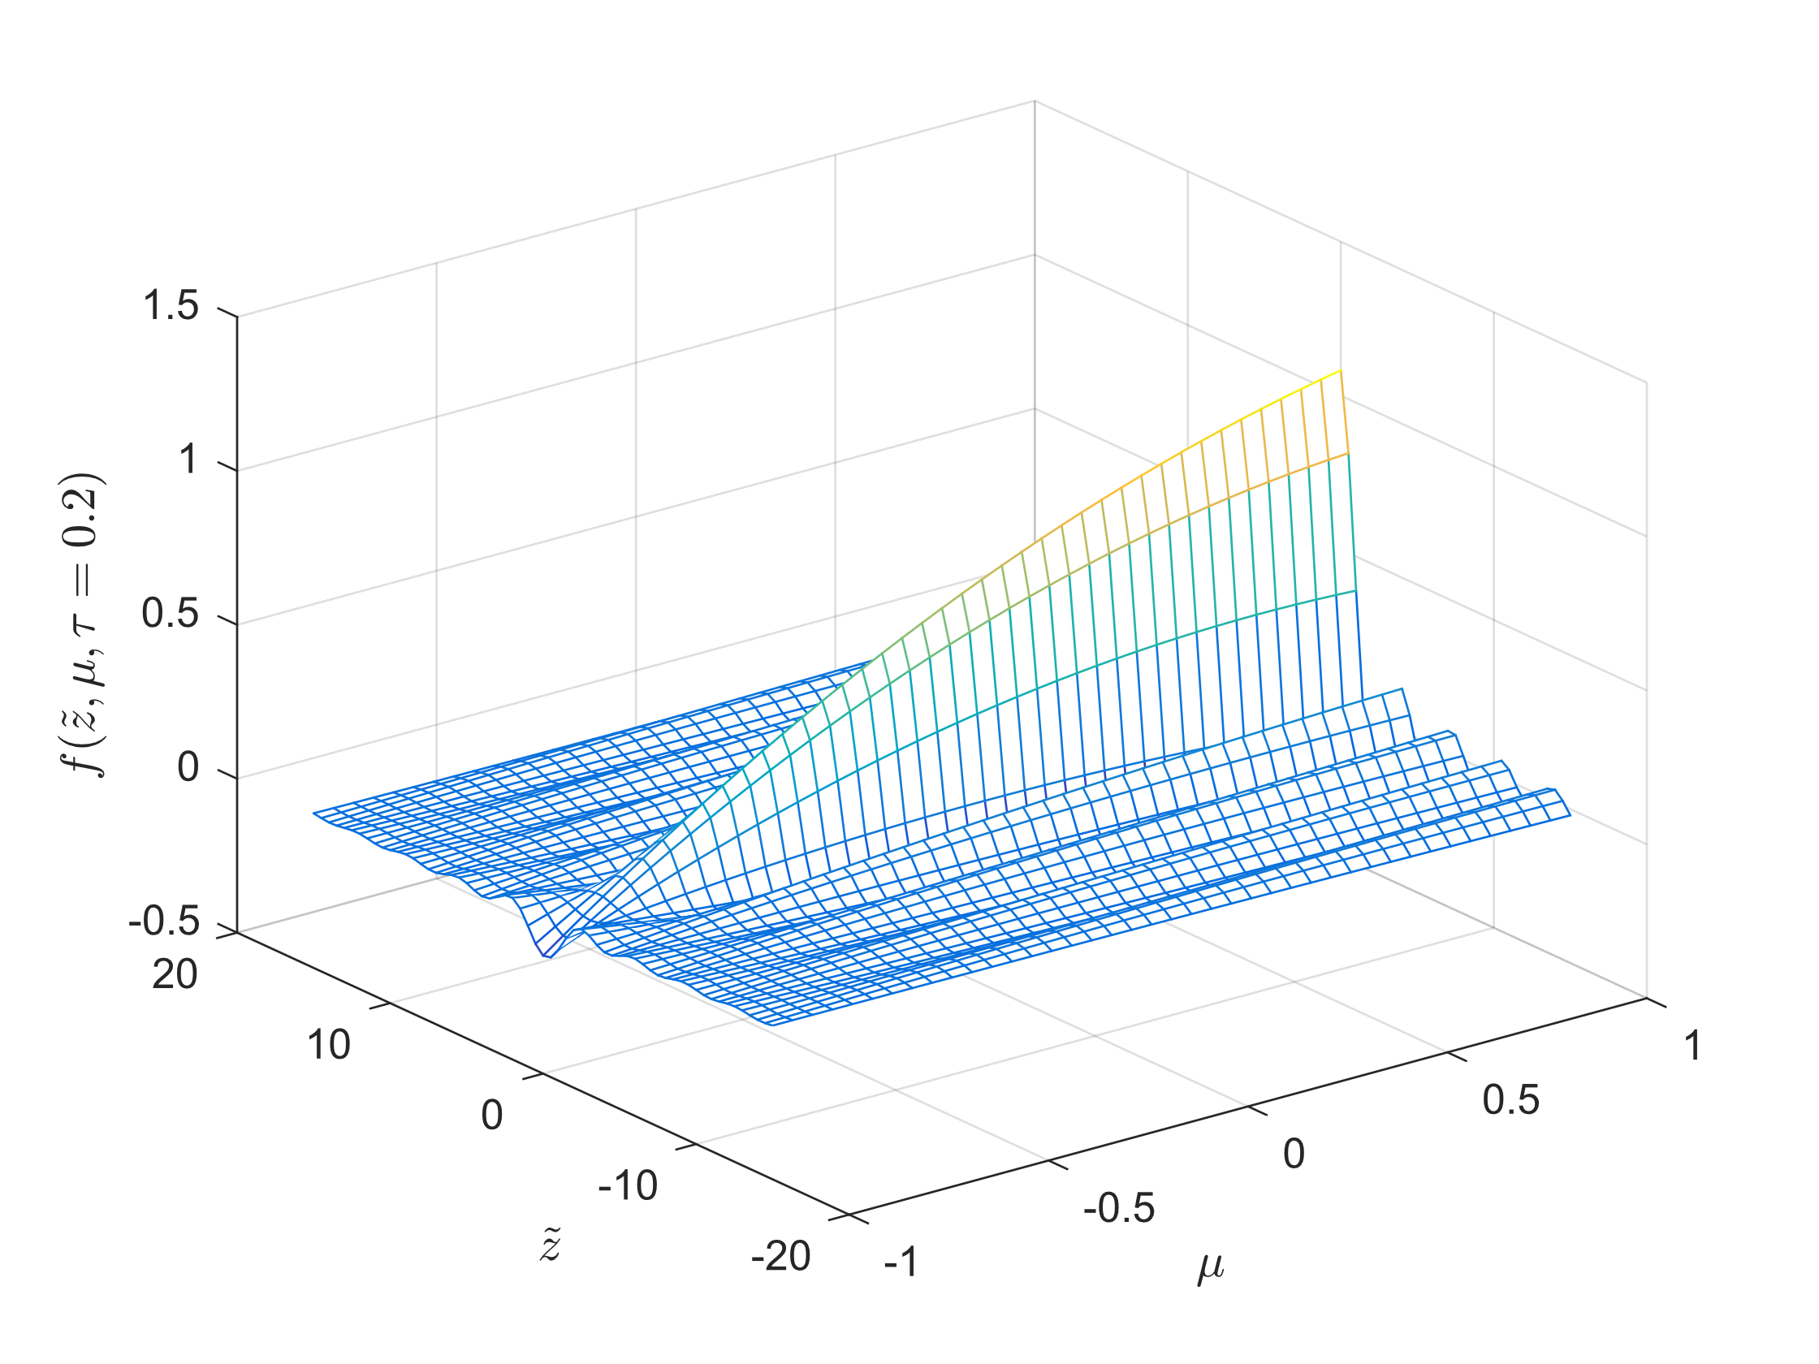
Recent Publications

Lasuik, Jordan, and Andreas Shalchi. "Time-dependent Perpendicular Transport of Energetic Particles for Different Turbulence Configurations and Parallel Transport Models." The Astrophysical Journal 847.1 (2017): 9.

Lasuik, J., and A. Shalchi. "Solutions of the cosmic ray velocity diffusion equation." Advances in Space Research 60.7 (2017): 1532-1546.

Lasuik, J., J. D. Fiege, and A. Shalchi. "Numerical analysis of the Fokker-Planck equation with adiabatic focusing: Realistic pitch-angle scattering." Advances in Space Research 59.2 (2017): 722-735.

Lasuik, J., and A. Shalchi. "The influence of non-Gaussian distribution functions on the time-dependent perpendicular transport of energetic particles." Advances in Space Research61.11 (2018): 2827-2836.

Biography
Jordan Lasuik has done both numerical and analytical work on the trajectory of cosmic rays through turbulent magnetic fields. He is currently 24, and is finishing up his Master’s degree at the University of Manitoba.. He has created a new scholarship for his department through fundraising, and is also the founder of a national organization for physicists who are also part of the lgbtq+ community.
Email: lasuikj@myumanitoba.ca

Notes/Comments:

Presenting author details
Full name: Jordan Lasuik
University/Industry/Organization name: University of Manitoba
Designation (Director/Prof/Assistant or Associate prof/Researcher/Student): Master’s Student
Country: Canada
Telephone: 1-204-461-2410
Email: lasuikj@myumanitoba.ca
Track name: Astrophysics and Space Science
Category (Oral presentation/ Poster presentation/Young researcher forum/E-poster): Poster presentation
Research interest: Cosmic Rays

Note: Please fill up the Red mark fields so that it would be easier for us to cite your details in the conference particulars. (Please do not forget to fix your photo above the title)

