SUPREME THEORY OF EVERYTHING
Ulaanbaatar Tarzad
Department of Physics, School of Applied Sciences,
Mongolian University of Science and Technology,
Ulaanbaatar, Mongolia
tarzad@must.edu.mn; ubshine@gmail.com

Abstract. Not only universe, but everything has general characters as eternal, infinite, cyclic and wave-particle duality. Everything from elementary particles to celestial bodies, from electromagnetic wave to gravity is in eternal motions, which dissects only to circle. Since everything is described only by trigonometry. Without it science cannot indicate all the beauty of harmonic universe. Other method may be very good, but it is not perfect. Some part is very nice, another part is problematic. General Theory of Relativity holds that gravity is geometric. Quantum Mechanics describes all particles in the Universe by wave function. The trigonometry is science of triangle and circle. Since, using trigonometry, particularly mathematics circle, I would like to show a possible version of the general law of cyclic universe for unification of partial theories in this paper.

Keywords: From infinity to zero, number line, wave world, HRD, trigonometry, projection of circle, singularity, celestial body, black hole, everything circle, quantum mechanics and relativity.

INTRODUCTION
… Today scientists describe the universe in terms of two basic partial theories – the general theory of relativity and quantum mechanics. …Unfortunately, however, these two theories are known to be inconsistent with each other – they cannot both be correct. One of the major endeavors in physics today, is the search for a new theory that will incorporate them both – a quantum theory of gravity. …But ever since the dawn of civilization, people have not been content to see events as unconnected and inexplicable. They have craved an understanding of the underlying order in the world. Today we still yearn to know why we are here and where we came from. Humanity’s deepest desire for knowledge is justification enough for our continuing quest. And our goal is nothing less than a complete description of the universe we live in (Stephen Hawking, 1988).
Quantum mechanics governs the world of the small-the weird realm in which an atom or particle can be in many places at the same time and can simultaneously spin both clockwise and anticlockwise. Gravity governs the Universe at large-from the fall of an apple to the motions of planets, stars, and galaxies-and is described by Albert Einstein’s of general theory of, announced 100 years ago this month. The theory holds that gravity is geometry: particles are deflected when they pass near the massive object not because they feel a force, said Einstein, but because space and time around the object are curved (Ron Cowen, 2015).
…However, if we do discover a complete theory, it should in time be understandable in broad principle by everyone, not just a few scientists. Then we shall all, philosophers, scientists, and just ordinary people, be able to take part in the discussion of the question of why it is that we and the universe exist. If we find the answer to that, it would be the ultimate triumph of human reason – for then we would know the mind of God (Stephen Hawking,1988).
It is correct to describe the reality of universe by geometry, because of that not only gravity is geometrical, but everything is it and nothing is linear. One of the important branch of geometry is trigonometry dealing with triangle. The important terms of triangle are not so much: angle, vertex, line, circle, radius, chord, hypotenuse, bisectrices, angular momentum and so on. For this reason, it is easier to describe nature of universe by triangle or mathematics circle.
The concept of the circle is ubiquitous. It can be described mathematically, represented physically and employed technologically. The circle is an elegant, abstract form that has been transformed by humans into tangible, practical forms to make our lives easier. And yet no one has ever discovered a true mathematical circle (Ernest Zebrowski, 2000).
The language of physics dealing with cosmology and quantum physics is mathematics. In order to study physics seriously, one needs to learn mathematics that took generations of brilliant people centuries to work out. Hundreds of scientists such as Isaak Newton, Charles-Augustin de Coulomb, George Ohm, Max Planck, Wilhelm Wien, De Broiglie, Albert Einstein, Nels Bohr, Werner Heisenberg reached to the top of physical science. However, there are some disadvantages in their formulas and discoveries, in which didn’t use trigonometry and which include unsolved singularity problems by expression 1/0. To avoid difficulties in physics they used only the certainty of canonic and complex conjugate and discarded the uncertainty. In latest years these disadvantages are revealed in results and development of quantum mechanics and Heisenberg’s uncertainty principle. For this reason, we are necessary to understand that the concept of a singularity is a mathematical concept, not a physics concept.
But the mathematics is not yet ready for such problems (Paul Erdos, 1983). Maybe.
Today, we know that the scientific differentiation has produced a lot of collection of results, facts and data without any unification, reason of which reconnects ultimately with old scientific method from detailed investigations to globalization is not changed eventually from dawn of science.
Our mission at this paper is to bring to light the geometric principles and is shown a possible theory for unification of partial theories. I lock up my proposed theory can open a new prosperity for humanity.
But to bring to end the unified theory of reality we need to solve some basic problems of science.
- DIFFICULTIES IN THE WAY TO FIND REALITY
Problem#1: Thinking from 0 to Infinity
Dominant scientists have thinking from zero to infinity. Coordinate system begins from zero-point and its axes go to plus or minus infinities. According to scientists the zero-point has neither secret of nature and nor substantial and indicates only nothing. Zero-point appearances as unclear or meaningless and denotes only location of coordinate system in space and is used for beginning of thinking and calculation of all.
This kind of thinking encircles not only in scientific community, but just in ordinary people also.

Solution: Thinking from Infinity to Infinitesimal and Zero
Why we have not possible to think outside the box about infinitesimal and zero? We suggestthat one can enter into the “zero-point gate” of reality, if we give weight to it. On other hands, there is aphysical interesting phenomenon that an atom or particle and somebody can be in many places at the same time, no matter how far awayin Quantum Physics and deepest Buddhism. Without universal compulsory education Buddhist Masters can understand everything, forecast, prospect and help.

Table 1. Limit to zero
Size | Number of piece
Division by 0 | Divide by limit to 0 | Divide by limit to infinity
$$\frac{1}{0}=1$$ | $$\lim_{x→1}{\frac{1}{x}=1}$$ | $$\lim_{x→∞}{\frac{1}{x}=0}$$
$$\frac{10}{0}=10$$ | $$\lim_{x→0.1}{\frac{1}{x}=10}$$ | $$\lim_{x→∞}{\frac{10}{x}=0}$$
$$\frac{100}{0}=100$$ | $$\lim_{x→0.01}{\frac{1}{x}=}100$$ | $$\lim_{x→∞}{\frac{100}{x}=}0$$
$$\frac{1000}{0}=1000$$ | $$\lim_{x→0.001}{\frac{1}{x}=1000}$$ | $$\lim_{x→∞}{\frac{1000}{x}=0}$$
..................... | …………… | ……………
$\frac{n}{0}=n$ (1) | $\lim_{x→0.000001}{\frac{1}{x}=1000000}$ (2) | $\lim_{x→∞}{\frac{n}{x}=0}$(3)
We did not divide anything | $\lim_{x→0}{\frac{1}{x}=∞}$ (4) | $$\lim_{x→∞}{\frac{∞}{x}=0}$$
Tab.1 shows that any number divided by 0, it equals itself (identity (1)), because we do not divide or cut nothing. If 1 is divided by limit 0 it becomes very large number (identity 2 and 4). And number is divided by infinite (identity (3)), it converges tozero. But in ordinary mathematics the 0/0 and ∞/∞ is undefined.
Based on the Tab.1 we can formulate next bifurcation:
$f\left(x\right)=\left\{\begin{aligned}0 if x→∞ \\ 1 if x=0 \\ ∞ if x→0\end{aligned}\right.$ (5)

Problem#2: Mathematical Concept
There is a misunderstanding in mathematical concept (Tab.2).
Table 2.Division of 1 according to nowadays mathematical education
Division of whole number 1 | Size or dividend
$$\frac{1}{1}$$ | 1
$$\frac{1}{2}$$ | 0.5
$$\frac{1}{3}$$ | 0.33
$$\frac{1}{4}$$ | 0.25
..................... | ………………
Tab.2 shows only dividend without amounts. Everyone experiences that we cannot divide correctly an apple each other until present.
Solution: Distinctive Arithmetic
Table 3. Division of 1 according to my investigations
Size of dividend | Number of piece or amounts
$$\frac{1}{0}=1$$ | $$\frac{1}{0}=1$$
$$\frac{1}{1}=\frac{1}{2}$$ | $$\frac{1}{1}=2$$
$$\frac{1}{2}=\frac{1}{3}$$ | $$\frac{1}{2}=3$$
$$\frac{1}{3}=\frac{1}{4}$$ | $$\frac{1}{3}=4$$
..................... | ……………
$$\frac{1}{n}=\frac{1}{n+1}$$ | $$\frac{1}{n}=n+1$$
$\frac{1}{∞}≈\frac{1}{∞+1}=0$ (6) | $\frac{1}{∞}=∞+1≈∞$ (7)
$\lim_{x→∞}{\frac{1}{x}=0}$ (8) | $\lim_{x→∞}{\frac{1}{x}=∞+1}$ (9)
Slice consists of number of chopping and pieces. These parameters are in relations with each other shown in Tab.3. Attention: Here the parallel chopping’s are only shown. But there need to study and analyze this problem.
Suppose to chop 1kg meat for preparing “buuz” (Fig.1). As results, the size of piece is very little (1/1000), but its number or amount islarge (1000).
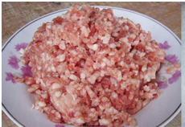
Figure 1. One kilogram chopped meat
$\left(\frac{1}{1000}\right)∙1000=1$ (10)
One kilogram chopped meat keeps one kilogram.
If we chop it as pasta, it is described in next form:
$\left(\frac{1}{∞}\right)∙∞=1$ (11)
It is by mathematical formulation:
$\lim_{x→∞}{\frac{1}{x}=\left\{\begin{matrix}0 \\ ∞\end{matrix}\right.}$ (12)
There are two solutions, not one. It has deepest meaning. This kind of solutions becomes clearly in Quantum Mechanics in last years (Ulaanbaatar, T., 2018). It displays the Heisenberg uncertainty law also. Detailed investigations send us to inconceivable consequences and vice versa the observation without conversation reaches to reality.
From Tab.3 we can see that identity (6) equals identity (7).
$$\frac{1}{∞}≈\frac{1}{∞+1}=0=∞+1≈∞$$
$0=∞$ (13)
It means that everything is circleas same number line or described by method of trigonometry.

Problem#3: Number Line
Mathematics manifests that number line continues from 0 to the plus and minus infinities.
Solution:But this concert is violated the law of energy conservation, when we use in
practice.
If we ponder over from different angles the number line is cyclic.Everything goes backto starting point. One pinpoint of numberline connects to another pinpoint or 0 links-up with infinity.The 0 in number line showsdeepest reality of nature, according to which nothing goes to infinity. In this case the number line begins by 1, but not by 0.
$$0=∞$$
Since, if number line is a circle, there is neither 0 nor infinities in mathematics.
Problem#4: Electromagnetic Wave
The wavelength of electromagnetics continues from 0 to infinity.
Solution:It is same Problems #1, Problem #2 and Problem #3. Long wavelength consists of
short wavelengths. Short waves produce long wave. We know that one circle is divided by De Broglie wavelength. This circulating peculiarity is a common law in universe. So, the electromagnetic circle is suitable to call WAVE WORLD (Fig.2).
$$0=∞$$
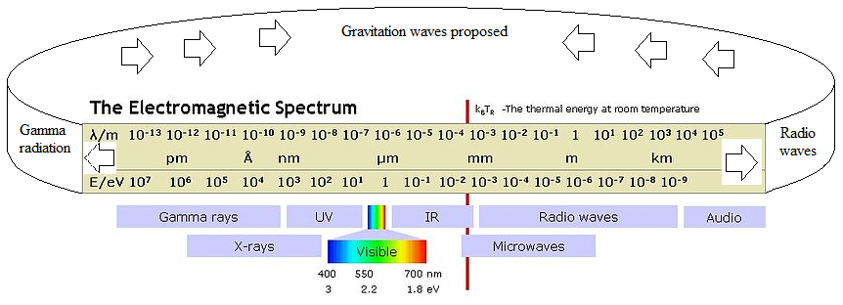
Figure 2. Circle of wave world (Ulaanbaatar, T., 2018)
Whole has unit, unit has whole.
Problem #5: Challenge to Develop the Hertzsprung–Russell Diagram
In circa 1910 Einar Hertzsprung and Henry Norris Russell created a diagram so-called Hertzsprung–Russell diagram (abbreviated H–R diagram, HR diagram or HRD), which shows the scatter plot of stars describing the relationship between the stars' absolute magnitudes or
luminosity versus their stellar classifications, or effective temperatures. More simply, it plots each star on a graph measuring the star's brightness in relation with its temperature (color) between 2000K and 30000 K (Fig.3). About 90 percent of the stars in the universe, including the Sun, are main sequence stars in HRD.The diagram represents a major step towards an understanding of stellar evolution, but this diagram has a great possibility to accommodate everything in aspect of thermodynamics.
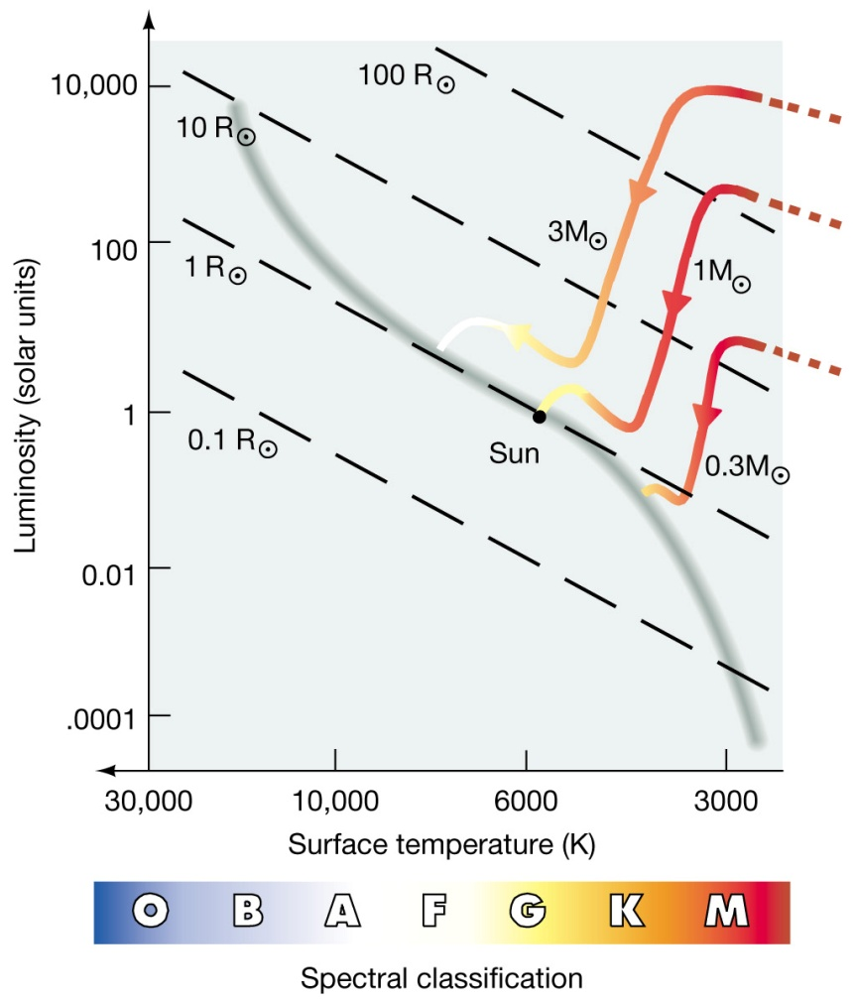
Figure 3.Hertzrung-Russel diagram
https://www.google.mn/search?q=hertzsprung+russell+diagram&source=lnms&tbm=isch&sa=X&ved=0ahUKEwjLyIDXzMvbAhUhCqYKHTPeBHoQ_AUICigB&biw=1350&bih=635#imgrc=aUNcrGCH7Qq5YM:
Solution:The rest of the universe appears to be made of a mysterious, invisible substance
called dark matter (21 percent) and a force that repels gravity known as dark energy (75 percent). Only 4 percent is visible matter, which is shown in HRD. Astronomy registers the celestial bodies, surface temperatures of whichoscillate 0Kelvin to some million degrees in the universe (Fig.4). Unfortunately, everything cannot set in HRD, because the effective temperature of stars is given in logarithm scales, which is not enough for range of everything.
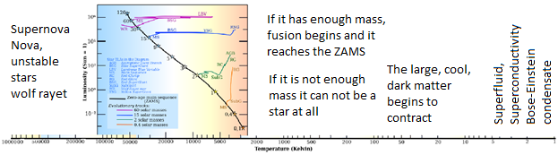
Figure 4. Temperature range of everything diagram

According to our study the logarithm scaling of effective temperature in HRD is a big source of problem. So, we need to extend the HRD to everything diagram (ED), by another scale, which can abbreviate more strongly (see you in Subsection 3.4).
Problem #6: Fundamental Forces
The gravitational force is attributed to the curvature of spacetime, described by Einstein's general theory of relativity. The other three are discrete quantum fields, and their interactions are mediated by elementary particles described by the Standard Model of particle physics.
Presently, Professor Sean Carroll showed quantum field theory suggests two strategies go to high energies or look for very small effects (Fig.5).
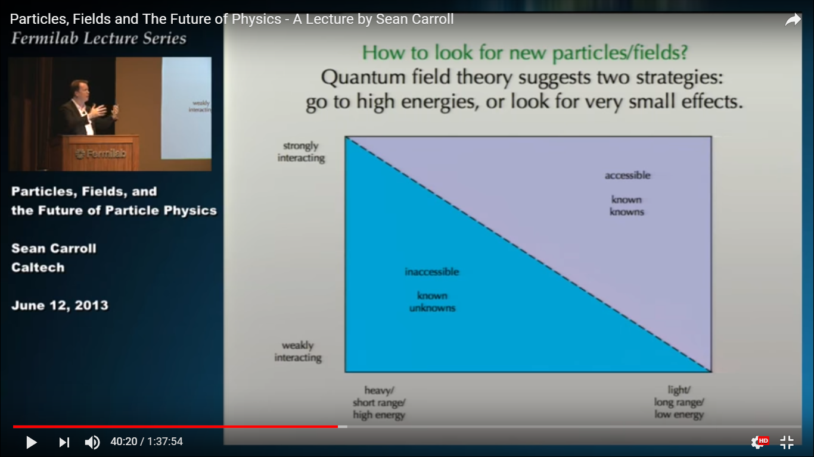
Figure 5. Strong and weak interactions in Quantum Field Theory
(Particles, Fields and The Future of Physics - A Lecture by Sean Carroll) https://www.youtube.com/watch?v=gEKSpZPByD0
Solution:
The interior interaction of nuclei is very strong and exterior is weak. Two forces
connect by somewhat critical line or surface, which is called membrane. For example, Sean Carroll has given two very different answers for the strong and weak nuclear forces. Strong force is confined and its force-carrying gluons interact with themselves, not letting them ever escape to the outside. It is like a closed shutter. Weak force is absorbed and its force-carrying W/Z bosons interact with Higgs field that pervades empty space. It is like an obscuring fog.
The surface of nuclei is a membrane or inflectionsurface (see you in 3.6 subsection).
Problem #7: Differentiation of Sciences
All known physics equation displays in Fig.6 and Fig.7.
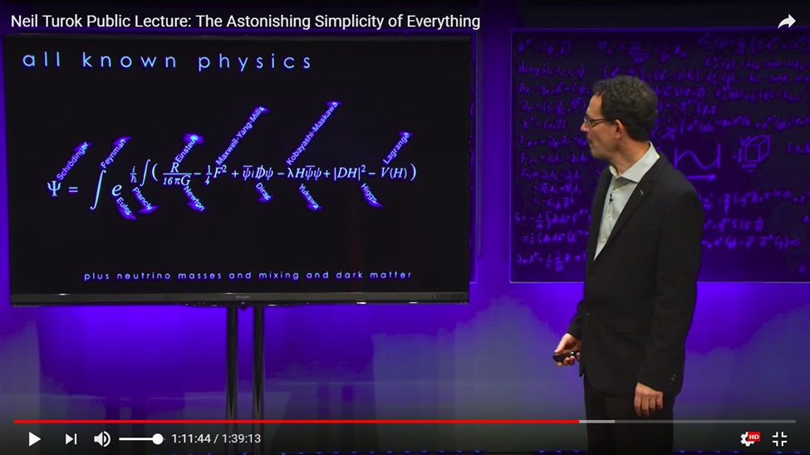
Figure 6. Structure of ψ function by all known physics
https://www.youtube.com/watch?v=f1x9lgX8GaE
Neil Turok said that this formula has plus neutrino masses and mixing and dark matter. But we see the wave function can include everything.
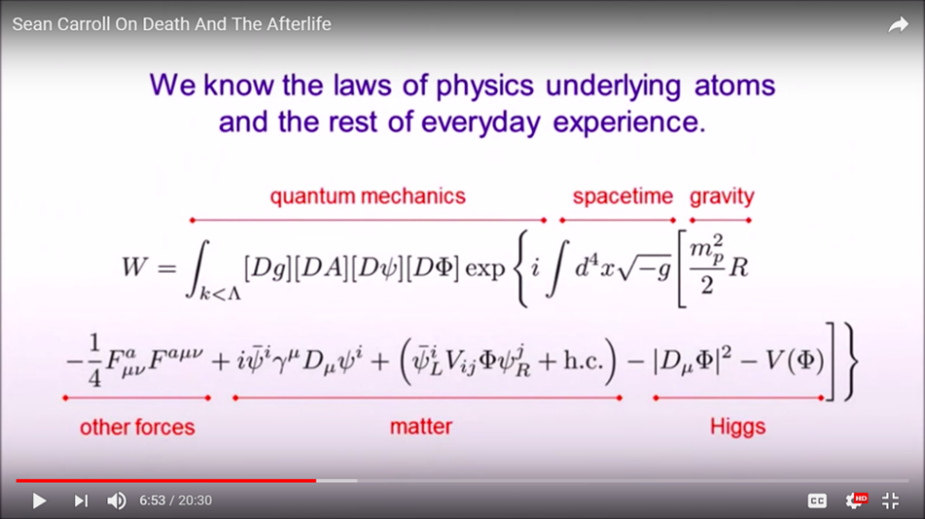
Figure 7. Unification of laws of modern physics
Sean Carroll said the laws encapsulated by this formula include no notions of purpose, meaning or morality, and sign of teleology and design.Doesnot mean these notions don’t exists; such ideas could be part of a higher-level vocabulary. But not a purely scientific description. So, the complete formula of modern physics is always not perfect as shown by Neil Turok, Sean Carroll and others.
Solution:The unification of partial theories is shown brand-newly in Section 3.

- SMART WAVE FUNCTION
The physicists attempt to unity all theory in a formula of wave function until now (Fig.6 and Fig.7). It manifests that how smart and clever the wave function. The wave function is central point of Quantum Mechanics and Supreme Theory of Everything.
$$\cos{θ}+i\sin{θ}=e^{θ}$$
$$ψ=x+iy$$
Probability ${\left|ψ\right|}^{2}=x^{2}+y^{2}=1$
So, wave function is a complex exponential function.
$ψ\left(x,t\right)=\cos\left(kx-ωt\right)+isin\left(kx-ωt\right)=e^{i(kx-ωt)}$ (14)
2.1 Wave Function in Time Dependent Schrodinger Equation(TDSE):
$$ψ\left(x\right)=\cos\left(kx-ωt\right)+isin\left(kx-ωt\right)$$
$a. kx-ωt=0$
$\frac{x}{t}=\frac{ω}{k}=V (speed)$ (15)
$ω=2πυ$; $k=\frac{2π}{λ}$; $\frac{ω}{k}=νλ=V$;
$νλ=V (speed)$ (16)
Matter wave (De Broglie):
$E=mc^{2}; E=hν$; $c=νλ; ν=\frac{c}{λ};$
$mc^{2}=hν;mc=\frac{h}{λ}=p$ (momentum is true for matter) (17)
- We have more interesting condition in aspect of singularity, when
$$kx-ωt=±\frac{π}{2}$$
$$x=\frac{ωt}{k}±\frac{π}{2k}$$
$\frac{x}{t}=\frac{ω}{k}±\frac{π}{2kt}=V (speed)$ (18)
$$\frac{x}{t}=νλ±\frac{λ}{4t}$$
$V (speed)= νλ±\frac{λ}{4t}$ (19)
  - Wave Function in Time Independent Schrodinger Equation (TISE):
$$ψ\left(x\right)=\cos\left(kx\right)+isin\left(kx\right)=e^{ikx}$$
Where k is propagation constant.
$k=\frac{2π}{λ}$; $2π=\frac{h}{ℏ}$; $λ=\frac{h}{ℏk}$
$a. kx=0;$ it means that wave function becomes 1.
b. $kx=\frac{π}{2}$; wave function shows only imaginary i.
2.3 Heisenberg’s Uncertainty Principle in the Wave Function
Based on the equation (14-18) we can write the uncertainty of the next canonic conjugate.
Position-wavelength uncertainty
$∆x∙∆λ≥1$ by Fourier analysis
Position-momentum uncertainty
$$p=\frac{h}{λ};Δx∙∆p≥\frac{ℏ}{2}$$
Position-velocity uncertainty
$$Δx∙∆V≥\frac{ℏ}{2}$$
Energy-time uncertainty
$$ΔE∙∆t≥\frac{ℏ}{2}$$
$$Probablity of density=ψ^{2}(x)=constant$$
$$k=\frac{p}{ℏ}$$
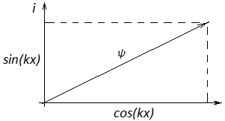
Figure 9. Components of wave function
$$ψ^{2}=\cos^{2}{kx=\cos^{2}\left(\frac{p}{ℏ}∙x\right)}$$
$$ψ\left(x\right)=\cos\left(kx\right)+isin\left(kx\right)=e^{ikx}$$
$$ψ^{2}=\cos^{2}\left(kx\right)+i\sin^{2}\left(kx\right)=1$$
$ψ=A∙e^{ikx}$; $ψ^{2}=A^{2}∙e^{2ikx}$

We can create a complex conjugate, which is complex conjugate any wave has a same real time.
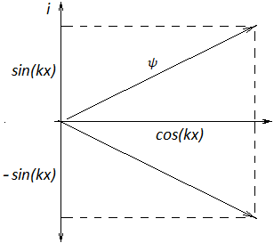
Figure 10. Complex conjugate of wave function

$$ψ\left(x\right)=A∙e^{ikx}=A∙(cos\left(kx\right)+isin\left(kx\right))$$
$$ψ^{*}\left(x\right)=A∙e^{-ikx}=A∙(cos\left(kx\right)-isin\left(kx\right))$$
$$ψ∙ψ^{*}=A^{2}=constant$$
An electron orbits around nuclei and exist standing wave.
$$L=2πr$$
$$ψ(x)=e^{ikx}$$
$$ψ\left(x+L\right)=e^{ik\left(x+L\right)}$$
$e^{ik\left(x\right)}=e^{ik\left(x+L\right)}$; $e^{ikL}=1$
$kL=n∙2π$ and $L=2πr$
$$2πr∙k=n∙2π$$
$$k=\frac{p}{ℏ}$$
$p∙r=n∙ℏ$ (20)
Where n-discret and integer number.
Equation (20) shows the momentum and angular momentum and it is a first great consequence of quantum mechanics.

2.4 Wave Function in General Relativity

Schrodinger took the wave equation for light and replaced the wave length with the de Broglie’s wave length for matter and got a wave function for matter.
$$p=mV; KE=\frac{1}{2}mV^{2}$$
Hence, $p=\frac{mV}{\sqrt{1-\frac{V^{2}}{c^{2}}}}$;
$\frac{p}{V}=\frac{m}{\sqrt{1-\frac{v^{2}}{c^{2}}}}$ (21)
$$E=\frac{pc^{2}}{V}$$
$$\frac{V}{c}=\frac{pc}{E}$$

$E=\frac{mc^{2}}{\sqrt{1-\frac{v^{2}}{c^{2}}}}$ (22)
$$E^{2}=\frac{m^{2}c^{4}}{1-\frac{v^{2}}{c^{2}}}=\frac{m^{2}c^{4}}{1-\frac{{p^{2}c}^{2}}{E^{2}}}$$
$$E^{2}=p^{2}c^{2}+m_{0}^{2}c^{4}$$
Where $m_{0}$ is the rest mass of photon, which is 0 in aspect of photon spectrum.
$E=pc$;$p=\frac{E}{c}$
$$E=hν$$
Hence, photon momentum $p=\frac{E}{c}$
$p=\frac{hν}{c}$;$c=νλ$
$p=\frac{h}{λ}; λ=\frac{h}{p}$ (23)
These formulas show the relation of photon and de Broglie wave length.
De Broglie stated that Bohr’s stable orbits corresponded to radii where waves are standing waves around nucleus.
$\frac{nh}{p}=2πr$ (24)
- SUPREME THEORY OF EVERYTHING
Everything is cyclical and cyclic processes are infinite. For this reason, the complete theory of everything is a convolution function (Fig.11) and described by next trigonometric formula:
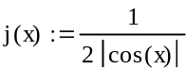

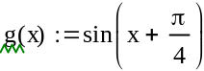

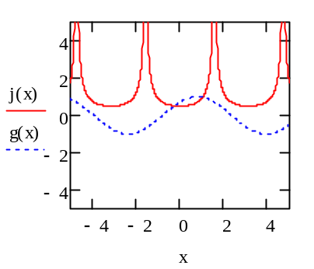
Figure 11. Components of convolution
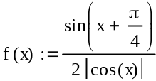 (25)
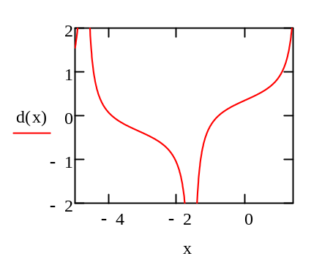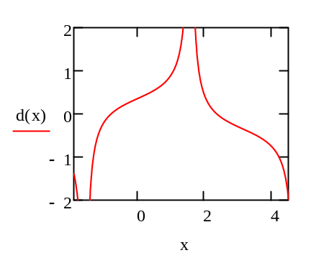
Figure 12. A full cycle of Everything Circle
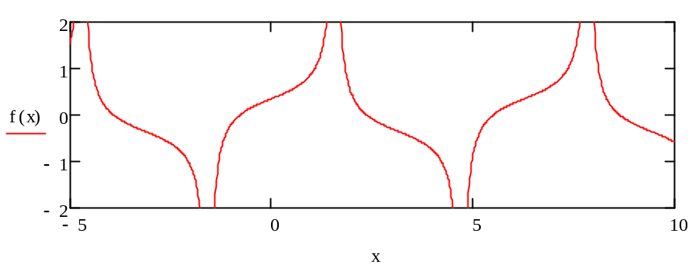
Figure 13. Function in Everything Theory
The Formula (25) can describe all laws of universe written by the sines, cosines and expression 1/0 or 1/x, which are not contained in most famous discoveries and formulations of wiseacres such as Newton, Charles-Augustin de Coulomb, George Ohm, Max Planck, Wilhelm Wien, De Broiglie, Albert Einstein, Nels Bohr, Werner Heisenberg and others. Hence, I would like to call this theory as Supreme Theory of Everything (STE) and the formula (25) as Everything Formula (EF) and lower diagram (Fig.14) as Everything Diagram (ED).
We can see that Everything Formula describes only everything by frequency, wavelength, phase, amplitude of waves, without any classic physical parameters such as mass, energy, electromagnetic charge and so on. It suggests that everything is only waves. We live in waves and we are also waves.
3.1 Convolution
This convolution consists of above two functions: g(x) and l(x).
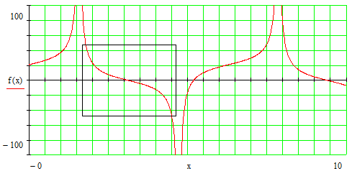
Figure 14. Everything Diagram (ED) of STE,in which shown the traditional HRD
by a rectangle (informal scaling).

3.2 Singularity
Everything formula has two large singularities: One is the black singularity such as black hole, axis of which lies at O degree Kelvin temperature ($x={3π}/2={270}^{0}=4.712$) on Figure 5 and other is the white singularity such as white hole at $x=π/2={90}^{0}=1.57$. In other words, the spectral radiation of the bodies is determined by next relation:
$0≤\frac{r_{λ, T}}{e_{λ,T}}≤∞$ (26)
Where $r_{λ, T}$ is the emissivity of a body and $e_{λ,T}$ denotes its absorptivity.
Absolute black body cannot emit any energy. In generally, if a universe is in thermal equilibrium, there is no entropy. In any case, local entropy always increases. If the emissivity becomes 100%, then its absorptivity is 0%, the ratio is infinite $\frac{r_{λ, T}}{e_{λ,T}}=\frac{1}{0}=∞$ , it means a perfect white body emits with a very high energy and when the $\frac{r_{λ, T}}{e_{λ,T}}=\frac{0}{1}=0$, it shows a perfect black body may be emit with low energy. The ratiois included in interval $0<\frac{r_{λ, T}}{e_{λ,T}}<∞$, it indicates the radiation of an ordinal body or grey body. We can explain it by next formulation:
$f\left(x\right)=\left\{\begin{aligned}0 go to infinity=white body or white hole \\ 0<1<∞ stays on basic state=grey bodies \\ ∞ go to 0=black body or black hole\end{aligned}\right.$ (27)
“Continue fields around both singularities - a cyclic universe with a unique continuation from one cycle to the next”. (Sir Roger Penrose)
3.3 Scaling of Everything Diagram on the Horizontal Axis
To avoid the disadvantage of traditional HRD we suggest the projection scale of a circle on the horizontal axis. The temperature range condenses only by projection scale of circle (Figure 15), which is most compressive than logarithm scale used in HRD.
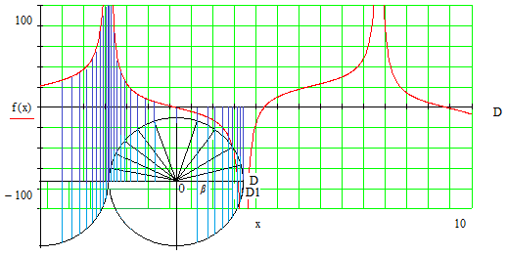
Figure 15. Scaling of Everything Diagram
Projection of circle on the horizontal axis as a Zeno-paradox indicates the scaling of everything diagram and its change is described by next formula:
$$DD_{1}=1-cosβ$$
$DD_{2}=1-cos2β$ (28)
…………………
$$DD_{n}=1-cosnβ$$
Where n denotes the number of degree on the circle.
Everything formula can scale itself.
3.4 Periodic and Monotonic Characters of Everything Formula
Everything Formula describing by sines, cosines and wave function (ψ) is periodic. Wave properties of particles are shown in Fig.16:
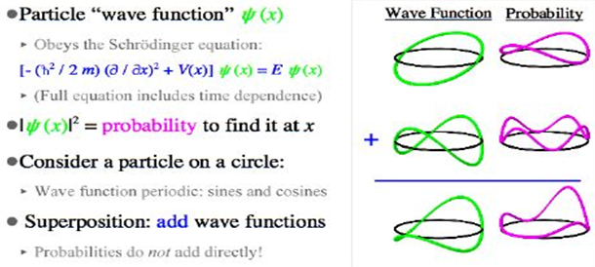
Figure 16. Wave properties of particles in Quantum mechanics
But its monotonic property is described by two large singularities in Everything formula (25).
The Heisenberg’s uncertainty principle actually applies to any particles with mass, but the more massive the particle the less the uncertainty.
https://www.bing.com/images/search?view=detailV2&ccid=Gb3StCT6&id=E599D2959E32E545D926BBEDA7F14EA4CD104C38&thid=OIP.Gb3StCT64uq-ZvN-wQPDZAHaFj&mediaurl=http%3A%2F%2Fslideplayer.com%2F8759414%2F26%2Fimages%2F56%2FThe%2Buncertainty%2Bprinciple.jpg&exph=720&expw=960&q=Uncertainty+Principle&simid=607999842122794399&selectedindex=70&ajaxhist=0
An example of a macroscopic objects: The insolation regime on the Earth’s surface is written by motion of the Earth on the ecliptic circle same as above written a particle at a circle is described by sines and cosines (Улаанбаатар, Т.,1994, Ulaanbaatar, T., 1998).
$$Q_{\left(φ\right)}^{\left(an\right)}\left(noon sun\right)=Q_{0}∙\sin{h_{\left(φ\right)}^{\left(n\right)}\left(noon sun\right)=}Q_{0}∙\cos\left(φ-{23}^{0}{27}^{'}∙\sin\left(0.9856∙n\right)\right)$$
(29)
Where $Q_{\left(φ\right)}^{\left(a\right)}$ is the noon sun insolation at a day accounting from vernal equinox
($n=1, 2, 3, …, 365)$and given geographical latitude, $Q_{0}$ is new solar
constant measuring on the earth surface in equatorial region, where the sun
rays fall perpendicularly, $h_{\left(φ\right)}^{\left(n\right)}$denotes the altitude of sun at latitude (φ) and
number of day (n).
In Fig.29 shows De Broiglie’s matter wave in case of macroscopic object. Yearly rotation of the Earth round the Sun on the ecliptic circle:
$\operatorname{kn}{=\frac{2π}{λ_{yearly}}∙n=\frac{360 (degree)}{365.2422 (day)}∙n\left(day\right)=0.9856∙n}$
The De Broiglie’s matter wavelength of Earth in a year is 365.2422.
Daily revolution around its axis is next:
$$\operatorname{kt}{=\frac{2π}{λ_{daily}}∙t=\frac{360 (degree)}{1436 (minute)}∙t\left(minute\right)=0.25069∙t}$$
The De Broiglie’s matter wavelength of Earth in a day is 1436.
Sean Carroll asked in his lecture that “How can a periodic function also be monotonic?”
https://www.youtube.com/watch?v=PX9RfvTWeJU.
Everything Formula is periodic and also monotonic. This formula indicates the circular motions and two singularities.
3.5 Sensitivity of Everything Formula
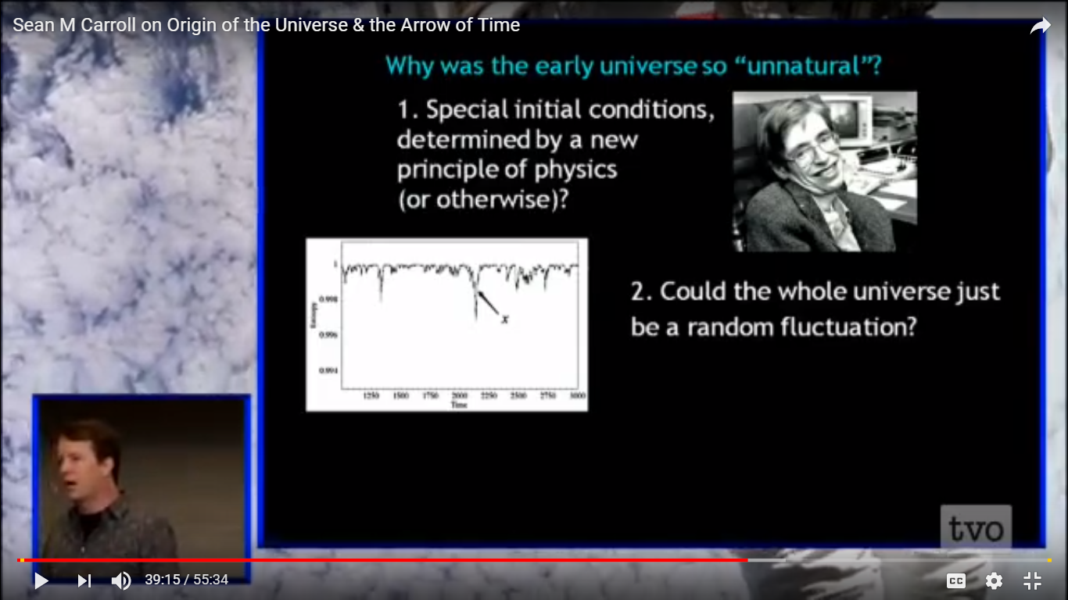

Figure 17. The whole universe fluctuation
(Particles, Fields and The Future of Physics - A Lecture by Sean Carroll) https://www.youtube.com/watch?v=gEKSpZPByD0

The early universe begins with a Big Bang, which is the end of a big black singularity. For this reason, the beginning of early universe is unnatural.

Ψ wave function in Supreme Theory of Everything is very sensitive in time evolution. The whole universe and everything are not a random fluctuation. Because g(x) and l(x) members in Everything Formula (25) exist a combined influence same to a logarithmic ruler on the final results. I imagine that the degree of sensitivity of outcome is very large and we can determine the impact of a variable under sensitivity analysis and make a catalogue for it. Some interval of everything formula may indicate weirds as socio-economic phenomena, climate fluctuation in different time-scale or human destiny, and so on.It is also to seek to identify important connections between observations, model inputs, and predictions or forecasts, leading to the development of better models.

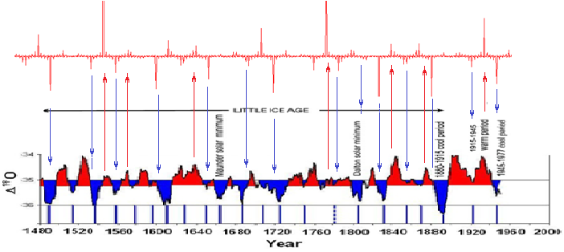
Figure 17. Climate fluctuation of of last 500 kys a) by Supreme Theory of Everything (25)
and b) Greenland ice core data https://www.bing.com/images/search?view=detailV2&ccid=fC%2FmZM7b&id=25BA5F2F7F6DA9C719052D21F13E06A66509DD9B&thid=OIP.fC_mZM7bCVFwIeqRJGU8QwHaDZ&mediaurl=http%3A%2F%2Fwww.21stcentech.com%2Fwp-content%2Fuploads%2F2012%2F07%2FGreenland-ice-core-data.png&exph=1778&expw=3880&q=Climate+Change+History&simid=608016407822470063&selectedindex=69&ajaxhist=0

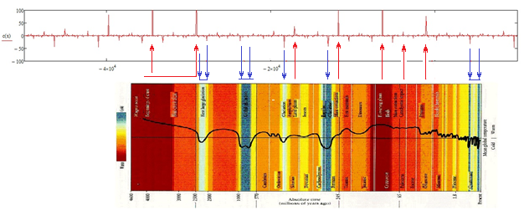
Figure 18. Climate change in Earth’s history: above, by STE and lower, climate history
http://www.ruf.rice.edu/~leeman/GeoColumn.gif

In Fig. 17 the climate changes of Little Ice Age and in Fig.18 the climate changes of Earth’s history are consimilar with spectrum of Supreme Theory of Everything. But we need to do more accuracy and detailed investigations by the way to change a and b coefficeints.

$f\left(x\right)=a+\frac{b*\sin\left(x+\frac{π}{4}\right)}{2\left|\cos{kx}\right|}$ (29)

Where a, b and k coefficients are different for every event, processes.

We think that we should carry out the detailed investigations in near future (Everything Formula (29)).

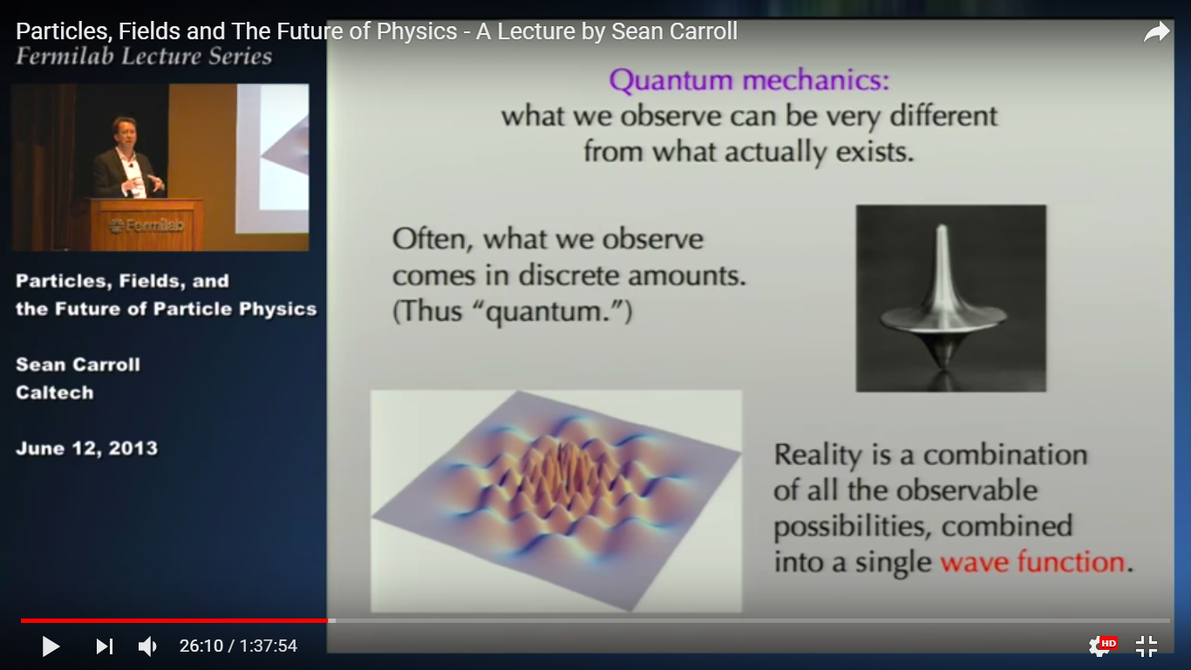
Figure 19. 3D wave function
https://www.youtube.com/watch?v=gEKSpZPByD0

There are all observable and unobservable possibilities in the wave function and everything formula, as said Sean Carroll, reality is a combination of all the observable possibilities, combined into a single wave function.
The spectrum of Everything Function depends on the selections of interval, coefficients of formula for determinations of all the phenomena of nature, geography and socio-economics, biology including human life, religion, culture and consciousness.
3.6 Connection of Strong and Weak Interactions
In Figure 19 the strong and weak interactions are shown. It is same to Everything Function(25).
Sean Carroll said that strong force is confined and force-carrying gluons interact with themselves, not letting them ever escape to the outside. It is like a closed shutter.Weak force is absorbed and force-carrying W/Z bosons interact with a Higgs field that pervades empty space. It like an obscuring fog.
It is same in case of the Earth or other celestial objects. Earth’s gravity is very large in its center, but weak outside into interplanetary space. Earth’s surface is an inflection.
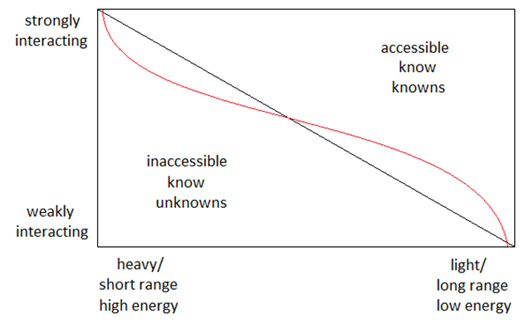
Figure 20. The strong and low energy interactions of nuclei.

The strong and low energy interactions of nuclei are shown in Identity (1) and Everything Formula (25).

$f\left(x\right)=\left\{\begin{aligned}0 go to infinity=internal or strong interactions \\ 1 stays on basic state=inflection point \\ ∞ go to 0=external or weak interactions\end{aligned}\right.$ (30)

According to uncertainty law, if the theory runs into deepest reality breaks out into the emptiness.
The inflection point indicates the surface of a glove or of two different media. For example, from Earth’s surface (inflection surface) downward (from Earth’s surface to Earth’s center) effect strong interaction and upward (from Earth’s surface to interstellar space) weak interaction to interplanetary and interstellar space objects. The Earth’s surface (2D) separates earth’s structure into the internal mass (3D) and external forces (3D or xD).

3.7 Scientific Unification

The long-term development of sciences has reached to scientific differentiation. To unify results of different scientific branches the formula of all known physics is established (See you in Problem#7). But all known physics cannot include everything.
The Everything Function can describe everything and unify partial theories.

3.8 Infinite Possibility in Supreme Theory of Everything
1. Imaginary number is real! Imaginary number is seen real number, when understands it in
3D space.
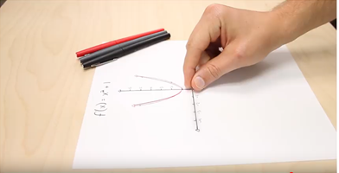
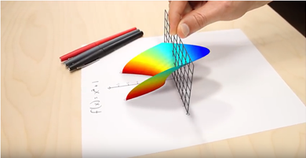
Figure 21. The imaginary number is real
https://www.youtube.com/watch?v=2HrSG0fdxLY
Dividend g(x) of formula (31) is, if imagine, a sine function shows a road, on which runs an independent $ψ$ vehicle l(x).
I imagine that $ψ$(x,t) is itself same a smart vehicle, in which cos(kx-ωt) is the wheel in straight motion, isin(kx-ωt) shows the driving direction on lift or right. It needs a driver, which may be consciousness and entanglement. For this reason, $ψ$(x,t) is an alive function.
So, the everything theory is formulated by Everything Function:
$f\left(x\right)=\frac{\sin\left(x+\frac{π}{4}\right)}{2\left|ψ\right|}=\frac{road}{2\left|vehicle\left(engine+driving wheel+driving direction\right)\right|}$ (31)
Except of God the contemporary scientific community lives always in divisor of the Everything Function.
Real function can go very long distance, imaginary part is short. It is same a car driving. When we drive a car, it goes very long distance in straight on the road by some hundreds or thousands of meters depending from velocity. But driving on right and left is only some centimeters on road. For this reason, we need to imagine that real part of wave function is some hundred times higher than imaginary part. Since, we use generally the real part in calculations. But imaginary part plays important roles, which does not handle in life.
2. Everything is dualistic. White-black, real-complex, death-born, breath in (as born)-breath out (as death), happiness-suffering, success-failure, come-go, find-lose, rich-poor, 0-∞, warm-cold, old-young, south-north, clever-stupid, liberal-helluo, long-short, positive-negative, and so on. This duality isinseparable as north pole-south poleof a magnet.
Supreme Theory of Everything shows this kind of conjugate by two singularities in a full circle. Negative event exchanges by positive, but as soon as comes back the negative one, and so on.
- PARALLEL UNIVERSES

Every singularity has different mass, size, length. The singularity can transform xD to 4D, 4D to 3D, 3D to 2D and 2D to 1D, may be also 1D to 0. Some singularity develops to wormhole and connect other wormhole. Some singularity can transform the wormhole or cannot. It means that a singularity looks forward a partner by entanglement. So, the parallel universes may be exist by next versions shown in Fig.22 and Fig.23.
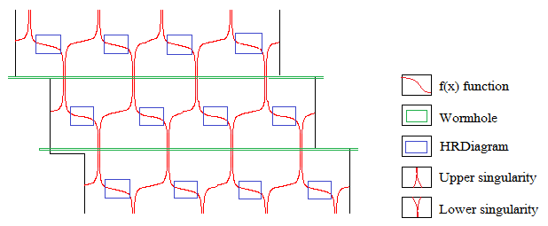
Figure 22. Parallel universes connecting between upper-lower or white-black singularities
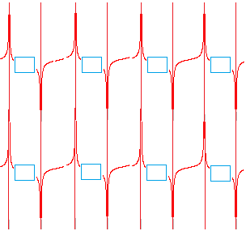
Figure 23. Parallel universes connecting between upper-upper and
lower-lower or white-white and black-black singularities
If the singularity can not find another singularity with connect by wormhole, a new baby universe has possible to be born. In this case the background of singularity will be entangled baby universe.
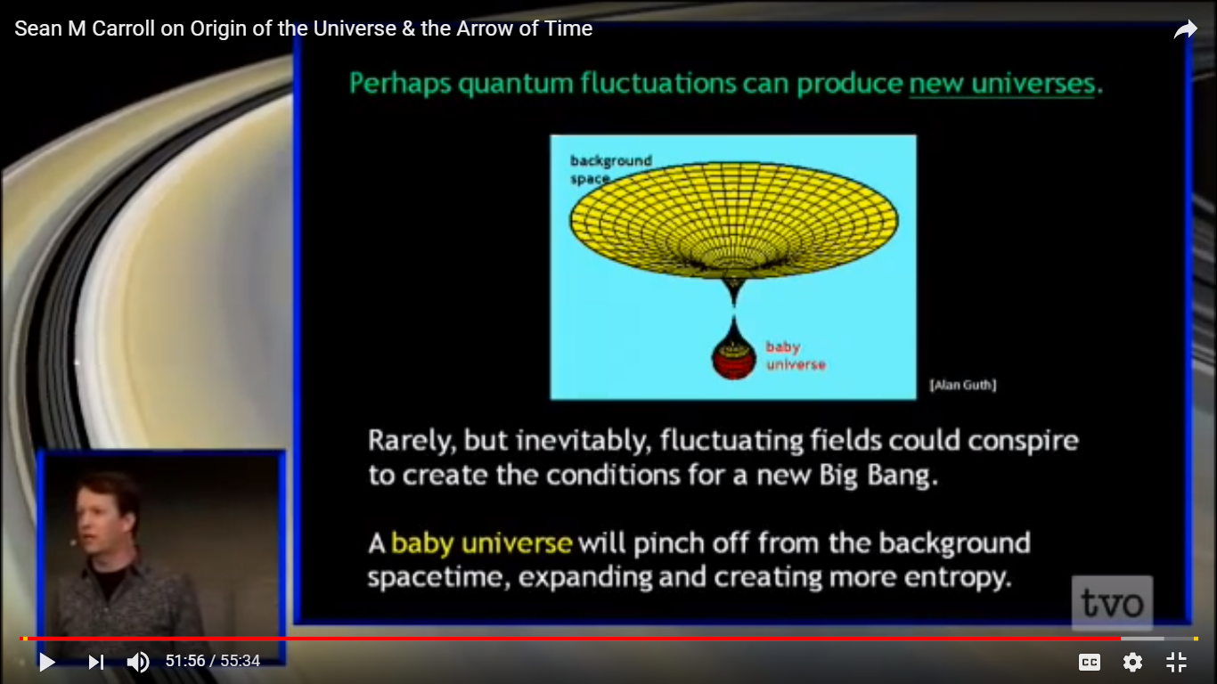
Figure 24. Exists of new universes
https://www.youtube.com/watch?v=rEr-t17m2Fo

The universe is a big place, uniform in large scales. But the local entropy needs to develop the universe.

4.1 Inflation
Inflation still produces density/tensor fluctuations. Inflation quantum state is “observed” at reheating, which generates entropy and induces decoherence. Slow-roll eternal fluctuation is problematic. Our analysis isn’t strictly applicable, since there is true time-dependence. But there is very little entropy generation, therefore no decoherence, and the state evolves slowly. We should be very skeptical of “stochastic fluctuations” upward in the potential (Sean Carroll, Origin of the Universe and the Arrow of time).
https://www.youtube.com/watch?v=rEr-t17m2Fo

The problem of inflation and entropy is solvable by the Supreme Theory of Everything. When reheats the system, generate the entropy and induces decoherence. Slow-roll fluctuation follows the Supreme Theory of Everything. The inflation curve is drawn by this theory. The graph in the Fig.25 shows same curve to ED illustrated in Fig.12.

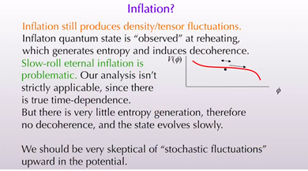
Figure 25. Inflation curve.

$f\left(x\right)=\left\{\begin{aligned}0 go to infinity=highest inflations \\ 1 inflection point \\ ∞ go to 0=lowest inflations\end{aligned}\right.$ (32)

- INFORMATION TRANSFER AND ENTANGLEMENT
5.1 Observation, Information Transferand Time
We think the future, in which incoming information will be transferred by observation and speed of light. Object A and object B observe each other. When A thinks that B is future of mine, because light comes to me from B and B thinks also A is my future. Visa versa, A thinks that object B see my past information and B thinks object A receives my past. For example, we see the Sirius, which brightens in 9 light years of distance from us. We see just its state after 9 years. Since, we don’t know Sirius is now alive or not. From surrounding the Sirius an observer may see Earth and receives information about us. He thinks that men of Earth receive his past information. Based on these we can conclude that imaginary time as future and past is very relative. Incoming light to my eye from all objects describe my future information. Objects need to locate in front of my face,but it is in my rear side, I cannot receive any information. Attention: We talk about light information, but we can also hear,smell, taste and touch, all which transfer less information to us. What is the present time? Please stand you on the x-axis of coordinate system and see it, which is shows present time. Question: What is the width of x-axis? Answer: Present time has no width, but it is real time. On other words, future time and past time is not real.
Another type of time is the relative motions of objects. Everything moves only at present time. Motion is described by Supreme Theory of Everything as a circle. We have two speculations about the time: real time (scalar time) being present time and imaginary time (vector time) related to motions. We try to explain everything by vector time (external time), but the reality lies in scalar time (internal time).
B) The Special Theory of Relativity established by Minkovski shows the spatiotemporal relations of objects, particularly past, present and future time. The world lines of objects with different speed are drawn in Fig 25. But there are some unsolved problems in Special Theory of Relativity:
We can draw the world-lines of objects in time-distance cross-section, if coordinate system stands in a stable location of space. But the units of axes are same the speed of light. Theory said the phenomena (F in Fig.26) will happen after 4 seconds in 2.5 seconds distance from us. It means the upward speed of coordinate system in space equals speed of light. Unfortunately, we see the objects by incoming speed of light to our eyes. For this reason, speeds of objects are not so important. Because we watch them by speed of light. The object moves by a speed slower than speed of light. We can see the flying hijacker by speed of light.
On the other words, we need only to use the world-line of speed for different objects.
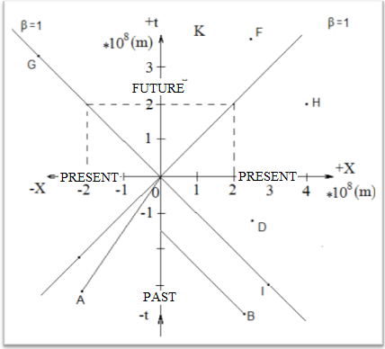
Figure 26. Future and past time cones in space and time
Chris Fields (2014) shows correctly that the observation equals the interaction, which is just information exchange through an imaginary boundary (Fig.27 and Fig.28).
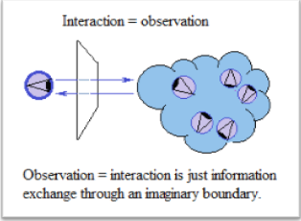
Figure 27. Observation and information exchange
https://www.youtube.com/watch?v=XGulRS2IyF8

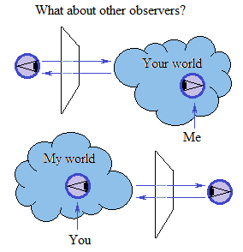
Figure 28. Interactions of observers
https://www.youtube.com/watch?v=XGulRS2IyF8
But interactions happen by speed of light. Since, information transfer has no time and no distance in spacetime. In this case “the spooky action at a distance” is correct.
Chris Fields (2014) said Quantum theory is the minimal mathematical formalism that correctly describes all physical interaction as classical information exchange and all classical information exchange as physical interaction.
5.2 Spooky Action at a Distance
Einstein showed the world lines from 0 to speed of light in the Special Theory of Relativity. From this theory we know the spacetime is hyperbolic. But he has also thinking from 0 to infinity as same others.
Suppose incoming information into our eyes by the speed of light (Fig.29).
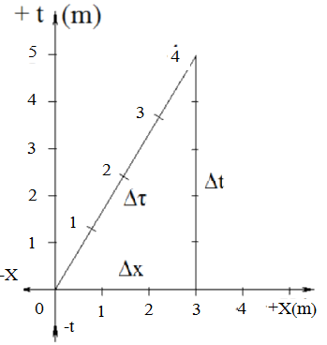
Figure 29. Triangle in spacetime
The Pythagorean theorem is not suitable in spacetime. In spacetime or in relativity the odd of the squares of the lengths of the two legs is equal to the square of the length of the hypotenuse:
${∆τ}^{2}={∆t}^{2}-{∆x}^{2}$(m²) or (33)
$∆τ=\sqrt{{∆t}^{2}-{∆x}^{2} }$(m) (34)
Where ∆t is the change in time, $∆x$(m)is the change in spatial distance and
$∆τ$(m) denotes the proper time
As conclusion, the hypotenuse is shorter than the longer cathetus.
If two cathetuses of right triangle equal each other, the proper time becomes zero. It displays that the speed of information does not depend from time and distance, because the observation carries out by speed of light. It is the spooky action at a distance. On the other words, if we see the object lying distance $∆x$ by speed of light, the information transfers directly to us. This timeless information exchange is impossible at H object, because it is outside of future cone.

5.3 Causality

What is the connection of causality? Does the consequence of a past causality come back from future? According to the STE the everything and causality happens in the present time by circle. Causality in a point of circle comes back ever. Your negative activities go elsewhere and come back to you. when the negative actions come back here, you cannot act, but causality toils you. it is natural law and necessary action. Your positive activities: love, compassion, amnesty, condescendence and welfare will send you to happiness. Everybody has a circle, which fulfills the positive activities, your life will brighten forever and may be until to happen negative activities. All of these is driven by entanglement.
The Quantum Physics and Buddhism discovered already that an atom or particle and somebody can be in many places at the same time, no matter how far away. It means that the Gods are everywhere. The Supreme Theory of Everything indicates everything including us has rebirth and incarnation. In results of meditation one has possible to rebirth in a happy family after positive life or can becomes God by deepest form of meditation. This location may be located in white singularity of Everything Diagram.

5.4 Consciousness
Thinking without consciousness is a brainstorm. Consciousness without thinking is meditation. Suppose x denotes our thinking. Mind consists of thinks. If one thinks less than normal state or state of unthink under the control of consciousness the result becomes larger (from infinite to zero) as shown in second column of Tab.1 and Equa.1. And if thinking is very large (from zero to infinite), it has no result (as in third column of Tab.1).
$f\left(x\right)=\left\{\begin{aligned}0 go to infinity \\ 1 stays on basic state \\ ∞ go to 0\end{aligned}\right.$ (35)
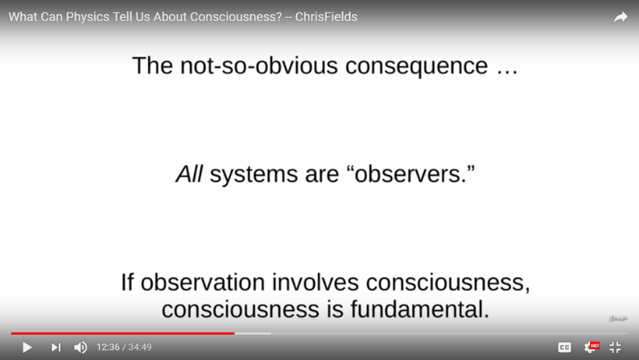
Figure 30. Observation-Consciousness
https://www.youtube.com/watch?v=Apds8KbtMr8

5.5 Entanglement
Entanglement lets the measurement of one particle instantaneously determine the state of a partner particle, no matter how far away it may be-even on the other side of the Milky Way (Ron Cowen, 2015).
In 1935 Einstein and Rosen showed that widely separated black holes can be connected by a tunnel through space-time now often known as a wormhole. Physicists suspect that the connection in a wormhole and the connection in a quantum entanglement are the same things, just on a vastly different scale. Aside from their size there is no fundamental difference. (Ron Cowen, 2015)
Several papers (one published by two noted physicists: Leonard Susskind and Juan Maldacena) posit that tiny wormholes act as umbilical cords to entangled particles-allowing them to exchange signals at speeds far exceeding the universal speed limit (light-speed).
Chris Fields (2014) said the entanglement is the condition of interacting with the world through an imaginary interface on which classical information appears. Entanglement or non-separability is the core idea of quantum theory.
The singularity and wormhole can transform 4D to 3D, 3D to 2D, 2D to 1D and 1D to 0D.

CONCLUSION
- The spectral radiation of the bodies is determined by next relation:
$$0≤\frac{r_{λ, T}}{e_{λ,T}}≤∞$$
- Everything theory is described by next formula:
$$f\left(x\right)=\frac{\sin\left(x+\frac{π}{4}\right)}{2\left|\cos{(kx)}\right|}$$
- Everything Formula is periodic, monotonic and very sensitive in time evolution.
- The Everything Function process everything and can unify scientifically.
- The strong and low energy interactions of nuclei are described by Everything Formula.
- Imaginary number is real. The sin(x+π/4) indicates a same road and $\cos{(kx)}=\cos{(ψ)}$ is a same smart vehicle, which has drive-wheel and driving mechanism to left and right direction.
- Everything is dualistic as negative event exchanges by positive, but as soon as comes back the negative one.
- Ψ wave function is alive function, which has consciousness and information holding, and transfering mechanisms.
- Some singularity of STE develops to wormhole and connect other wormhole. Some singularity can transform the wormhole or cannot. It means that a singularity looks forward a partner by entanglement. So, the parallel universes are there.
- Everything moves only at present time. Motion is described by Supreme Theory of Everything as a circle.
- Two speculations of time are there: real time (scalar time) being present time and imaginary time (vector time) related to motions. We try to explain everything by vector time (external time), but the reality lies in scalar time (internal time).
- We see the object lying distance ∆x by speed of light. So, this timeless information transfers directly to us.
- Everything in universe is nothing less than holography shown by sines and cosines.
- We receive information of the holographic images about universe by observation, , smeeling,

REFERENCES
Stephen Hawking, A Brief history of time, Bantam Books, 1988.
Ron Cowen, Space, time, entanglement, Nature, Vol 527, 291, 19 November 2015.
Ernest Zebrowski, A History of the Circle: Mathematical Reasoning and the Physical Universe,
Rutgers University Press, 2000.
Paul Erdos, Amer. Math. Monthly, 90, 35–41, 1983.
Ulaanbaatar, T., About singularity limiting to zero, Scientific journal, Mong. Univ. Sci. Tech.,
1/228, 50-58, (in Mongolian), Ulaanbaatar, Mongolia, 2018
Улаанбаатар, Т., Дэлхийн гадарга ба цэвдэгмандлын дулааны горимын математик загварчлал, Диссераци, ШУТИС, Улаанбаатар, 1994
Ulaanbaatar, T., Climate Supercirculation of the Earth, Scientific Translation, 3(132), 246-264, Nat. Univ. Mong., Ulaanbaatar, 1998
https://www.google.mn/search?q=hertzsprung+russell+diagram&source=lnms&tbm=isch&sa=X&ved=0ahUKEwjLyIDXzMvbAhUhCqYKHTPeBHoQ_AUICigB&biw=1350&bih=635#imgrc=aUNcrGCH7Qq5YM:
http://www.ruf.rice.edu/~leeman/GeoColumn.gif
https://www.youtube.com/watch?v=gEKSpZPByD0
https://www.bing.com/images/search?view=detailV2&ccid=fC%2FmZM7b&id=25BA5F2F7F6DA9C719052D21F13E06A66509DD9B&thid=OIP.fC_mZM7bCVFwIeqRJGU8QwHaDZ&mediaurl=http%3A%2F%2Fwww.21stcentech.com%2Fwp-content%2Fuploads%2F2012%2F07%2FGreenland-ice-core-data.png&exph=1778&expw=3880&q=Climate+Change+History&simid=608016407822470063&selectedindex=69&ajaxhist=0
https://www.youtube.com/watch?v=f1x9lgX8GaE
https://www.bing.com/images/search?view=detailV2&ccid=Gb3StCT6&id=E599D2959E32E545D926BBEDA7F14EA4CD104C38&thid=OIP.Gb3StCT64uq-ZvN-wQPDZAHaFj&mediaurl=http%3A%2F%2Fslideplayer.com%2F8759414%2F26%2Fimages%2F56%2FThe%2Buncertainty%2Bprinciple.jpg&exph=720&expw=960&q=Uncertainty+Principle&simid=607999842122794399&selectedindex=70&ajaxhist=0
https://www.youtube.com/watch?v=PX9RfvTWeJU
https://www.youtube.com/watch?v=2HrSG0fdxLY
https://www.youtube.com/watch?v=rEr-t17m2Fo
https://www.youtube.com/watch?v=XGulRS2IyF8
https://www.youtube.com/watch?v=Apds8KbtMr8

CONTENT
Supreme theory of Everything
Introduction ..1
1. Difficulties in way to find the reality ..2
Problem#1: Thinking from 0 to infinity.. ..2
Solution. ..3
Problem#2: Mathematical concept.. ..3
Solution .. ..4
Problem#3: Number line.. ..5
Solution.. ..5
Problem#4: Electromagnetic waves.. ..5
Solution.. ..5
Problem#5: Challenge to develop the Hertzsprung-Russel diagram….. ..6
Solution.. ..7
Problem#6: Fundamental forces.. ..8
Solution.. ..8
Problem#7: Differentiation of sciences. ..8
Solution.. ..9
2. Smart Wave Function ..9
2.1 Wave function in Time Dependent Schrodinger Equation (TDSE) 10
2.2 Wave function in Time Independent Schrodinger Equation (TISE) 11
2.3 Heisenberg’s uncertainty principle in wave function 11
2.4 Wave function in General relativity 12
3. Supreme Theory of Everything 13
3.1 Convolution 14
3.2 Singularity 15
3.3 Scaling of Everything Diagram on the horizontal axis 15
3.4 Periodic and monotonic Everything Formula 16
3.5 Sensitivity of Everything Formula 16
3.6 Connection of strong and weak interactions 18
3.7 Scientific unification 18
3.8 Infinite possibility of Supreme Theory of Everything 19
4. Parallel Universes 20
4.1Inflation 22
5. Information transfer and entanglement 22
5.1 Observation and information transfer 22
5.2 Spooky action at a distance 25
5.3 Causality 26
5.4 Consciousness 26
5.5 Entanglement 27
Conclusion 28
References 29

