Numerical modeling for episodic thermal convection in Enceladus ice shell.
Mariana C Villamil Sastre, Universidad de los Andes, Colombia.

Abstract
In 2005, Cassini’s mission made a historical finding in one of the Saturn’s moons. The probe evidenced geothermal activity on the South Pole of Enceladus while circling its orbit. It also produced images showing fractures in Y shape in Enceladus South Pole terrain, which is geologically younger than the rest of the surface. These fractures were designated as "Tiger Stripes". The material emerging from these fractures were studied by spectroscopy, being consistent with a composition of pure water, ice grains of the order of micrometers and organic material. Some authors attribute this geological activity to the tidal forces on Enceladus when they enter into resonance with other satellites, establishing a variable and unstable eccentricity of the orbit that generated the observed heat. In this research, we seek to explain how Enceladus maintains the observed heat, the existence of an episodic thermal convection in the Enceladus crust is proposed, with numerical models of finite differences in spherical coordinates, which include geodynamical parameters such as tidal forces, a non-uniform viscosity in the crust and a type of convection under a layer not convective. In addition, it is included in the model that the convection is taking place episodically, giving rise to events of maximum heat transport in a span of a few million years and a consequent stability, allowing that the high heat flow can be explained as the release of heat stored in the past. The model is design to obtain an energy value close to the data obtained by the Cassini mission.

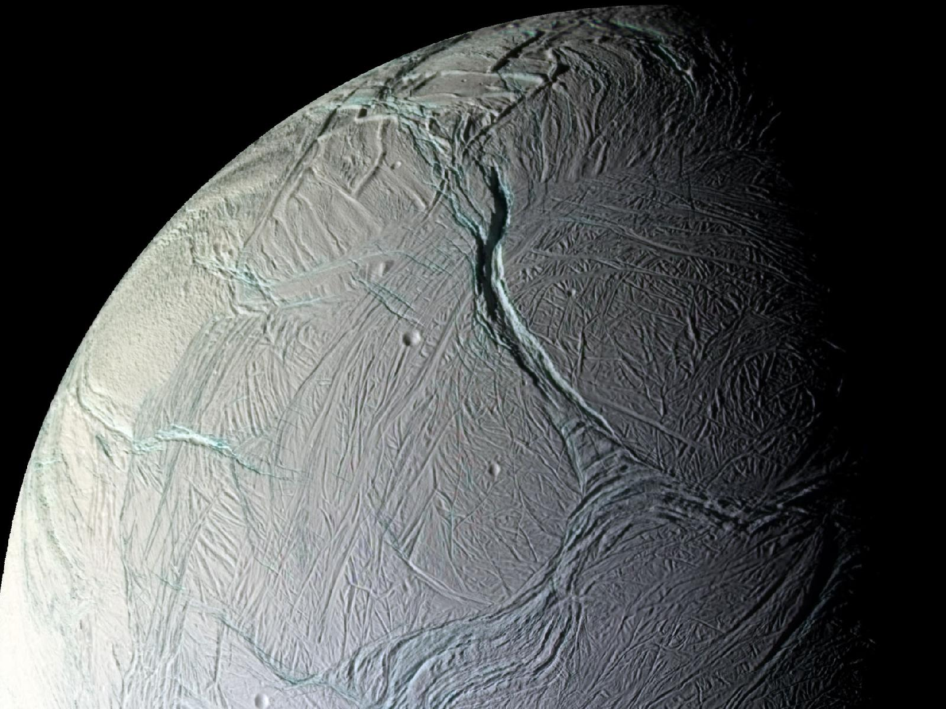
Recent Publications

The impact of a weak south pole on thermal convection in Enceladus’ ice shell.
Han, L., Tobie, G., Showman, A. P. (2012).

Cassini observes the active south pole of Enceladus.

C. C. Porco, P. Helfenstein, P. C. Thomas, A. P. Ingersoll, J. Wisdom, R. West, G. Neukum, T. Denk, R. Wagner, T. Roatsch, S. Kieffer, E. Turtle, A. McEwen, T. V. Johnson, J. Rathbun, J. Veverka, D. Wilson, J. Perry, J. Spitale, A. Brahic, J. A. Burns, A. D. DelGenio, L. Dones, C. D. Murray,S. Squyres.

Shear heating as the origin of the plumes and heat flux on Enceladus.
Nimmo, F., Spencer, J. R., Pappalardo, R. T., Mullen, M. E. (2007).

Tidal heating in Enceladus.
Meyer, J., Wisdom, J. (2007).

The Dichotomy of Thermal Convection in Enceladus’ Ice Shell.

Hana, L., Tobieb, G., Showmanc, A. P. (2011)

Biography
Mariana Carolina Villamil Sastre is completing her two majors in Physics and Geoscience at Universidad de los Andes, Colombia. Since she started the university she showed great interest in planetary science, in 2016 was speaker in the III International Astrobiology Congress in Manizales, Colombia, with the conference named: “What hides inside Enceladus? Geysers, a small part of the puzzle”. Her undergraduate thesis is based on a numerical model of heat convection in Saturn´s moon, Enceladus, with geodynamical parameters that fits with the data showed by remote sensing instruments of Cassini mission. Email: mc.villamil10@uniandes.edu.co

Notes/Comments:

Presenting author details
Full name: Mariana Carolina Villamil Sastre
University/Industry/Organization name: Universidad de los Andes
Designation (Director/Prof/Assistant or Associate prof/Researcher/Student): Student
Country: Colombia
Telephone: +57 3006908954
Email: mc.villamil10@uniandes.edu.co
Track name: Satellite Orbits: Models and Methods
Category (Oral presentation/ Poster presentation/Young researcher forum/E-poster): Young researcher forum
Research interest: Planetary sciences
Linked In account: www.linkedin.com/in/mariana-carolina-villamil-sastre-3853bb152

Note: Please fill up the Red mark fields so that it would be easier for us to cite your details in the conference particulars. (Please do not forget to fix your photo above the title)

