Accelerated Expansion of a symmetric Universe
Maarten van der Burgt, Ir.

Abstract
— A universe containing matter and antimatter can only exist when matter and antimatter repel each other. Such a system, where like
attracts like and like repels unlike, will always expand. Calculations made for such a symmetric universe demonstrate that the expansion is consistent with Hubble’s law, the observed increase in the expansion velocity with time, the initial high acceleration and the foam structure of the universe. Conversely, these observations can be considered as proof for a symmetrical universe and for antimatter possessing a negative gravitational mass. This underpins the untenability of the Weak Equivalence Principle which states that in a gravitational field all structure less point-like particles follow the same path.

Image

Recent Publications (minimum 5)

 Biography (150 word limit)
Maarten J. van der Burgt holds an M.Sc. degree in Chemical Engineering of Delft University (Chemical Engineering). After a year in Purdue he joined Shell where he worked for over 30 years in hydrogen processes and strategy. Since his retirement he worked for over 20 years as an independent consultant in the field of power generation and related subjects. He has lectured around the world including some seminars at Princeton university and wrote a standard work on the conversion of hydrocarbon fuels into synthesis gas and power. In 1953 he was awarded the DOW Chemical Energy prize and became a Knight in the order of Orange Nassau.
It is his live long interest with physics and astronomy that has resulted in various manuscripts.
Email: maagburgt@gmail.com

Notes/Comments:

I cannot produce any publications in but do include the full manuscript.

Accelerated Expansion of a Symmetric Universe
M.J. van der Burgt

Abstract— A universe containing matter and antimatter can only exist when matter and antimatter repel each other. Such a system, where like
attracts like and like repels unlike, will always expand. Calculations made for such a symmetric universe demonstrate that the expansion is consistent with Hubble’s law, the observed increase in the expansion velocity with time, the initial high acceleration and the foam structure of the universe. Conversely, these observations can be considered as proof for a symmetrical universe and for antimatter possessing a negative gravitational mass. This underpins the untenability of the Weak Equivalence Principle which states that in a gravitational field all structure less point-like particles follow the same path.

Keywords— Cosmology, theory, inflation, early Universe, Gravitation, Large-scale structure of Universe, Miscellaneous (Matter and Antimatter).

INTRODUCTION
W
HEN Fred Hoyle coined the name “Big Bang Cosmology” the resulting acronym BBC may have been intended as a pun to the corporation that broadcast his speech. Unfortunately, the name Big Bang provided inadvertent support to the idea of an explosion causing the expansion of the universe; ironically an idea Fred Hoyle himself did not believe in. Although the “Big Bang” is not an explosion in the classical sense, we may consider it as such for the present argument. The particles will flow away in all directions with different velocities. Some of these will coalesce. Moreover, some will move around a center of gravity thus forming a system. However, none of these systems can have a recessional velocity that increases with time.

Matter and Antimatter
Currently most scientists are convinced that although both matter and antimatter were formed in equal quantities from the Big Bang, after a very short period only a matter part survived. None of the studies took into account the fact that matter and antimatter repelled each other. The idea of a negative gravitational mass of antimatter is nothing new but its consequences for the development and structure of the universe have never been addressed [1]. The purpose of this treatise is to fill this omission.

Arguments against a symmetrical universe
Three principal theoretical arguments against the symmetry of matter and antimatter and the negative gravitational mass of antimatter are CP violation, the violation of Einstein’s Equivalence Principle (EP) and violation of the Weak Equivalence Principle (WEP) [2].
CP violation is based on small statistical differences. Explanations of the small discrepancy in favor of matter received all the attention. The possible influence of the matter environment on CP experiments got little, if any, attention. Had this been taken into account the conclusion could well have been that there is CP invariance.
The EP as stated by Einstein assumes that uniform gravitational fields are entirely equivalent to accelerated reference frames, implying that for a matter reporter locked in a windowless matter capsule, it is impossible to differentiate whether the capsule is located in a uniform gravitational field or is being pushed through space with an acceleration of equal value [3]. However, the same holds for an antimatter reporter in an antimatter capsule. In a thought experiment where both capsules with their reporters would be thrown from a tower on our matter earth they would both feel weightless during the free “fall”, although the antimatter capsule will “fall” up (see Fig. 1a).
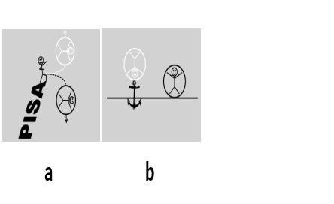
Fig. 1 Behavior of matter and antimatter

When in another thought experiment the antimatter capsule would be tethered to the matter earth, the antimatter reporter inside would stand on the “ceiling” of the capsule but could not tell the nature of the earth he was “standing” on (Fig. 1b). In other words, the antimatter reporter experiences the same forces as a matter reporter inside a matter capsule standing on the matter earth. Repeating these experiments on an antimatter earth will give similar results. In both cases the EP will be validated and it can be concluded that the EP as defined by Einstein is obeyed if antimatter has a negative gravitational mass.
Another obstacle often mentioned is that the gravitational force is more than 40 orders of magnitude weaker than the Coulomb force; this is only true under macroscopic conditions. For two charged elementary particles having Planck masses of 5.5 x 10⁻⁸ kg, the product of the gravitational constant and the square of the Planck mass is two to three orders of magnitude larger than the product of their charges (taken as one third to two times the charge of an electron) divided by 4πε₀ (for symbols see the glossary Table III). This proof is essential because otherwise all matter and antimatter would have annihilated each other during the start of the universe. The fact that we have Planck dimensions makes it a priori plausible that the universe started with particles having such dimensions. The main argument for the symmetrical presence of matter and antimatter in the universe is that at the very small scale of primordial particles the gravitational repulsion between matter and antimatter avoided most annihilation. During the development of the universe gravitational forces became more and more important resulting in larger and larger accretions of electrically neutral matter and antimatter, ending with clusters of galaxies.
It is demonstrated below that a negative gravitational mass for antimatter results in a promising model of the universe. Conversely, our celestial observations are the best proof for the presence of antimatter and for the untenability of the WEP stating that in a gravitational field all structure less point-like particles follow the same path [2].

The expansion of the Universe

A. Repulsion leads to expansion
How repulsion between matter and antimatter will result in expansion can best be explained by taking a look at a one-dimensional example consisting of two matter bodies that are initially at rest, with a restless antimatter body between these two. The antimatter body will, when coming too close to one matter body, be pushed back to the other matter body thus moving repeatedly back and forth between the two. By doing so, the antimatter body will push the two matter bodies apart resulting in expansion as illustrated in Fig. 2. Calculations were made using the same formulae as applied by astronomers for centuries [4]. The only exception is the inclusion of antimatter having a negative gravitational mass.

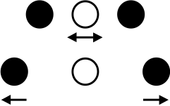
Fig. 2 Expansion owing to the presence of a white antimatter body between two black matter bodies

In a gravitational field, a matter and an antimatter body at rest will, when starting from the same initial position, always initially move in an opposite direction. This is demonstrated in the example given in Fig. 3 which shows the matter and antimatter body moving in a two-dimensional space within a square pattern of other fixed matter and antimatter bodies with a random gravitational mass distribution.

Fig. 3 Movement of a matter and an antimatter body from the same initial position in a two-dimensional space

B. Assumptions
In the calculations the following assumptions were made:
- All bodies have a spherical shape and a fixed radius independent of their mass
- Distances between bodies are distances between their centers of mass
- In the one-dimensional studies the initial center to center distance between adjacent bodies is identical
- In the two-dimensional studies the bodies are initially located in a square pattern within a circle
- In the three-dimensional studies the bodies are initially located in a regular cubic lattice within a sphere
- All bodies are at rest at time zero
- When bodies of similar matter touch each other they will coalesce to one body. When bodies of opposite matter touch, equal masses of matter and antimatter will annihilate and a body will be formed comprising the surplus of either matter or antimatter. The effect of the annihilation energy on the expansion has not been taken into account
- General relativity has not been taken into account

C. The Jacob number
In this model the universe started with very small particles packed together in a very small space and currently features galaxies and clusters separated by huge distances. For each consecutive step the masses, distances and time increments to be used are different, therefore standard bodies with an average mass of 1 kg and a radius of 1 m were used in the calculations. In the figures data are given in SI units for standard bodies (m, m/s, and m/s). These can be converted to actual data for galaxies and clusters as well as for their much smaller precursors, provided the group of bodies has the same proportional gravitational mass distribution, a congruent initial spatial distribution and the same dimensionless Jacob (J) number. The (J) number is defined as:
$$J=\frac{GMΔt^{2} }{D^{3}} (1)$$
where G is the gravitational constant, M is the (average) inertial mass of the group of bodies, Δt is the time interval used in the calculations and D is the initial distance between adjacent bodies. The standard data given in the figures can be converted into data of galaxies and clusters, for example, by multiplying by the conversion factors given in Table I. In these calculations J values of 0.04 have been used. A smaller J value implies a smaller time interval, resulting in more accurate results.

TABLE I
MULTIPLICATION FACTORS TO CONVERT STANDARD DATA INTO DATA FOR GALAXIES AND CLUSTERS [5]
Variable | Mass | Radius | Velocity | Acceleration | Time interval
Standard | 1 | 1 | 1 | 1 | ¹
Galaxy | 2 x 10⁴¹ | 1.5 x 10²⁰ | 3.7 x 10¹⁰ | 8.9 | 4.11 x 10⁹
Cluster | 6 x 10⁴⁵ | 5 x 10²² | 3.5 x 10¹¹ | 2.4 | 1.44 x 10¹¹

Distances between other bodies are obtained by multiplying their radii by the 1 meter for the standard bodies. Masses of other bodies are obtained by multiplying their mass by the (average) 1 kg for the standard bodies. To obtain real times in seconds for the standard bodies, the time units used in the graphs have to be multiplied by the time interval calculated with (1). For other bodies these times have to be multiplied with the factors given in Table I. Velocities for other bodies are obtained by multiplying the standard velocities by the radius of the other bodies divided by the multiplication factor for the time interval. Accelerations for other bodies are obtained by dividing their velocities by the multiplication factor.

Calculations

One-dimensional results
Calculations for the expansion of the universe started with the study of the behavior over time of a one-dimensional group consisting of 16 standard bodies of alternating matter and antimatter, all with equal inertial mass and equal initial distance between adjacent bodies (Fig. 4c). All distances in this section are given relative to the common center of the system at time zero.
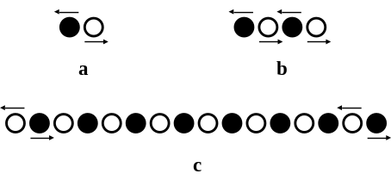
Fig. 4 Initial movements of black matter and white antimatter bodies in one dimension
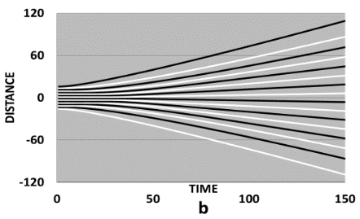
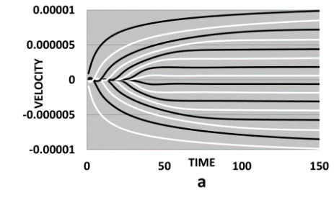
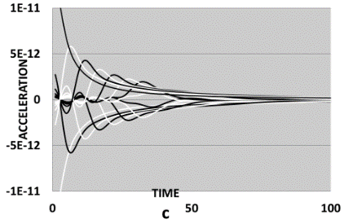
Fig. 5a, Fig. 5b, and Fig. 5c show the velocity, distance and acceleration respectively of the 16 bodies as a function of time.

Fig. 5 Velocities (a), distances (b) and acceleration (c) as a function of time for 16 bodies of alternating matter (black lines) and antimatter (white lines) in one dimension. Initial distance between bodies 2.1 times the body radius. One time unit is 6.66 x 10⁴ s
The velocities behave primarily rather erratically. This is best illustrated in Fig. 4b comprising four bodies where the resultant force of the other three bodies makes the two inner bodies move initially inwards rather than outwards. After this initial erratic period, the velocities start to increase and eventually become almost constant [6]. During the whole process each body has neighbors of opposite matter. Furthermore, the differences in velocities between adjacent bodies (Δv) tend to converge to the same value (Fig. 5a). As a result, the distances between adjacent bodies also tend to converge to the same value (Fig. 5b). From the data in Fig. 5a and Fig. 5b it can be concluded that after a certain time, the same recessional velocities and distances would be observed at other locations in the “universe”, which is in agreement with the cosmological principle. The initially high acceleration rapidly drops during the first 100 time units (Fig. 5c). Calculations show that the initial potential energy is proportional to the number of bodies and that the maximum velocity the peripheral bodies eventually obtain is independent of the number of bodies.

The potential energy of the original 16 bodies in Fig. 4 and 5 must be equal to their kinetic energy when their velocities have become constant. As the initial distances between adjacent bodies are equal and the initial velocities are zero, the initial potential energy (E_{pot}) of the system with more than about ten bodies of alternating matter and antimatter amounts to:
$$E_{pot}=\frac{GM^{2}(2N\ln{2-1)}}{D} ≈\frac{2GM^{2}N\ln{2}}{D} (2)$$
where M is the inertial mass of the bodies, G is the gravitational constant and 2N is the number of bodies. For the same masses and initial distances D, the potential energy is approximately proportional to the number of bodies. When the velocities become constant the potential energy becomes zero and the kinetic energy (E_{kin}), because of the almost identical differences in velocities between adjacent bodies, (Δv see Fig. 5a) may be written as:
$${ E}_{kin}=\frac{N\left(N+1\right)(2N+1)}{6}MΔv^{2 }≈ \frac{N^{3}}{3 }M Δv^{2} (3)$$
Equating the simplified equations in (2) and (3) results in:
$$N^{2 } Δv^{2} ≈ \frac{6GM}{D}\ln{2} (4)$$
The maximum velocity (v_{max}) away from the center is NΔv. Hence:
$$v_{max}≈\sqrt{\frac{6GM\ln{2}}{D}} (5)$$
For large values of N v_{max} is almost independent of N and only dependent on M and D. This is about twice the maximum velocity a matter body and an antimatter body, each with the same inertial mass M, will eventually obtain when placed at the same initial distance D (√(GM/D) see Fig. 4a.

Although the assumptions of this one-dimensional case with equal inertial masses of alternating matter and antimatter were of the utmost simplicity, they already support five observations: expansion, accelerated expansion, a very high initial acceleration and implicitly Hubble’s law and the cosmological principle.
Step by step the “universe” is made more complex. First the above study has been repeated for bodies with different masses where matter and antimatter are not uniformly distributed. In Fig. 6a and Fig. 6b the inertial masses of the original 16 and of the 9 remaining bodies are shown. The bars in Fig. 6b show the alternating of matter and antimatter bodies.
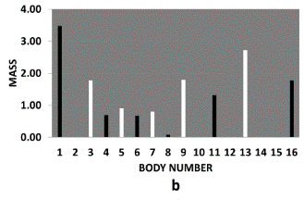
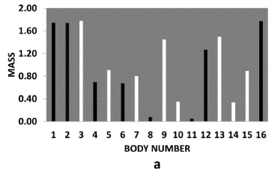
Fig. 6 Mass distribution of matter (black bars) and antimatter (white bars) at time zero (a) and at time 3000 (b)
The result for the distance-time relationship of the 16 adjacent bodies is given in Fig. 7a and in detail in Fig. 7b. Adjacent bodies of the same (anti)matter coalesce almost immediately. The distances behave more erratically than for bodies having the same mass and only after about 600 time units does a pattern emerge where matter and antimatter bodies consistently alternate. Bodies of matter are pushing apart their antimatter neighbors and vice versa resulting in expansion.
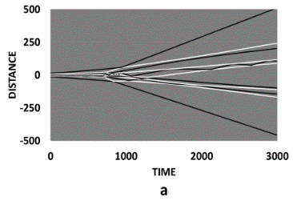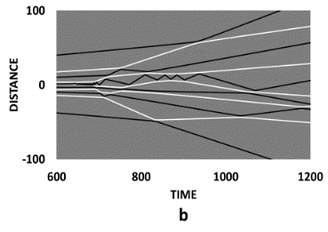
Fig. 7
Expansion and coalescence 16 matter (black lines) and antimatter (white lines) bodies of different mass. Initial distance between bodies 1.2 times the body diameter. Fig. 6b is a detail of Fig. 6a

In Fig. 8 the velocity as a function of time is plotted for the same system. It shows the hectic beginning and also that the `
average velocities become constant over time.
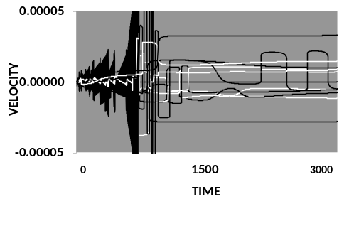
Fig. 8 Velocity versus time for the 9 remaining bodies after coalescence. Matter bodies (black lines) and antimatter (white lines)

In Fig. 9 a Hubble plot is given where the velocities (both positive and negative) are plotted against the distance from the origin after 3000 time units. A trend line would go approximately through the origin at the center of the figure where both the velocity and distance are zero.
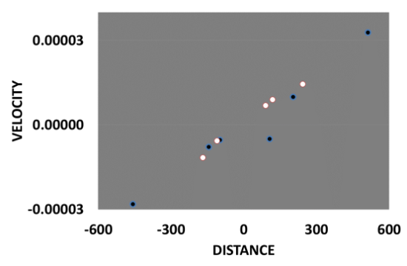
Fig. 9 Hubble graph after 3000 time units (black dots matter and white dots antimatter)

B. Two-dimensional results
The foam structure with large voids, clusters and filaments becomes clear in Fig. 10 where the distribution is given after 200 time units when starting with a mixture of 4484 bodies of matter and antimatter. During this time 3619 coalescences and 34 partial annihilations occurred resulting in 831 bodies of which 420 were matter and 411 antimatter.

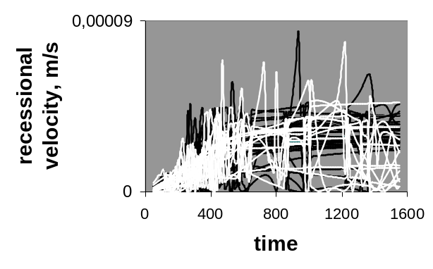
Fig. 10 End position of 831 remaining coalesced bodies (black dots are matter, white dots are antimatter). Average inertial mass of the original 4484 bodies was 1 kg. Initial distance between bodies six times the body radius

C. Three-dimensional results
A group of 3912 bodies was studied with an asymmetry between matter and antimatter of 0.002 %. The initial distance between adjacent bodies amounts to four times the body radius. During the first 50 time units, 3533 coalescences occurred of which 196 partial annihilations resulting in 379 bodies. During the following 5000 time units only 107 pure coalescences occurred, leaving 272 bodies of which 136 were matter and 136 were antimatter. No annihilations occurred during these last 5000 time units which confirms that no cataclysmic encounters between matter and antimatter have ever been observed. If they occurred it must have been in the very early universe [5].
The gravitational mass distribution of the original 3912 bodies before coalescence is given in Fig. 11.
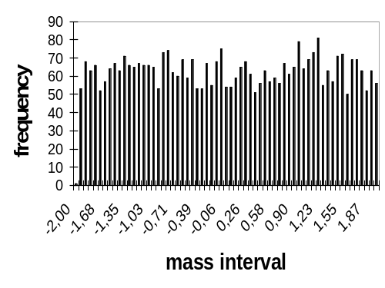

Fig. 11 Gravitational mass distribution of the original 3912 bodies of matter and antimatter

The total inertial mass of both the coalesced matter and antimatter bodies amounted to 921 kg. Only four bodies have a high inertial mass of over 100 kg and together they form about one- third of the total inertial mass of 1842 kg. Their gravitational masses were -190, -144, 102, and 133 kg. Some 250 bodies did fall in the narrow inertial mass range of 3-5 kg forming about half of the total mass. The remaining bodies fell in the 10-50 kg range. Many of the coalesced bodies formed part of a system. In Fig. 12a and Fig. 12b the inertial mass distribution is given after coalescence.
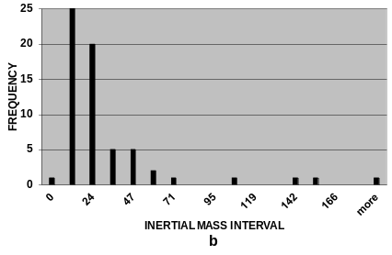
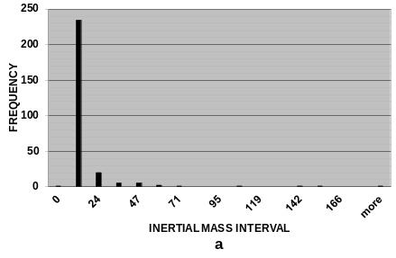

Fig. 12 Inertial mass distribution of the coalesced 272 bodies (a) and in detail (b)
In Fig. 13 the vast majority of the bodies coalesced bodies are given as projections in the three Cartesian planes. Just as in the case of two dimensions, they show at a first glance a disorderly distribution of bodies with voids and clusters.
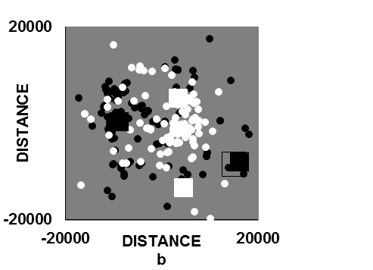
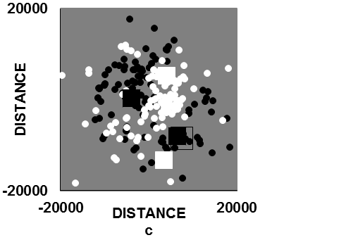
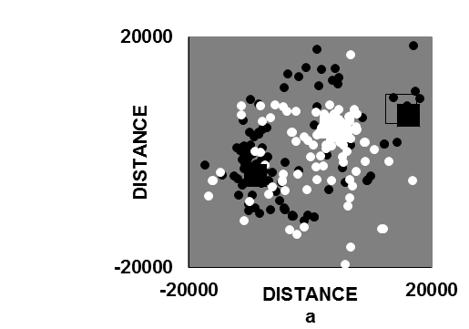

Fig. 13 End position of the remaining 272 bodies in the three Cartesian planes after 5050 time units. Black dots are matter, white dots are antimatter. Initial distance between adjacent bodies four times the body radius. One time unit is 1.96 x 10⁵ s
It is shown that the center of gravity of the two antimatter bodies with the highest mass (solid white squares) are responsible for keeping apart the two matter bodies with the highest mass (solid black squares). This example shows that there is a balance of power and therefore some order in the seemingly disordered bodies.
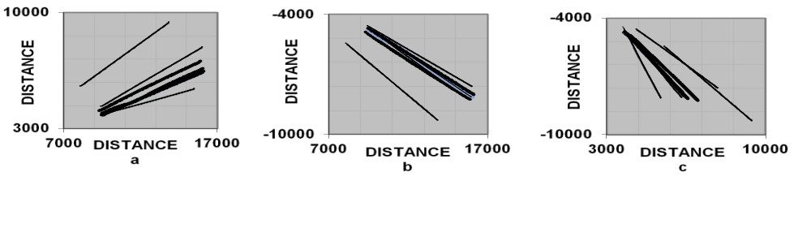
Fig. 14 Last part of the matter trajectories of the bodies enclosed by the squares in Fig. 13
A fascinating point is why clusters exist, and why the bodies within a cluster do not form a system. In Fig. 14, the last part of the trajectories of four bodies enclosed by squares in Fig. 14 is shown. The trajectories show that all bodies move away from the center where they originated (near the point (0,0,0) laying outside all three graphs) towards more negative or more positive distances, but also away from each other. It can hence be concluded that also within a cluster there is inflation.. This has been demonstrated by for example the studies of Guthrie and Napier and Bajan et al [7].
Hubble plots
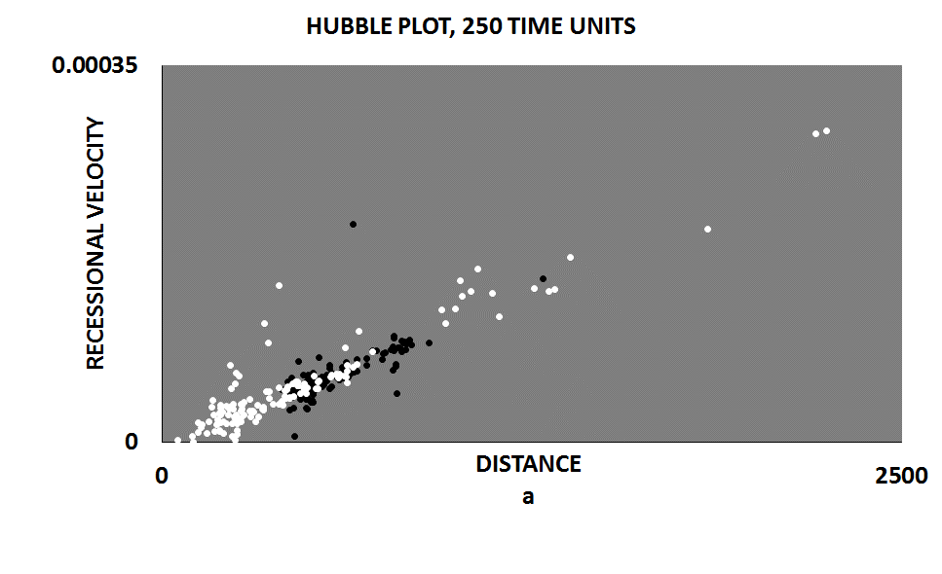
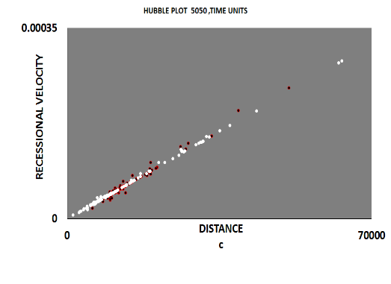
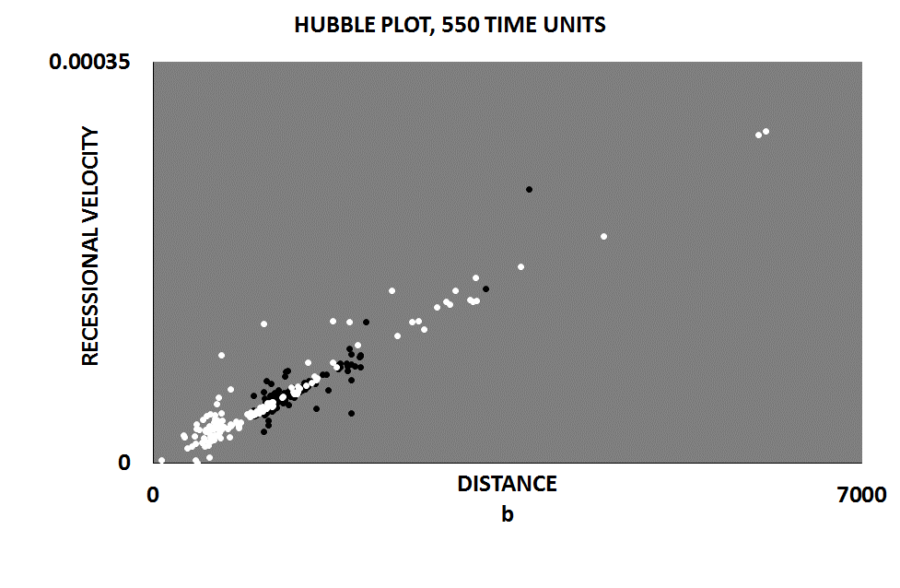
Three Hubble plots are given in Fig. 15 starting with 3912 bodies of matter and antimatter with a random inertial mass distribution and an equal initial distance between adjacent bodies. The Hubble plots are given after 250, 550, and 5050 time units resulting in 293, 278, and 272 remaining coalesced bodies respectively. Both recessional velocities and distances pertain to all directions relative to the origin of the “universe”. The reducing number of remaining bodies as a function of time is caused by additional coalescence. All three trend lines go approximately through the origin where velocities and distances are zero. The Hubble plots in Fig. 15 show that the antimatter bodies have, on average, a lower recessional velocity than the matter bodies that agrees with the plots in Fig. 13. This result is an artefact. Calculations with a larger amount of bodies will show a more random distribution of matter and antimatter as found in the two-dimensional data (Fig. 10). Hubble’s law holds for a wide range of ages of the universe. The younger the universe, the more bodies in the Hubble plot will deviate from the trend line (Fig. 15). The fact that the maximum recessional velocities are similar is an indication that the universe is already well advanced in its development. This is in agreement with the data in Fig. 5a. When converting standard units to those for clusters using the conversion factors in Table I, the calculated age of the “universe” is in all three cases far beyond its age of 14 billion years. Even when converting the standard data in the plot comprising 250 time units to those for clusters, the calculated life of the universe is 38 billion years (Fig. 15a). Given the uncertainty in the data used for our calculations (especially the initial distance between the bodies) the above results are at best order of magnitude.

Fig. 15 Hubble plots of coalesced bodies fter 250, 550, and 5050 time units. Black dots are matter and white dots are antimatter. One time unit is 1.96 x 10⁵ s
D. Sensitivity analysis
A sensitivity analysis has been carried out for some variables for 480 standard bodies of matter and antimatter, with a random mass distribution and originally located in a cubic “lattice”. The masses of matter and antimatter were equal within 0.04%. The calculations were made for a period of 1200 time units. As shown in Table III, increasing the initial center to center distance (runs 1-3) between adjacent bodies from 4 to16 m has a large effect as it reduces the total number of bodies due to coalescence from 412 to 42 and, due to partial annihilation collisions, from 11 to zero, when other variables are kept constant. Increasing the average inertial mass of the bodies (runs 4, 1 and 5) from 0.5 to 2 kg while keeping other variables constant has little effect on the number reduction due to coalescence and annihilation, hence also on the number of remaining bodies.
TABLE II
EFFECT OF INITIAL DISTANCE BETWEEN ADJACENT BODIES AND MASS ON COLLISIONS AND ANNIHILATION
Run | 1 | 2 | 3 | 4 | 5
Distance adjacent bodies, m  Average mass, kg  Total time units  Original number of bodies  Reduction due to coalescence  Reduction due to annihilation  Remaining bodies | 4  1  1200  480  412  11  57 | 8  1  1200  480  335  2  143 | 16  1  1200  480  42  0  438 | 4  0.5  1200  480  408  11  61 | 4  2  1200  480  414  10  56

E. Discussion of the expansion results
The standard data in our treatise may be considered as a representative model for a group of bodies where galaxies are the largest structured systems and clusters form the largest non-structured accretions. The data show that clusters consist of either matter or antimatter. The lack of structure in clusters is caused by the fact that the bodies within the cluster have diverging trajectories resulting in inflation of the cluster and prohibiting system formation. The result is a universe that has a certain dynamic structure. The Greeks were right in that κοσμος means both universe and order. Starting with a random distribution of inertial masses resulted in coalesced masses with a narrow mass distribution but with a few very massive bodies. It could well be that due to the many consecutive steps of system and cluster formation that the mass distribution between clusters in our universe is fairly narrow. The mechanism of coalescence, system formation and clustering will have been essentially the same for very small bodies as well as for galaxies and clusters. The early stage comprising small bodies will have taken a relatively short time and added little to the age of the universe but will have resulted in Big Bang temperatures. The very beginning could well have been cool, which is more in line with low entropy. Although data are available for the masses of clusters, there are no data on the initial distances between these bodies, mass distributions, etc. Hence without further information one cannot calculate the maximum recessional velocities or distances. However, using existing observations one can try to discriminate between matter and antimatter clusters.

IV. Summary and Conclusions
A model where antimatter has a negative gravitational mass can be underpinned by the following observations in the universe:
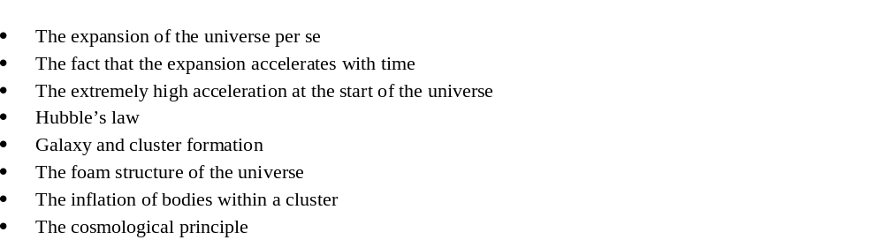
Together these observations can be considered as a strong argument against the WEP and do support a symmetric universe and the negative gravitational mass of antimatter. A prerequisite for the above conclusions is that the EP also holds if antimatter has a negative gravitational mass. Some simple thought experiments can prove that this is the case. The effect of a matter environment could explain the small discrepancy between matter and antimatter in CP experiments. Hence there is not CP violation but CP invariance. The fact that the universe started with very small elementary particles where the gravitational force is much stronger than the Coulomb force and now features galaxies and clusters implies that the accretion of matter and of antimatter will have involved many consecutive stages. Whence the size has reached the dimensions of galaxies and clusters, further growth becomes difficult because clusters of opposite matter block the joining of clusters of similar matter, and/or the distances between clusters become so large that the gravitational forces between neighbors become negligible. Gauging the model by using available astronomical data on masses and distances will enhance the chance to look forward into the future as well as to look backward into the history of the universe. Simulations with many more bodies and involving consecutive accretion steps and smaller time increments, together with including general relativity and the effect of partial annihilation of matter and antimatter in the early universe, are required to refine the above model.

TABLE III
GLOSSARY
Symbol | variable |  | quantity | unit
c  D  E_{kin}  E_{pot}  G  J  M  N  v  ε₀  Δt | velocity light in vac. Initial distance bodies  kinetic energy  potential penergy  Gravitational constant  Jacob number  mass  number  velocity  permittivity of vacuum  time interval | 3x10⁸  6.67x10⁻¹¹  8.85x10⁻¹² |  | m/s  m  J  J  m³.kg⁻¹.s²  kg  m/s  coul².s².kg⁻¹.m⁻³⁻

References
[1] J. Travis, Science, Vol. 257 25 September, 1992, pp. 1860.
[2] H. Dittus and C. Lämmerzahl. Tests of the weak equivalence principle for charged particles in space, Advances in Space Research, Vol. 39, Issue 2, 2007, pp. 244-248.
[3] A. Pais, “Subtle is the Lord”, Oxford University Press, Oxford, 1982, pp 180.
[4] R.P. Feynman, R.B. Leighton, R.B. and M. Sands, M.,, “The Feynman lectures on physics”, Addison-Wesley publishing company, 1963, pp. 9-6 – 9-9.
[5] M. Riordan, and D.N. Schramm, “The Shadows of Creation”, Freeman and Company, New York, 1991, pp 138-143 and p. 98.
[6] S. Perlmutter, Science Magazine Names Supernova Cosmology Project “Breakthrough of the Year”, Research News Berkeley Lab. December 17, 1998.
[7] B.N.G. Guthrie, and W.M. Napier, “Astronomy and Astrophysics”, 310, 1996, pp 353-370.

M. J. van der Burgt, Beatrixlaan 7, 1921BP Akersloot, the Netherlands, phone: +31-251-312418 or: +31-622-904-277; e-nail: maagburgt@gmail.com.

