Diagnosis of complex regional pain syndrome type 1 in a patient with corticobasal degeneration: a case report
Running title: Corticobasal degeneration combined with complex regional pain syndrome type 1

Authors
Hee Sup Chung, MD¹, Seung Min Kim, MD, PhD², Min Cheol Chang, MD³, You Gyoung Yi, MD, MS¹, Hyo Jung Kang, MD, MS¹, Dae Hyun Kim, MD, PhD¹, Kyung Hee Do, MD, PhD¹

Author Affiliations
¹ Department of Physical Medicine and Rehabilitation, Veterans Health Service Medical Center, Seoul, Korea
² Department of Neurology, Veterans Health Service Medical Center, Seoul, Korea
³ Department of Physical Medicine and Rehabilitation, College of Medicine, Yeungnam University, Daegu, Korea

Corresponding author
Kyung Hee Do, MD, PhD
Department of Physical Medicine and Rehabilitation
Veterans Health Service Medical Center, Seoul, Korea
Tel: 82-2-2225-4602; Fax: 82-2-2225-4602
E-mail: khdo79@gmail.com

Conflicts of interest: No potential conflict of interest relevant to this article was reported.
Acknowledgement: This study was supported by a VHS Medical Center Research Grant, Republic of Korea (grant number: VHSMC19014).
Clinical Trial Registry Number: 2019-03-001
Funding: No funding was received.

Abstract
Here, we report a patient with corticobasal degeneration (CBD) who was also diagnosed with complex regional pain syndrome type I (CRPS I), which has similar clinical characteristics. A 76-year-old man who had been diagnosed with CBD several years prior presented with asymmetric severe pain, postural instability, limb rigidity, limb dystonia, tremor, ideomotor apraxia, and bradykinesia especially on his left upper extremity on admission at our rehabilitation center. Due to the severe pain on his left upper extremity with a visual analogue scale (VAS) score between 8~9, he could neither transfer well nor lie on his left side, and he woke up from his sleep more than 10 times during the night due to severe pain. Additional physical examination showed darkened skin color change, edema, reduced skin elasticity, cold skin temperature, wet skin, and limited range of motion of the left side compared to the right side. A three phase bone scan showed increased blood flow, pool, and delayed periarticular uptake in the left wrist and hand as well as relatively increased bone and joint uptake in the left upper extremity, which is indicative of typical CRPS I. Therefore, we initiated treatment for CRPS I, including steroid pulse therapies and non-steroidal anti-inflammatory drugs; subsequently, his left extremity pain reduced from a VAS score of 8~9 to 3 and his functional level also improved. To the best of our knowledge, this is the first report of a CBD patient being also diagnosed with CRPS I. Given their similar clinical features, clinicians should always consider the differential diagnosis of CRPS I from CBD. Moreover, proper management based on a precise diagnosis is important because these symptoms affect the patients’ quality of life and activities of daily living.

Key Words:
Complex Regional Pain Syndrome; Complex Regional Pain Syndrome, Type I; Movement disorder; Corticobasal degeneration; Pain
Figure Legends
Figure 1. (A) ¹⁸F-fluorodeoxyglucose positron emission tomography (PET), (B) ¹⁸F-florinated-N-3-fluoropropyl-2-β-carboxymethoxy-3-β-(4-lodophenyl) nortropane PET, (C) maximum intensity projection images of 18F-florinated-N-3-fluoropropyl-2-β-carboxymethoxy-3-β-(4-lodophenyl) nortropane PET demonstrating an asymmetric decrease of the FP-CIT uptake in the bilateral posterior putamen (Right > Left) with relative sparing of the ventral putamen, which showed an aggravated status compared to the previous scan conducted 8 months before admission
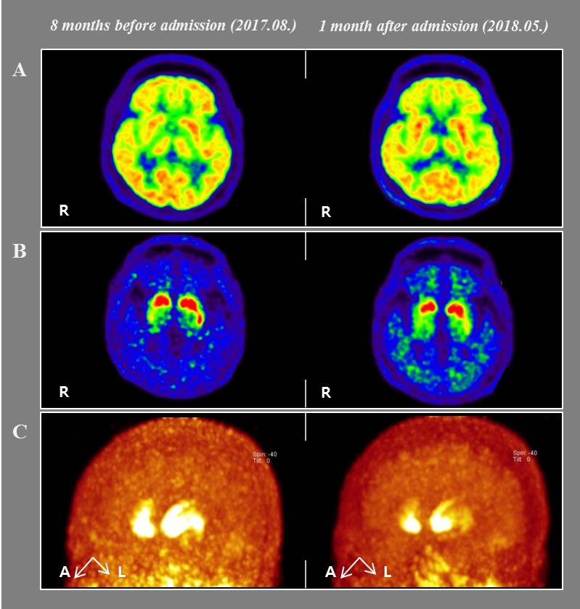

Figure 2. Three phase bone scan of the patient.
Three phase bone scan showed an increase of blood flow, pool, and delayed periarticular uptake in the left wrist and hand, and relatively increased bone and joint uptake in the left upper extremity, which is indicative of typical complex regional pain syndrome.
(A) Blood pool phase
(B) Delayed phase
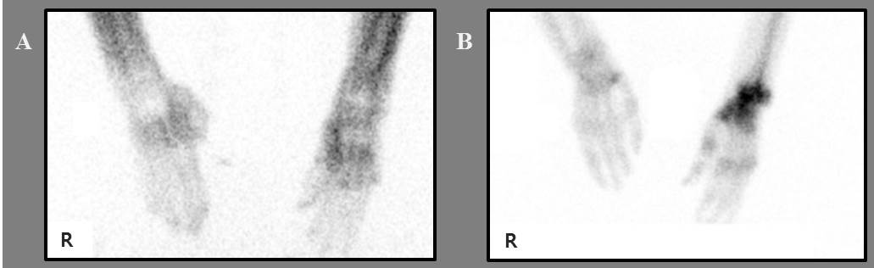

Table I. Changes in Medical Research Council scores of left upper extremity for the patient
 | At admission | After steroid pulse treatment
Shoulder flexors | 1 | 3
Elbow flexors | 1 | 3⁺
Elbow extensors | 1 | 3⁺
Wrist extensors | 1 | 3⁺
Finger flexors | 1 | 3⁺
Finger abductors | 1 | 3⁺
Medical Research Council scores are as follows: 0, no contraction; 1, palpable contraction but no visible movement; 2, movement without gravity; 3, movement against gravity; 4, movement against a resistance lower than the resistance overcome by the healthy side; and 5, movement against a resistance equal to the maximum resistance overcome by the healthy side.

