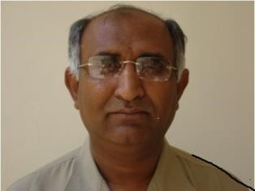
HANDLING HYDATID CYST DISEASE
Prof. Abdullah G Arijo
Department of Veterinary Parasitology
Sindh Agriculture University
Tandojam-70060, Pakistan
abdullaharijo@gmail.com
Abstract:
Hydatid disease (also known as hydatidosis or echinococcosis) is a potentially serious, sometimes fatal, condition caused by cysts containing the larval stages of the Echinococcus granulosus (E. granulosus) tapeworm (Dog Tapeworm). The infection is not un-common in Pakistan, and dogs play role in disease transmission.
11 years data (1998 to 2008) from Department of Histopathology, Liaqat University of Medical and Health Sciences, Jamshoro, Sindh-Pakistan were collected and analyzed for human hydatid cyst cases. The data revealed that out of 43656 registered cases, 44 were recorded hydatid cyst cases. The data further revealed that hydatid cyst prevails more in females (30 cases) as compare to male (14 cases). In the recorded data the patient were divided into four age groups A (5-20 years), B (21-40 years), C (41-60 years) and D (61 years - onward), hydatid cyst prevails more in age group B (22 cases) followed by age group A, C and D with 14, 06 and 02 cases of hydatid cyst respectively. The favorable site for hydatid cyst development was liver (29 cases) followed by spleen, abdomen, lung, uterus, thigh, ovary, gallbladder, endometrium, thyroid and thorax (03, 03, 02, 01, 01, 01, 01, 01, 01 and 01 cases respectively).
The disease seems to be on rise and there is dire need of mass awareness aimed at avoiding offal and contact with canines (Dogs in particular) to be at bay from infection. This presentation addresses the issue.
Key words: Hydatid cyst, Hyderabad, Echinococcus granulosus

Biography
  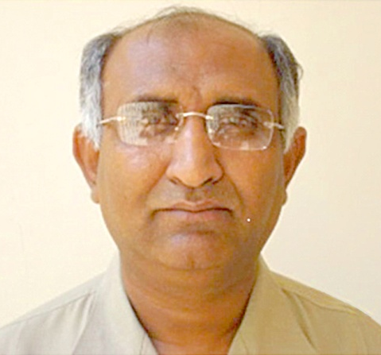 | Dr Abdullah G Arijo
 | Professor and Chairman
 | PhD Parasitology (United Kingdom) 1997
 | Department of Parasitology, Faculty of Animal Husbandry & Veterinary Sciences, Sindh Agriculture University Tandojam
 | Telephone | Home: +92-2100349 (Hyderabad-Pakistan)
 | Telephone | Mobile: +92-3463811898
 | Email | abdullaharijo@sau.edu.pk

BIOSKETCH

PROF DR ABDULLAH G ARIJO
- HEC Recognized Ph.D. Supervisor
- Best University Teachers Award 2015 by HEC, Islamabad
- World Bank ARP-II Ph.D. Award 1993
- The Productive Scientists of Pakistan 2007
- Zoologist of the Year Award 2015 by Zoological Society of Pakistan

KEY FACTS

Doctoral Degree Ph.D.)
University of North Wales, Bangor-United Kingdom (1997) World Bank ARP-II Award
Awards
- Zoologist of the Year Award-2015
- Best University Teacher Award-2015
Research Publications
- 94
Books authored in the field of Veterinary Parasitology
- 04
University course manuals authored in the field of Veterinary Parasitology
- 03
Ph.D. supervised, degrees awarded
- 03 (major supervisor) 2 underway
- 02 (co-supervisor)
Principal investigator International Projects
- 02 (USA and Germany)
National Projects
- 02 (UGC, HEC)
Visiting Faculty
- The Benazir Bhutto University of Veterinary and Animal Sciences, Sakrand Benazir Abad
Consultancy services
- Anti-Snake Venom Project, Govt of Sindh
- United Energy Pakistan
Teaching Experience
- 2-year (s) experience as instructor biology @ Pakistan Air Force College, base Masroor Karachi (1986-88)
- 31 year (s) teaching experience @ Sindh Agriculture University Tandojam (1988 to date)
Research Experience
- Completed 2 international research projects with USA and Germany, and 2 nation research projects
- Produced 3 PhD(s) as major supervisor in the field of Veterinary Parasitology
- Produced 3 PhD(s) as co-supervisor in field of Vety Physiology & Biochemistry, Vety: Parasitology
- Produced about 50 M Sc and M Phil scholars in Veterinary Parasitology as major supervisor
- Supervised research work of over 25 M Phil and PhD students of medical universities (LUMHS, LUMHS, University of Karachi)
- Established world class Molecular Parasitology lab for advance research in Veterinary Parasitology
- Established state of the art experimental animal house for research in biological sciences.

Presenting author details
Full name: Abdullah G Arijo
Contact number: +923463811898
Twitter account: abdullaharijo@wteeter.com
Linked In account:
Session name/ number: Arijo
Category: (Oral presentation)

