Plasmodium falciparum Parasitaemia: Levels of Knowledge, Attitudes and Practices among pregnant women on initial attendance to Antenatal care in Umuahia, Abia State, Nigeria.
¹Amadi, A. N. C and ¹Nwosu, C. D.
¹Department of Zoology and Environmental Biology, College of Natural Sciences, Michael Okpara University of Agriculture, Umudike, Abia State, Nigeria.

Corresponding Author: Dr A.N.C Amadi
e-mail: an_amadi@yahoo.com

Abstract
A clear understanding of the Knowledge, Attitudes, Practices and the current status of infection of malaria in a community can inform the design of Behaviour Change Communication (BCC) campaigns to influence acceptance and use of any malaria control measure. This study determined the prevalence of Plasmodium falciparum infection among pregnant women on initial attendance to Antenatal Care (ANC), Knowledge, Attitudes and Practices (KAP) about malaria and its control and their major sources of information on malaria. The study was carried out between February and April, 2016, in two selected specialists hospitals in Umuahia, where pregnant women registering for ANC were consented and recruited for the study. Well structured questionnaires were used to determine their KAP towards malaria and their sources of information on malaria, Peripheral blood smears were used as diagnostic tools to determine infection rates by microscopy. Out of 374 pregnant women examined on initial attendance to ANC, 210(56.2%) were infected by P. falciparum, with Primigravidae 138(71.13%) and those that came in their second trimester 120(60.9%) having the highest and this varies significantly across gravida and trimester at P<0.05. Majority 232(62.0%) of the respondents had good knowledge about malaria, positive attitude 239(63.5%) and good practices 198(52.9%) towards its control measures. The Media 110(29.7%) and Health centres/clinics 96(25.9%) were their major sources of information on malaria. The prevalence of malaria among this study group was relatively high, many registered late to ANC which contributed to this high prevalence. Majority of the respondent had good knowledge, positive attitudes and good practices toward malaria and its control measures. The study advocated for early registration to ANC and improved sensitization of the pregnant women during ANC visits is necessary to address the gaps highlighted by the study.

Keywords: Knowledge, attitudes, practices, Plasmodium falciparum, trimester, primigravidae, secungravidae, multigravidae.

Introduction
The scourge called malaria has been century old. The disease is endemic in sub-Saharan Africa, and indeed in Nigeria. Today, approximately 40% of the World’s poorest countries, are at risk of malaria (1, 9). Malaria is caused by the parasite of the genus Plasmodium which is usually transmitted by the bite of an infected anopheles mosquito. Plasmodium falciparum is the commonest species in Africa, and it accounts for up to 98% of the cases in Nigeria. Other species include P. ovale, P. vivax and P. malariae. Malaria is endemic in most parts of Nigeria with stable transmission all year round. High temperature, humidity, and rainfall are some of the factors that enhance mosquito breeding and malaria transmission (5).
The disease remains one of the most terrible public health problem in Nigeria, causing about 60% of all outpatient attendances and 30% of all hospital admissions. It is responsible for nearly 110 million clinical cases and an estimated 300,000 deaths per year, including up to 11% of maternal mortality. Also, malaria’s economic impact is enormous with about N132 billion lost to malaria annually in form of treatment costs, prevention, loss of man hours and so on (6, 11). Pregnant women and children are the most vulnerable groups to attacks. Pregnant women, particularly those pregnant for the first time are doubly at risk from malaria (1,4,16). This is because when a woman is pregnant, her immunity drops. Making her more dangerous to malaria with dangerous consequences for the mother and her unborn child (6).
Advocacy and all other techniques used to create awareness have indeed been effective in creating awareness and should be upheld. However, to effectively mobilize the community, we need to know what information they have about malaria, their attitudes and practices towards malaria, so that we can tailor messages that will suit their needs, hence the KAP study. Sound knowledge of community beliefs and practices towards malaria will help in surveillance and control activities (12). It’s important to note that improving the health of poor people depends on understanding their socio-cultural and economic aspect and using these to design effective public health interventions. This information can be gathered through various types of surveys, the most popular and widely used being the KAP surveys (12). Therefore, this study was aimed at determining the current prevalence of Plasmodium falciparum, knowledge, attitudes and practices towards malaria and to prioritize the sources of information utilized by pregnant women on initial attendance to ANC.
The research was a hospital based cross sectional study conducted between February and April, simultaneously in Federal medical centre (Queen Elizabeth specialist hospital) and Abia State Specialist Hospital and Diagnostic Centre, (Amachara annex) where pregnant women living in Umuahia and its environs seeking for antenatal care in the Antenatal Care Unit (ANC) of Obstetrics and Gynaecology department of the two hospitals for the current pregnancy, planned to deliver at the two hospitals and met the inclusion criteria were consented for the study and followed till delivery.
MATERIALS AND METHODS
Study design: This study was to determine the current prevalence of Plasmodium falciparum, levels of Knowledge, Attitudes and Practices towards malaria and to prioritize the sources of information utilized by pregnant women on initial attendance to ANC. The research consisted of a hospital-based cross sectional study conducted between the 10th of February and 29th April, 2016 simultaneously at the antenatal clinics (ANC) of Federal medical centre (Queen Elizabeth specialists hospital) and Abia State Specialist Hospital and Diagnostic Centre, (Amachara annex), where Pregnant women registering for antenatal care and met the inclusion criteria were consented for the study and recruited for the study. A total of 374 pregnant women took part in the study. Pregnant women on any form of curative and preventive malaria drugs on initial attendance to ANC and those that refused consent were excluded from the study. Prior to the kick-off of the research, a selected number of residents who were in charge of the ANC during the period of the study were trained on important aspects of the research work and they assisted in conducting the research. The two instruments used to collect the data for this study were; the Questionnaire and Peripheral blood. Data obtained were analyzed using percentages and Chi-Square, Luyiga, 2013 method of analysis was used to assess the level of knowledge, attitude and practices about malaria.
Description of the study area: Umuahia is the capital city of Abia State. The city has since its creation been expanding, stretching into two local government councils of Umuahia North and South. Umuahia has a low-lying to moderately high plain topography, coordinate of Latitude 5° 29´ 00´´N, Longitude 7° 29´ 00´´ E. A total population of 359,230 according to 2006 census. The land mass covers 145sqmi (385km²). The City is in the Tropical rain forest zone with an average rainfall of 13mm. Maximum and minimum temperature of 31.8°C and 20.2°C. Most of the inhabitants of this municipal are civil and public servants, marketers and students. Malaria is therefore endemic in the area, and its transmission can be described as meso-endemic.
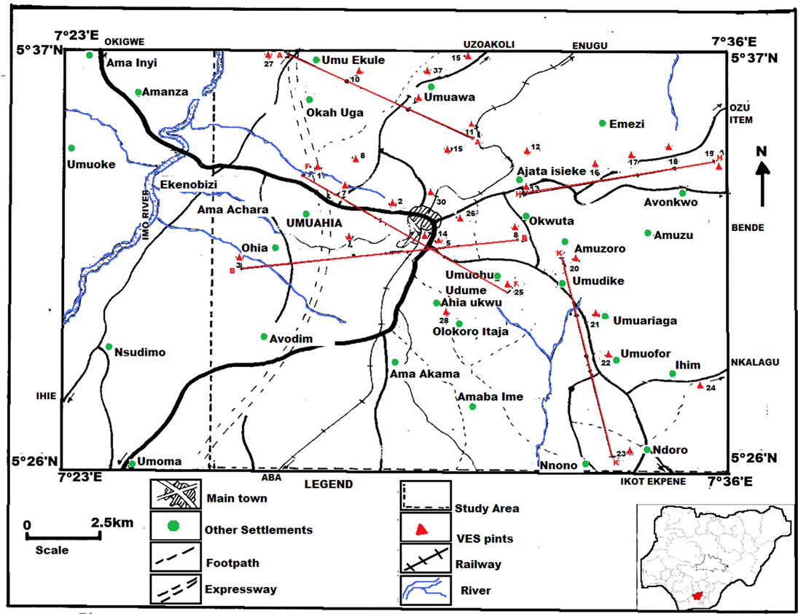
Amachara General Hospital. Federal Medical Center.

Figure 1: Atlas Map showing Umuahia and its environs indicating the study sites (Uchenna et al., 2013).
Ethical consideration: All aspects of the study were reviewed, authorized and approved by the Health Research Ethics Committee of the two hospitals to conduct the research and letters of consent were issued. Informed verbal and written consent was obtained from each subject.
Assessment of Knowledge: The study generated seven multiple choice questions. Each of which was scored one point for a correct response and zero for the rest. An overall knowledge score was calculated by adding up the scores for each respondents across all seven questions.
Assessment of Attitude: There were eleven questions related to attitude. Positive and negative statements are scored the right answer scoring 4 points and the wrong answer 1 point. Following likert’s scale, an overall attitude score across the 11 attitude questions were calculated.
Assessment of Practices: The seven questions that indicate malaria practices were scored for each respondents. If a respondent indicated that they “Always” performed a good practice, they were given a score of two points. If they indicated that they “Sometimes” performed a good practice, they were given a score of one and that they “Never” performed a good practice, they were given a score of zero. An overall practice score was determined for each respondent by adding up the scores across the seven malaria practices questions.
Malaria microscopy: Two millimetres of blood was collected intravenously under a sterile condition. The Blood samples were stored in EDTA bottles, labelled and sent to the Hospital’s laboratories where thick and thin blood films were made on clean slides properly labelled for each participant. The thin blood film was for species identification while the thick blood film was used for parasite count, Densities and stages identification. The thin film was fixed in methanol for few seconds, buffered Giemsa stains (10% Giemsa in phosphate buffer pH 7.2) was used in staining the blood samples for 30 minutes, air dried and observed under oil immersion (×10) objective. The number of asexual P. falciparum for 200 leucocytes was counted and 10 or more parasites identified, then the number recorded. A blood sample was regarded as negative if the examination of thick films failed to show the presence of asexual parasites. The species and different stages, forms (rings and gametocytes) of the parasites present was counted and recorded. The density of the parasite attack was determined by counting the number of asexual parasite against the white blood cells (WBC).
Parasite load quantification: Average White blood cell per µL of blood 1-10 parasite/100 high power field (hpf) was regarded as (+) or mild infection, 11-100 parasites/100 hpf was regarded as (+ +) or moderate infection, 1-10 parasite/1 hpf of blood as (+ + +) or severe infection.
Data analysis and management: Data obtained were analysed using SPSS version 20.0, where Chi-square was used to analyze the difference in prevalence rate in each group at P<0.05 level of significance and Luyiga, 2013 method of analysis was used to assess the level of knowledge, attitude and practices about malaria.
RESULTS
Prevalence of Plasmodium falciparum on initial attendance to ANC
Out of the 374 blood samples collected from the respondents on initial attendance to ANC, 210(56.2%) tested positive for P. Falciparum with 147(70.0%) mild and 63(30.0%) cases of moderate parasitaemia. Primigravidae had the highest prevalence of 138(71.1%) out of 194 samples examined with 93(67.4%) mild and 45(32.6%) moderate cases of parasitaemia. Followed by Secundigarvidae 48(47.1%) out of 102 with 30(62.5%) mild and 18(37.5%) moderate cases of parasitaemia. While Multigravidae had a prevalence rate of 24(30.8) out of 78, 24(100%) mild cases of parasitaemia. The highest prevalence was recorded by women that registered in their second trimester 120(60.9%) out of 197 samples tested, with 88(73.3%) mild and 32(26.7%) moderate cases of parasitaemia. Followed by the first trimester 24(57.1%) out of 42 with 14(58.1%) mild and 10(41.7%) moderate cases, while the third trimester recorded the least 66(48.8%) out of 135 samples tested, 45(68.2%) mild and 21(31.8%) moderate cases of parasitaemia. The infection rate in various gravida and trimesters varies significantly. P<0.05. Also, 8(61.5%) out of 13 examined in 15-20yrs age group were infected with 6(75.0%) mild and 2(25.0%) moderate cases of parasitaemia. Followed by 21-30yrs age group, category where 119(58.1%) out of 205 examined were infected with 86(72.3%) mild and 33(27.7%) moderate cases of parasitaemia, 31-40yrs age group 77(55.8%) with 50(64.9%) mild and 27(35.1%) moderate cases while the least falls in 40>yrs age group where 6(33.3%) out of 18 examined were infected with 5(83.3%) mild and 1(16.7%) moderate cases of parasitaemia.
No case of severe parasitaemia was recorded. As summarized in table 1.
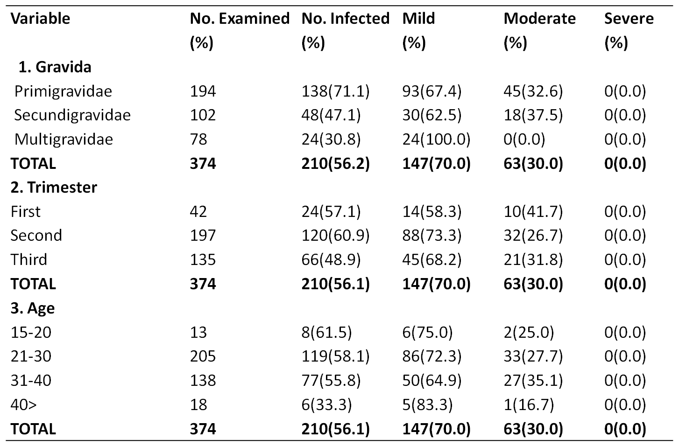
Table 1: Prevalence of malaria on initial attendance to ANC
Chi-Square analysis carried out also showed that there was a significant difference in prevalence of P.falciparum with gravida (1) and trimester (2)(X²cal(1)=83.9 , X²cal(2)= 59.7, df=2,P<0.05
Basic knowledge about malaria and its control
Out of the 374 respondents examined, 232(62.03 %) had “Good knowledge” about malaria (scoring 4-7) while 142(37.97%) had “Poor knowledge” (scoring 3). Maximum score is 7. Respondents with tertiary (92.22%) and secondary (41.06%) education had more knowledge about malaria than those with Primary (15.79%) and no formal education (4.17%). Those that fall in the 40>yrs (83.13%), 31-40yrs (72.46%) and 21-30yre age groups had more knowledge than those in 15-20yrs age group. Those that reside in Ibeku (90.51%) and Umuopara (57.65%) had more knowledge than those that reside in Olokoro (42.86%), Ubakala (35.56%), Ohuhu (32.43%) and outside Umuahia (39.62%). As summarized in table 2.
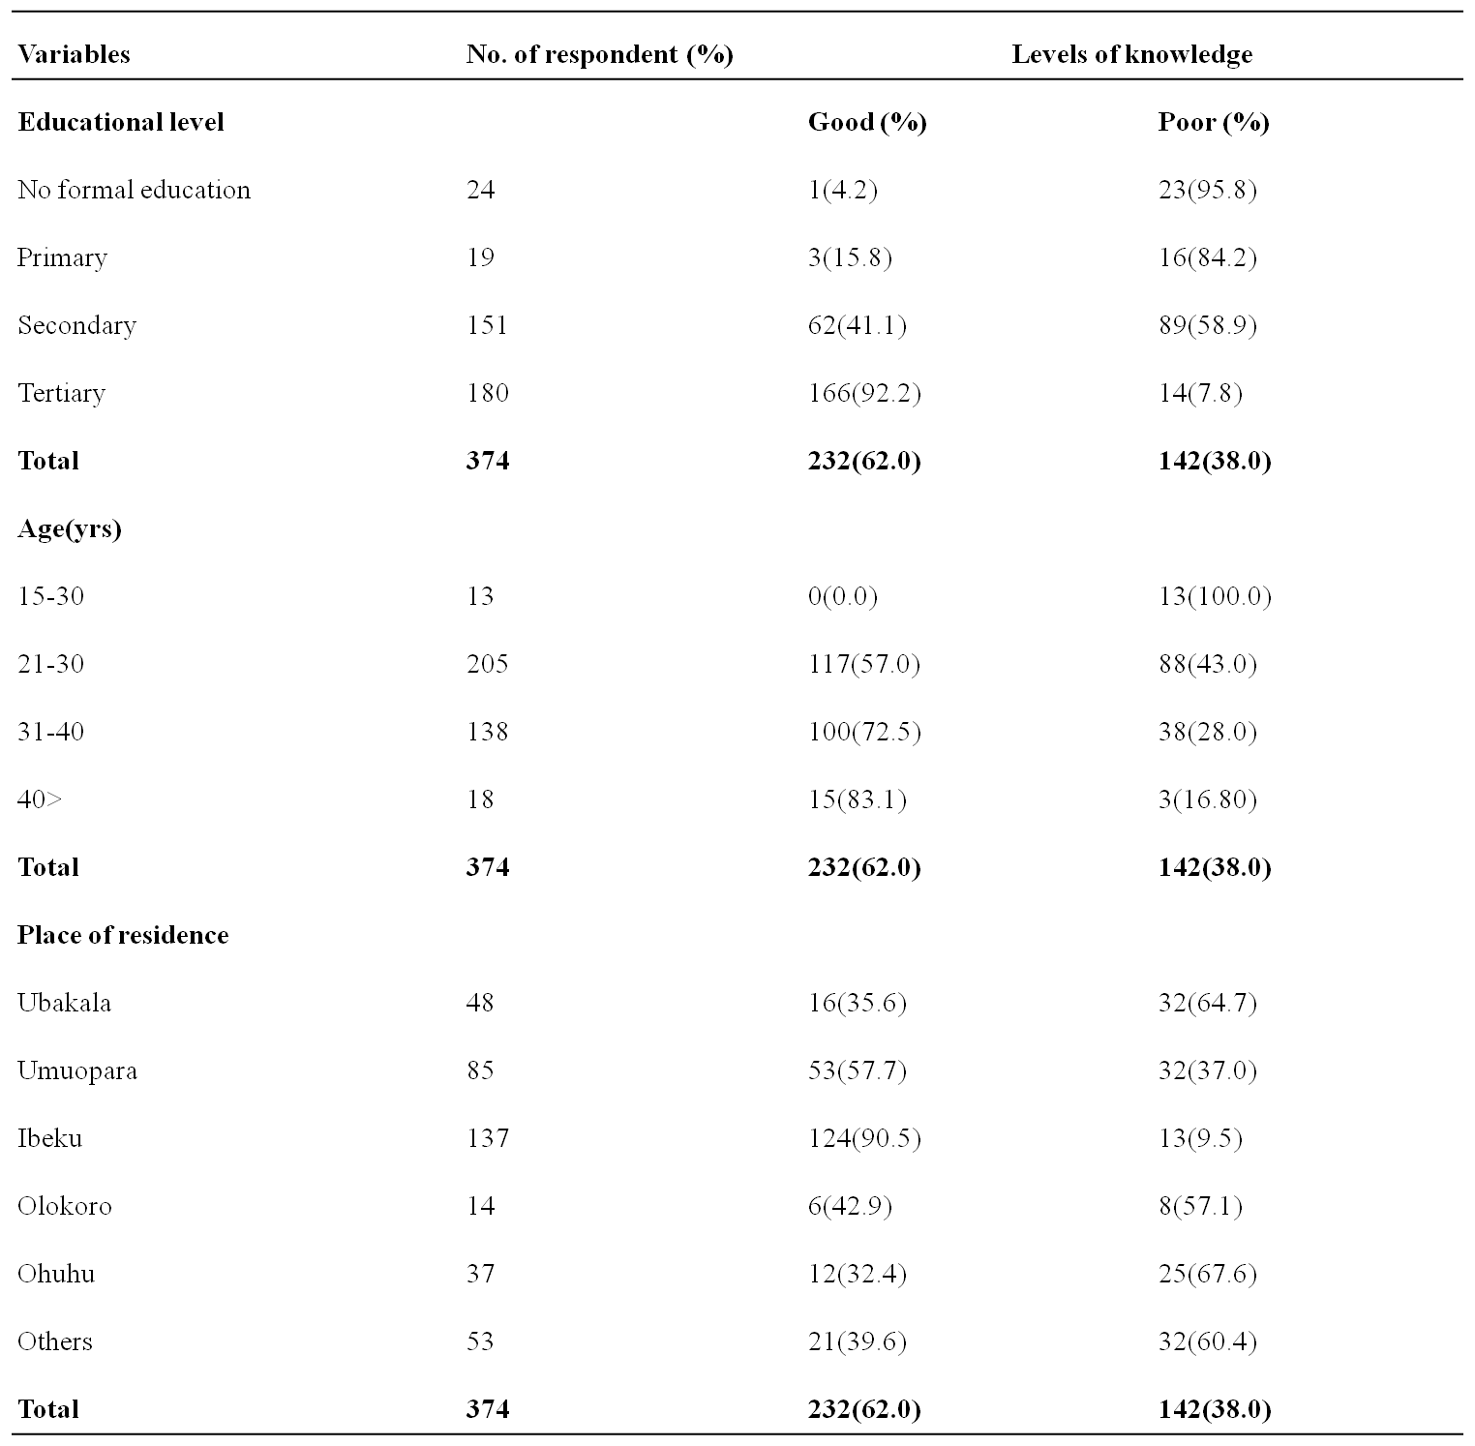
Table 2: Distribution of knowledge in relation to educational level, age, place of residence amongst the respondents.
Note: Good knowledge ranges from scores 4-7, scores 3 and below poor knowledge

Attitudes about malaria and its control
Out of the 374 responses obtained, 239(63.9%) of respondents had “Positive” attitude (scores 30-44), while 135(36.1%) of them had “negative” attitude (scores 30). The maximum score is 44.
Those with tertiary education (92.8%) had positive attitude towards malaria and its control measure than those with secondary (42.8%), primary (26.3%) and no formal education 3(12.5%). Those that fall into age groups 40> (66.7%), 31-40yrs (65.9%) and 21-30yrs (65.9%) had positive attitude than those in 15-20yrs (7.7%) age group. Respondents that reside in Ibeku (83.2%), Umuopara (63.5%) and Ohuhu (59.5%) had positive attitude towards malaris than those that reside in Ubakala (41.7%), Olokoro (42.9%) and outside Umuahia (43.4%). As summarized in table 3.
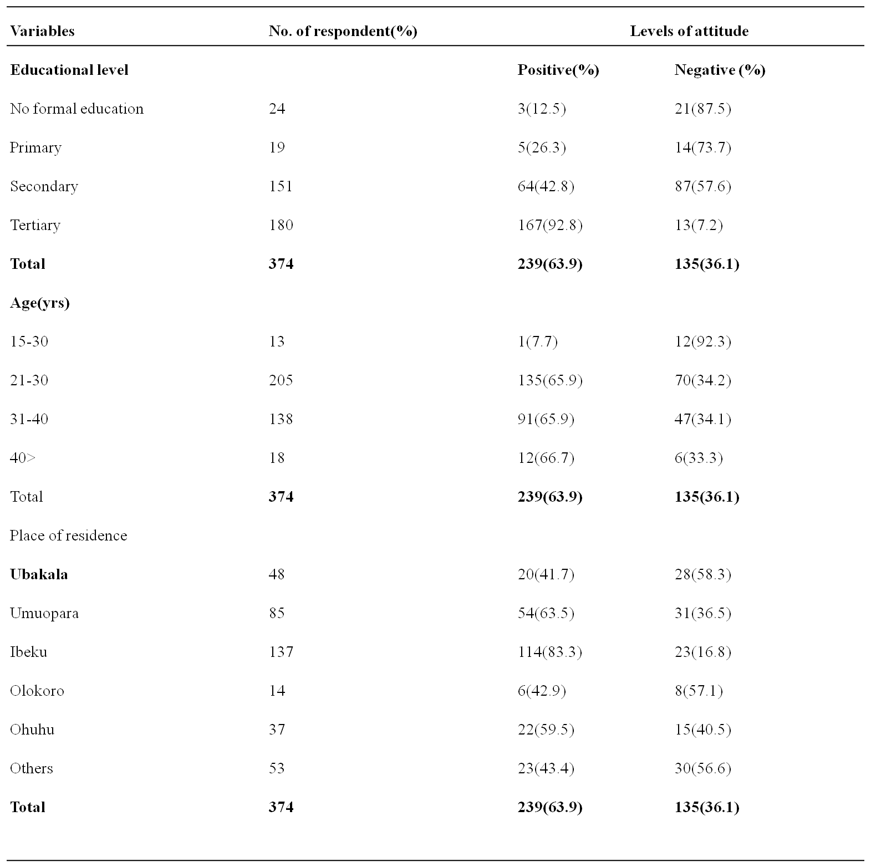Practices towards malaria and its control
Table 3: Distribution of attitude in relation to educational level, age, place of residence amongst the respondents.
Positive attitude ranges from scores 31-44, Negative attitude ranges from 0-30.
Out of the 374 responses obtained, 198(52.9%) of respondents had “Good” practices (Scores 8), while 174(47.1%) of them had “Poor” practices (scores 7). The maximum score is 14. Those that had tertiary education had good practices towards malaria and its control measures than those with secondary (47.0%), primary (10.5%) and no formal education (4.2%). Those that fall in the 21-30yrs (62.4%) age group had good practices than those in 31-40yrs (47.8%), 40>yrs (22.2%) and 15-20yrs age groups. Those that reside in Ibeku (80.3%) and outside Umuahia (60.0%) had good knowledge than those that reside in Ohuhu (32.3%), Olokoro (21.4%), Umuopara (36.5%) and Ubakala (25.0%). As summarized in table 4.
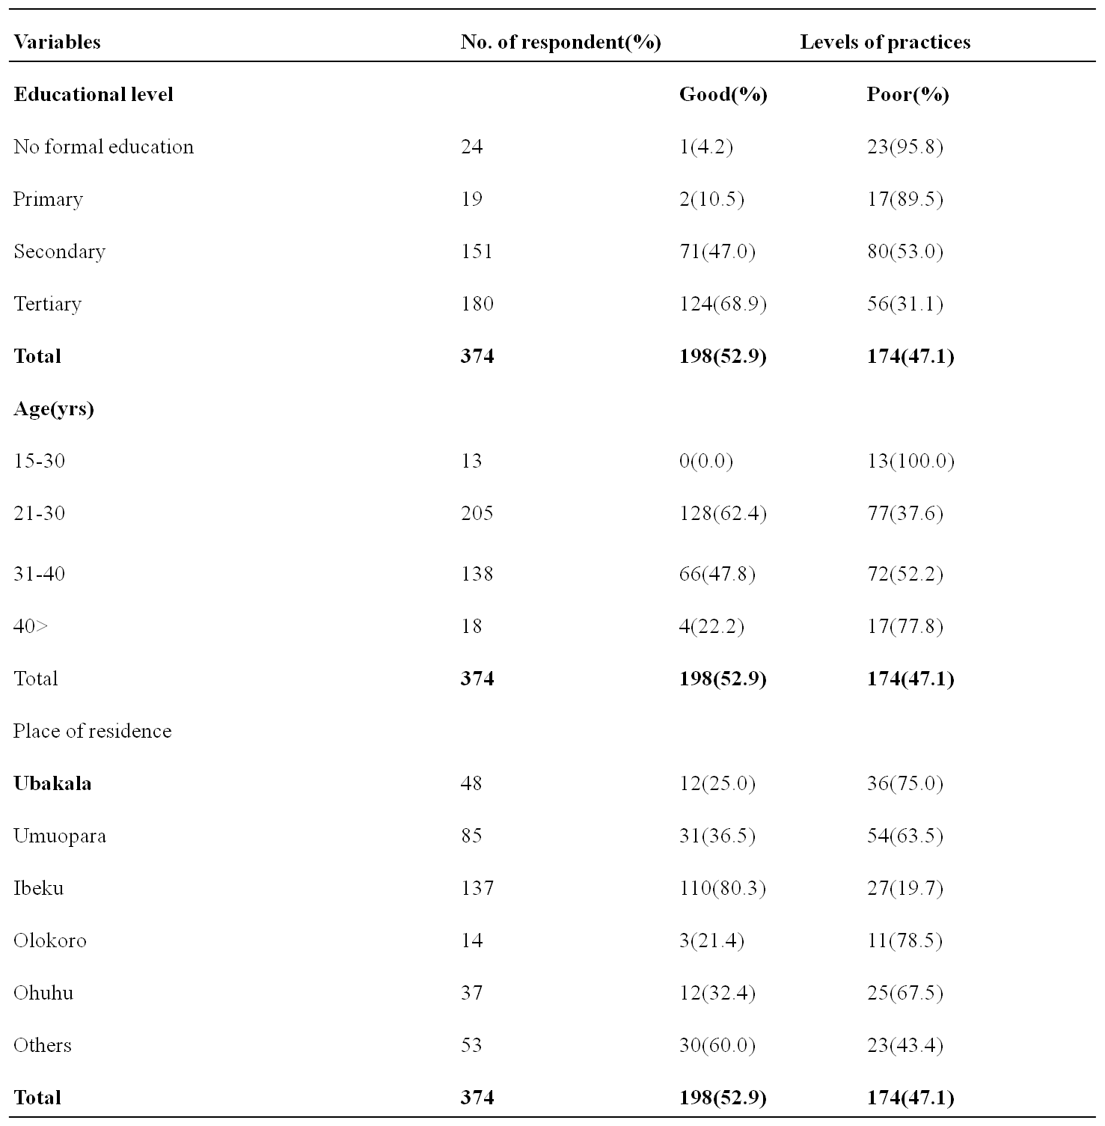
Table 4: Distribution of practices in relation to educational level, age, place of residence amongst the respondents.
Good practices ranges from scores 7-8, Negative attitude ranges from 0-7.

Performance of respondents on malaria knowledge (correct answers only).
Respondents answered a couple of questions to gauge their knowledge, out of the 379 responses obtained, 229(61.2%) knew that mosquitoes causes malaria, 265(70.9%) knew that it is an infected female Anopheles mosquito that transmits malaria, 193(51.6%) know of the seriousness of malaria if untreated, 277(74.1%) recognized at least one of its signs and symptoms, 241(64.4%) recognized at least one of its preventive measures, 313(83.7%) were aware of mosquitoes breeding sites while 289(77.3%) know when malaria mosquitoes feed.
Table 5: Performance of respondents on malaria knowledge (correct answers only).
N/S | Statement | No. of respondent |  | percentages(%)
1  2  3  4  5  6  7 | Which animal can transmit malaria to human? (Mosquito).  Malaria can be transmitted to human by? (Bite of an infected mosquito).  Do you think malaria can kill if untreated? (Yes).  What do you think are the most common signs and symptoms of malaria? (ability to recognize more than one)  Which of these are ways to prevent and control malaria (ability to recognize at least one).  Where do malaria mosquito? (Stagnant water).  When do mosquito feed? (Night) | 229  265  193  277  241  313  289 | 61.2  70.9  51.6  74.1  64.4  83.7  77.3
 |  | N=374
Performance of respondents’ on attitude (Positive Questions)
Out of the 374 pregnant women examined, 90.8% of them agreed that malaria is a life threatening disease, 74.7% know of the best way to avoid malaria, 82.3% agreed that it is a général problem, 67.2 know that sleeping under mosquito nets can prevent malaria, 52.2% are aware of the groups at risk while 52.2% are aware of the dangers of self treatment of malaria.
Table 6.1: Performance of respondents on Attitude (Positive Question).
No | Statement | Strongly Disagree/Disagree % | Agree/ Strongly Agree  %
1  2  3  4  5  6 | I think that malaria is a life threatening disease.  I think the best way to prevent myself from getting malaria is to avoid getting mosquito bite.  I am sure anyone can get malaria.  I believe sleeping under a mosquito net during the night is one way to prevent myself from getting malaria.  In my opinion, Children and pregnant women are more at risk of malaria.  I think Malaria is more dangerous when medication is not taken completely. | 9.2  25.3  17.7  32.8  37.8  41.0 | 90.8  74.7  82.3  67.2  52.2  59.0
 |  | N=374
Performance of respondents’ on attitude (Negative Questions)
On response to negative attitude about malaria 67.8% disagreed that malaria can be transmitted just like the common cold, a lower number 33.5% objected to self treatment, 44.8% are aware of the dangers of not treating malaria, 33.4% objected to stigmatization of malaria patients while only 7.9 disagreed to self medication.
Table 6.1: Performance of respondents on Attitude (Negative Questions).
No | Statement | Strongly Disagree/Disagree  % | Agree/Strongly Agree  %
1  2  3  4  5 | Malaria can be transmitted from one person to another like the common cold.  I am sure I can treat myself if I get malaria.  I think one can recover spontaneously from malaria without treatment.  If someone has got malaria, people should avoid having close contact with him or her.  I can buy anti-malarial drug from drugstore/pharmacy to treat myself when I get malaria. | 67.8  33.5  44.8  33.4  7.9 | 32.2  66.5  55.2  66.6  92.1
 |  |  | N=374
Practices of respondents towards malaria control measures.
On practices about malaria 31.3% always sleep on insecticide treated nets, other households of 24.6% also always sleep in the nets, few 5.5% always use mosquito repellents, 15.2% use mosquito sprays regularly, a higher number 22.5% clears their bushes regularly, 24.6% drains stagnant water always while 35.5% do visit clinics whenever they fall sick.
Table 7: Practices of respondents towards malaria control measures
No | Statement | Always  % | Sometimes  % |  | Never  %
1  2  3  4  5  6  7 | How often do you sleep in a mosquito net?  How often do other member of your household sleep in mosquito nets?  How often do you use mosquito repellent coil on your house?  How often do you use anti-mosquito spray in your house?  How often do you clear/cut bushes around?  How often do you drain stagnant water in and around your environment?  How often do you visit health centre/clinic when you fall sick? | 31.3  24.6  5.5  15.2  22.5  24.6  35.5 |  | 10.7  27.8  2.9  52.7  49.9  37.7  9.63 | 59.0  47.6  91.6  32.1  27.6  37.7  54.8
 |  | N=374

Sources of information about malaria.
The various sources of information utilized by the respondents to access information on malaria was documented and prioritized, 371(99.2%) out of the 374 respondents agreed to have heard of malaria. 110(29.7%) utilized the media, Health centres/clinics 96(25.8%), 44(11.9%) Schools, 38(10.0%) Family member, 28(7.6%) Neighbours, 28(7.6%) Village Health team, 17(4.6%) Churches and 10(2.7%) used drugstores/Hawkers while the remaining 3(0.80%) had no information about malaria as summarized in fig.2.

Figure 2: Major sources of information on malaria and its control
Sources of information about malaria

DISCUSSIONS
In Table 1, The prevalence of Plasmodium falciparum on initial attendance to ANC was 56.2%, this is comparable to 54.0% by (2) in Nigeria but higher than the 36.3% reported by (13) in Kumasi, 19.2% by (17), the 48.22% by (18), 42.4% by (9) and lower than 77.6% by (14) and 59.9% by (15) all carried out in Nigeria. These differences in prevalence according to (3) could be as a result of variation in community-acquired immunity, socio-demographic characteristics of the study population, case selection, seasonal variation, use and resistance to malaria chemoprophylaxis or the diagnostic tools employed. Primigravidae recorded the highest prevalence of (65.7%), followed by secundigravidae (22.8%) and this differ significantly at P<0.05. This according (18) and (2) could be as a result efficient antibody response in secundigravida and multigravida and the delayed production of antibodies in primigravida appeared to account for the gravity dependent and differential prevalence of Plasmodium falciparum in pregnant women. Prevalence also differ significantly with trimester, this could be as a result of the attitude of the women not starting ANC early in pregnancy.
In tables 2, 3 and 4, a higher number (63.0%) of the subjects had good Knowledge, 63.9% had positive attitude and (52.9%) good practices towards malaria and its control measures. The study also discovered that majority of the respondents were able to recognize the signs and symptoms of malaria these could be as a result of the increasing level of campaign programmes on malaria in the country and self experience with malaria. A higher proportion of the respondents mentioned mosquito bites as the mode of transmission and at least one sign and symptoms of malaria. Environmental vector control method through elimination of the habitat of the vector is an important preventive measure for malaria as advocated by many authors, a higher proportion of the respondents had good were aware of the vector control methods.
On practices, a good proportion of the respondents recognized that malaria is a life threatening disease, knowledge on the use of the preventive measures were also advocated. A higher number (90.8%) recognized the use of bed nets as the major control measure, this has also. Many of the respondents also know that malaria is a problem which anyone can get and that mosquito bites and they bite mostly at night. A higher number of the respondents also revealed that pregnant women and children are the major groups at risk. Majority of the respondents disagreed that malaria can be contacted just like the common cold but this did not manifest in their practices. And self medication was practiced by majority of the respondents so also delay in treatment. Though a higher proportion of the respondents agreed to be using insecticide treated nets but just a few used it regularly and with other members of their household so also coils and repellents. A good number of the respondents clear bushes, drain stagnant water around their vicinity and practice effective case arrangement.
Those that had tertiary and secondary education, 21-30yrs and 31-40yrs age group and those that reside in the urban area of Umuahia had more knowledge, positive attitude and good practices towards malaria. This indicates the role of education status in malaria control, as those with high education status can easily understand information materials. The 21-40yrs age bracket has better understanding of both verbal and written instructions and those that reside in urban areas are easily reached by campaign programmes because they are closer to information materials than their rural counterparts. Other studies in other parts of Africa like (12) in Uganda showed that knowledge, attitude and practices about malaria is higher among urban dwellers than in their rural counterparts.
In figure 2, the media (29.6%) and the health centre or clinic (25.9%) were the major sources of information. This according to (7) could be as a result of their educational status and the influence of place of residence, as those with high level of education are more likely to reside in the city where they have access to Information Education and Communication (IEC) materials for malaria and they also understand information materials, such as radio and television adverts, poster and fliers. This calls for an improved dissemination of information about malaria to their areas like the internet, social gatherings, Churches and Mosques, Town hall meetings etc. Where people can be easily reached. Also these information should be interpreted on our local languages to enable the illiterates have a better understanding of it. It could also be relayed in videos, dramas and riddles for children. This will go a long way in spreading information about malaria to the interior villages to get to the minors.
CONCLUSION AND RECOMMENDATIONS.
The prevalence of malaria among this study group was relatively high, many registered late to ANC which contributed to this high prevalence. Majority of the respondent had good knowledge, positive attitudes and good practices toward malaria and its control measures.
This study recommends that;
- Pregnant women should register for ANC not later than the 13th week of pregnancy for effective management of complications during pregnancy.
- Health education during regular ANC visits on good use of malaria control measures should be encouraged, LLITN and IPTp should be distributed freely to pregnant women.
- Information on malaria should be disseminated through other means like the internet, social gatherings, Churches and Mosques, Town hall meetings etc.
Acknowledgement
The research team is grateful to the management and staff of the two hospitals for their contributions towards the success of this research.

REFERENCES
Abdul-Kareen, H.A. (1999). Promotion of the use of insecticide treated Nets. Paper Presented to the National Consensus Meeting on Roll Back Malaria Programme By Primary Healthcare and Diseases Control Department, Federal Ministry of Health. Abuja, Nigeria. 145 pages.
Amadi, A. N. C. and Nwankwo, P. C. (2012). Malaria Parasitaemia and Anaemia among Pregnant Women in Umuahia Metropolis. Journal Applied Science Environmental Management. 16 (4): 367-370.
Bassey, G., Nyengidiki and John, C. T. (2015). Prevalence of Placental Plasmodium parasitaemia and pregnancy outcome in asymptomatic patients at delivery in a University Teaching Hospital in Nigeria. Nigerian Journal of Clinical Practices. 18(1):27-32.
Efunshile, M., Amoo, A.O.J., akintunde, G.B., Ojelekan, O.D., Konig, W and Brigitte, K. (2011). Use and effect of malaria control measures in Lagos, Nigeria. Korean Journal of Parasitology. 49(4):365-371.
Federal Ministry of Health. (2005) Federal Republic of Nigeria training manual for management of malaria in Nigeria Participants’ Manual. Vector Control Division Abuja-Nigeria.
Federal Ministry of Health. (2011) National Malaria Control Programme, Abuja. A Road Map for Roll Back Malaria (RBM) Impact in Nigeria. A 5-year Strategic Plan: 2006-2010.
Francisco Ricci (2012) Social implications of malaria and other relationship with poverty. Mediterranean Journal of Hematology and Infectious Disease.4.133-34.
Ijemba, C.N. (2010). An Appraisal of the utilization of insecticide treated Nets by Pregnant women in Enugu Capital Territory: Socio-cultural and economic consideration. A Dissertation submitted in partial fulfilment of the requirement for the award of Master of Public Health (M.PH) to the Department of Community Medicine College of Medicine, Nnamdi Azikiwe University Teaching Hospital Nnewi. 173 pages.
Jombo, G. T. A., Mbaawuaga, E. M., Ayegba, A. S and Araoye, M.A. (2011). Anaemia, malaria burden and its control methods among women in a semi-urban community of northern Nigeria. Journal of Public Health and Epidemiology. 3. (7):317-323.
Kachur, S.P., Nicolas, E., Jean-Francois, V., Benitez A., Bloland, P.B., Saint Jean, Y., Mount, D.L and Ruebush, T.K. (1998) Prevalence of malaria parasitaemia and accuracy of microscopic diagnosis in Haiti, October 1995. Rev Panam Salud Publica. 3:35-39.
Lagos State Ministry of Health (2008) Malaria control programme. Yearly Bulletin. (10). 98-102.
Luyiga, F. M. (2013). Knowledge, Attitude and Practices on malaria prevention and control in Uganda; a case study of Nsaabwa village Mukono District. A thesis submitted MASKPH CDC. 95pages
Nelly, J. Y., Pauline, E. J., Ellen, F., Tsiri, A., Rayner, J. C., John, E. E., Turpin, A., Stiles, J.K., William, O. E and Jonathan, H.W. (2010). The effect of Malaria and intestinal Helminth Coinfection on birth Outcomes in Kumasi, Ghana. American Journal of Medical Hygiene. 82(1):28-34.
Nwali, M. I., Odidika, U., Umeora, B. C., Ozumba, R. C., Onoh, U. U and Agwu, J. A.(2014). Outcomes of asymptomatic malaria parasitaemia in neonatal in a tertiary hospital, southeast Nigeria. Nigerian Medical Journal. 55 (3):250-253.
Ogbodo, S. O., Nwagha, U. I., Okaka, A. N. C., Ogenyi, S. C., Okoko, R. D. and Nwagha, T. U. (2009). Malaria Parasitaemia among Pregnant women in a rural community of Eastern Nigeria: Need for Combined Measures. Nigerian Journal of Physiological Sciences. 24 (2):95-100.
Omo-aghoja, I. O., Aghoja, C. O., Oghaghon, K and Omo Aghoja, V. W. (2008). Prevention and treatment of malaria in pregnancy in Nigeria: Obstetricican’s knowledge of guidelines and policy changes- A call for action. Journal of Chinese Clinical Medicine. 3 (2):114-120.
Uchenna, U., Alexander, O., Theophilus, T. E., Frank, F. D. I., Alexander, T. O. and Edwin, N. W. (2013). Delineation of shallow Aquifers of Umuahia and its environs, Imo river Basin, Nigeria, Using Geo-Sounding data. Journal of Water Resources and Protection. 5 (11):511-524.

Wogu, M. D and Obasohan, H. O. (2014). Malaria Parasitaemia and Anaemia Among Pregnant Women attending a Secondary Health Care Faculty in Benin City, Southern, Nigeria. American-Enrasian Journal of Scientific Research. 9(4). 76-81.
Yahaya, O., Minaihi, O.E., Unar, I.O and Uwaokhonye, E. (2009). Malaria parasitaemia among pregnant women with multiple Child birth attending ante-natal Clinics in parts of idah and igalamala/odolu Local Government Areas of Kogi State, Nigeria. Malaria Journal. 68: 49-50.
Singh, R., Musa, J., Singh, S and Ukatu, V. E. (2014). Knowledge Attitude and Practice on malaria among the rural communities in Aliero, Northern Nigeria. 3(1):39-44.

