New Approaches to Low-Resource Diagnostics
David W. Wright, Ph.D., Vanderbilt University, Nashville, TN, USA 37235

Abstract
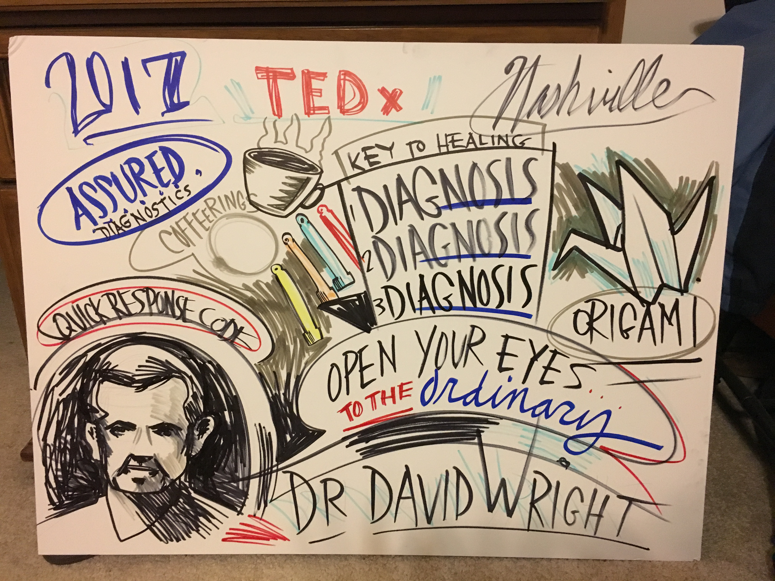

There are over 2 billion people on the planet who live on less than $2.00 a day. What happens when they get sick? How can they afford to go to the doctor and find out why they don’t fell well? The solutions for the diagnostic needs of the people living at the bottom of the healthcare pyramid can be found in our children's toy box, the kitchen counter, or on the poster advertising this weekends rave. The creation of ASSURED diagnostic devices requires new, non-traditional approaches for the development of effective tests for parasitic diseases. In this talk, we will highlight how the principles of everyday objects and phenomena can be adapted for highly sensitive and specific medical tests.

This talk will demonstrate how three different everyday objects have been successfully adopted as low resource diagnostics. The concepts originate from origami, the ancient art of Japanese paper folding, coffee rings, like those left on the kitchen counter, and glow sticks, a favorite children’s' toy. These new devices provide new solutions to the challenges of field deployable diagnostic tests for the detection of asymptomatic malaria.

Image

Recent Publications
- Gibson, L.E.; Wright, D.W. Sensitive Method for Biomolecule Detection Utilizing Signal Amplification with Porphyrin Nanoparticles. Anal. Chem. 2016, 88 (11), pp 5928–5933
- Gulka CP; Swartz JD; Trantum JR; Davis KM; Peak, Corey M.; Denton, Alexander J.; Haselton FR; Wright DW. Coffee Rings as Low-Resource Diagnostics: Detection of the Malaria Biomarker Plasmodium falciparum Histidine-Rich Protein-II Using a Surface-Coupled Ring of Ni(II)NTA Gold-Plated Polystyrene Particles. ACS App. Mat. & Inter. 2014, 6(9), 6257-6263.
- Trantum JR; Wright DW; Haselton FR. Biomarker-Mediated Disruption of Coffee-Ring Formation as a Low Resource Diagnostic Indicator. Langmuir, 2012, 28, 15330-15339
- Scherr, TF; Gupta, S; Wright DW; Haselton, FR. Mobile phone imaging and cloud-based analysis for standardizing malaria detection and reporting. Sci. Rep. 2016, 6, 28645.
- Davis KM, Bitting AL, Wright DW, On-Particle Detection of Plasmodium falciparum Histidine Rich Protein II by a “Switch-On” Iridium (III) Probe. Anal. Biochem. 2014, 445, 60-66.

Biography
David Wright (b. 1965) attended Tulane University in New Orleans, Louisiana where he received a B.S. in Chemistry and a B.A. in Classical Languages and Ancient History. He pursued his graduate work at the Massachusetts Institute of Technology in Cambridge, MA under the supervision of Prof. William. H. Orme-Johnson, focused on understanding the structure and function of the FeMo-cofactor of the enzyme nitrogenase. David joined the faculty of Vanderbilt University in 2001. His research focus spans areas ranging from heme detoxification in hemophagous parasitic infectious diseases to developing tools and diagnostics for low-resource settings to understanding the biomineralization of novel materials in biological systems.
Email: david.wright@vanderbilt.edu

Notes/Comments:

