Toxoplasma gondii induced changes in neurotransmitter regulation in neurones in brains of infected animals and potential neurological consequences
Glenn A. McConkey, Heredity, Disease & Development, Faculty of Biological Sciences, University of Leeds, Leeds LS2 9JT UK

Abstract

During chronic Toxoplasma gondii infection, these ubiquitous, single-cell protozoan parasites are encysted in neurones in the host animal’s brain. Changes have been observed in dopaminergic, glutamatergic, and GABAergic neurotransmission. To understand the effect that these parasites impose on neurones during infection, RNA sequencing (RNA-Seq) analysis was performed on infected, differentiated neurotransmitter-expressing cells. T. gondii infection altered gene expression of several neurological functions including host genes involved in catecholamine regulation, cell-cell signalling, neurodevelopment, and behaviour. The most significantly changed genes during T. gondii infection are involved in catecholamine regulation (ie. dopamine, norepinephrine, epinephrine). Altered gene expression was also observed in the brains of rats chronically infected with T. gondii. Indeed, gene changers were sex-specific which may help clarify differences in behavioural responses to infection. Neurotransmission changes are consistent with observed behavioural effects associated with toxoplasmosis. Hence, parasitic infection alters several host neurological functions with specific direct effects on neurotransmission that may explain observations of behavioural and neurological deficits with infection.

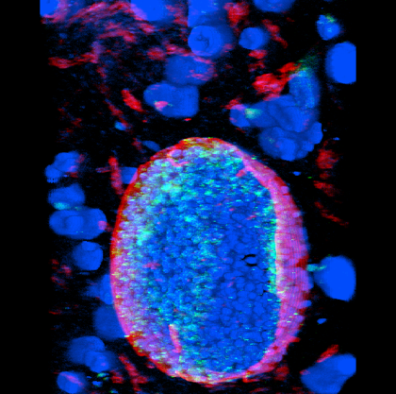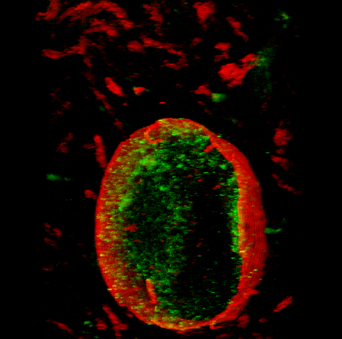
Figure 1. Tissue cyst of T. gondii stained for dopamine. Brains section from chronically-infected mouse triple-stained for dopamine (green), nuclei (blue), and parasite cyst wall (red). Right field only dopamine and cyst wall illuminated.
Recent Publications
- TEDFORD, E. & MCCONKEY, G.A. (2017) Neurophysiological changes induced by chronic neurological infection Pathogens (Special Issue), 6(2)
- TOTANES, F.I., MCCONKEY, G.A., WESTHEAD, D., SHAMEER, S., & FABIEN JOURDAN, F. (2016) Understanding Protozoan Parasite Metabolism and Identifying Drug Targets through Constraint-based Modelling in Analysis of parasite biology – from metabolism to drug discovery (eds. S. Müller et al)
- WEBSTER, J.P., LAMBERTON P.H.L., & MCCONKEY, G.A. (2016) The Toxoplasma gondii Model of Schizophrenia in the Handbook of Behavioral Neuroscience Series (eds. Pletnikov, Waddington)
- DUBEY, J.P., FERREIRA, L.R., ALSAAD, M., VERMA, S.K., ALVES, D.A., HOLLAND, & MCCONKEY, G.A. (2016) Experimental Toxoplasmosis in Rats Induced Orally with Eleven Strains of Toxoplasma gondii of Seven Genotypes: Tissue Tropism, Tissue Cyst Size, Neural Lesions, Tissue Cyst Rupture without Reactivation, and Ocular Lesions. PLoS ONE 11(5): e0156255.
- MARTIN, H.L., ALSAADY, I., HOWELL, G., PRANDOVSZKY, E., PEERS, C., ROBINSON, P., & MCCONKEY, G.A. (2015) Effect of parasitic infection on dopamine biosynthesis in dopaminergic cells. Neuroscience 306:50-62


Biography
Glenn McConkey is a molecular and cellular biologist that focuses on parasites and host-parasite interactions. He applies genetic and genomic technologies to investigate metabolic pathways of incendiary single-celled parasites and their interaction with host metabolism. This has resulted in delineation of numerous pathways in malaria parasites identifying a plethora of novel antimalarial drug targets, as well as in Toxoplasma gondii. Current interests investigate changes in metabolism of neurotransmitters in the brain during T. gondii infection to understand links with schizophrenia and changes in host behaviour.
Email: G.A.McConkey@leeds.ac.uk

