The Impact of Propofol on the Pain Score and Frequency of Migraine in Patients with Chronic Migraine Headache: An Observational Study
Nima Saeedi MD
Department of Anesthesiology and Critical Care, Shahid Beheshti University of Medical Sciences, Tehran, Iran
Abstract
Propofol is a short-acting intravenous anesthetic that is commonly used for induction and maintenance of anesthesia. Subanesthetic low doses of propofol has also been used to treat intractable migraine attacks in emergency wards with dramatic results. However, there is little information on the long-term efficacy of this drug in migraine headaches. The aim of this nonrandomized prospective observational study was to assess the effect of propofol anesthesia on the pain severity and frequency of migraine attacks in a 6-month follow-up period after anesthesia in patients with migraine headaches. The study was conducted on 51 known cases of migraine ranging in age from 21 to 66 years. Before anesthesia, patients completed a questionnaire including their characteristics, pain intensity of the headache using a visual analog scale, and a number of headache repetitions per month. All patients received propofol as the main anesthetic agent. At the end of anesthesia, the total amount of propofol usage was recorded. Patients were then followed up by telephone in the first, third, and sixth months after anesthesia, and the severity and frequency of the headache were recorded. Pain intensity or pain frequency significantly improved in 22 patients (43.1%), remained unchanged in 24 (47%), and worsened in 5 cases (9.8%) 6 months after anesthesia compared to before the anesthesia. In conclusion, since about half of the patients had significant improvement in the headache, propofol anesthesia may be considered as an acceptable anesthetic method in patients with migraine.
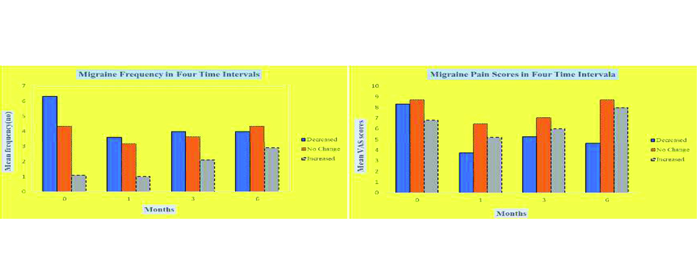
Figure_1: The Effect of Propofol Anesthesia on the Pain Severity and Frequency of Migraine

Recent Publications:
- Krusz JC, Scott V, Belanger J. Intravenous propofol: unique effectiveness in treating intractable migraine. Headache: The Journal of Head and Face Pain. 2000 Mar 27;40(3):224-30.
- Orr SL, Aube M, Becker WJ, Davenport WJ, Dilli E, Dodick D, Giammarco R, Gladstone J, Leroux E, Pim H, Dickinson G. Canadian Headache Society systematic review and recommendations on the treatment of migraine pain in emergency settings. Cephalalgia. 2015 Mar;35(3):271-84.
- Kelly AM. Propofol for migraine: Just because we can, should we?. EMA-Emergency Medicine Australasia. 2020 Aug 1;32(4):540-1.
- Piatka C, Beckett RD. Propofol for treatment of acute migraine in the emergency department: a systematic review. Academic Emergency Medicine. 2020 Feb;27(2):148-60.
- Sheridan DC, Spiro DM, Nguyen T, Koch TK, Meckler GD. Low-dose propofol for the abortive treatment of pediatric migraine in the emergency department. Pediatric emergency care. 2012 Dec 1;28(12):1293-6.
- Giampetro D, Ruiz-Velasco V, Pruett A, Wicklund M, Knipe R. The effect of propofol on chronic headaches in patients undergoing endoscopy. Pain Research and Management. 2018 Jan 21;2018.
- Mendes PM, Silberstein SD, Young WB, Rozen TD, Paolone MF. Intravenous propofol in the treatment of refractory headache. Headache: The Journal of Head and Face Pain. 2002 Jul;42(7):638-41.


Name: Nima Saeedi
Shahid Beheshti University of Medical Science, Tehran, IRAN

Biography

Nima has completed his Medical Doctor degree at the age of 25 years from Najaf Abad University and Specialty in Anesthesiology studies from Shahid Beheshti University of Medical Science. He has published more than 9 papers in reputed journals and has been serving as an Anesthesiology Research Center of Shahid Beheshti University of Medical Sciences member. During his studies, he has been honored as a top assistant.
Presenting author details
Full name: Nima Saeedi
Contact number: 00989122128799
Twitter account: Nima_Saeedi_MD
Linked In account: linkedin.com/in/nima-saeedi-082ab792
Session name/ number: 6th International Anesthesia and Pain Medicine Conference
Category: Poster presentation

