Impact of Ultrasound-Guided Femoral Nerve Block on Ease of Positioning for Spinal Anesthesia in Patients with Femoral Fracture
Nima Saeedi MD, Houman Teymourian MD
Department of Anesthesiology and Critical Care, Shahid Beheshti University of Medical Sciences, Tehran, Iran

Abstract
Background: Spinal anesthesia is commonly used for orthopedic surgeries. The most important issue to improve outcome is patient cooperation to have a proper position for reducing pain during spinal anesthesia procedure. However, any change in position is painful which leads to sympathetic activation, tachycardia and hypertension, which may put patients with ischemic heart disease at risk. Peripheral nerve block is a safe and reliable alternative to systemic analgesia. Using the ultrasound-guided method reduces local anesthetics’ amount and side effects.
Methods: In this study, 53 patients who came to the operating room with femoral fracture as candidates for spinal anesthesia were enrolled and received ultrasound-guided Femoral Nerve Block (FNB) (10 ml Lidocaine 1.5%). Before and after receiving the nerve block, the patients were asked about the severity of their pain using the Numerical Rating Scale (NRS). Both groups of patients and physicians were asked about their satisfaction according to a 5-point Likert scale.
Results: Mean pain intensity in the NRS score at the time of admission to the operating room was 7.6±0.8, which was reduced to 1.8±1.5 after blockade. In this study, 39 (73.5%) patients were very satisfied (Likert scale 5), 10 (18.8%) were satisfied (Likert scale 4), 2 (3.7%) had no opinion (Likert scale 3), 2 (3.7%) were not satisfied (Likert scale 2), and no one was very dissatisfied (Likert scale 1). There was significant difference in physician’s satisfaction.
Conclusion: Ultrasound-guided nerve block is a safe and effective method to be used for positioning during spinal anesthesia procedure.

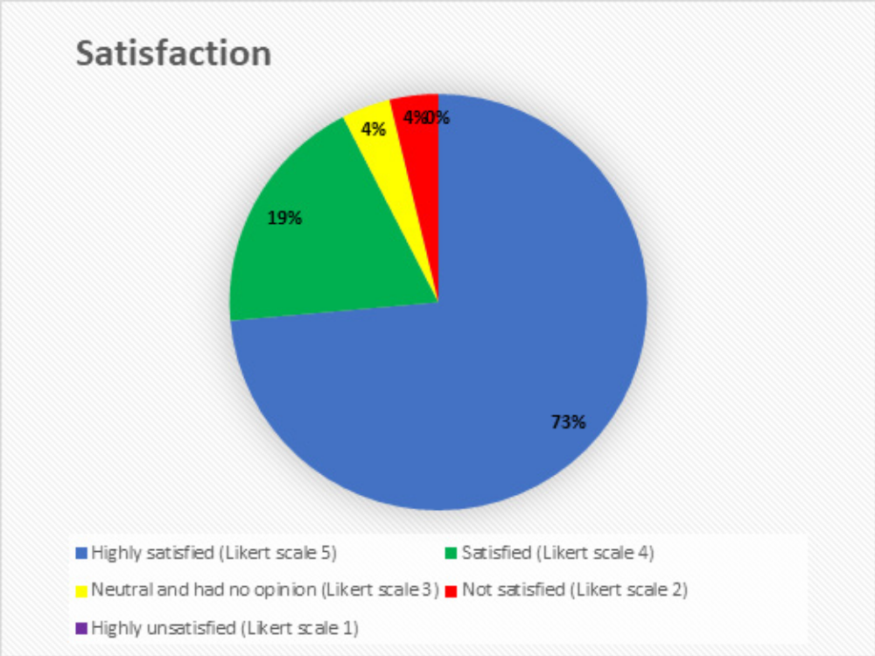
Figure 1. Patient satisfaction

Recent Publications:
- Jakobsson J, Johnson MZ. Perioperative regional anaesthesia and postoperative longer-term outcomes. F1000Research. 2016;5.
- Diakomi M, Papaioannou M, Mela A, Kouskouni E, Makris A. Preoperative fascia iliaca compartment block for positioning patients with hip fractures for central nervous blockade: a randomized trial. Regional Anesthesia & Pain Medicine. 2014 Sep 1;39(5):394-8.
- Jadon A, Kedia SK, Dixit S, Chakraborty S. Comparative evaluation of femoral nerve block and intravenous fentanyl for positioning during spinal anaesthesia in surgery of femur fracture. Indian J Anaesth 2014;58(6):705-8.
- Bantie M, Mola S, Girma T, Aweke Z, Neme D, Zemedkun A. Comparing analgesic effect of intravenous fentanyl, femoral nerve block and fascia iliaca block during spinal anesthesia positioning in elective adult patients undergoing femoral fracture surgery: a randomized controlled trial. Journal of Pain Research. 2020;13:3139.
- Kacha NJ, Jadeja CA, Patel PJ, Chaudhari HB, Jivani JR, Pithadia VS. Comparative study for evaluating efficacy of fascia iliaca compartment block for alleviating pain of positioning for spinal anesthesia in patients with hip and proximal femur fractures. Indian J Orthop 2018;52(2):147-53.


Name: Nima Saeedi
Shahid Beheshti University of Medical Science , Tehran, IRAN

Biography

Nima has completed his Medical Doctor degree at the age of 25 years from Najaf Abad University and Specialty in Anesthesiology studies from Shahid Beheshti University of Medical Science. He has published more than 9 papers in reputed journals and has been serving as an Anesthesiology Research Center of Shahid Beheshti University of Medical Sciences member. During his studies, he has been honored as a top assistant.
Presenting author details
Full name: Nima Saeedi
Contact number: 00989122128799
Twitter account: Nima_Saeedi_MD
Linked In account: linkedin.com/in/nima-saeedi-082ab792
Session name/ number: 6th International Anesthesia and Pain Medicine Conference
Category: Poster presentation

