The complete Breast Block, an approach to prevent the postmastectomy chronic pain progression.

Juan Bernardo Schuitemaker R. MD. Hospital Universitari General de Catalunya. Hypnos S.L.P. Tintoré & Brasó Cirujanos Plásticos
Xavier Sala-Blanch.MD. Hospital Clinic i Provincial Barcelona. UB Departamento de Anatomía.
Arturo Sánchez Cohen. RN. Inovaciones Tecnológicas en Medicina (INTEM).
Ana Teresa Imbiscuso Esqueda. Parc Hospitalari Martí i Juliá. Hospital Santa Caterina.

Abstract
Statement of the Problem:

The breast cancer is the most common cancer suffered by woman in the United States, the lifetime risk of developing breast cancer is about 12% for the average woman, that means 1 in 8 women in the United States will develop it. An estimated 253,000 women in the United States will be diagnosed with invasive breast cancer in 2017, and another 63,000 with in situ breast cancer. According to a recent epidemiologic study, higher breast cancer rates were expected between 2009 and 2015. Acute postoperative pain is an integral risk factor in the development of chronic postmastectomy pain; 40% of women will have severe acute postoperative pain after breast cancer surgery, whereas 50%will develop chronic postmastectomy pain with impaired quality of life.

For the cohort of women receiving breast cancer surgery (BCS), accumulating evidence suggests a substantial prevalence of chronic postsurgical pain estimated to range between 29 and 57%. Similarly, available studies suggest that from one-fourth to one-half of women who undergo post-mastectomy breast reconstruction surgery report chronic postsurgical pain. Based in this we proposed in 2015 a new approach of complete breast block for breast surgeries, based in the complex breast innervation, so we perform a modified PECSII, B.R.I.L.M.A., B.R.C.A. plus a subcutaneous infiltration in the inferior edge of the clavicle for block de cutaneous branches of the superficial cervical plexus (Fig 1).

With this approach we have performed more than 500 breast surgeries, using it as a part of a multimodal approach, general anesthesia with LMA, remifentanyl for the air way management, with an excellent hemodynamic stability and pain free postoperative period.

We believe that using this approach the patients must have a pain free intraoperative and postoperative period and will fall the progression to chronic pain. Future studies needed to validate this observations.

Image

One in 8 women in the United States will
develop breast cancer in her lifetime
One in 8 women in the United States will
develop breast cancer in her lifetime
One in 8 women in the United States will
develop breast cancer in her lifetime
One in 8 women in the United States will
develop breast cancer in her lifetime
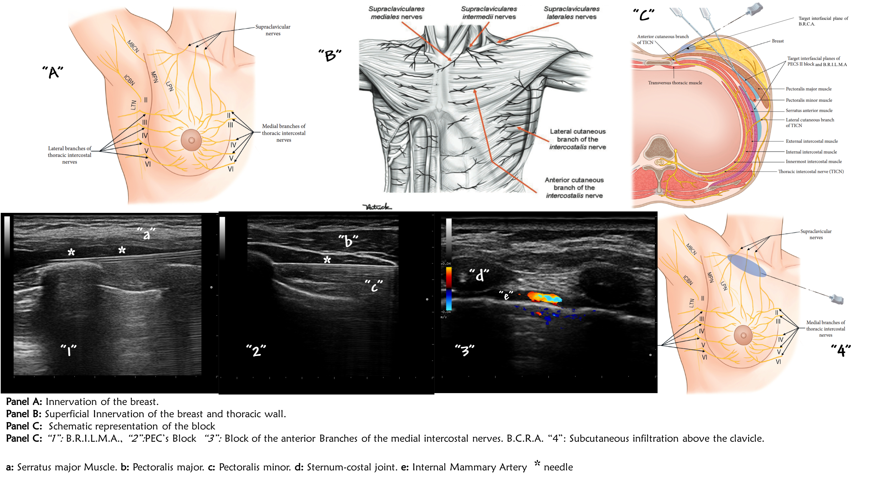


Biography
Juan Bernardo Schuitemaker is a passionate anesthesiologist with special interest in regional anesthesia. Have experience also in obstetric anesthesia. Mostly work with interfascial blocks, with special interest in chest blocks. Xavier Sala – Blanch is a worldwide known regional anesthesiologist, speaker in the most important conferences always in regional anesthesia, professor of anatomy in the medicine School in the Universitat de Barcelona. Arturo Sánchez – Cohen is a nurse specialist in interventional hemodynamics and pain medicine with great interest in clinical investigations. Ana Teresa Imbiscuso Esqueda, it’s an Anesthesiologist pain medicine physician also Intensive care unit trainee.
Email: juanbernardosr@iCloud.com

Recent Publications

Parker CC. Management of Breast Cancer. Surg Clin North Am. 2018 Aug; 98(4): XVII – XVIII.
Desantis C, Ma J, Bryan L, Jemal A. Breast cancer statistics, 2013. CA Cancer J Clin. 2014; 64: 52 – 62.
Sbitany H. Breast Reconstruction. Surg Clin North Am. 2018 Aug; 98(4): 845 – 57.
Hirko KA, Soliman AS, Hablas A, et al. Trends in breast cancer incidence rates by age and sage at diagnosis in Gharbiah, Egypt, over 10 years (1999-2008). J Cancer Epidemiol. 2013; 2013: 916394.
Poleshuck EL, Katz J, Andrus CH, Hogan LA, Jung BF, Kulick DI, Dworkin RH. Risk factors for chronic pain following breast cancer surgery: a prospective study. J Pain. 2006; 7: 626 – 34.
Roth RS. Chronic postsurgical pain following breast reconstruction: a commentary and critique. Breast Cancer Res Treat. 2018 Jun; 169(2): 209 – 16.
Schuitemaker Requena JB, Mayoral Ripamonti JT, Sala-Blanch X, Muñoz Pérez SL.,López Pantaleon LA, Tintore Caicedo X, Brasó Vicen C, Colomer Castro M, Hidalgo García M, Sánchez Cohen AP. Complete breast block. A new approach for breast surgery. Reg Anesth Pain Med. 2015 Sept – Oct; Supp1 40(5): e122.
Schuitemaker Requena JB, Mayoral Ripamonti JT, Sala Blanch X, Muñoz SL, Imbiscuso Esqueda AT, Pesa Vendrell N, Arteaga Mejía D, Brasó Vicen C, Tintoré Caicedo X, Sanchez Cohen AP. In Plane Lateral Approach of the Pectoral Nerves. A PEC II Modification. Reg Anesth Pain Med. 2015 Sept – Oct; Supp1 40(5): e123.
Diéguez García P, Fajardo Pérez M, López Álvarez S, Alfaro de la Torre P, Pensado Castineiras P. Abordaje guiado por ultrasonidos de los nervios intercostales en la línea medio axilar para cirugía de mama no reconstructiva y de la axila. Rev Esp Anestesiol Reanim. 2013; 60: 365 – 70.
Fajardo Pérez M, García Miguel FJ, López Álvarez S, Dieguez García P, Alfaro de la Torre P. Bloqueo de las ramas cutáneas laterales y anteriores de los nervios intercostales para analgesia de mama. Cir May Amb 2012. 17 (3): 95 – 104.

