The Integrative Model of Adjustment to Chronic Conditions; towards clinical testing and impact in chronic pain
Dr Lis D. Hammond, Counselling Psychologists and Senior Lecturer, Teesside University, United Kingdom

Abstract
Statement of the Problem: A range of psychosocial factors impact on chronic pain and function and poor adjustment has negative consequences for e.g. mental health, activities of daily living and quality of life. Around a third of people attending specialist clinics need clinical intervention for adjustment difficulties. Hammond & Hirst-Winthrop proposed an integrative model of adjustment to chronic conditions (IMACC) based on a Grounded Theory study into type 2 diabetes. The model is directly clinically applicable as an assessment and intervention tool for people struggling to adjust. This paper reports on preparations for clinical testing in chronic pain. Methodology & Theoretical Orientation: In order to evidence applicability to chronic pain, a theoretical review aimed to link key theories and standard interventions to the IMACC. This was followed by identification of a testing design and development of assessment, treatment and test study protocols. Findings: All components of the IMACC could be linked to one or more key theories in chronic pain. Furthermore, the IMACC showed compatibility with a range of multidisciplinary interventions in standard practice. A multiple baseline single case experimental study design was identified as an appropriate first level testing of the IMACC and behavioural outcome measures were identified. Conclusion & Significance: The theoretical evidence points towards application of the IMACC to chronic pain, which warrants clinical testing of the model. The chosen study design aims to demonstrate clinical effectiveness of the IMACC before progressing to comparative studies.

Recent Publications
- Hammond L D & Hirst-Winthrop S (2016) Proposal of an integrative model of adjustment to chronic conditions: An understanding of the process of psychosocial adjustment to living with type 2 diabetes. Journal of Health Psychology doi: 10.1177/ 1359105316664131.
- Dekker J & de Groot V (2018) Psychological adjustment to chronic disease and rehabilitation – an exploration. Disability and Rehabilitation 40:116.
- Tan G, Teo I, Anderson K, & Jensen M (2011) Adaptive Versus Maladaptive Coping and Beliefs and Their Relation to Chronic Pain Adjustment. Clinical Journal of Pain 27: 769.
- Morley S (2008) Psychology of Pain. British Journal of Anaesthesia 10:25.
- Moss-Morris R (2013) Adjusting to chronic illness: Time for a unified theory. British Journal of Health Psychology 18:681.

Image
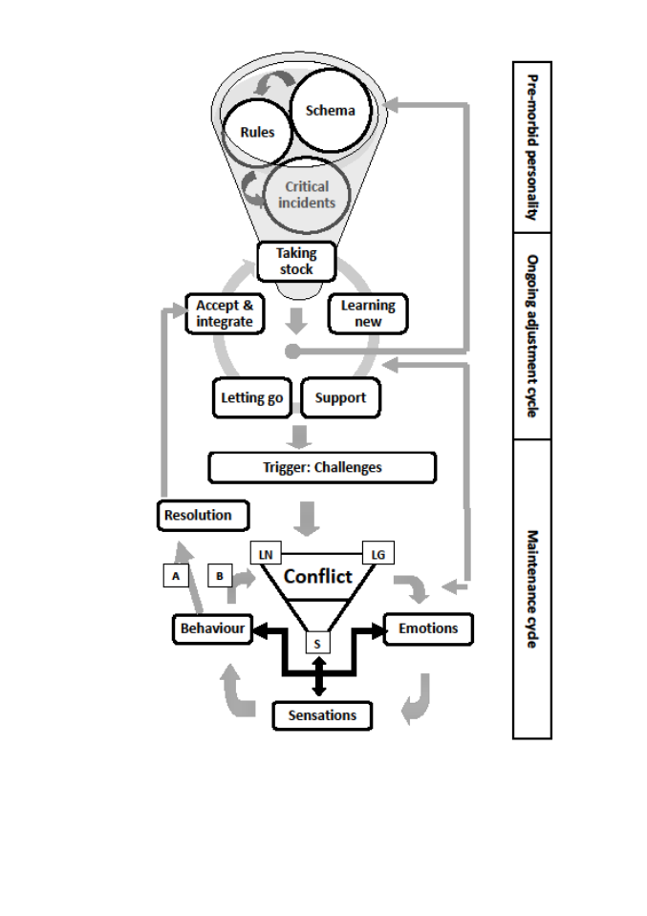

Figure: The Integrative model of adjustment to chronic conditions (IMACC)

Notes/Comments:
The integrative model of adjustment to chronic conditions (IMACC) has been theoretically verified for applicability to diabetes, chronic pain and epilepsy. The IMACC was implemented in a pain service in North East England. Several of the multidisciplinary professionals incorporated the model into their standard practice as well as including a session on the model in the pain management programme. This work now forms the basis for an impact case study on improving function and wellbeing for people with chronic conditions.

 Biography
Dr Lis Hammond is a Counselling Psychologist specialising in psychosocial adjustment to chronic conditions. She gained years of clinical experience in brain injury rehabilitation and pain management before going into academia with the aim of focusing on adjustment research. She is currently the appointed representative of the British Psychological Society on the NHS England Clinical Reference Board for Specialised Pain.

Email: Lis.Hammond@tees.ac.uk

