Peer volunteerism: does it help in managing pain?
Mimi MY Tse, RN, Phd, Hong Kong

Abstract (300 word limit)
Chronic non-cancer pain is common among older adults and is often associated with significant physical and psychosocial incapacities. Older adults with pain are more depressed, anxious, and have reduced social interaction. Pain in older adults tends to be constant in nature, moderate to severe in intensity, and years long in duration. Prevalence of pain among nursing home residents is as high as 70%-80%. Nursing home residents are physically frail, live in “closed” nursing home environments, and may have difficulty seeking pain management strategies.

Aim: to recruit and train peer volunteers (PVs) to lead pain management program targeting the older adults living in nursing homes

Design: A pre-post experimental study

Method: A total of 45 peer volunteers were recruited from the Institute of Active Ageing, hosted by the Faculty of Health and Social Sciences of The Hong Kong Polytechnic University in the past few years. They completed the pain management training and visited older adults living in nursing homes that suffered from chronic pain. The pain management education program included physical exercises, interactive teaching and sharing of pain management using non-pharmacological strategies.

Results: The pain management program helped the nursing home residents to learn ways to soothe the pain, reduce the pain intensity, enhance activity of daily living, and increase happiness. Peer volunteers showed a significant increase in self-rated pain management knowledge.

Conclusion: Findings of this study indicate that education on pain self-management is essential. Due to the limited health care resources and budgets, training of laypersons provides an opportunity for them to transfer pain self-management knowledge to nursing home residents.

Image
Peer volunteers leading exercise for elderly
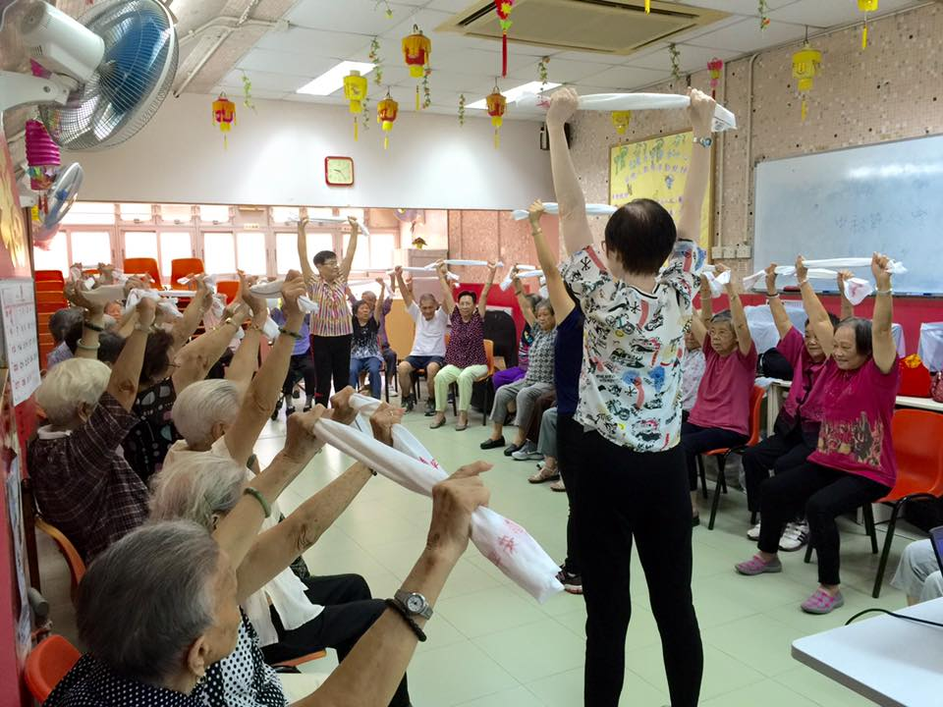

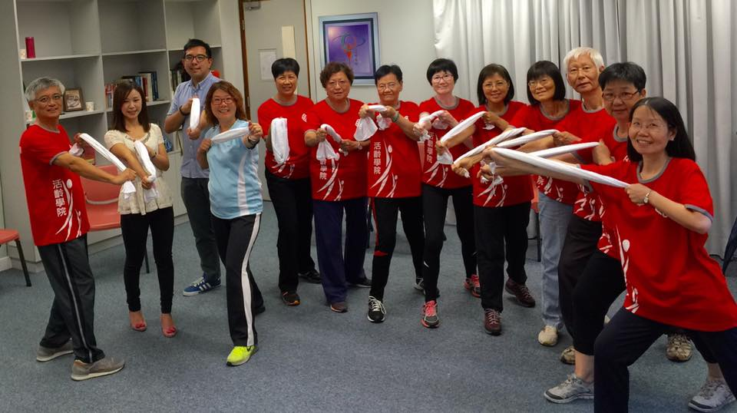
Recent Publications (minimum 5)
- Tse, M. Y. M., Kwan, R. Y. C., & Lau, J. L. (2018). Ageing in people with intellectual disability: Issues and concern in Hong Kong. Hong Kong Medical Journal, 24(1), 68-72. DOI: 10.12809/hkmj166302
- Tse, M. Y. M., Ng, S. S. M., Tang, S. K., Budnick, A., & Yeung, S. (2017). Pain & Pain Management among University Students: Online Survey & Web-Based Education. Cyberpsychology, Behavior, and Social Networking, 20(5), 305-313.
- Tse, M. Y. M., Ng, S. M., Lee, P. H., Lai. C., Kwong, E., Yuen, J., Bai, X., & Yeung, S. S. Y. (2016). Play activities program to relieve chronic pain and enhance the functional mobility and psychological well-being for frail older adults: a pilot cluster randomized controlled trial. Journal of the American Geriatrics Society, 60(10), e86-e88.
- Tse, M.Y.M., Lee, P. H., Ng, S. M., & Yeung, S. S. Y. (2016). Effects of a peer-led pain management program for nursing home residents with chronic pain: A pilot study. Pain Medicine. DOI: http://dx.doi.org/10.1093/pm/pnv121
- Tse, M.Y.M., Tang, S.K., Wan, V.T.C., & Vong, S.K.S. (2014). The effectiveness of physical exercise training in pain, mobility and psychological well-being of older persons living in nursing home. Pain Management Nursing, 15 (4), 778-788.

 Biography (150 word limit)
Dr. Mimi Tse is an Assistant Professor in the School of Nursing at The Hong Kong Polytechnic University. She is a Fellow in the Hong Kong Academy of Nursing the specialty of education, reviewer of international peer-reviewed journals. Mimi serves as co-opted council member in Hong Kong Association of Gerontology. Her program of research focuses on the care of frail older adults, people with pain situations, nutrition and lifestyle as well as online learning. She is eager to promote pain management employing non-pharmacological strategies. Mimi provides health education and pain management education to profession and to public.
Email: mimi.tse@polyu.edu.hk

Notes/Comments:

