Pain Management Clinic: non-pharmacological strategies in helping those with chronic pain
Mimi MY Tse, RN, Phd, Hong Kong

Abstract (300 word limit)

Pain, regardless of its level, can have a negative impact on the physical well-being, emotions, and even quality of life of the individuals. Using painkillers is one method to relieve pain, yet, painkillers always have undesirable side effects. The Pain Management Clinic established in 2017, under The Hong Kong Polytechnic University. The clinic aims to provide pain management services to individuals with pain and associated physical and psychological problems involving multidisciplinary practitioners of nursing academics and traditional Chinese medicine doctors.

The Pain Management Clinic adopts non-drug approaches to managing pain, such as music therapy, multisensory stimulation, aromatic foot reflexology, and traditional Chinese medicine, which cater to the needs and health problems of different people.

In this presentation, two cases will be shared:

Case 1, Ms A, suffered from fracture spine because of traumatic accident happened in 2011. She was then paraplegic and wheel-chaired bound. Ms A is living with her daughter and her husband, and two servants employed to take care of her. She also had history of diabetic mellitus, hypertension and high cholesterol, on regular medications and follow up.

Case 2, Mr. B, aged 65, suffered from right forearm pain for 2 months. Mr. B is a retired account and living with his wife and his two adults children in sub-urban area. His past health is good and no any history of chronic illness.

Mimi will share the treatment strategies for Ms A and Mr. B including physical and psychosocial support to them and their family members using multi-disciplinary approach.

Image

Photos of Ms A: performing home-based exercsie after attending the Pain management clinic

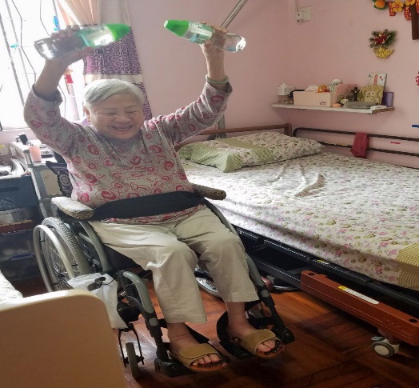

Recent Publications (minimum 5)
- Tse, M. Y. M., Kwan, R. Y. C., & Lau, J. L. (2018). Ageing in people with intellectual disability: Issues and concern in Hong Kong. Hong Kong Medical Journal, 24(1), 68-72. DOI: 10.12809/hkmj166302
- Tse, M. Y. M., Ng, S. S. M., Tang, S. K., Budnick, A., & Yeung, S. (2017). Pain & Pain Management among University Students: Online Survey & Web-Based Education. Cyberpsychology, Behavior, and Social Networking, 20(5), 305-313.
- Tse, M. Y. M., Ng, S. M., Lee, P. H., Lai. C., Kwong, E., Yuen, J., Bai, X., & Yeung, S. S. Y. (2016). Play activities program to relieve chronic pain and enhance the functional mobility and psychological well-being for frail older adults: a pilot cluster randomized controlled trial. Journal of the American Geriatrics Society, 60(10), e86-e88.
- Tse, M.Y.M., Lee, P. H., Ng, S. M., & Yeung, S. S. Y. (2016). Effects of a peer-led pain management program for nursing home residents with chronic pain: A pilot study. Pain Medicine. DOI: http://dx.doi.org/10.1093/pm/pnv121
- Tse, M.Y.M., Tang, S.K., Wan, V.T.C., & Vong, S.K.S. (2014). The effectiveness of physical exercise training in pain, mobility and psychological well-being of older persons living in nursing home. Pain Management Nursing, 15 (4), 778-788.

 Biography (150 word limit)
Mimi Tse has her expertise in pain management and improving the health and wellbeing, for older people in particular. She is a Fellow in Hong Kong Academy of Nursing in the specialty of education and research and a reviewer of international peer-reviewed journals. She has numerous publications in the field of elderly care, pain management, nutrition and health. Mimi is frequently invited by professional bodies to delivery talk regarding pain management and elderly care.
Email: mimi.tse@polyu.edu.hk

Notes/Comments:

