Paraneuraxial nerve blocks: Can they replace neuraxial nerve blocks?
Jeff L. Xu, MD, Westchester Medical Center/New York Medical College, New York, USA

Abstract

Over the past 10 years, the introduction of ultrasound has rapidly changed the practice of regional anesthesia including the greater use of truncal nerve blocks. In the truncal block family, some of the blocks are performed just outside of neuraxial region, such as paravertebral nerve block (PVB) and lumbar plexus block, in addition to Thoracolumbar Interfascial Plane (TLIP),¹ retrolaminar block (RLB), erector spinae plane (ESP) block, and cervical columnar interfascial plane (CLIP) block, which are new techniques. These techniques are comparable to neuraxial nerve blocks in terms of success rate and analgesic efficacy and may confer many of advantages over neuraxial nerve blocks.²Specifically, neuraxial blocks are not site-specific, they cause hypotension, and some of them may lead urinary retention, the placement of Foley catheters, limited mobility.²⁻³ Furthermore, neuraxial nerve block, such as epidural, was limited on patient who has spine fracture, spine instability, spine surgery or sepsis. Instead, paravertebral nerve block, most recently, has been performed more often clinically. In addition, most of the truncal techniques can be performed in fully anesthetized patients, pronounced hypotension is unusual as sympathetic blocks are rarely bilateral, and urinary retention does not occur.

We have proposed the use of the new terminology “Paraneuraxial Nerve Block (ParaNXB)”.⁴ This new term provides a direct pictorial anatomy of the nerve block and would help clinicians develop clinical insights. This terms has never been well-defined either anatomically or clinically.⁵⁻⁷

Anatomically, the paraneuraxial nerve is the spinal nerve between the lateral margin of the spinal foramen and the lateral edge of the erector spinae muscle. It contains the roots of the spinal nerve and its dorsal and ventral branches and their plexuses, white and gray rami communicantes, the sympathetic ganglion, and the sympathetic chain. The ParaNXB family may include (but is not necessarily limited to) the PVB and the lumbar plexus nerve block, as well as ESP, RLB, TLIP block, CLIP block, sympathetic chain block.

We believe that ParaNXB will become even more popular clinically, due to its clinical and anatomical characteristics. It is thus clinically significant and beneficial in the practice, teaching, and training aspects of regional anesthesia. Study has shown that since 1990, wherein the relative percentage of spinal and epidural techniques has declined, and peripheral nerve blocks have increased.⁸ ParaNXBs will challenge the clinical role of the traditional neuraxial nerve blocks fundamentally.
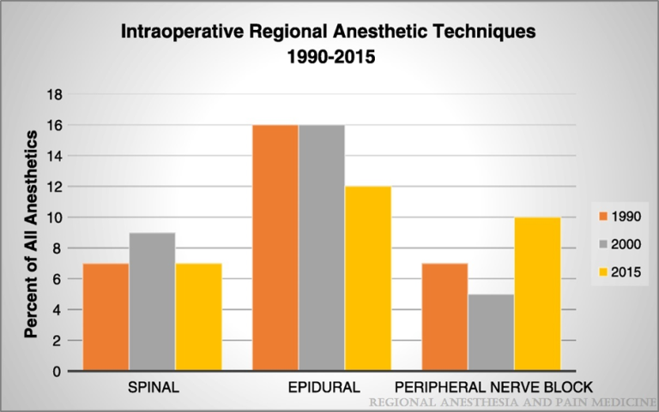
Neal,et al, Regional Anesthesia and Pain Medicine42(4):437-441, July/August 2017
Reference
1. Hironobu Ueshima, Hiroshi Otake. Clinical Experiences of the Continuous Thoracolumbar Interfascial Plane (TLIP) Block. Journal of Clinical Anesthesia 2016; 34, 555–556
2. Davies RG, Myles PS, Graham JM. A comparison of the analgesic efficacy and side-effects of paravertebral vs epidural blockade for thoracotomy—a systematic review and meta-analysis of randomized trials. Br J Anaesth 2006;96:418–26.
3. Powell ES, Cook D, Pearce AC, et al. A prospective, multicentre, observational cohort study of analgesia and outcome after pneumonectomy. Br J Anaesth 2011;106:364–70.
4. Jeff L. Xu. Paraneuraxial Nerve Blocks: A well-defined novel terminology that is clinically essential for regional anesthesia. J Clin Anesth. 2017 Sep 13;43:14
5. Alan David Kaye，Richard D. Urman，Nalini. Essentials of Regional Anesthesia. New York, NY: Springer Science+Business Media, LLC, 2012. Page 585
6. David L. Brown. Atlas of Regional Anesthesia.4th ed. Philadelphia, PA: Sunders, 2010. Page 254
7. Andrea Toufexis Esch, Andrew Esch, John L. Knorr, Andre P. Boezaart. Long-Term Ambulatory Continuous Nerve Blocks for Terminally Ill Patients: A Case Series. Pain Medicine 2010; 11:1299–1302
8. Joseph M. Neal, Anne Gravel Sullivan, Richard W. Rosenquist, Dan J. Kopacz. Regional Anesthesia and Pain Medicine US Anesthesiology Resident Training—The Year 2015. Regional Anesthesia and Pain Medicine, 2017; 42:437-441


Jeff L. Xu, MD, chief of Regional Anesthesia & Acute Pain Management, Program Director of Regional Anesthesia & Acute Pain Medicine Fellowship. As the founder of the Regional Anesthesia & Acute Pain Services at Westchester Medical Center, he initiated and developed the regional anesthesia program for the anesthesia residents. He also is the founder of the fellowship program for Regional Anesthesiology & Acute Pain Medicine at Westchester Medical Center/New York medical College, New York, USA, and served as fellowship program director. He also served as principal investigator on multiple clinical studies, speaker for regional anesthesia workshops, and reviewer for peer review journals.
Email: jeff.xu@wmchealth.org

