Opioid Free Goldilocks Anesthesia… Stopping Pain Before It Begins

Prior to the ability to directly measure cortical anesthesia response, anesthesiologists depended on the absence of heart rate (HR) and/or blood pressure (BP) response to determine the adequacy of anesthesia for skin incision.

HR & BP are reflections of brain stem response and highly unreliable guides to cortical response. The advent of direct cortical response monitors like the bispectral (BIS) index and Entropy made it possible to provide guides to cortical response for skin incision as well as during the surgical procedure.

The original factory default setting of the BIS monitor was without a real-time signal, leaving the anesthesiologist in the unfavorable position of catching up to patient needs.

All free-standing BIS monitors have the software enabling the display of the electromyogram (EMG) of the frontalis muscle as a secondary trend, forewarning the anesthesiologist of incipient arousal ahead of the need for additional hypnosis sufficient enough to bring the EMG spike back to the baseline.

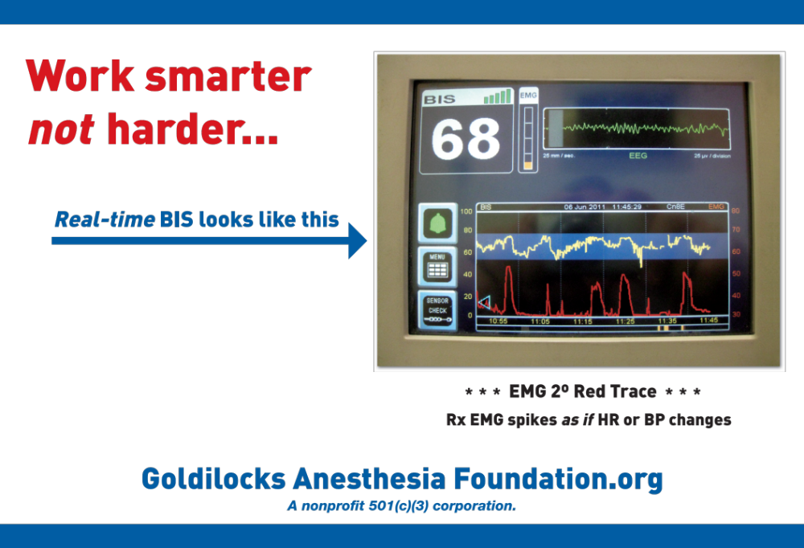

Absence of EMG spike with skin incision, trocar puncture or multiple local anesthetic injections is evidence of saturation of midbrain NMDA receptors. This saturation can be obtained with 50 mg IV ketamine 2-5 minutes ahead of skin stimulation. Ketamine side effects are avoided by creating a stable CNS propofol level via incremental, not bolus, induction.

Proof of concept? Over 25 years for >6,000 painful outpatient surgeries, no hospital admissions for either pain management of postoperative nausea and vomiting (PONV).

