Pilot Evaluation of Scrambler Therapy for the Treatment of Chronic Neuropathic Pain.

Moon Ju Ko, MD, Department of Physical and Rehabilitation Medicine, Daegu Hospital, Korea Worker’s Compensation & Welfare Service, Republic of Korea
Je Sung Rhu, PT, Department of Physical and Rehabilitation Medicine, Daegu Hospital, Korea Worker’s Compensation & Welfare Service, Republic of Korea
Young Bum Kim, MD, Department of Physical and Rehabilitation Medicine, Daegu Hospital, Korea Worker’s Compensation & Welfare Service, Republic of Korea

Objectives: Neuropathic pain is common after neural injury but often difficult to effectively treat. Scrambler therapy, a novel therapeutic modality which treats pain via noninvasive cutaneous electric stimulation by providing ‘‘non-pain’’ information. This study performed to investigate the effect of Scrambler therapy for the treatment of chronic neuropathic pain.
Methods: Eligible patients had neuropathic pain symptoms of ≥3 month duration with pain rated as 4 or more on a visual analogue scale (VAS) during the prior week. Patients were treated with Scrambler therapy to the affected area(s) for up to ten daily 30-min sessions. Symptoms were monitored using a VAS ranging from 0 to 10, before and after each treatment session. Primary outcome measure was change in VAS scores at one week; secondary outcome measure was change in VAS scores at two weeks.
Results: Six patients were enrolled. Four patients were spinal cord injury, 1 patient was intracerebral hemorrhage and 1 patient was brachial plexus injury. Treatment session 1 to 6, the difference in VAS between before and after therapy was significant (p<0.05, paired t test), but treatment session 7 to 10, the difference in VAS between before and after therapy was not significant (p>0.05, paired t test). At one week, the mean VAS score was reduced from 6.0 to 4.1 (32%) (p=0.037, paired t test). At two weeks, the mean VAS score was reduced from 6.0 to 4.8 (20%) but not significant (p=0.058, paired t test). No undesirable side effects were observed during this study.
Conclusion: Preliminary data support that Scrambler therapy may be reduce chronic neuropathic pain immediately during short-term (about 1 week), but did not reduce pain immediately after 1 week of therapy. Pain reduction effect of Scrambler therapy did not persist beyond 1 or 2 weeks. Further randomized sham controlled research is warranted.

Image

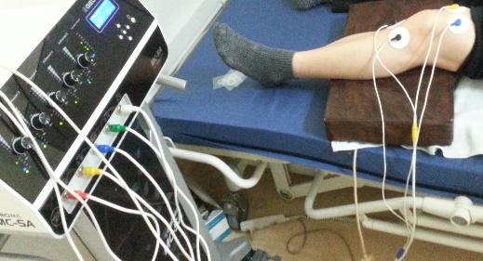
Fig1. Scrambler therapy

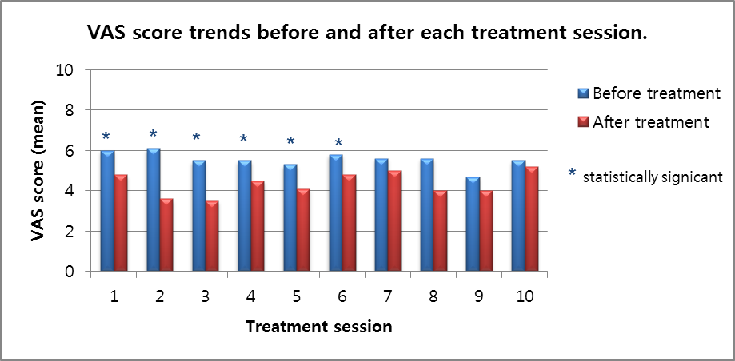
Fig 2. Visual analogue scale(VAS) score trends before and after each treatment session.

Recent publications (minimum 5)
1.Lesenskyj, A., Maxwell, C. & Cruciani, R. (393) Neuropathic pain reduction with scrambler therapy treatment. J Pain 17, S73 (2016).
2.Kim, Y.-N., Lee, D.-K. & Lee, H.-J. Effect of pain scrambler therapy on antineuralgic pain and quality of life after shingles. J Phys Ther Sci 29, 1113–1115 (2017).
3.Lee, D.-K. & Kim, E.-K. Effect of pain scrambler therapy on shoulder joint pain and range of motion in patients who had undergone arthroscopic rotator cuff repair for the first time. J Phys Ther Sci 28, 2175–2177 (2016).
4.Joo, S. Y., Cho, Y. S., Cho, S.-R., Kym, D. & Seo, C. H. Effects of pain Scrambler therapy for management of burn scar pruritus: A pilot study. Burns 43, 514–519 (2017).
5.Erratum: Impact of Scrambler Therapy on Pain Management and Quality of Life in Cancer Patients: A Study of Twenty Cases. Indian J Palliat Care 23, 217 (2017).
6.Majithia, N. et al. Scrambler Therapy for the management of chronic pain. Support Care Cancer 24, 2807–2814 (201



Biography (150 word limit)
Dr. Moon-Ju Ko has been Graduated from Kyoung-sang National Univesity as Medical Doctor, and then have done resident training at a department of Physical and Rehabilitation Medicine of Samsung Medical Center in Korea. Later on he obtained his post-graduation from Sungkyunkwan University School of Medicine, and then started working at Parkside Rehabilitation Center in Pusan, Korea, where he has continued his research. Presently he has been working at the Daegu Hospital of Korea Worker’s Compensation & Welfare Service at the Daegu City.
Email: iluli0104@naver.com

