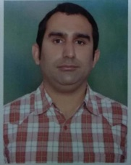

Dynamic MPFL reconstruction with hamstring tendon in traumatic recurrent dislocation

of patella: A retrospective clinical study of 15 cases
Dr Amit Lakhani¹, Dr S M Bhatnagar¹, Dr Ena Sharma
¹Department of Orthopaedic Surgery, Maharishi markandeshwar medical college & hospital , Solan India,

Introduction
Patellar dislocation can occur following a major trauma in a normal knee or minor trauma in a bio-mechanical abnormal knee. Main factor that results in patellar dislocation is injury to medial patellofemoralligament(MPFL)¹. There are various methods of MPFL reconstruction .The graft choice for MPFL reconstruction are synthetic grafts, part of the adductor magnus tendon, semitendinosus, part of the quadriceps tendon, or part of the patellar tendon and allograft² .Many studies in literature now also recommend gracilis tendon as graft option for MPFL reconstruction as its bio-mechanical properties closely resemble to MPFL³ .
Material and methods
In this retrospective study we present clinical result in 15 cases[11 female and 4 male] of traumatic recurrent dislocation of patella, in which reconstruction of the medial patellofemoral ligament was done with autograft (gracilis tendon) that was looped via two transverse holes(with 4.5mm drill) in the patella and it was fixed at the natural site of MPFL footprint on the medial femoral condyle with an screw

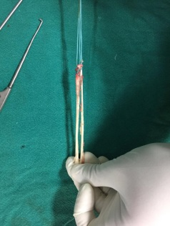

Fig 1: Gracilis graft prepared with Ethibond

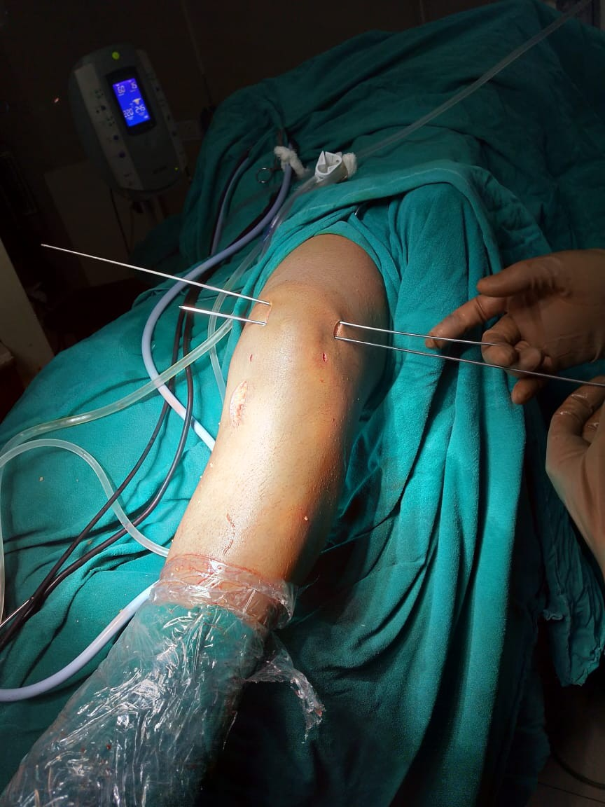

Fig 2: Wire passed through patella
Results & Conclusion
After follow up of one year, there was no episode of recurrent dislocation and range of motion was normal. This method gives a rigid fixation on both side and provides dynamic stability as graft moves in loop. On average Kujala score increased from 40 preoperative to 90 post operative. So in accordance to the results, we strongly recommend this technique for MPFL reconstruction
References
1.Kyung H.-S., Kim H.-J(2015). Medial patellofemoral ligament reconstruction: A comprehensive review. Knee Surg Relat Res.

2.Sandmeier R.H., Burks R.T., Bachus K.N., Billings A.(2000)
The effect of reconstruction of the medial patellofemoral ligament on patellar tracking. Am J Sports Med.

.3.Amis AA, Firer P, Mountney J, Senavongse W, Thomas NP(2003). Anatomy and biomechanics of the medial patellofemoral ligament. Knee.

Dr Amit lakhani ( MS orthopaedics, FAGE ), Professor in MMMCH, Solan having 8 years plus experience of teaching undergraduate and post graduate , has done more than 800 arthoplasties and 1000 arthroscopies with his eminent hardwork and sincerity. Attended various national and international conferences,Workshops. Has been selected for scholarships on international platform by EUROSPINE ( Orthoregeneration) at Finland and ESSKA ( Orthoregeneration of spine ) at Spain. Has been invited many times by GOVT of INDIA on various programme like “Able the Disable “, “Handling geriatric orthopaedics patients”. Main area of interest is Sports Medicine and arthroscopy. Has been in Editorial board panel in various international journals. Though working in rural set of himachal Pradesh his aim is to provide best patient care to the people of himachal and other rural areas with his new and intricate surgical and non surgical techniques.
Presenting Authors Details
Dr Amit Lakhani
Contact number: +91 9882382325
Email id : dramitlakhani@gmail.com

