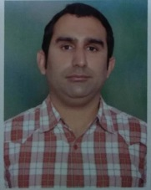
Augmentation compression plating with bone grafting in aseptic non union
shaft femur with nail in situ: a study of 20 cases
Dr Amit Lakhani¹, Dr S M Bhatnagar¹, Dr Ena Sharma
¹Department of Orthopaedic Surgery, Maharishi markandeshwar medical college & hospital , Solan India,

Introduction
Femur fracture is common injury in orthopaedics emergency and closed intramedullary nailing is now standard method of fixation in these cases¹. Non union of shaft femur is also a common complication
Exchange nailing was standard mode of management in such cases.. But due to high failure rate of exchange nailing treatment is shifting towards other procedure Augmentation plating with retained nail is a novelmethod of treatment in these cases²

Material and methods,
We reviewed result of augmentation compression plating with bone grafting in twenty cases of aseptic non union femur with nail in situ. We used compression device to achieve compression at nonunion site. Use of
compression device is not mentioned in English literature to best of our knowledge in these cases.
All cases were operated through lateral approach. After excising Fibrotic tissue, fracture site reduced and fixed with broad LCDCP on nail in situ. Eccentric position of holes in broad LCDCP facilitates insertion of unicortical screw in front and behind nail . Unnatural mobility and sclerotic avascular bony ends were common finding in every case. Compression was achieved through compression device Bone grafting was done in all cases.
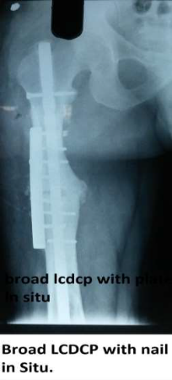

Results
Union was achieved in all cases in mean 7(3-14) months. Radiological criteria of union was healing of 3cortex out of 4.There was no infection in any case. There was breaking of single screw in distal fragmentwhile giving compression at fracture site in 6 cases. Mean follow up was 18 months (range 9 months to 3years).

Conclusion
The combination of plate augmentation and bone grafting while leaving the nail in situ offers the benefits of triple attack on nonunion by extremely rigid fixation, the possibility of early-applied loadbearing force, and precise bone graft implantation. Compression at fracture site achieve primary union. So all these factors helps to achieve union. So weather the union is atrophic or hypertrophic plate augmentation is an effective method of treatment in all long bone fracture with nail in situ.
Reference
1. Vécsei V1, Seitz H, Greitbauer M, Heinz T. [Borderlineindications for.locked intramedullary nailing of femur and tibia]. Orthopade. 1996 Jun;25(3)
2. Galal Zaki Said, Hatem G. Said, and Mohammad M. El- Sharkawi. Failed intramedullary nailing of femur: open reduction and plate augmentation with the nail in situ. Int Orthop. 2011 Jul;35(7)

Dr Amit lakhani ( MS orthopaedics, FAGE ), Professor in MMMCH, Solan having 8 years plus experience of teaching undergraduate and post graduate , has done more than 800 arthoplasties and 1000 arthroscopies with his eminent hardwork and sincerity. Attended various national and international conferences,Workshops. Has been selected for scholarships on international platform by EUROSPINE ( Orthoregeneration) at Finland and ESSKA ( Orthoregeneration of spine ) at Spain. Has been invited many times by GOVT of INDIA on various programme like “Able the Disable “, “Handling geriatric orthopaedics patients”. Main area of interest is Sports Medicine and arthroscopy. Has been in Editorial board panel in various international journals. Though working in rural set of himachal Pradesh his aim is to provide best patient care to the people of himachal and other rural areas with his new and intricate surgical and non surgical techniques.
Presenting Authors Details
Dr Amit Lakhani
Contact number: +91 9882382325
Email id : dramitlakhani@gmail.com
Session name:
Category : oralpresentation

