Modified Internal fixator for anterior pelvic ring fractures versus conventional two-screw fixation
Shenglong Ding, Medical master, Qingpu Branch of Zhongshan Hospital, China
Xiaotian Wu & Zhiyong Ruan, M.D., Qingpu Branch of Zhongshan Hospital, China

Abstract (300 word limit)
Purpose: The present study aims to evaluate the short-term clinical effects and complications of modified three-screw fixation and conventional two-screw fixation for treating anterior pelvic ring fractures. Methods: A retrospective study of 51 patients with type B fractures was performed. 25 patients (modified group) were treated with modified three-screw fixation and the other 26 patients (conventional group) with conventional two-screw fixation. Outcome measures included operation time, intraoperative blood loss, hospital stays, postoperative complications and the Majeed score at postoperatively 2 months, 3 months, 1 year and the time of implant removal. Results: The mean operative times and mean blood loss for modified three-screw fixation versus conventional two-screw fixation bilateral were 54.8±10.7 min versus 32.3±9.9 min, and 153.3 mL versus 550.0 mL(p<0.001), respectively. However, the Majeed score was better in modified group at postoperatively 2 months (75.6±9.5 vs 69.7±8.3, P=0.008) and 3 months (80.3±10.7 vs. 75.1±11.9, P=0.014). No statistical difference between two groups at the time of implant removal (82.1±9.3 vs 80.9±8.8, P=0.272) and postoperatively 1 year (83.5±7.8 vs 82.6±8.2, P=0.723). No patients experienced surgical wound infection, deep vein thrombosis, delayed union or nonunion, implant loosening or rupture. 1 patient complained of tardive unilateral thigh pain at postoperatively 4 months in conventional group. Conclusions: Both modified three-screw fixation and conventional two-screw fixation could ultimately afford satisfactory clinical and radiological outcomes with less complication for anterior pelvic ring fractures. The modified three-screw fixation might have better biomechanical strength and faster pelvic rehabilitation.


Image
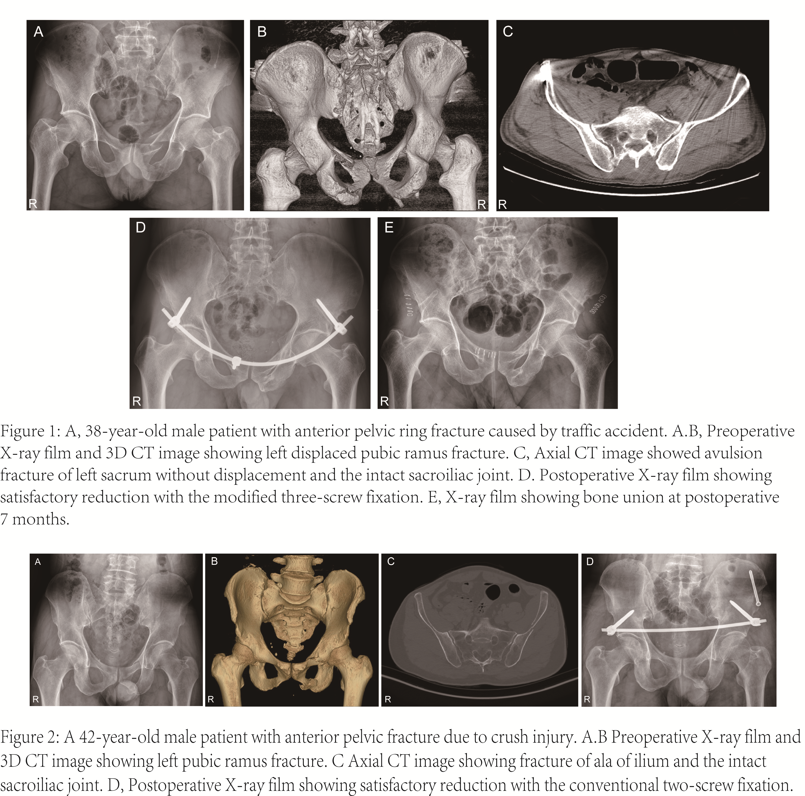
Recent Publications (minimum 5)
- Wu X, Liu Z, Fu W, Zhao S, Feng J. Modified pedicle screw-rod fixation as a minimally invasive treatment for anterior pelvic ring injuries: an initial case series. J Orthop Surg Res. 2017; 12:84.
- Vaidya R, Colen R, Vigdorchik J, Tonnos F, Sethi A. Treatment of unstable pelvic ring injuries with an internal anterior fixator and posterior fixation: initial clinical series. J Orthop Trauma. 2012; 26:1-8.
- Hiesterman TG, Hill BW, Cole PA. Surgical technique: a percutaneous method of subcutaneous fixation for the anterior pelvic ring: the pelvic bridge. Clin Orthop Relat Res. 2012; 470:2116-23.
- Wang Q, Wang Q, Wang J. Treatment of type B pelvic fracture using anterior subcutaneous internal fixator with triple pedicle screws: a new surgical technique. Arch Orthop Trauma Surg. 2017; 137:887-93.
- Reichel LM, MacCormick LM, Dugarte AJ, Rizkala AR, Graves SC, Cole PA. Minimally invasive anterior pelvic internal fixation: an anatomic study comparing pelvic bridge to INFIX. Injury. 2018; 49:309-14.

Biography (150 word limit)
Shenglong Ding, a graduate student in orthopedics at Shanghai Medical College, Fudan University, has his expertise in Intervertebral disc degeneration and biomaterials field. He has published articles entitled “Salt-assisted toughening of protein hydrogel with controlled degradation for bone regeneration"(online in April 2019; Advanced Functional Materials; IF=13.5) and " Bombyx mori Silk Based Materials with Implication in Skin Repair: Sericin versus Regenerated Silk Fibroin "(online in April 2019; Journal of Biomaterials Applications; IF=2.35) in the field of materials. He is also focused on problems of clinical work, and his article entitled “Two application modes of pedicle screw-rod fixator for anterior pelvic ring fractures: a retrospective study” has just been received by Journal of International Medical Research.
Email: 17211350004@fudan.edu.cn
Notes/Comments:

