OGR1 mediates the inhibitory effects of acidic environment on proliferation and angiogenesis of endothelial progenitor cells
Shenglong Ding, Medical master, Qingpu Branch of Zhongshan Hospital, Fudan university, China
Zhiyong Ruan, M.D., Qingpu Branch of Zhongshan Hospital, Fudan university, China.

Abstract (300 word limit)
Ovarian cancer G-protein-coupled Receptor 1 (OGR1), an acid-sensitive receptor, plays a key proton-sensing role through stimulation of inositol phosphate formation. Avascular necrosis of the femoral head (ANFH) is characterized by apoptosis of bone cells mainly resulting from deficient local blood perfusion, eventually leading to acidification with disruption of Endothelial progenitor cells’ (EPCs) function. Nevertheless, whether EPCs express OGR1 is not cleae. The current study sought to delineate effects of OGR1 on proliferation, migration, and angiogenesis in EPCs. FITC-UEA-I and Dil-Ac-LDL double-staining methods were used to identify EPCs. Expression of OGR1 was analyzed by RT-PCR and western blot after incubation in media ranging in pH, cell counting kit-8 and cell cycle analysis were used to analyze proliferation and cell cycle distribution. Scratch test, transwell migration assay, and tube formation experiments were performed to analyze migration and vascularization of EPCs after silencing OGR1 with siRNA. Our study demonstrated that EPCs were positive for FITC-UEA-I and Dil-Ac-LDL double-staining, and expressed OGR1. Expression of OGR1 increased gradually with decreased pH, and was highest in pH 6.4 medium. Incubation in pH 6.4 medium inhibited proliferation of EPCs and caused cell cycle arrest. Silencing of OGR1 using siRNA partially reversed the effect of acidic environment on EPCs. Migration and angiogenesis of EPCs were inhibited in pH 6.4 medium, and silencing of OGR1 partially reversed this effect. The results demonstrated EPCs express the OGR1, and the OGR1 mediated the effects of acidic environment on proliferation, migration, and angiogenesis of EPCs.


Image
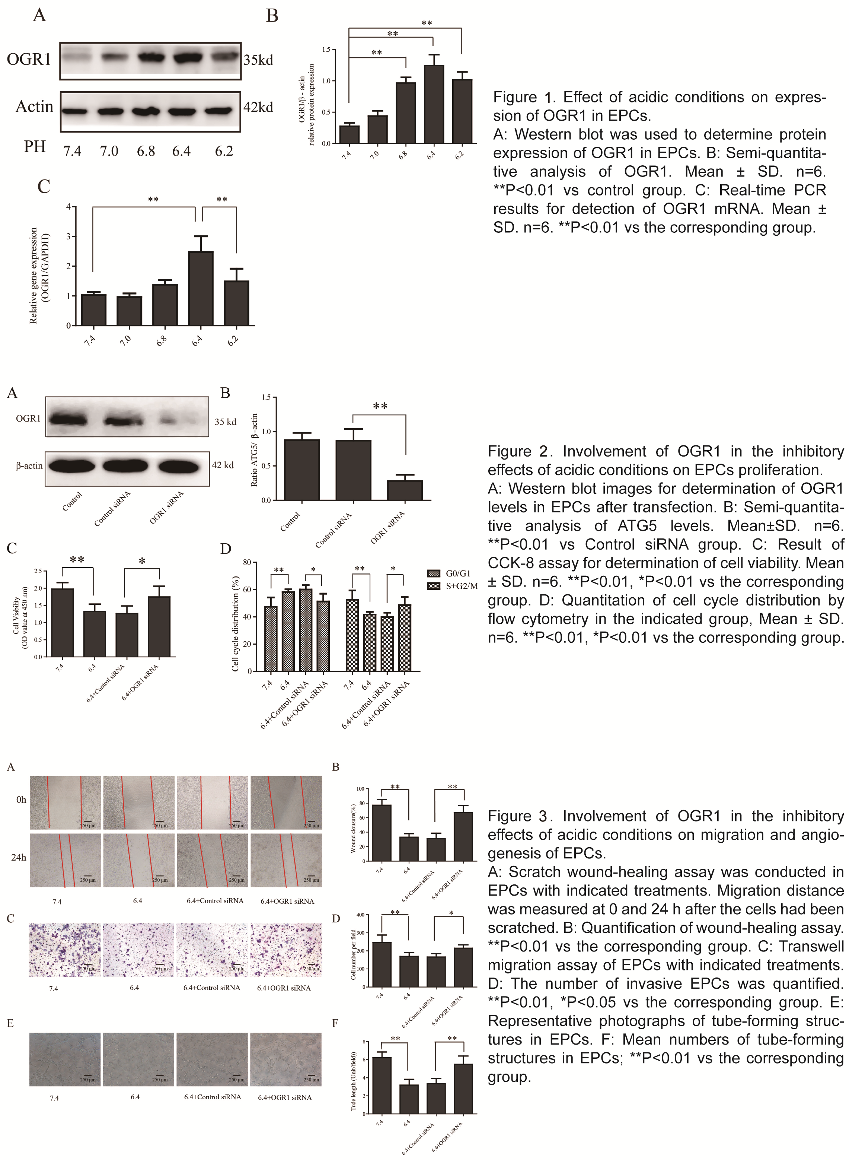
Recent Publications (minimum 5)
- Guerado, E., & Caso, E. (2016). The physiopathology of avascular necrosis of the femoral head: an update. Injury, 47, S16-S26.
- Ludwig, M. G., Vanek, M., Guerini, D., Gasser, Jürg A., Jones, C. E., & Junker, U., et al. (2003). Proton-sensing g-protein-coupled receptors. Nature, 425(6953), 93-98.
- Qin, M., Guan, X., Wang, H., Zhang, Y., Shen, B., & Zhang, Q., et al. (2017). An effective ex-vivo approach for inducing endothelial progenitor cells from umbilical cord blood CD³⁴⁺ cells. Stem Cell Research & Therapy, 8(1), 25.
- Edward Zhou, X., Melcher, K., & Eric Xu, H. (2018). Structural biology of G protein‐coupled receptor signaling complexes. Protein Science.
- Wang, J. Q., Kon, J., Mogi, C., Tobo, M., Damirin, A., Sato, K., ... & Kuwabara, A. (2004). TDAG8 is a proton-sensing and psychosine-sensitive G-protein-coupled receptor. Journal of Biological Chemistry, 279(44),45626-45633.

Biography (150 word limit)
Shenglong Ding, a graduate student in orthopedics at Shanghai Medical College, Fudan University, has his expertise in Intervertebral disc degeneration and biomaterials field. He has published articles entitled “Salt-assisted toughening of protein hydrogel with controlled degradation for bone regeneration"(online in April 2019; Advanced Functional Materials; IF=13.5) and " Bombyx mori Silk Based Materials with Implication in Skin Repair: Sericin versus Regenerated Silk Fibroin "(online in April 2019; Journal of Biomaterials Applications; IF=2.35) in the field of materials. He is also focused on problems of clinical work, and his article entitled “Two application modes of pedicle screw-rod fixator for anterior pelvic ring fractures: a retrospective study” has just been received by Journal of International Medical Research.
Email: 17211350004@fudan.edu.cn
Notes/Comments:

