ABSTRACT

Efficacy of Serial Percutaneous Steroid Injection Treatment in Simple Bone Cyst Patients. A One Year Follow Up
Achmad Fauzi Kamal¹, Yogi Prabowo¹, Ajiantoro¹

¹Department of Orthopaedic and Traumatology, Cipto Mangunkusumo General Hospital / Faculty of Medicine University of Indonesia.

Introduction: Simple bone cyst (SBC) is a benign tumor that relatively rare and particularly occurred in the first second decade of life. Males are more frequent than females with comparison of 3:1 and the most common location is on proximal humerus (59%), followed by proximal femur (25%) and calcaneus (6%). More than 20 methods of treating SBCs have been described in the literature, the most commonly used ones being curettage and bone grafting, and injection of steroid. Scaglietti et al. reporting that methylprednisolone injections into the cyst resulted in a 96 % treatment success rate.

Methods: We collected data from of all patients in Cipto Mangunkusumo Hospital with simple bone cyst who were treated by three times of percutaneous steroid injection between 2013 until 2016. We evaluated the Modified Chang Radiology Criteria, and MSTS functional score in theh 3 months, 6 months, and 12 months post operation.

Results: 10 patients were reported in this serial cases, 8 males and 2 females. Average age of these subjects is 7.8 years old. MSTS functional score determine good result after 3rd injection of steroid. Bone healing evaluation using Chang Criteria showed good healing proccess.

Conclusion: MSTS functional score, and Modified Chang Radiology Criteria of steroid injection for SBCs after one year treatment is good. Steroid injection therapy get solid union relatively quick, simple operation procedure, widely available and less side effect therefore this procedure can be a choice for treatment of SBCs patient. Further study need to be conducted with more sample size.

Keywords: Simple Bone Cysts, Percutaneous Steroid Injection, MSTS.

INTRODUCTION

Simple bone cyst (SBC) is a benign tumor that relatively rare and particularly occurred in the first and second decade of life. The symptoms of SBCs including pain, swelling, or stiffness at the nearest joint. A pathologic fracture is often the first sign of the lesion that patient realize [1]. The expansive cysts tend to thin and weaken the involving bone, producing a mechanical threat that may result in subsequent pathological fracture. The aetiology is unknown, but it is suspected that venous obstruction elevates intraosseous pressure, leading to cyst formation [2].

Radiographically, the appearance of the SBC are centrally located, well-circumscribed, radiolucent lesion with sclerotic margins. The lesion is located within the diaphysis or the metaphysis of a long bone, abutting or being remote from the cartilaginous growth plate, and epiphyseal extension is unusual. The cortex is frequently thinned and cortical expansion may be present, but the width of the SBC does not exceed the width of the neighboring plate. A periosteal reaction is absent unless there has been a pathologic fracture. The diagnosis may be demonstrated by conventional radiographs and magnetic resonance imaging (MRI) [1].

The aim of treating SBC is to prevent all possible complications and to avoid prolonged restriction of physical activity. The appropriate treatment, however, remains uncertain and a wide spectrum of treatment modalities have been proposed ranging from observation to subtotal resection [1].

More than 20 methods of treating SBCs have been described in the literature, the most commonly used ones being curettage and bone grafting, autogenic bone marrow, flexible intramedullary nailing and injections of steroids. Decompression and percutaneous steroid injection (PSI) has many advantages, such as its simplicity, low cost, high availability and lack of direct post-operative adverse effects [3]. A study published by Scaglietti et al [4]. reporting that methylprednisolone injections into the cyst resulted in a 96 % treatment success rate. This study reports the results of patients who were treated by steroid injections in our institution.

METHODS

We collected all patients with SBC who were treated with PSI three times in Cipto Mangunkusumo Hospital between 2013 until 2016. The diagnosis of SBC was made based on radiographs and MRI. Functional outcomes were measured by musculoskeletal tumor society (MSTS) score. Evaluation after PSI also was conducted based on radiographic examinations using Chang criteria 1 month post each injection (Figure 1).
The maximal score of MSTS scoring system is 30. Scoring system is divided into 4 categories, if the score < 25% of maximal score is categorized as bad, 25-49% is categorized as fair, 50-74% is categorized as good, and >75% is categorized as very good.
The PSI in our hospital was performed with the following procedure :
- With the patient under general anesthesia, we visualize the lesion with C-arm guidance
- Core bone needles no 11 are introduced in the proximal and the distal pole of the cystic lesion
- We evaluate the fluid (colour) which came out from the cavity without force and send it to histopathologic examination
- After the characteristic fluid of SBC is empty, we aspirate haemorrhagic one from the cavity and also send it to histopathologic examination
- The cavity was flushed with normal saline from proximal core bone needle,
- With closed distal core bone needle, we perform PSI 80 -120 mg.

RESULTS

The study included 10 patients. They consist of 8 boys and 2 girls with the mean age 7.8 years old (range 3-14 years old). The mean follow up was 12.6 months (range 5 – 48 months). The locations of SBC are 6 cases at the humerus, 3 cases at the femur, and reaming 1 case at the calcaneus. Four patients presented with pathologic fractures. We followed up each patient every 1 months until 3rd PSI was complete, and every 6 months thereafter. The overall characteristic features of the patients are shown in table 1.
Successful clinical outcomes with very good MSTS score were observed 90 of 10 (90%) and all cases 100% in 3 and 6 months after 3rd PSI respectively.MSTS scoring evaluation of this study is presented on the table 2. We noted no recurrent cases or no response to treatment in our study during follow up. Bone healing were assessed using Chang criteria for radiological examination (Tabel 3 and Figure 2).

DISCUSSION

Many studies stated that boys are more common than girls with comparison 3:1 and particularly occurred in the first and second decade of life. The most common predilection of SBC is on proximal humerus (59%) followed by proximal femur (25%) and calcaneus (6%) [1,5]. In this study, boys are more common than girls (8:2). Similar with previous studies, SBCs in our cases occurred on the first second decade of life. 6 of 10 (60%) cases are located in the humerus followed by 3 of 10 (30%) in the femur, and the remaing 1 (10%) in the calcaneus.
In our study, pathological fractures were significantly more often located in the humerus than in the femur which was comparable to previous studies. It is believed that due to the absence of a significant weight load, which usually leads to significant pain, SBC in the humerus remain undetected longer than in the femur. Thus, SBC in the humerus often grow until they reveal themselves through a pathological fracture usually arising in the context of a minimal trauma [6].
The aim of treating SBC is to prevent all possible complications and to avoid prolonged restriction of physical activity. The appropriate treatment, however, remains uncertain and a wide spectrum of treatment modalities have been proposed ranging from observation to subtotal resection. From many of previous studies, the efficacy of SBC is still debatable. Study conducted by Kadhim et al. [5]. stated that the curettage therapy has higher bone healing compared to steroid therapy (98.7% vs 77.4%). Meanwhile, Mylle et al [7]. in their study showed that steroid is a chosen method for treatment of SBC due to it is easy, effective and safe. Scaglietti et al [4]. reported that methylprednisolone injections into the cyst resulted in a 96 % treatment success rate.
In this study, all patients were treated with three times of PSI with a month interval for each injection. The number of injection referred from several previous studies. Campanacci et al [8]. reported healings in 68 % of cysts treated with methylprednisolone. Each patient was submitted to 3–4 injections of methylprednisolone. Hashemi et al [9]. also was performed similar study that number of injections was three times. Moreover, study from Scaglietti et al [4]. noticed that 76 % of failure happened in one PSI treatment.
The fluids of SBC contain combination of substances inside those are prostaglandins, free oxygen radical, interleukins, cytokines and metalloproteinase. This combination resulting higher pressure of the fluid inside the cyst compared to pressure in the bone marrow causing bone necrosis. Some of the SBC will spontaneously recover, however others may also enlarge until symptoms exist and require treatment [7,10,11]. The role of methylprednisolone in enhancing bone healing is by reducing the cyst fluid production from the inner cyst wall with its anti-prostaglandin effect or by decreasing the cyst pressure after initially drilling a hole and aspirating the fluid [12].
The patient’s functional outcomes were evaluated using MSTS scoring system which is divided into upper and lower extremity. Each items has 0-5 scale, higher score reflect higher progression of functional outcomes. The results show that after 6 month after 3rd PSI, functional outcomes of all patients are very good. The results even better than several previous studies. A study from Cho et al [13]. found the success rate after steroid injection for simple bone cyst was 86.7% (26 of 30 patients). Another study that was conducted by Pavone et al. [14] showed a good clinical outcome after steroid injection (98/100).
The radiographic outcomes were measured using Chang criteria [15]. Based on this criteria, there are 4 classifications of bone healing, those are (1) Healed (cyst filled by formation of new bone with or without small static, radiolucent area(s) less than 1 cm in size), (2) Healed with defect (Static, radiolucent area(s) less than 50% of the diameter of bone with enough cortical thickness to prevent fracture), (3) Persistent cyst (radiolucent areas greater than 50% of diameter of the bone and with a thin cortical rim. No increase in cyst size. Continued restriction of activity or repeated treatment is required), and (4) Recurrent cyst (cyst reappeared in a previously obliterated area or a residual radiolucent area has increased in size). Radiographic examination was performed before first injection, one month after 1st, 2nd, and 3rd PSI respectively.
The results show that all patients have good radiological outcomes (complete healing) in 6 months follow up after 3rd injection. All patients were healed (cyst filled by formation of new bone with or without small static, radiolucent area(s) less than 1 cm in size). These results are better from several previous studies. Oppenheim et al. [16] conducted study to evaluate steroid injection in simple bone cyst and the result was 75% of the cysts which achieved satisfactory radiological healing after numerous injections. A meta-analysis study from Kadhim et al. [5] published that radiological healing after steroid injection for simple bone cysts achieved 83.6%.
In our cases, clinical outcomes were consistent with radiological outcomes. Other case series also showed satisfactory radiological and clinical outcomes following steroid injection [17]. Hashemi-Nejad et al. [9] reported 24 of 24 (100%) children with satisfactory radiological outcomes and 23 of 24 (96%) had good clinical results. However, 5 of 8 (63%) children with an unsatisfactory radiological outcome had a satisfactory clinical result. Hashemi-Nejad reported that good radiological outcomes always had good clinical outcomes, but good clinical outcomes are not always in line with good radiological outcomes.
The relationship between basic characteristics with bone healing and SBC recurrence from several previous studies remains controversial. Chang et al. [15] confirmed that there is a significant relationship between the size of the cyst and the patient's age but not on gender, location and type of cyst, and pathologic fracture. Another study conducted by Baig et al. [18] showed the same thing that age was reported to be a reliable predictor, with children >10 years of age having a higher rate of cyst healing than those <10 years [18]. Hashemi-Nejad and Cole [9] said that there was no significant relationship between radiology results and cyst size, type or age. Recently, Haidar et al [19]. reported that a lesion located <2 cm from the growth plate may be a risk factor for recurrence. In the present study, a significantly higher recurrence rate was found for patients with a lesion contacting the physis. However, the other studies demostrated that the results of PSI might be worse in as many as half of the patients had the lesion relapses [20].

CONCLUSION
MSTS (musculoskeletal tumor society) functional score of steroid injection for simple bone cyst is good. Steroid injection therapy get solid union relatively quick, simple operation procedure, widely available and less side effect therefore this procedure can be a choice for treatment of simple bone cyst patient. Further study need to be conducted with more sample size.

Conflict of interests
The authors declare that there is no conflict of interests regarding the publication of this paper.

Author contribution .
AFK performed the operation, wrote the paper and made scientific analysis. A and YP performed the documentation of the patient and follow up care and wrote the paper

REFERENCES

- Ulici A, Balanescu R, Topor L, Barbu M. The modern treatment of the simple bone cysts. J Med Life. 2012;5:469-73.
- Sakamoto A, Matsuda S, Yoshida T, Iwamoto Y. Clinical outcome following surgical intervention for a solitary bone cyst: emphasis on treatment by curettage and steroid injection. J Orthop Sci. 2010;15:553-9.
- Flont P, Kolacinska-Flont M, Niedzielski K. Factors predictive of positive response to steroid therapy in simple bone cysts: an old trick that still works. Inter Orthop 2013;37:1519-25.
- Scaglietti O, Marchetti PG, Bartolozzi P. The effects of methylprednisolone acetate in the treatment of bone cysts. Results of three years follow-up. J Bone Joint Surg Br. 1979;61:200–204
- Kadhim M, Thacker M, Kadhim A. Treatment of unicameral bone cyst: Systematic review and meta-analysis. J Child Orthop. 2014;8:171-91
- Hagmann S, Eichhorn F, Moradi B, Gotterbarm T, Dreher T, Lehner B, et al. Mid- and long-term clinical results of surgical therapy in unicameral bone cysts. BMC Musculoskelet Disord. 2011; 12: 281
- Mylle J, Burssens A, Fabry G. Simple bone cysts. Arch Orthop Trauma Surg. 1992;111:297-300
- Campanacci M, Capanna R, Picci P. Unicameral and aneurysmal bone cysts. Clin Orthop Relat Res.1986; 204:25–36
- Hashemi-Nejad A, Cole WG. Incomplete healing of simple bone cysts after steroid injections. J Bone Joint Surg. 1997;79-B:5
- Yandow S. What is the best treatment for simple bone cysts. In: James G. Wright, editor. Evidence-Based Orthopaedics.2nded: Philadelphia: Elsevier; 2009. p. 683-702.
- Suei Y, Taguchi A, Nagasaki T, Tanimoto K. Radiographic findings and prognosis of simple bone cysts of the jaws. Dentomaxillofac Radiol. 2010;39(2):65-72.
- Kao ST, Scott DD. A Review of Bone Substitutes. Oral Maxillofacial Surg Clin N Am. 2007;19:513-21.
- Cho Hs, Oh Jh, Kim Hs, Kang Hg, Lee Sh. Unicameral Bone Cysts A Comparison Of Injection Of Steroid And Grafting With Autologous Bone Marrow. J Bone Joint Surg [Br] 2007;89-B:222-6
- Pavone V, Caff G, Di Silvestri C, Avondo S, Sessa G. Steroid injections in the treatment of humeral unicameral bone cysts: long-term follow-up and review of the literature. Eur J Orthop Surg Traumatol. 2014;24(4):497-503
- Chang C, Stanton R, Glutting J. Unicameral bone cyst treated by injection of bone marrow or methylprednisolone. J Bone Joint Surg. 2002;84:407-12
- Oppenheim WL, Galleno H. Operative treatment versus steroid injection in the management of unicameral bone cysts. J Pediatr Orthop. 1984;4(1):1–7
- Faisham W, Nawasz AH, Ezane AW, Zulmi W, Ibrahim W, Halim ARA. Non-Operative Treatment Versus Steroid Injections in the Management of Unicameral Bone Cysts. Malaysian Orthop J. 2011;5:2
- Baig R, Eady JL. Unicameral (simple) bone cysts. South Med J 2006; 99:966–976
- Haidar SG, Culliford DJ, Gent ED, Clark NM. Distance from the growth plate and its relation to the outcome of unicameral bone cyst treatment. J Child Orthop. 2011; 5:151–156
- Shirai T, Tsuchiya H, Terauchi R, Tsuchida S, Mizoshiri N, Ikoma K. Treatment of a simple bone cyst using a cannulated hydroxyapatite pin. Medicine. 2015;94:25.

Table 1. Patient’s Characteristics

Characteristic | N=10
Age (average) | 7.8 yo
Group Age
- 0-10 y.o
- 11-20 y.o
Group Age  - 0-10 y.o  - 11-20 y.o | 7
Group Age  - 0-10 y.o  - 11-20 y.o | 3
Sex
- Male
- Female
Sex  - Male  - Female | 8
Sex  - Male  - Female | 2
Location
- Humerus
- Femur
- Cacaneus

Location  - Humerus  - Femur  - Cacaneus | 6
Location  - Humerus  - Femur  - Cacaneus | 3  1
Site  - Right  - Left | 3  7
Pathological Fracture  - Yes  - No | 4  6

Table 2. MSTS Scoring Evaluation
 | MSTS Scoring
Time of Evaluation
Pre Procedure
Bad | 3 (30,0)
Fair | 7 (70,0)
Good | 0 (0,0)
Very Good | 0 (0,0)
1 month after 1stPSI
Bad | 0 (0,0)
Fair | 3 (30,0)
Good | 7 (70,0)
Very Good | 0 (0,0)
1 month after 2ndPSI
Bad | 0 (0,0)
Fair | 0 (0,0)
Good | 5 (50,0)
Very Good | 5 (50,0)
1 month after 3rdPSI
Bad | 0 (0,0)
Fair | 0 (0,0)
Good | 3 (30,0)
Very Good | 7 (70,0)
3 month after 3rdPSI  Bad | 0 (0,0)
Fair | 0 (0,0)
Good | 1 (10,0)
Very Good | 9 (90,0)
6 month after 3rdPSI
Bad | 0 (0,0)
Fair | 0 (0,0)
Good | 0 (0,0)
Very Good | 10 (100,0)

Table 3. Distribution of Patient’s Characteristics
No | ID | Sex | Age  (yo) | Location | Site | Pathological fracture | Chang Criteria (Size of lesion after complete PSI)
1 | D | Boy | 6 | Humerus | Right | Yes | Healed (0.2 cm)
2 | F | Girl | 3 | Humerus | Left | No | Healed (1.0 cm)
3 | R | Boy | 6 | Humerus | Left | No | Healed (0.6 cm)
4 | R | Boy | 7 | Femur | Left | No | Healed (0.9 cm)
5 | A | Girl | 11 | Humerus | Left | Yes | Healed (1.0 cm)
6 | A | Boy | 6 | Femur | Left | No | Healed (0.9 cm)
7 | A | Boy | 5 | Humerus | Left | Yes | Healed (0.6 cm)
8 | P | Boy | 5 | Humerus | Left | Yes | Healed (0.8 cm)
9 | R K | Boy | 14 | Femur | Right | No | Healed (1.0 cm)
10 | F | Boy | 14 | Calcaneus | Right | No | Healed (0.4 cm)

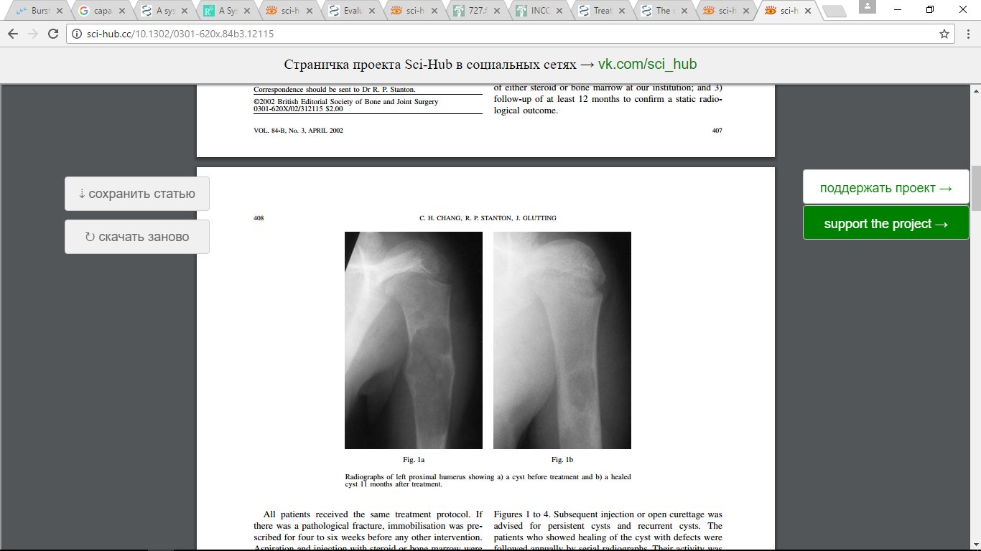
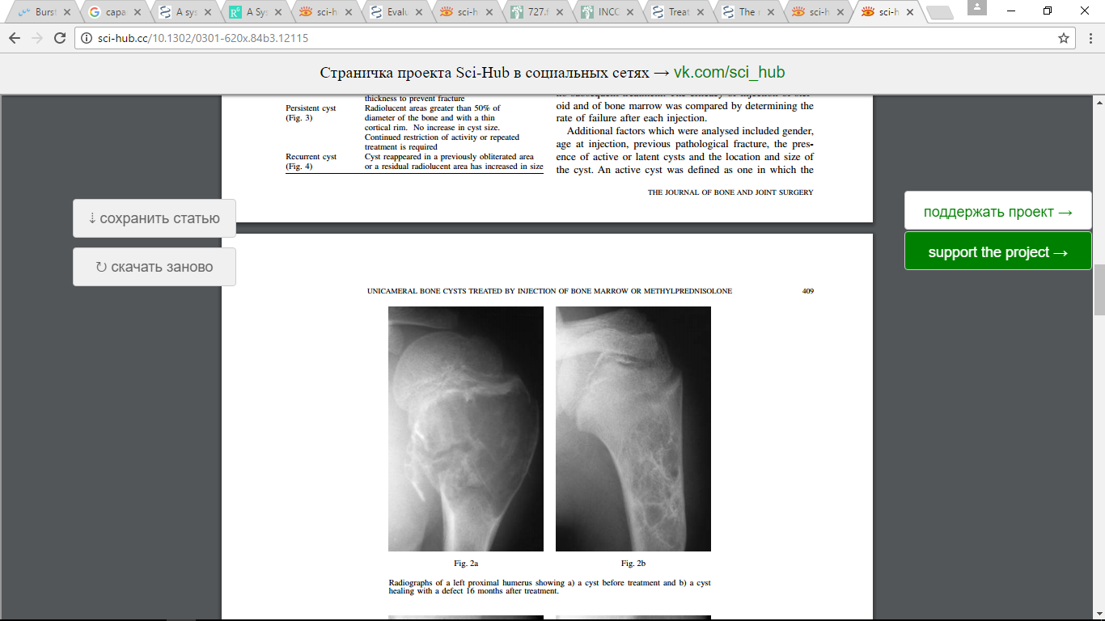
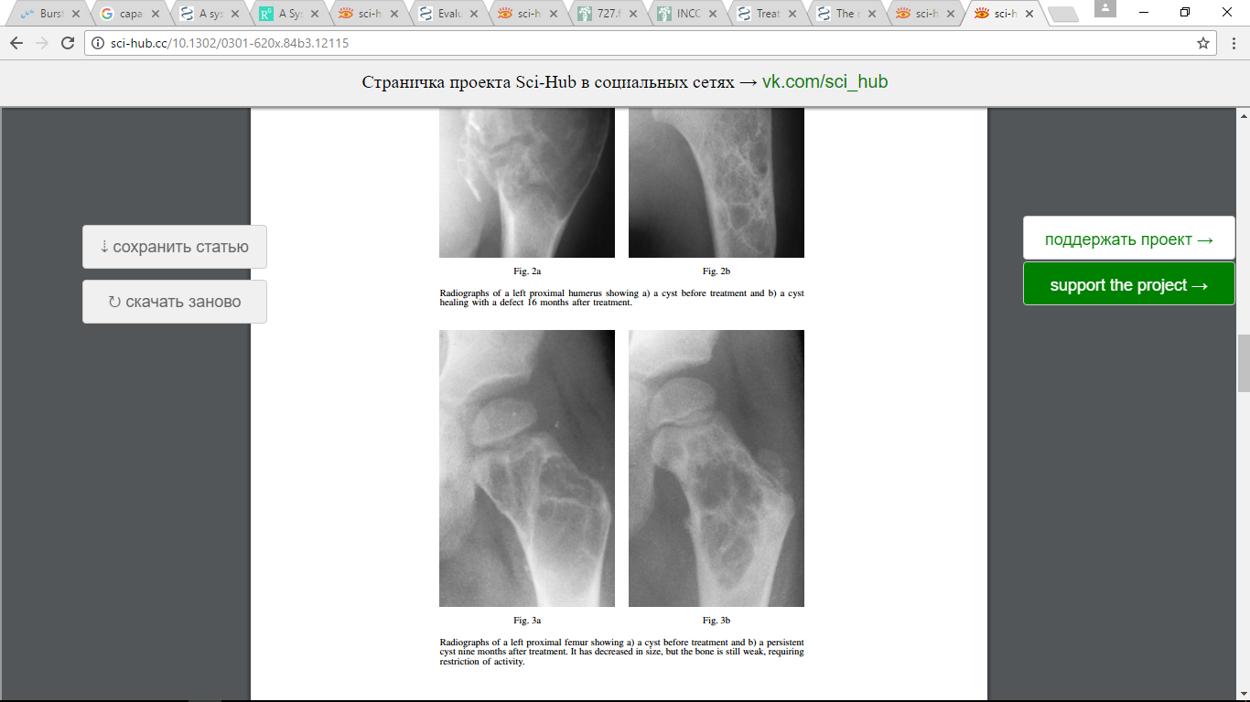
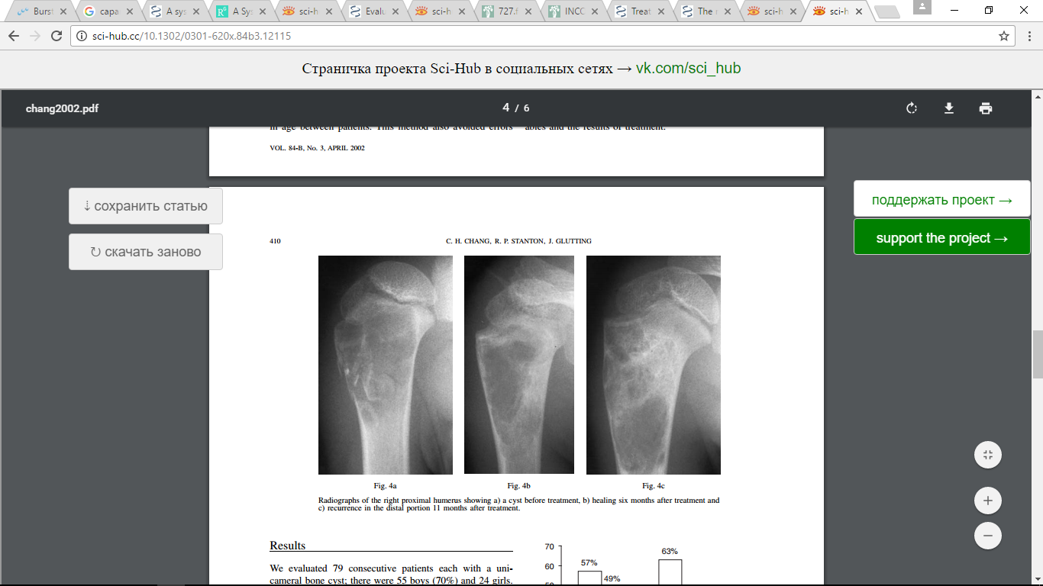
a
b
c
d

Figure 1. Radiographic evaluation by Chang Criteria
(a) Healed cyst, (b) Healing with defect, (c) Persistent cyst, (d) Recurrent cyst

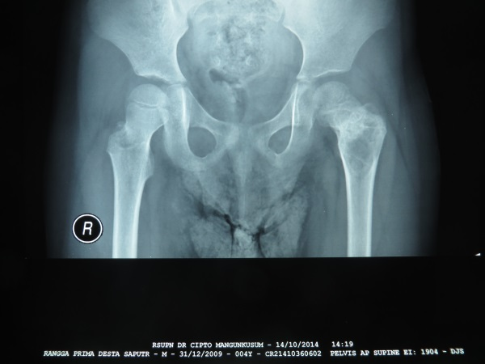
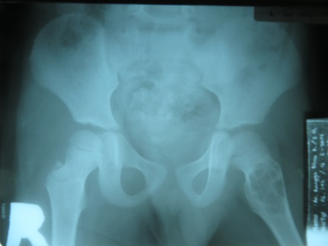
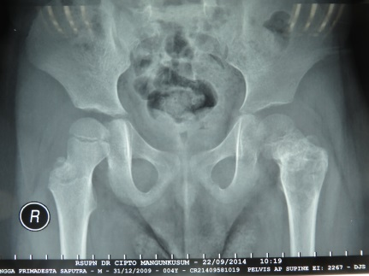
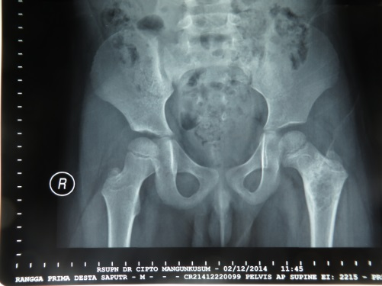
c
d
b
a

Figure 2. Radiology evaluation in patient with SBC on left femur
(a) pre injection (b) 1 month post 1st injection (c) 1 month post 2nd injection (d) 1 month post 3rd injection

