Development of Pro-transporters with Enzyme-cleavable Anion Transport Activity

RAC Report

A Report submitted to Indian Institute of Science Education and Research, Pune for the second year comprehensive examination and up-gradation to Senior Research Fellow

Submitted by
Avisikta Upadhyay
Registration Number – 20152022

Project Supervisor
Dr. Pinaki Talukdar



Acknowledgement:

I express my sincere regards to my supervisor Dr. Pinaki Talukdar for being supportive and guiding me at every stage of my research.
I would like to thank IISER Pune Chemistry Department for providing me with fellowship and excellent research atmosphere.
I would also take this opportunity to thank all my lab mates, friends and family for being co-operative and supporting me throughout.

Introduction:
Biological membranes are primarily self-assembled phospholipid structures, which play crucial role in the survival of living cells by protecting these from the extreme external environments.¹ Although, hydrophobic species such gases, small organic molecules can pass through the lipid membranes, the permeation of hydrophilic entities e.g. inorganic cations, inorganic anions, amino acids, ATP, proteins etc. are prevented completely.²⁻⁴ Therefore, nature has developed membrane proteins, which allow the selective transport of ions to regulate the cellular pH, osmotic pressure, and also help in the cellular signalling process.⁵ The transport of ions across biological membranes is facilitated by molecules that act either as carriers or channels (Figure 1A-B). Channels are usually membrane-bound proteins, while carriers may or may not be membrane-associated. Carriers that shuttle their guests from one side of the membrane to the other side of the membrane need to be lipophilic enough to diffuse through the hydrophobic part of the bilayer. Channels, on the other hand, typically traverse the width of the bilayer membrane and provide a hydrophilic pathway for ions to move across the phospholipid barrier.⁵
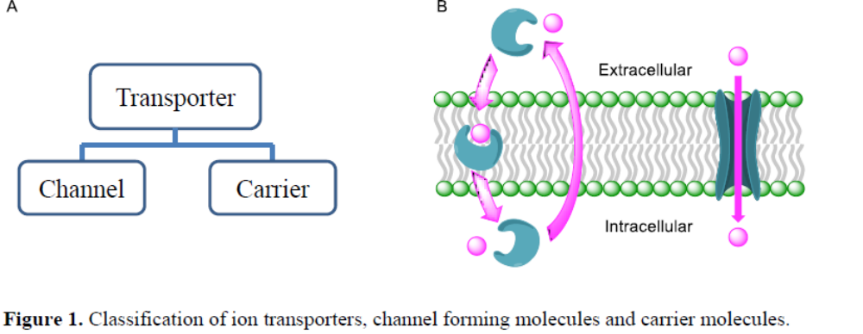
Any defect in these channel forming proteins, mainly caused by mutation, results in the imbalance of ion transport process, leading to different types of diseases.⁶ For example, cystic fibrosis, Bartter syndrome, Dent’s disease, Myotonia, epilepsy, hyperekplexia, lysosomal storage disease, etc. are diseases, which are caused by the dysfunction of chloride channel forming proteins.⁷ There are also evidences that chloride flux has direct correlation to cell death via impairing the intrinsic pathway of apoptosis, without effecting the extrinsic pathway.^{8, 9} Considering the role of apoptosis in cancer, there has been tremendous interest in developing synthetic ion transporters which facilitate are capable of selectively transport the Cl⁻ at low concentration. For example, Prodigiosin and ceramide, naturally occurring anionophores have shown significant anion-transport ability and anticancer activity (Figure 2A-B). The diamide-strapped calix[4]pyrroles, reported by Sessler et al. transport Cl⁻ and Na⁺ to the intracellular region of cell, and bis-sulfonamide, bis-diol derivatives, reported by our group, transport Cl⁻ in to the cell via ion carrier and channel forming mechanism (Figure 2C-D). The increase of Cl⁻ ion concentration in the cell by the transporter molecules leads to reactive oxygen species generation followed by cytochrome-c release from the mitochondria, which subsequently resulted in the apoptosis, so called program cell death.¹⁰⁻¹²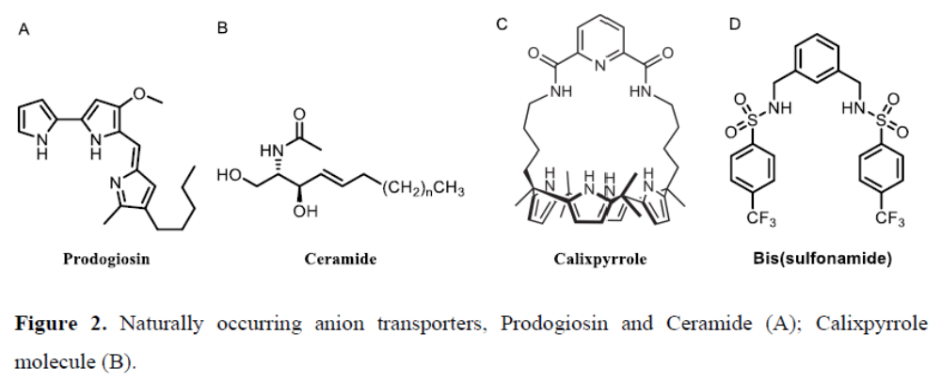
However, many of the channels forming molecules are too large to be considered as a drug like molecules. Therefore, there has been recent interest in developing small synthetic transporter molecules which are capable of transporting anions across plasma membrane via mobile carrier mechanism. These small molecules can bind with complex anionic guest by employing electrostatic interactions like hydrogen bonding, anion-π interactions, halogen bonds, anion dipole interactions etc
Indole (as tryptophan) is found in the anion binding sites of the nitrate-binding protein NrtA,9 the bicarbonate-binding protein CmpA,10 and the sulfate-binding protein.11 Inspired by nature, synthetic indole containing receptors have been used for anion complexation and transport.¹⁹

General Methods:
All chemical reactions were performed under nitrogen atmosphere. All reagents and solvents for synthesis were purchased from commercial sources (Sigma-Aldrich, Spectrochem) and used further without purification. The column chromatography was carried out using Merc silica (100-200/230-400 mesh size). The thin layer chromatography was performed on E. Merck silica gel 60-F254 plates. Egg yolk phosphatidylcholine (EYPC) as a solution of chloroform (25 mg/mL), mini extruder, polycarbonate membrane of 100 nm and 200 nm were purchased from Avanti Polar Lipid. HEPES, HPTS, Lucigenin, NaOH, Triton-X, FCCP, valinomycin and all inorganic salts were obtained as molecular biology grade from Sigma Aldrich.
- Physical Measurements:
The ¹H NMR spectra were recorded at 400 MHz whereas ¹³C at 101 MHz. The residual solvent signals were considered as an internal reference (CDCl₃ ¹_{H} at 7.26 ppm, DMSO-d₆ ¹_{H} at 2.50 ppm, CD₃CN ¹_{H} at 1.94 ppm) to calibrate spectra. The chemical shifts were reported in ppm. Following abbreviations were used to indicate multiplicity patterns m: multiplet, s: singlet, d: doublet, t: triplet, q: quartet, dd: doublet of doublet, td: triplet of doublet. Coupling constants were measured in Hz. Infra-red (IR) spectra were measured in cm⁻¹ using FT-IR spectrophotometer. Melting points were measured on micro melting point apparatus. High-resolution mass spectra (HRMS) were recorded on electron spray-ionization time-of-flight (ESI-TOF). Fluorescence experiments were recorded on Fluoromax-4 from Jobin Yvon Edison equipped with injector port and magnetic stirrer in microfluorescence cuvette. All buffer solutions were prepared from the autoclaved water. Adjustment of pH of buffer solutions were made using Helmer pH meter. The extravesicular dye was removed by performing gel chromatography using Sephadex-G. The fluorescence studies were proceeded using Origin-pro 8.5.
I: Aim of the project:
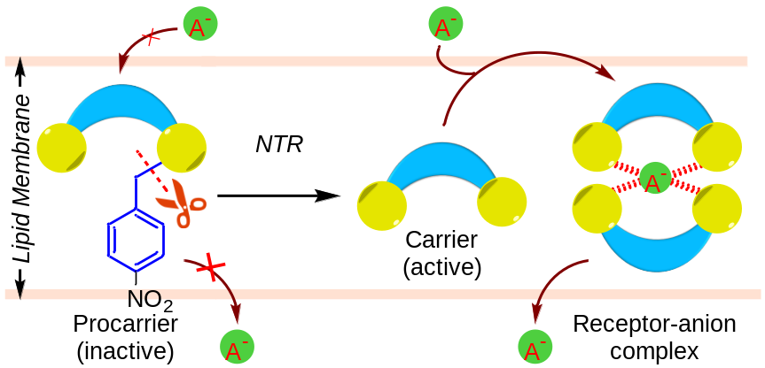

II: Synthesis:
General procedure for synthesizing indole amide derivatives (1a-1d):

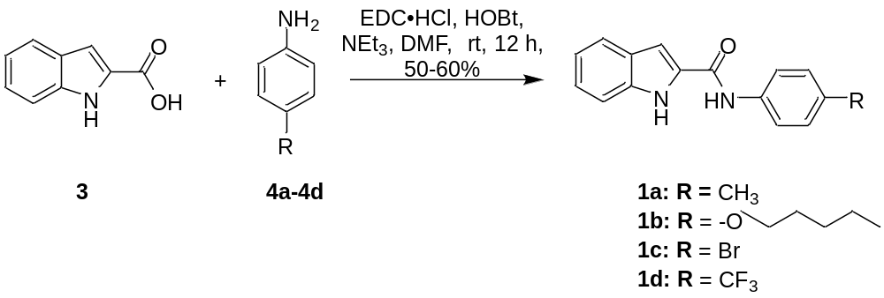

Scheme S1: Synthetic scheme for the compounds 1a-1d
In a 100 mL round bottom flask, Indole 2 carboxylic acid (300 mg, 1.86 mmol), EDC·HCl (428 mg, 2.23 mmol), and HOBt (301 mg 2.23 mmol) was dissolved in DMF (3 mL) and stirred at room temperature for 30 minutes. After 30 minutes, para-substituted aniline derivatives 4a-4d (2.80 mmol) and NEt₃ (389 µL, 2.80 mmol) were added. The reaction mixture was stirred at room temperature for 12h. After completion of the reaction, the reaction mixture was quenched by water(10 mL), extracted with ethyl acetate(3 × 20 mL), washed with brine(2 × 10 mL), organic layer dried over Na₂SO₄ and concentrated under reduced pressure. The purification of the crude product was done by using silica gel chromatography to give pure compounds (1a-1d).
N-(p-tolyl)-1H-indole-2-carboxamide (1a):
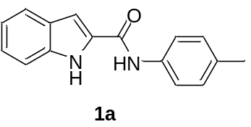Eluent: CH₂Cl₂, obtained as white solid, Yield = 54%; ¹H NMR (400 MHz, DMSO-d₆): δ 11.71 (s, 1H), 10.13 (s, 1H), 7.72 – 7.64 (m, 3H), 7.47 (dd, J = 8.2, 0.8 Hz, 1H), 7.41 (dd, J = 2.1, 0.7 Hz, 1H), 7.22 (ddd, J = 8.2, 7.0, 1.1 Hz, 1H), 7.17 (d, J = 8.2 Hz, 2H), 7.07 (ddd, J = 8.0, 7.0, 1.0 Hz, 1H), 2.29 (s, 3H); ¹³C NMR (101 MHz, DMSO-d₆) : δ 159.56, 136.76, 136.40, 132.48, 131.59, 129.08, 127.04, 123.67, 121.68, 120.17, 119.87, 112.36, 103.64, 20.50; IR (ν cm⁻¹): 3740, 3674, 3616, 3400, 3300, 1640, 1600, 1517, 1403, 1300, 1225, 810, 739, 630; HRMS (ESI): Calcd. for C₁₆H₁₅N₂O-[M+H]+: 251.1184; Observed: 251.1190; M.P.: 248 °C.
N-(4-(o-pentyl)phenyl)-1H-indole-2-carboxamide (1b):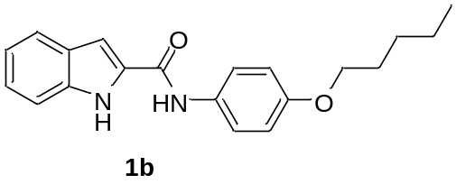 Eluent: 6 % ethyl acetate in petroleum ether), obtained as white solid,Yield = 50%; ¹H NMR (400 MHz, CDCl₃): δ 9.54 (s, 1H), 7.88 (s, 1H), 7.68 (d, J = 8.1 Hz, 1H), 7.59 (d, J = 8.6 Hz, 2H), 7.47 – 7.38 (m, 3H), 7.31 (t, J = 8.0 Hz, 1H), 7.17 (dd, J = 7.7, 7.2 Hz, 1H), 7.01 (d, J = 1.7 Hz, 1H), 1.34 (s, 9H) ¹³C NMR (101 MHz, CDCl₃): δ 159.70, 147.90, 136.73, 134.92, 130.95, 127.79, 126.17, 125.00, 122.19, 121.01, 120.16, 112.20, 102.61, 34.61, 31.52; IR (ν cm⁻¹): 3743, 3676, 3623, 3269, 2936, 1739, 1643, 1518, 1466, 1372, 1226, 808, 737. HRMS (ESI): Calcd. for C₁₉H₂₁N₂O-[M+H]⁺: 293.1654; Observed: 293.1660; M.P.: 205°C.

N-(4-bromophenyl)-1H-indole-2-carboxamide (1c):
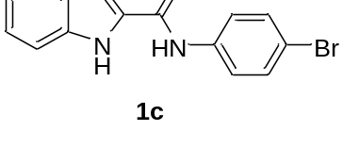Eluent: 5 % ethyl acetate in petroleum ether), obtained as white solid Yield = 55%; ¹H NMR (400 MHz, DMSO-d₆): δ 11.77 (s, 1H), 10.33 (s, 1H), 7.82 – 7.78 (m, 2H), 7.69 (d, J = 8.0 Hz, 1H), 7.59 – 7.54 (m, 2H), 7.47 (d, J = 8.2 Hz, 1H), 7.43 (d, J = 1.8 Hz, 1H), 7.23 (ddd, J = 8.2, 7.0, 0.9 Hz, 1H), 7.08 (dd, J = 10.9, 3.9 Hz, 1H).; ¹³C NMR (101 MHz, DMSO-d₆): δ 159.81, 138.40, 136.91, 131.55, 131.19, 126.98, 123.94, 121.97, 121.82, 119.99, 115.18, 112.43, 104.15; IR (ν cm⁻¹): 3744, 3672, 3607, 3405, 3328, 1702, 1642, 1586, 1387, 1297, 1223, 1058, 812, 742, 623; HRMS (ESI): Calcd. for C₁₅H₁₂BrN₂O-[M+H]⁺: 317.0113; Observed: 317.0115; M.P.: 276 °C.

N-(4-(trifluoromethyl) phenyl)-1H-indole-2-carboxamide (1d):
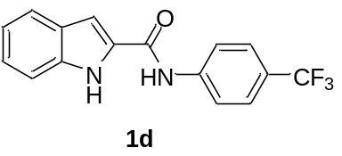Eluent: 4 % ethyl acetate in petroleum ether), obtained as white solid,Yield = 60%; ¹H NMR (400 MHz, DMSO-d₆): δ 11.81 (s, 1H), 10.52 (s, 1H), 8.05 (d, J = 8.5 Hz, 2H), 7.75 (d, J = 8.6 Hz, 2H), 7.70 (d, J = 7.9 Hz, 1H), 7.48 (dd, J = 7.2, 1.3 Hz, 2H), 7.24 (ddd, J = 8.1, 7.0, 1.1 Hz, 1H), 7.12 – 7.05 (m, 1H).;¹³C NMR (101 MHz, DMSO-d₆): δ 160.10, 142.67, 137.03, 130.93, 126.94, 126.04, 125.78, 124.43, 123.25, 121.90, 120.05, 119.84, 112.46, 104.60.IR (ν cm⁻¹): 3745, 3307, 1654, 1527, 1408, 1317, 1234, 1100, 829, 743; HRMS (ESI): Calcd. for C₁₆H₁₂F₃N₂O-[M+H]⁺:305.0901; Observed: 305.0906; M.P.: 269.7°C.

Synthesis of N-(4-nitrobenzyl)-4-(trifluoromethyl) aniline (5):

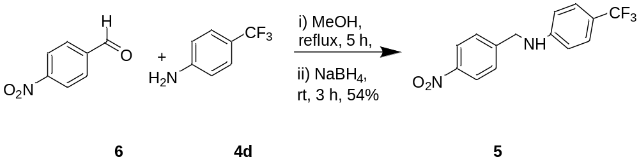

Scheme S2: Synthesis of 5.
In a 25 mL round bottom flask, the solution of p-nitro benzaldehyde 6 (500 mg, 3.31 mmol) and 4-(trifluoromethyl) aniline 4d (533 mg, 3.31 mmol) was refluxed for 5 h. The reaction mixture was allowed to cool to room temperature, NaBH₄ (250 mg, 6.62 mmol) was added to the reaction mixture and stirred for 3h at room temperature. The solvent was evaporated under reduced pressure; the residue was dissolved in ethyl acetate (50 mL), and 30 ml water added. The crude product was extracted using ethyl acetate (3 × 20mL). The organic layer was washed with water (2 × 20mL) and brine (2 × 20mL), dried over Na₂SO₄, filtered and concentrated under reduced pressure. The purification of the crude product was done over silica gel chromatography (Eluent: 1 % ethyl acetate in petroleum ether) to obtain5as a yellow liquid in a 55%yield. ¹H NMR (400 MHz, CDCl₃): δ8.11 (d, J = 7.8 Hz, 1H), 7.63 – 7.57 (m, 2H), 7.46 (ddd, J = 6.4, 5.8, 3.1 Hz, 1H), 7.38 (d, J = 8.8 Hz, 2H), 6.58 (t, J = 5.7 Hz, 2H), 4.79 (d, J = 6.1 Hz, 2H), 4.71 (d, J = 5.7 Hz, 1H);¹³C NMR (101 MHz, CDCl₃): δ 149.96, 148.27, 134.74, 134.00, 129.69, 128.51, 126.87 (q, J = 3.7 Hz), 125.60, 125 (d, J = 168.9 Hz), 119.91, 112.21, 45.50.IR (ν cm⁻¹): 3745, 3430, 2926, 1614, 1523, 1319, 1274,1104, 1057, 824, 730, 590; HRMS (ESI: Calcd. for C₁₅H₁₂BrN₂O [M+H]⁺: 295.0856; Observed: 295.0690.
Synthesis of protected amide derivatives (2):
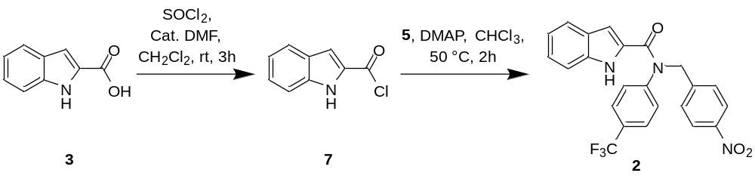
Scheme S3: Synthesis of compound 2:
To a solution of indole-2-carboxylic acid 3 (100 mg, 0.62mmol) in CH₂Cl₂ (2 mL), thionyl chloride (0.09 mL, 1.24 mmol) and 2 drops of DMF were added. The reaction mixture was stirred for three hours at room temperature. Then the solvent was evaporated to dryness in vacuo to give indole-2-carbonyl chloride 7. The residue was dissolved in CHCl₃ (2 mL). To this solution of amine 5 (50 mg, 0.17 mmol) in CHCl₃ (3 mL) was added dropwise followed by the addition of DMAP (21 mg, 0.17 mmol). The reaction mixture was heated at 50 °C and stirred for one hour and quenched with water. Following extraction with CH₂Cl₂ (3 × 20 mL), the organic phase was washed with water (2 × 15 mL) and brine (2 × 10 mL) and then dried over Na₂SO₄, filtered and concentrated under reduced pressure. The crude product was purified by silica gel chromatography (Eluent: CH₂Cl₂) to give the pure compound 2 as a white solid. ¹H NMR (400 MHz, CDCl₃): δ 9.31 (s, 1H), 8.04 (dd, J = 8.2, 1.2 Hz, 1H), 7.70 (t, J = 8.8 Hz, 3H), 7.64 (td, J = 7.6, 1.3 Hz, 1H), 7.50 – 7.43 (m, 1H), 7.43 – 7.36 (m, 4H), 7.27 (dd, J = 7.1, 1.2 Hz, 1H), 7.06 (td, J = 8.0, 7.0, 1.0 Hz, 1H), 5.53 (s, 2H), 5.45 (dd, J = 2.1, 0.8 Hz, 1H);¹³C NMR (101 MHz, CDCl₃:δ 162.63, 148.55, 146.16, 135.83, 133.86, 132.46, 131.00, 130.67, 129.34, 128.63, 128.60, 128.53, 128.5, 127.24 (q, J = 3.7 Hz), 125.46, 125.42, 122.55, 120.88, 111.80, 108.24 , 52.10.IR (ν cm⁻¹): 3322, 2923, 2853, 1594, 1515, 1405, 1319, 1267, 1113, 1066, 848, 748; HRMS (ESI):Calcd. for C₂₃H₁₇F₃N₃O₃[M+H]⁺: 440.1222; Observed: 440.1217; M.P.: 226 °C.

- Anion recognition by ¹H NMR titration:
¹H NMR titration was carried out at room temperature on Bruker 400 MHz spectrometer. The residual solvent signal (CD₃CN ¹_{H} δ ppm 1.94) was considered as an internal reference to calibrate spectra. The titrations were performed by addition of aliquots of tetrabutylammonium chloride (TBACl) (0.4M in CD₃CN) in the solution of receptor 1d (0.005 M in CD₃CN). Both the TBACl salt and receptor were dried in high vacuum before use. All NMR data were processed using MestReNova 6.0 and change in chemical shift plotted and fitted in 1:1 binding model using WinEQNMR2 programme.
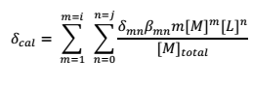Equation S1
Where, M represents the free un-complexed receptor and L is the ligand; δ_{cal}, is the weighted average of the chemical shifts of the various M-containing species present, M^{m}L^{n}, and i and j represent the maximum values of m and n respectively.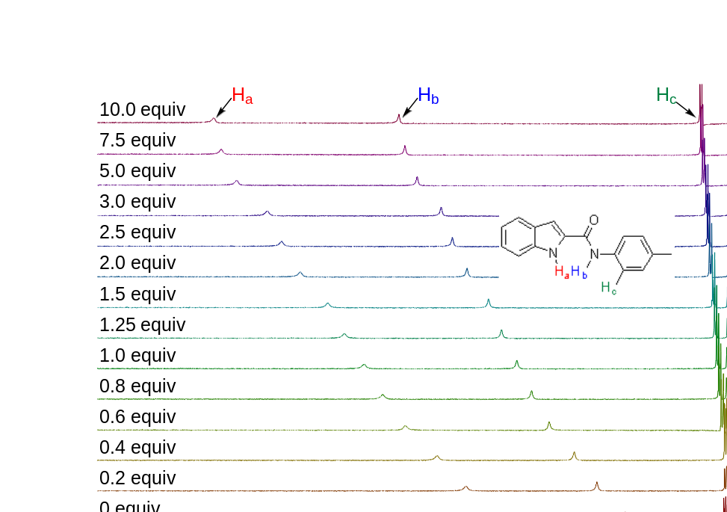
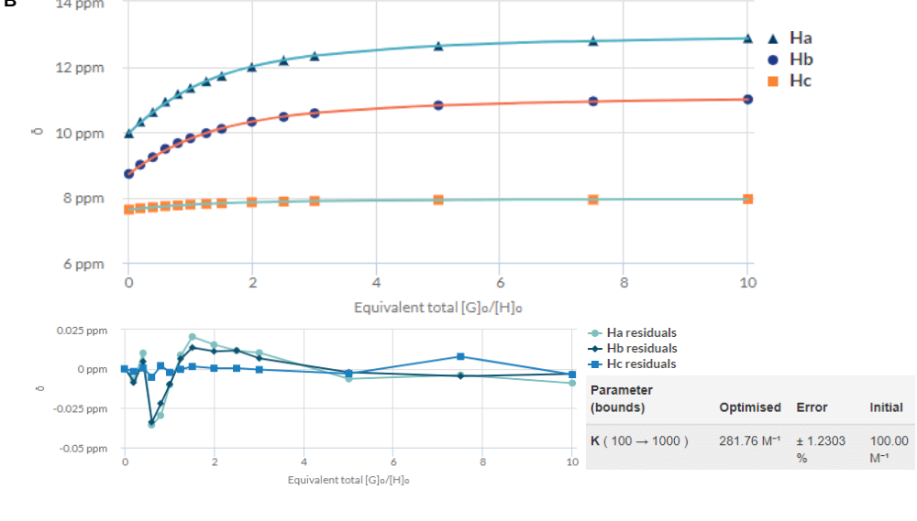
Figure S1.¹H NMR titration spectra for 1a with stepwise addition of TBACl in CD₃CN. The equivalents of added TBACl are shown on the stack spectra. Plot of concentration of TBACl verses δ of H_{a}, H_{b}, H_{c} fitted to 1:1 binding model of supramolecular.Org – Binding Constant Calculator (B).
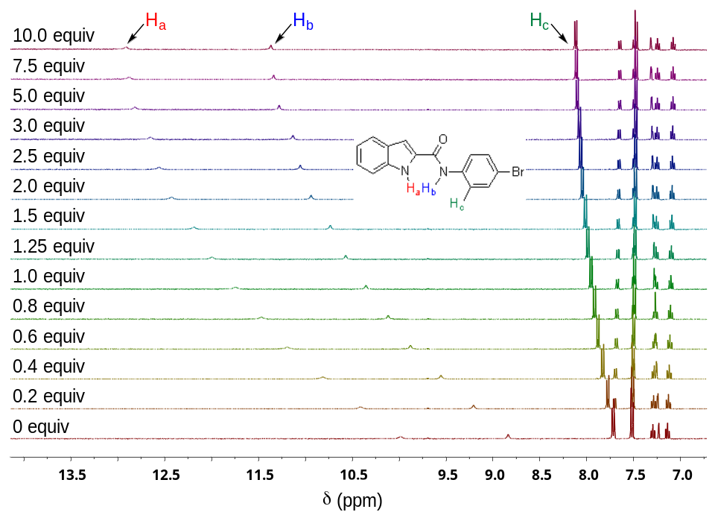
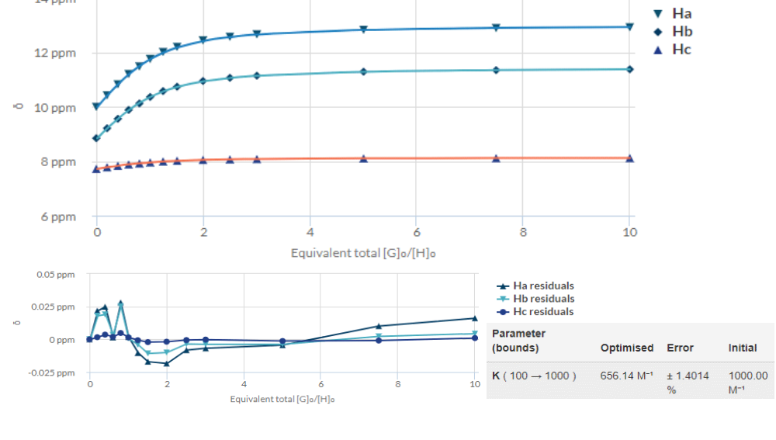
Figure S2.¹H NMR titration spectra for 1c with stepwise addition of TBACl in CD₃CN. The equivalents of added TBACl are shown on the stack spectra. (A) Plot of concentration of TBACl verses δ of H_{a}, H_{b}, H_{c} fitted to 1:1 binding model of supramolecular.Org – Binding Constant Calculator (B).
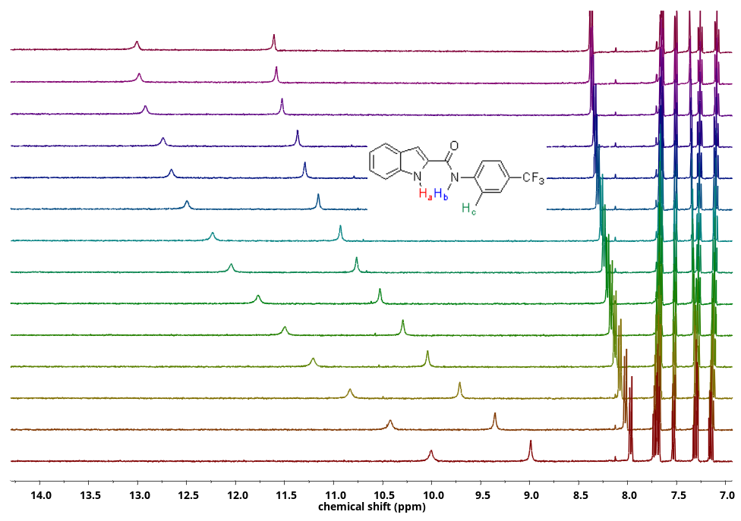
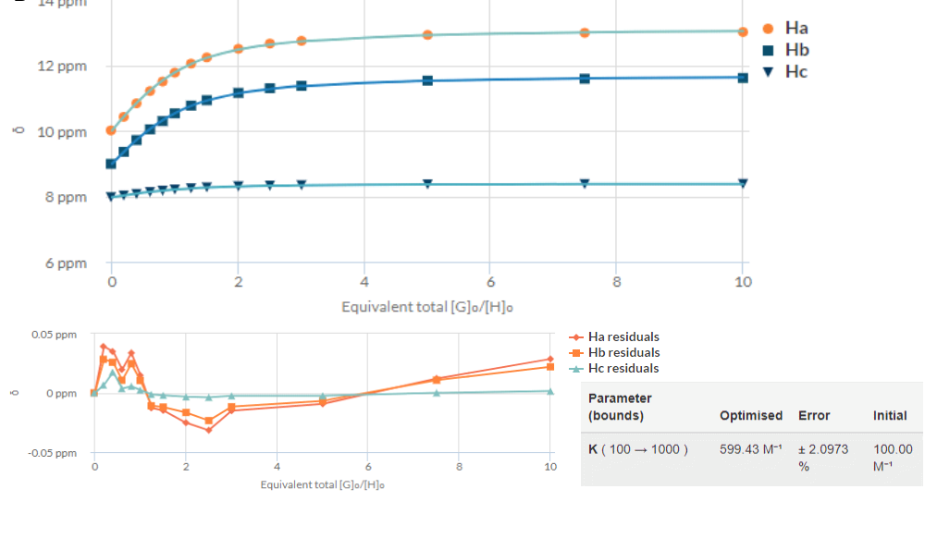
Figure S3.¹H NMR titration spectra for 1d with stepwise addition of TBACl in CD₃CN. The equivalents of added TBACl are shown on the stack spectra. (A) Plot of concentration of TBACl verses δ of H_{a} fitted to 1:1 binding model of supramolecular.Org – Binding Constant Calculator (B).

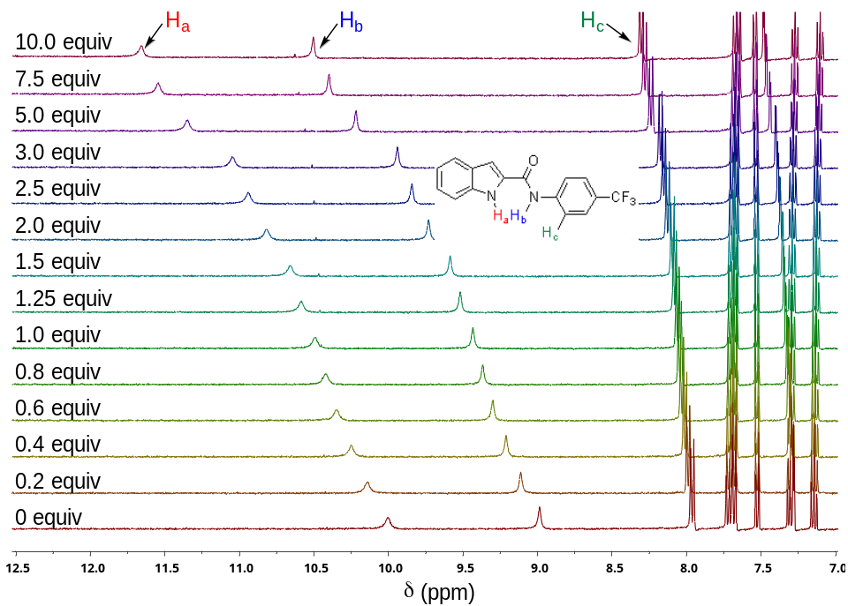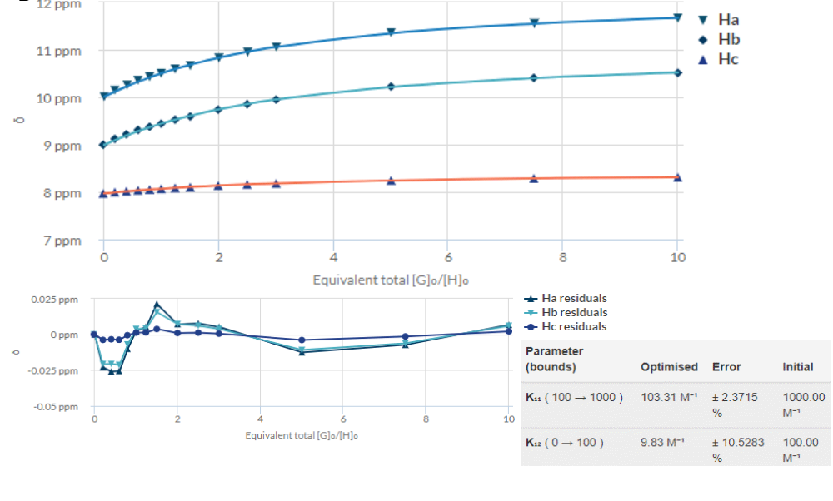

Figure S4.¹H NMR titration spectra for 1d with stepwise addition of TBABr in CD₃CN. The equivalents of added TBABr are shown on the stack spectra. (A) Plot of concentration of TBABr verses δ of H_{a}, H_{b}, H_{c} fitted to 1:1 and 1:2 binding model of supramolecular.Org – Binding Constant Calculator (B).

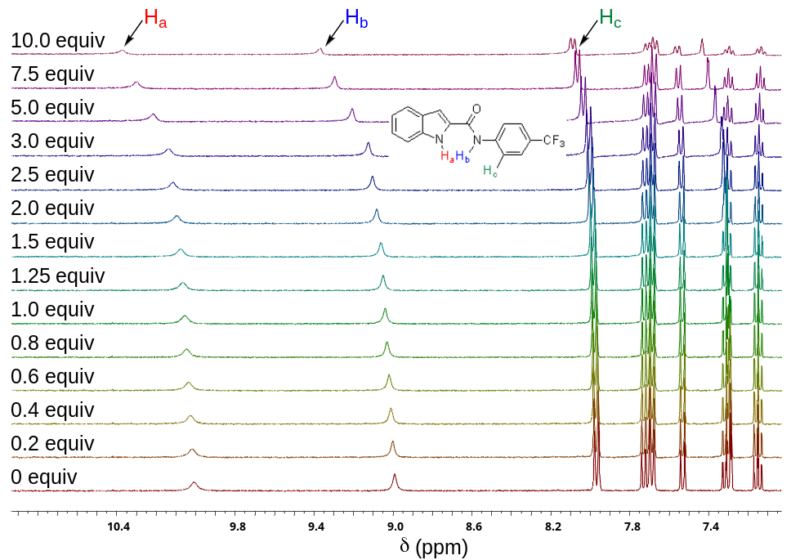

Figure S5.¹H NMR titration spectra for 1d with stepwise addition of TBAI in CD₃CN. The equivalents of added TBAI are shown on the stack spectra (A). Shift in δ values of H_{a}, H_{b}, H_{c} was not much predominant upon addition of TBAI so binding constant could not be determined.
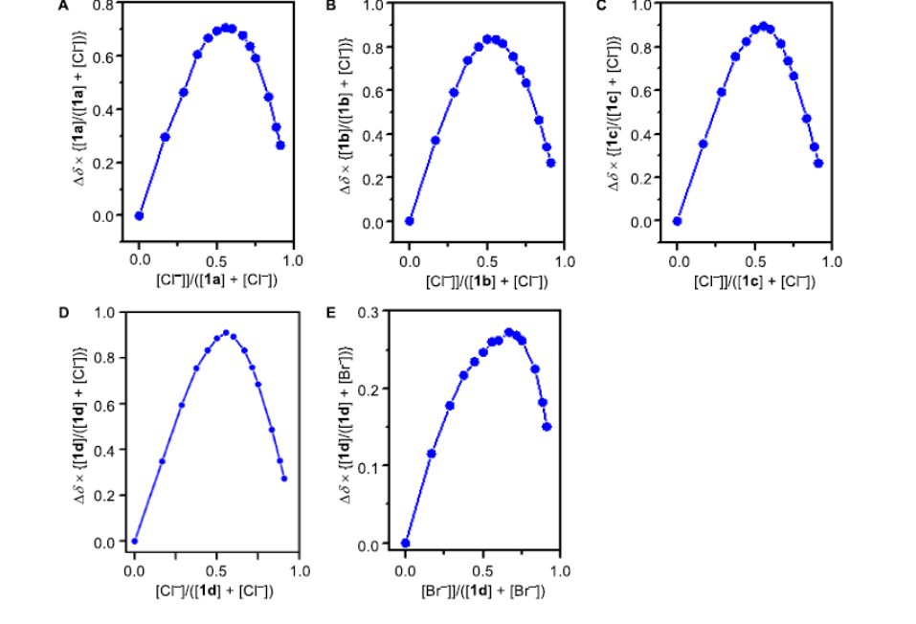
Figure S6. Job plot analysis for the N-Ha proton shift of 1a (A), 1b (B), and 1c (C) upon
titration with TBACl. Job plot analysis for the N-Ha proton shift of 1d upon titration with
TBACl (D), and TBABr (E).
IV: Ion transport experiments:
- Ion transporting activity studies across EYPC-LUVs ⊃HPTS:
Preparation of HEPES buffer and stock solutions: The HEPES buffer of pH = 7.0 was prepared by dissolving an appropriate amount of solid HEPES (10 mM) and NaCl (100 mM) in autoclaved water. The pH was adjusted to 7.0 by addition aliquots from 0.5 M NaOH solution. The stock solution of all carriers was prepared using HPLC grade DMSO.
Preparation of EYPC-LUVs⊃HPTS in NaCl: In a 10 mL clean and dry round bottom flask thin transparent film of egg yolk phosphatidylcholine (EYPC) was formed using a 1 mL EYPC lipid (25 mg/mL in CHCl₃) by providing continuous rotation and purging nitrogen gas. The transparent thin film was completely dried under high vacuum for 4-5 hrs. After that transparent thin film was hydrated with the addition of 1 mL HEPES buffer (1 mM HPTS, 10 mM HEPES, 100 mM NaCl, pH = 7.0) by giving 10 minutes interval vertexing during 1 hour. This hydrated suspension was subjected to 15 cycles of freeze and thaw (N₂ gas, 55 °C) followed by extrusion through 100 nm(pore size) polycarbonate membrane for 21 times, to get vesicles of average 100 nm diameter. The un-entrapped HPTS dyes were removed by size exclusion chromatography using Sephadex G-50 (Sigma-Aldrich) with eluting of HEPES buffer (10 mM HEPES, 100 mM NaCl, pH = 7.0).Finally collected vesicles were diluted to 6 mL to get EYPC-LUVs⊃HPTS. Final conditions: ~ 5 mM EYPC inside: 1 mM HPTS, 10 mM HEPES, 100 mM NaCl, pH = 7.0, outside: 10 mM HEPES, 100 mM NaCl, pH = 7.0.
Ion transport activity by HPTS assay: In a clean and dry fluorescence cuvette, 1975 μL of HEPES buffer (10 mM HEPES, 100 mM NaCl, pH = 7.0) and 25μL of EYPC-LUVs⊃HPTS vesicle was added. The cuvette was placed in slowly stirring condition using magnetic stirrer
equipped in fluorescence instrument (t = 0s). The time-dependent HPTS emission intensity monitored at λ_{em} = 510 nm (λ_{ex} = 450 nm) by creating pH gradient between intra and extra vesicular system by addition of 0.5 M NaOH (20 μL) at t = 20s, transporter at t = 20s. Then different concentrations of transporter molecules in DMSO were added at t = 100s. Finally, the vesicle was lysed by addition of 10% Triton X- 100 (25 μL) at t = 100s to disturb pH gradient. The time-dependent data were normalized to percent change in fluorescence intensity using I_{F} = [(I_{t}− I₀)/(I∞− I₀)] × 100) (Equation S2)
Where I₀ is the initial intensity, I_{t} is the intensity at time t, and I∞ is the final intensity after addition of Triton X-100.
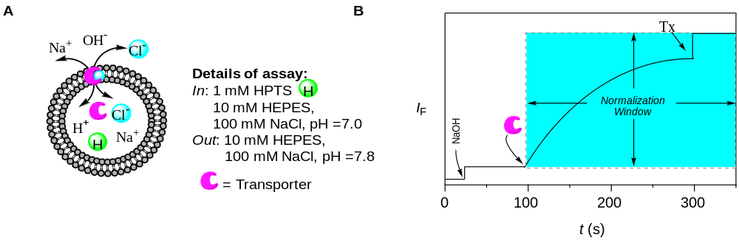
Figure S7. Representations of fluorescence-based ion transport activity assay using EYPC-LUVs⊃HPTS (A), and illustration of ion transport kinetics showing normalization window (B).
Dose-response activity:
The fluorescence kinetics of each transporter at different concentration was studied as a course of time. The concentration profile data were evaluated to get effective concentration (EC₅₀) using Hill equation (Equation S2):
Y = Y∞ + (Y₀– Y∞)/[1 + (c/EC₅₀)^{n}] (Equation S3)
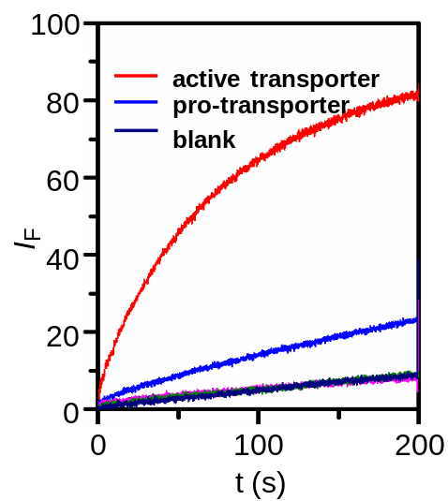where Y₀ = fluorescence intensity just before the transporter addition (at t = 0s), Y∞ = fluorescence intensity with excess transporter concentration, c = concentration of transporter compound.

Figure S8. Comparison of ion transport activities of active (1d) and pro-transporter (7) across EYPC-LUVs⊃HPTS at a concentration of 400 nm each.

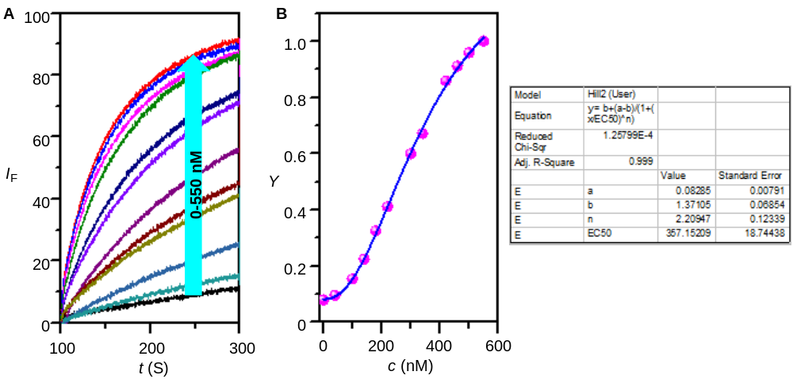
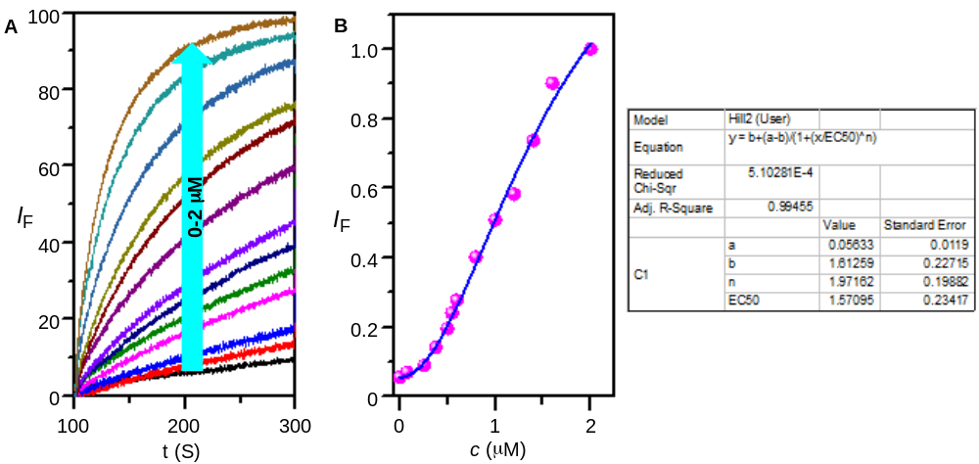Figure S9. Concentration dependent activity of compound 1d across EYPC-LUVs⊃HPTS (A). Hill plot analysis of compound 1d (B).

Figure S10. Concentration dependent activity of compound 1c across EYPC-LUVs⊃HPTS (A). Hill plot analysis of compound 1c (B).

- Ion selectivity studies across EYPC-LUVs⊃HPTS :
Preparation of EYPC-LUVs⊃HPTS: The vesicles were prepared by the following protocol as stated above.
Preparation of buffer and stock solutions : The HEPES buffer solution of 10 mM HEPES and 100 mM salts were prepared by dissolving appropriate amounts of solid HEPES and salts (NaCl, NaF, NaBr, NaI, NaNO₃, NaSCN, NaOAc, NaClO₄, LiCl, KCl, RbCl, and CsCl) in autoclaved water, followed by adjustment of pH = 7.0 using 0.5 M NaOH. The stock solution of the most active transporter was prepared in HPLC grade DMSO.

Anion selectivity assay: In a clean and dry fluorescence cuvette 1975 μL HEPES buffer (10 mM HEPES, 100 mM NaX, pH = 7.0; where X = F⁻, Cl⁻, Br⁻, I⁻, OAc⁻, NO₃⁻, SCN⁻ and ClO₄⁻) was taken, followed by addition of 25 μL EYPC-LUVs⊃HPTS. The resulting solution was slowly stirred in fluorescence instrument equipped with the magnetic stirrer (t = 0s). The fluorescence intensity of HPTS was observed at λ_{em} = 510 nm (λ_{ex} = 450 nm) as a course of time, with creating pH gradient by addition of 20 μL 0.5 M NaOH at t = 20s, followed by addition of transporter 1d (as a DMSO solution) at t = 100s to initiate ion transport and finally vesicle was lysed for complete destruction of pH gradient by addition of 25 μL 10% Triton X-100 at t = 300s. The time-dependent data were normalized to percent change in intensity using Equation S2 (I_{F} = [(I_{t} − I₀)/ (I∞− I₀)] × 100), where I₀ is the initial intensity, I_{t} is the intensity at time t, and I∞ is the final intensity after addition of Triton X-100).
Cation selectivity assay: In a similar way, cation selectivity of transporter 1d (as a DMSO solution) was explored by changing extravesicular HEPES buffer solution (10 mM HEPES, 100 mM MCl, pH = 7.0) of chloride salts (MCl) of different cation (M= Li⁺, Na⁺, K⁺, Rb⁺, Cs⁺). Using the same condition, no difference in fluorescence intensity was observed for different cations. The fluorescence data were normalised to percent change in intensity as a course of time using Equation S2 (I_{F} = [(I_{t} − I₀)/ (I∞− I₀)] × 100), where I₀ is the initial intensity, I_{t} is the intensity at time t, and I∞ is the final intensity after addition of Triton X-100).

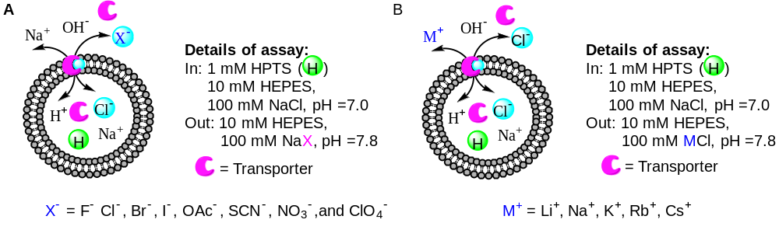
Figure S11. Schematic representations of fluorescence-based anion (A) and cation (B) selectivity assays.
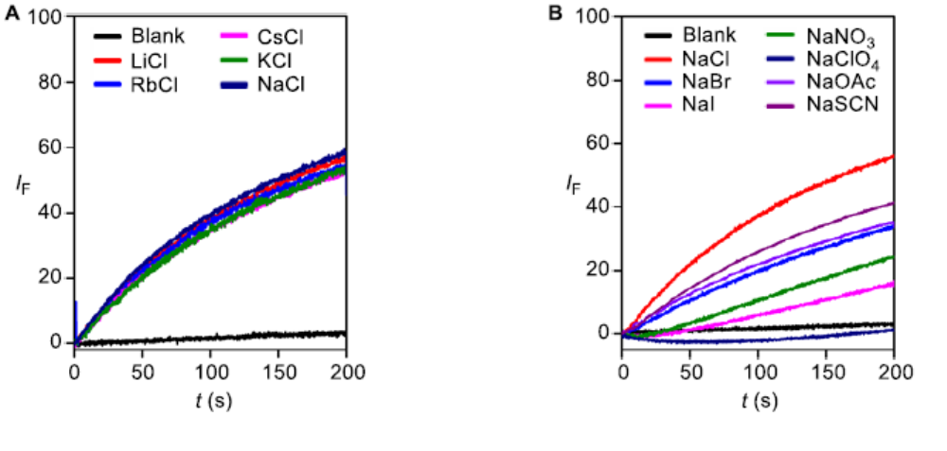
Figure S12. Cation selectivity of (A) 1d (340 nm) and (B) Anion selectivity of 1d (340 nm) determined from HPTS assay.

- Ion transport mechanism by HPTS assay:
Ion transport activity in the presence of FCCP: Following the same procedure as stated above vesicles were prepared. The fluorescence intensity of transporter 1d was measured with and without FCCP. In clean and dry fluorescence cuvette 1975 μL HEPES buffer solution (10 mM HEPES, 100 mM NaCl, pH = 7.0) and 25 μL EYPC-LUVs⊃HPTS was taken, and then this solution was placed in slowly stirring condition in fluorescence instrument equipped with magnetic stirrer. The time-dependent fluorescence intensity was measured at λ_{em} = 510 nm (λ_{ex} = 450 nm) by addition of 20 μL 0.5 M NaOH (at t = 20s) to create pH gradient across the intra and extracellular system, followed by addition of FCCP (at t = 50s) and transporter in DMSO solution (at t = 100s), finally vesicle was lysed using 25 μL 10 % Triton-X (at t = 300s) to achieve complete disturbance of pH gradient. The time-dependent collected data was normalized to percent change in intensity using equation S2 (I_{F} = [(I_{t} − I₀)/(I∞ − I₀)] × 100), where I₀ is the initial intensity, I_{t} is the intensity at time t, and I∞ is the final intensity after addition of Triton X-100).
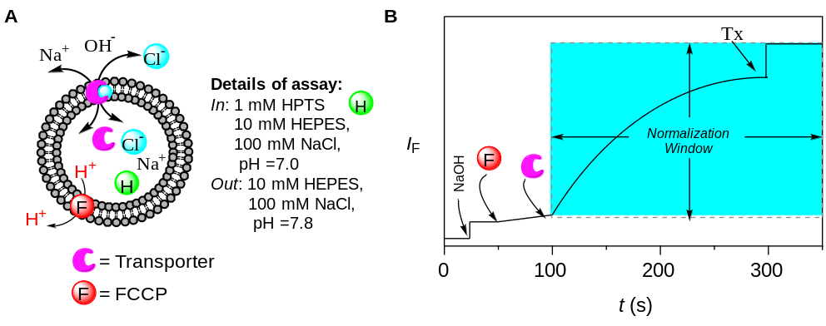
Figure S13. Representative fluorescence-based FCCP assay using EYPC-LUVs⊃HPTS (A) and representation of ion transport kinetics showing normalization window (B)
Ion transport activity in the presence of valinomycin: The vesicles were prepared using the same protocol as mentioned above. The fluorescence data was investigated with and without valinomycin. In a clean and dry fluorescence cuvette 1975μL HEPES buffer (10 mM HEPES, 100 mM KCl, pH = 7.0) was taken, followed by addition of 25μL EYPC-LUVs ⊃HPTS. The resulting solution was slowly stirred using magnetic stirrer equipped with fluorescence instrument. The time-dependent fluorescence intensity was monitored at λ_{em} = 510 nm (λ_{ex} = 450 nm). The pH gradient was created by addition of 20μL 0.5 NaOH at t = 20s, followed by addition of valinomycin at t = 50s, transporter in DMSO solution at t = 100s and finally complete disturbance of pH gradient was achieved by addition of 10% Triton-X (to lyse vesicle) at t = 300s. Fluorescence intensity was normalised to percent change in intensity using Equation S2.
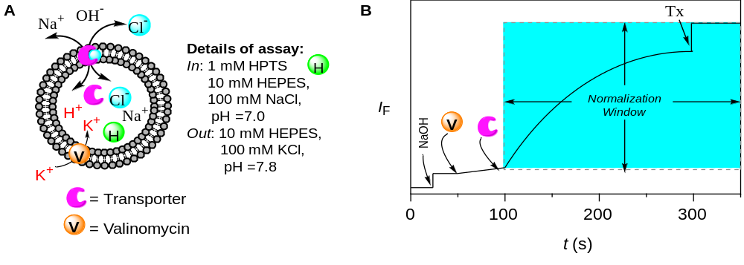
Figure S14.Representative fluorescence-based valinomycin assay using EYPC-LUVs⊃HPTS (A) and representation of ion transport kinetics showing normalization window (B)
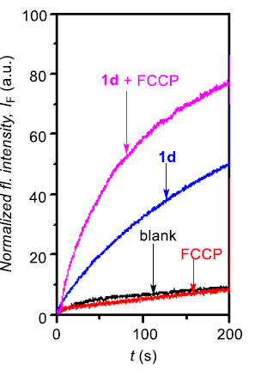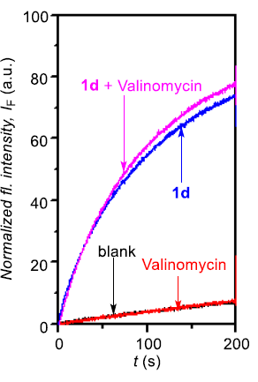
A
B
Figure S15. Ion transport activity of 1d (1.25 μM) determined in the absence and presence of FCCP (A). Ion transport activity of 1d (1.25 μM) determined in the absence and presence of valinomycin (B).
- Chloride transport activity across EYPC-LUVs⊃Lucigenin vesicles:
Preparation of EYPC-LUVs⊃Lucigenin vesicles:
In a 10 mL clean and dry round bottom flask the thin transparent film of egg yolk phosphatidylcholine (EYPC) was formed by drying 1 mL egg yolk phosphatidylcholine (EYPC, 25 mg/mL in CHCl₃) with providing continuous rotation and purging nitrogen. The transparent thin film was kept on high vacuum for 4 hrs to remove all trace of CHCl_{3.} Then the transparent thin film was hydrated with 1 mL aqueous NaNO₃ (200 mM, 1 mM Lucigenin) with occasional vertexing at 10 minute interval for 1 hour. The resulting suspension was subjected for freeze and thaw cycles (≥15, liquid nitrogen, 55°C water bath) and 21 times extrusion through 200 nm pore size polycarbonate membrane. The size exclusion chromatography (using Sephadex G-50) was performed to remove extracellular dye using 200 mM NaNO₃ solution as eluent, finally collected vesicles were diluted to 4 mL. Final conditions: ~5 mM EYPC; inside: 200 mM NaNO₃, 1 mM lucigenin, pH = 7.0; outside: 200 mM NaNO₃.
Ion transport activity by Lucigenin assay:
In a clean and dry fluorescence cuvette, 1975 µL 200 mM NaNO₃ solution and 25 µL EYPC-LUVs⊃Lucigenin was taken. This suspension was placed in a slowly stirring condition in fluorescence instrument equipped with a magnetic stirrer (at t = 0s). The fluorescence intensity of lucigenin was monitored at λ_{em} = 535 nm (λ_{ex} = 450 nm) as a course of time. The chloride gradient was created by addition of 33.3 µL NaCl (2.0 M) at t = 20s between intra and extra vesicular system, followed by addition of transporter at t = 100s. Finally, vesicles were lysed by addition of Triton X-100 at t = 300s for the complete destruction of chloride gradient.
The time-dependent data were normalized to percent change in fluorescence intensity using Equation S3: I_{F} = [(I_{t} − I₀)/(I∞ − I₀)] × −100)
Where, I₀ is the initial intensity, I_{t} is the intensity at time t, and I∞ is the final intensity after addition of Triton X-100.

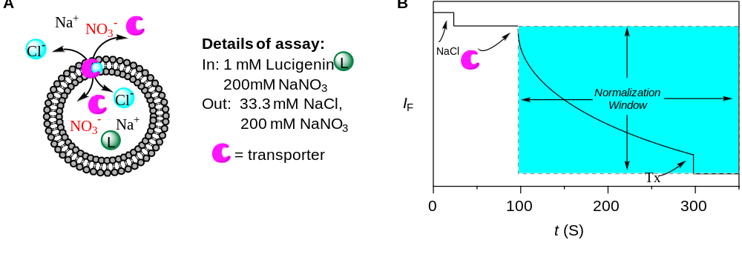
Figure S16. Representations of fluorescence-based ion transport activity assay using EYPC-LUVs⊃Lucigenin (A), illustration of ion transport kinetics showing normalization window (B).
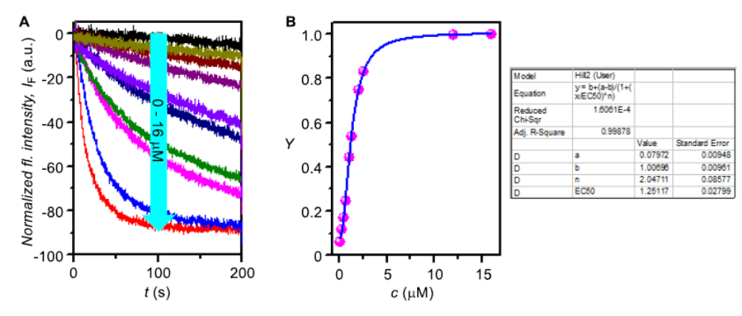
Figure S17. Concentration dependent activity of compound 1d across EYPC-LUVs⊃Lucigenin. (A). Hill plot analysis of compound 1d. (B)
Ion transport activity in presence of valinomycin:

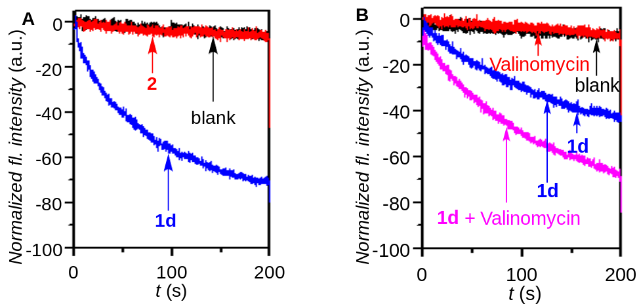
Figure S18. Comparison of Cl⁻ influx activity of 1d and 2 (2 µM each) across EYPC-LUVs⊃Lucigenin (A). Comparison of Cl⁻ influx activity of 1d (1.25 µM) in the absence and in the presence of valinomycin (1.25 µM) (B).

The antiport mechanism of 1d was experimentally confirmed by Lucigenin assay in presence of valinomycin. The ion transport activity of 1d was monitored in vesicle entrapped with Lucigenin and NaNO₃ (200 nM) suspended in KCl solution with and without valinomycin. The remarkable enhancement in ion transport activity of 1d in presence of valinomycin gave direct experimental insight of antiport mechanism of ion transport.
Preparation of EYPC-LUVs⊃Lucigenin vesicles: The vesicles were prepared by the following protocol as stated above.
Antiport mechanism: In a clean and dry fluorescence cuvette, 1975 µL 200 nM NaNO₃ solution and 25 µL EYPC-LUVs⊃Lucigenin vesicles were taken and slowly stirred in fluorescence instrument equipped with magnetic stirrer (at t = 0s). The time dependent fluorescence intensity of Lucigenin was monitored at λ_{em} = 535 nm (λ_{ex} = 450 nm). 33.3 µL KCl (2 M) was added at t = 20s to create chloride gradient between intra and extra vesicular system, followed by addition of valinomycin (1.25 µM) at t = 50s and transporter 1d (1.25 µM) at t = 100s. Finally, destruction of chloride gradient was done by addition of 25 µL Triton X – 100 at t = 300s. The time-dependent data were normalized to percent change in fluorescence intensity using Equation S3.
Control experiment: The enhancement of fluorescence intensity of HPTS is either due to transport of chloride ion by formation of 1d or cleavage of vesicles. To investigate if release of 1d is responsible for the chloride ion influx control experiment was carried out. The flurorescence intensity was monitored by following same procedure where instead of addition of procarrier 2, DMSO was added.

HPLC Assay:
The whole cell lysate of A549 in PBS was prepared following protocol. The total protein concentration of the whole cell lysate was found to be 5 mg/mL, as measured by Bradford assay. Stock solutions of 7 and 1d (10 mM) were prepared in DMSO. The stocks were diluted to 1 mM and then to 25 μM using 1 mM PB Buffer. In a typical reaction, the compound 7 (25 µL, final conc. 50 µM) was added to 475 µL of whole cell lysate in PB (pH 7.4, 10 mM, diluted to 1 mM) and incubated at 37 ºC on an Eppendorf thermomixer comfort (650 rpm) for 1h. An aliquot (100 µL) was taken after an hour, centrifuged and the supernatant was diluted with ACN (100 µL) and was injected in HPLC (final concentration of 7 (25 µM)). E. coli were grown overnight in LB media. The cells were centrifuged for 10 min at 4,000 rpm at 4 ºC. Supernatant was used to test activation of compound 7 outside cells and the bacterial pellet was washed twice with fresh media and re-suspended in fresh media. E. coli (1 mL, OD-600 of 1.0) was incubated with compound 7 (50 µM) for 4 h at 37 ºC. The cell suspension was then centrifuged at 10,000 rpm at 4 ºC for 5 min and the pellet was washed twice with PB to remove excess of compounds. The pellet was re-suspended in 0.5 mL PB. This cell suspension was transferred into a micro-centrifuge tube and cells were lysed by sonication using the 130 Watt ultrasonic processor (VX 130W) by stepping a microtip with a 5 minutes pulse on time (with 1s ON and 3s OFF pulse, 60% amplitude, 20 kHz frequency) under ice-cold conditions. The respective whole cell lysate in PB buffer was filtered, diluted with ACN (0.5 mL) to make final concentration of compound 7 (25 µM) and injected (25 µL) in an HPLC instrument attached with a diode-array detector at 250 nm and 280 nm. The stationary phase used was C-18 reversed phase column (4.6 mm ×250 mm, 5 µm). The mobile phase used was H₂O:ACN. HPLC run time was 22 min with a flow rate of 1 mL/min with 70:30 → 0-5 min, 80:20 → 5-10 min, 90:10 → 10-13 min, 20:80 → 13-18 min, 30:70 → 18-20, 70:30 → 20- 22 min.¹⁹
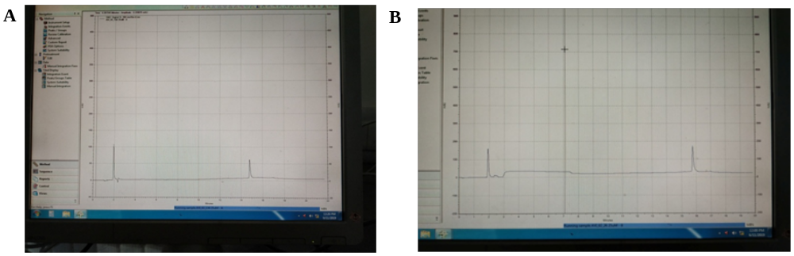
Figure S19. HPLC peaks (traces), i.e., retention times of compound 1d (A) and compound 7(B) in H₂O: ACN system.
NMR Spectra:
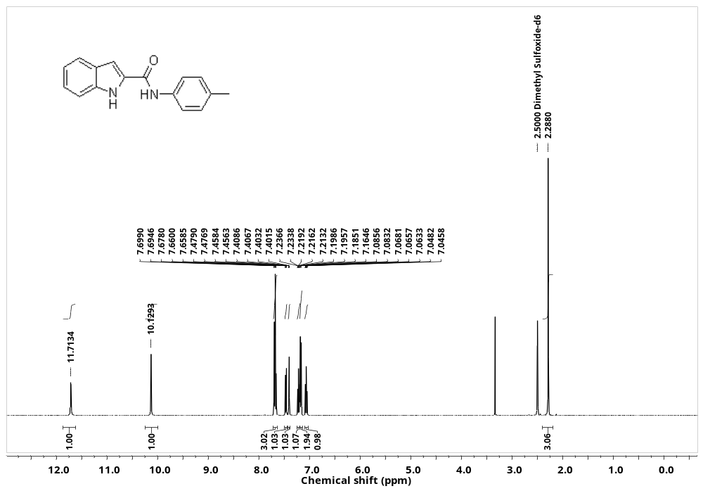
Figure S20. ¹H NMR spectrum of compound 1a
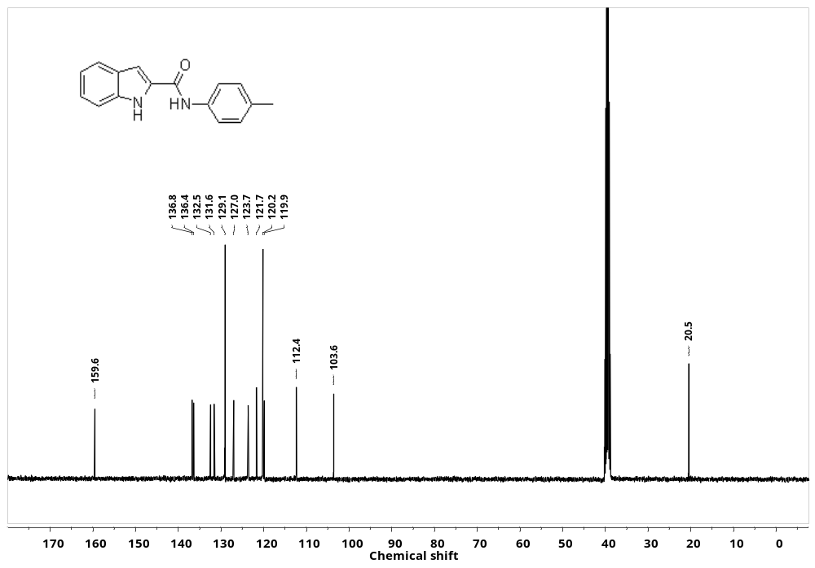
Figure S21. ¹³C NMR spectrum of compound 1a.
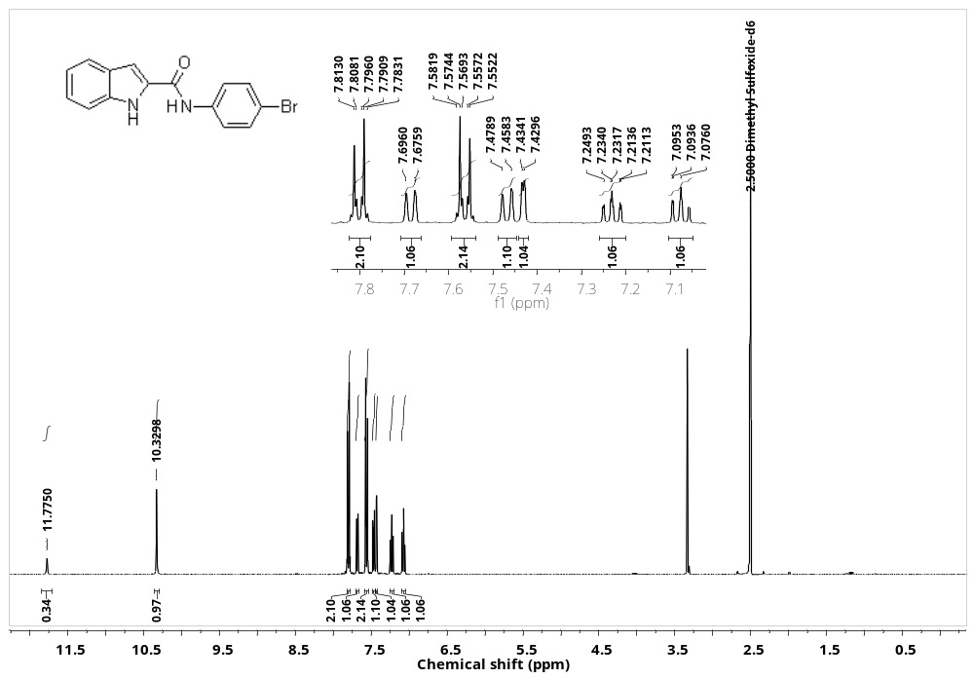
Figure S22. ¹H NMR spectrum of compound 1c
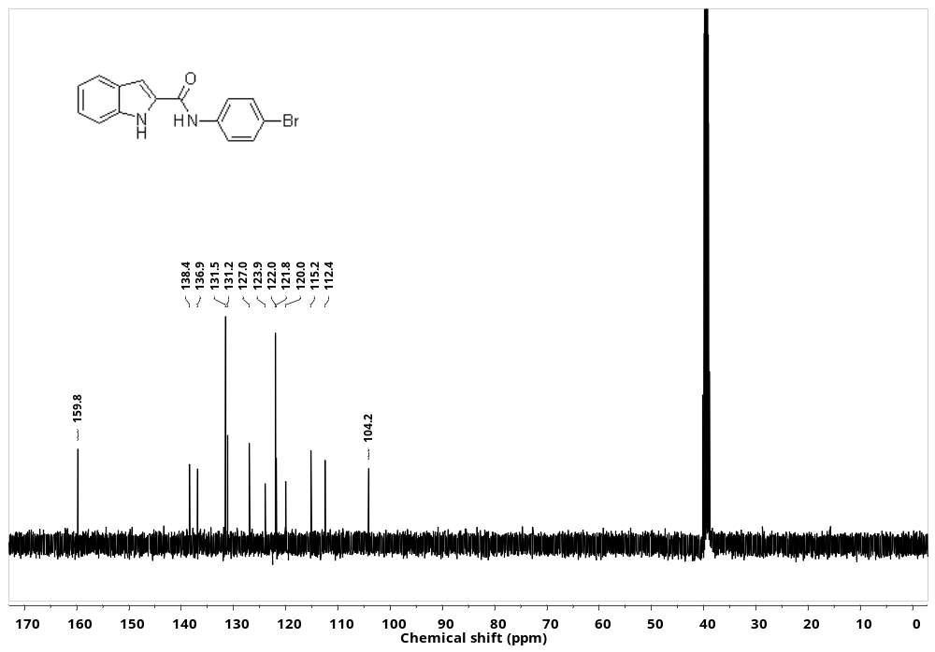
Figure S22.¹³C NMR spectrum of compound 1c.
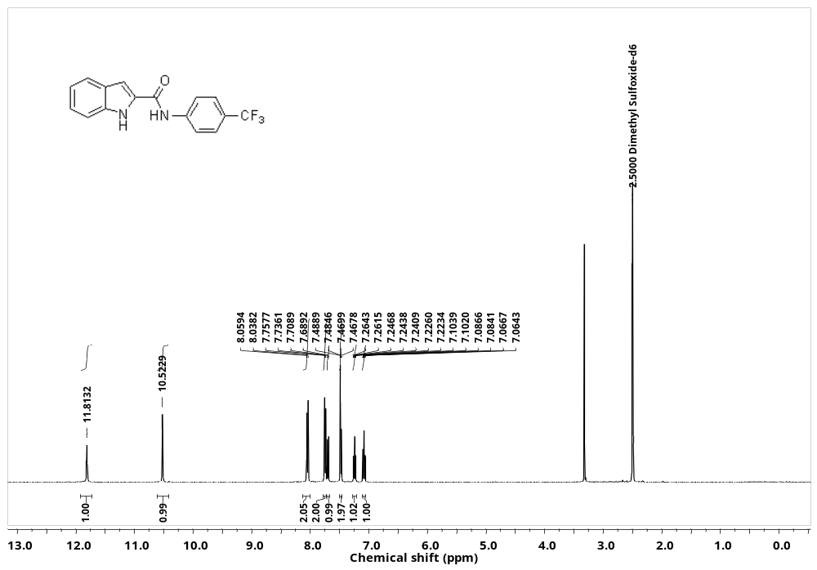
Figure S23. ¹H NMR spectrum of compound 1d.
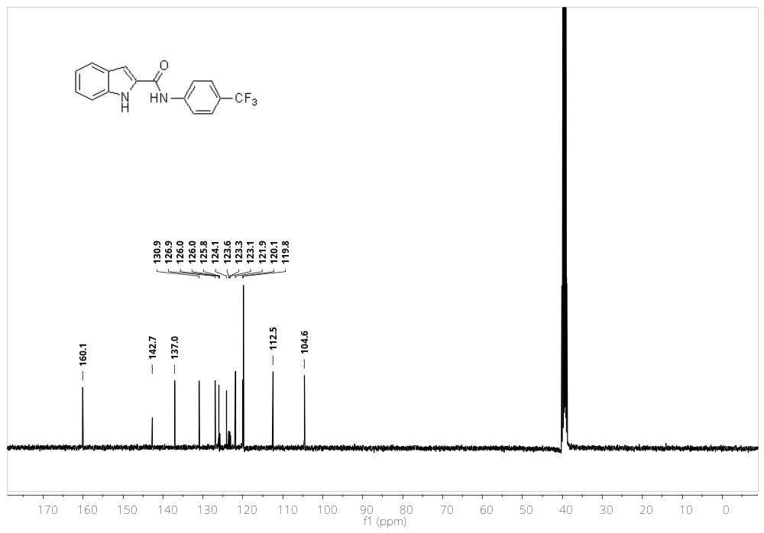
Figure S24. ¹³CNMR spectrum of compound 1d.
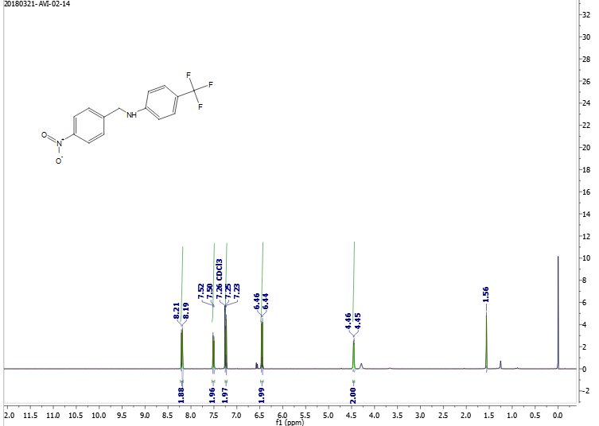
Figure S25. ¹H NMR spectrum of compound 5.
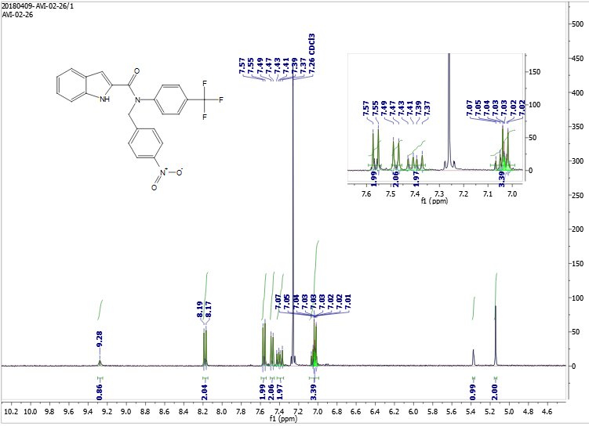
Figure S26. ¹H NMR spectrum of compound 7.

Objective II:
The proper introduction and removal of protecting groups is one of the most important and widely carried out synthetic transformations in preparative organic chemistry. For the manipulation of protecting groups, numerous classical chemical methods have been developed. Nevertheless, severe problems still remain caused by the need to selectively introduce or remove specific blocking functions which cannot or can only with great difficulties be solved by using classical chemical tools only.²⁰ In addition to their stereo-discriminating properties, enzymes offer the opportunity to carry out highly chemo- and regio-selective transformations. They often operate at neutral, weakly acidic or weakly basic pH values and in many cases combine a high selectivity for the reactions they catalyze and the structures they recognize with a broad substrate tolerance. Therefore, the application of these biocatalysts to effect the introduction and/or removal of suitable protecting groups offers viable alternatives to classical chemical methods.²¹

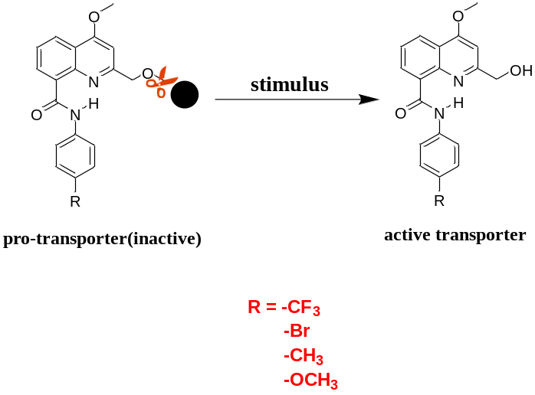
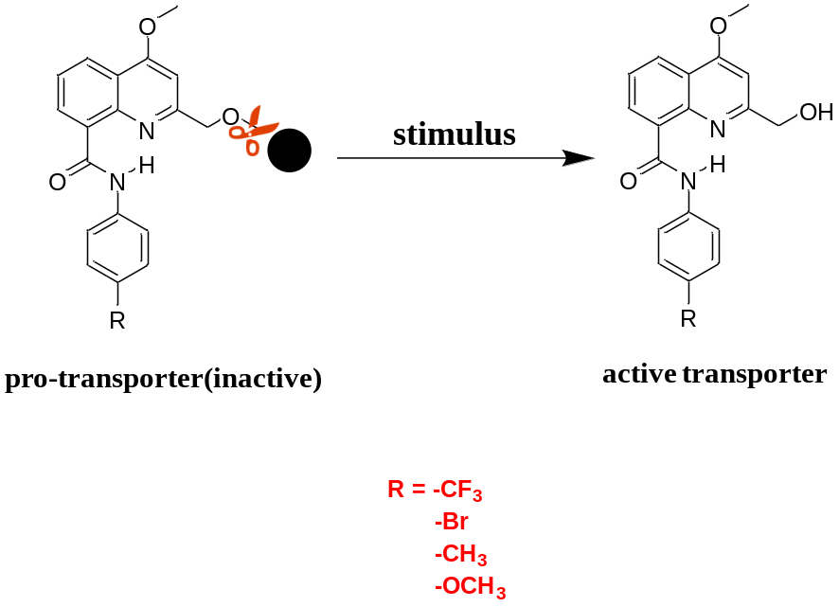Scheme S4: Synthesis of Active Transporters:
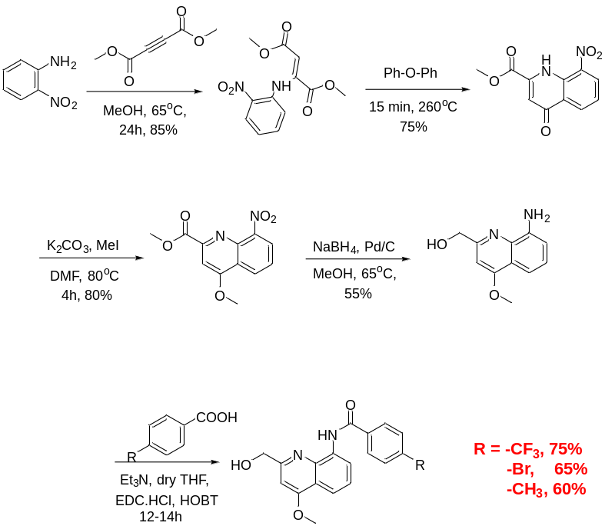

IV: Ion transport experiments:
- Ion transporting activity studies across EYPC-LUVs ⊃HPTS:
Preparation of HEPES buffer and stock solutions: The HEPES buffer of pH = 7.0 was prepared by dissolving an appropriate amount of solid HEPES (10 mM) and NaCl (100 mM) in autoclaved water. The pH was adjusted to 7.0 by addition aliquots from 0.5 M NaOH solution. The stock solution of all carriers was prepared using HPLC grade DMSO.
Preparation of EYPC-LUVs⊃HPTS in NaCl: In a 10 mL clean and dry round bottom flask thin transparent film of egg yolk phosphatidylcholine (EYPC) was formed using a 1 mL EYPC lipid (25 mg/mL in CHCl₃) by providing continuous rotation and purging nitrogen gas. The transparent thin film was completely dried under high vacuum for 4-5 hrs. After that transparent thin film was hydrated with the addition of 1 mL HEPES buffer (1 mM HPTS, 10 mM HEPES, 100 mM NaCl, pH = 7.0) by giving 10 minutes interval vertexing during 1 hour. This hydrated suspension was subjected to 15 cycles of freeze and thaw (N₂ gas, 55 °C) followed by extrusion through 100 nm(pore size) polycarbonate membrane for 21 times, to get vesicles of average 100 nm diameter. The un-entrapped HPTS dyes were removed by size exclusion chromatography using Sephadex G-50 (Sigma-Aldrich) with eluting of HEPES buffer (10 mM HEPES, 100 mM NaCl, pH =7 .0). Finally collected vesicles were diluted to 6 mL to get EYPC-LUVs⊃HPTS. Final conditions: ~ 5 mM EYPC inside: 1 mM HPTS, 10 mM HEPES, 100 mM NaCl, pH = 7.0, outside: 10 mM HEPES, 100 mM NaCl, pH = 7.0.
Ion transport activity by HPTS assay: In clean and dry fluorescence cuvette, 1975 μL of HEPES buffer (10 mM HEPES, 100 mM NaCl, pH = 7.0) and 25μL of EYPC-LUVs⊃HPTS vesicle was added. The cuvette was placed in slowly stirring condition using magnetic stirrer equipped in fluorescence instrument (t = 0s). The time-dependent HPTS emission intensity monitored at λ_{em} = 510 nm (λ_{ex} = 450 nm) by creating pH gradient between intra and extra vesicular system by addition of 0.5 M NaOH (20 μL) at t = 20s, transporter at t = 20s. Then different concentrations of transporter molecules in DMSO were added at t = 100s. Finally, the vesicle was lysed by addition of 10% Triton X- 100 (25 μL) at t = 100s to disturb pH gradient. The time-dependent data were normalized to percent change in fluorescence intensity using Equation S2: I_{F} = [(I_{t}− I₀)/(I∞− I₀)] × 100)
Where I₀ is the initial intensity, I_{t} is the intensity at time t, and I∞ is the final intensity after addition of Triton-X
Figure S27. Representations of fluorescence-based ion transport activity assay using EYPC-LUVs⊃HPTS (A), and illustration of ion transport kinetics showing normalization window (B).
Dose-response activity: The fluorescence kinetics of each transporter at different concentration was studied as a course of time. The concentration profile data were evaluated to get effective concentration (EC₅₀) using Hill equation (Equation S2):
Y = Y∞ + (Y₀– Y∞)/[1 + (c/EC₅₀)^{n}] (Equation S3)
where Y₀ = fluorescence intensity just before the transporter addition (at t = 0s), Y∞ = fluorescence intensity with excess transporter concentration, c = concentration of transporter compound.
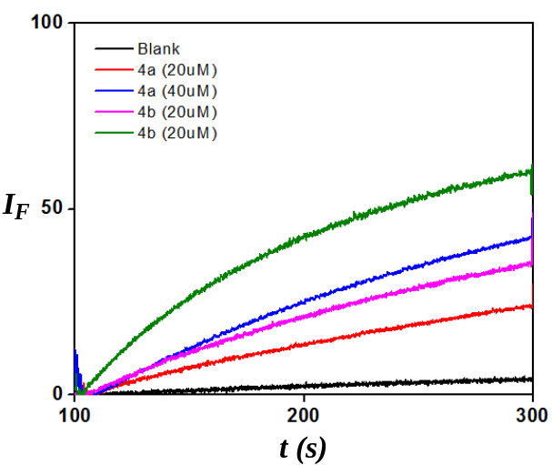

Figure S28. Comparison of ion transport activities of compounds 4a and 4b across EYPC-LUVs⊃HPTS at a concentration of 400 nm each.
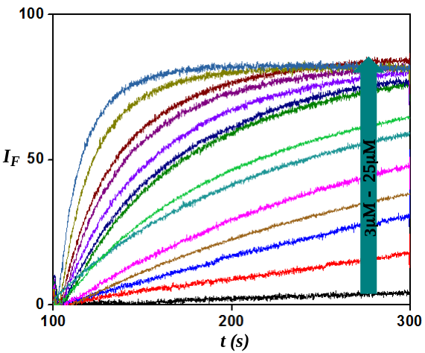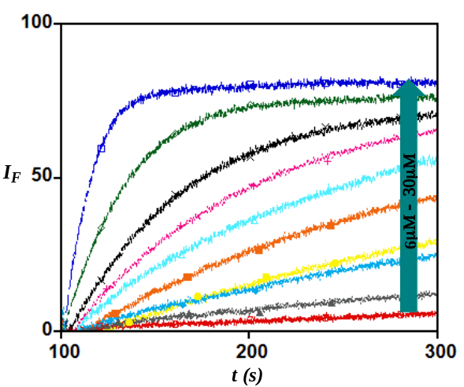

Figure S29: Concentration dependent activity of compound 4a (A) and 4b (B) across EYPC-LUVs⊃HPTS
Objective III:
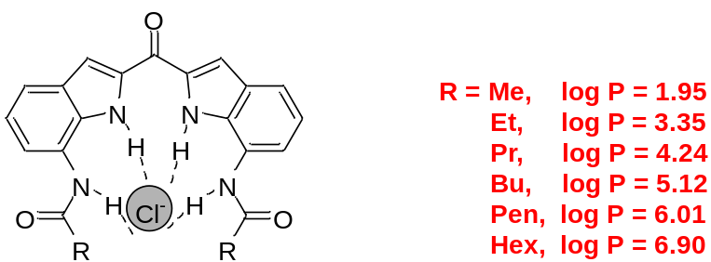

Scheme S5: Retrosynthetic Scheme:
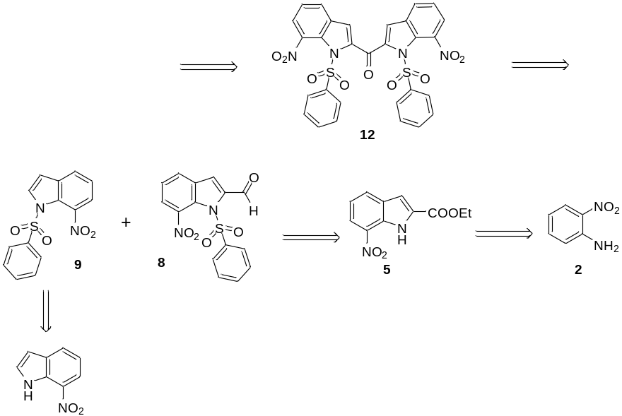

Scheme optimized so far:
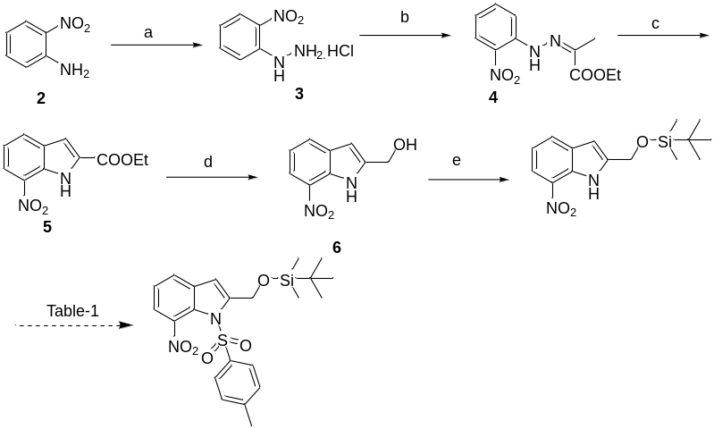

Future plan:
We will synthesize all the free and enzyme-cleavable group protected anion transporters and then study their ion transport activities across bilayer membrane.

References:
1) S. Licen, F. D. Riccardis, I. Izzo and P. Tecilla, Curr. Drug. Discov. Tech., 2008, 5, 86-97.
2) T. J. Jentsch, V. Stein, F. Weinreich and A. A. Zdebik, Physiol. Rev., 2002, 82, 503-568.
3) A. P. Davis, D. N. Sheppard and B. D. Smith, Chem. Soc. Rev., 2007, 36, 348-357.
4) L. Puljak and G. Kilic, Biochim. Biophys. Acta, Mol. Basis Dis., 2006, 1762, 404-413.
5) J. T. Davis, O. Okunola and R. Quesada, Chem. Soc. Rev., 2010, 39, 3843-3862.
6) R. Planells-Cases and T. J. Jentsch, Biochim. Biophys. Acta, Mol. Basis Dis., 2009, 1792, 173-189.
7) C. Duran, C. H. Thompson, Q. Xiao and C. Hartzell, Annu. Rev. Physiol., 2010, 72, 95-121.
8) Y. Okada, E. Maeno, T. Shimizu, K. Manabe, S. -I. Mori and T. Nabekura, Pflugers Arch, 2004, 448, 287-295.
9) G. Heimlich and J. A. Cidlowski, J Biol. Chem., 2006, 281, 2232-2241.
10) S.-K. Ko, S. K. Kim, A. Share, V. M. Lynch, J. Park, W. Namkung, W. Van Rossom, N. Busschaert, P. A. Gale, J. L. Sessler and I. Shin, Nat. Chem., 2014, 6, 885-892.
11) T. Saha, M. S. Hossain, D. Saha, M. Lahiri and P. Talukdar, Journal of the American Chemical Society, 2016, 138, 7558-7567.
12) T. Saha, A. Gautam, A. Mukherjee, M. Lahiri and P. Talukdar, J. Am. Chem. Soc., 2016, 138, 16443-16451.
13) A. Vargas Jentzsch, D. Emery, J. Mareda, P. Metrangolo, G. Resnati and S. Matile, Angew. Chem. Int. Ed., 2011, 50, 11675-11678.
14) V. Gorteau, G. Bollot, J. Mareda, A. Perez-Velasco and S. Matile, J. Am. Chem. Soc., 2006, 128, 14788-14789.
15) J. Mareda and S. Matile, Chem. Eur. J., 2009, 15, 28-37.
16) S. Valiyaveettil, J. F. J. Engbersen, W. Verboom and D. N. Reinhoudt, Angew. Chem. Int. Ed., 1993, 32, 900-901.
17) Stephen J. Moore, Marco Wenzel, Mark E. Light, Rebeka Morley, Samuel J. Bradberry, Patricia Gomez-Iglesias, Vanessa Soto-Cerrato, Ricardo Perez-Tomasc and Philip A.Gale, Chem. Sci., 2012, 3, 2501–2509.
18) Marvin 5.8.0, ChemAxon, 2012 (http://www.chemaxon.com)
19) Kundansingh A. Pardeshi, T. Anand Kumar, Govindan Ravikumar, Manjulika Shukla, Grace Kaul, Sidharth Chopra and Harinath Chakrapani, Bioconjugate Chem. 2019, 30, 751−759.

