Synthesis of 2‑Tetrazolylmethyl-isoindolin-1-ones via a One-Pot Ugi-Azide/(N-Acylation/exo-Diels−Alder)/Dehydration Process
Gámez-Montaño, Rocío, PhD, Universidad de Guanajuato, México
Rentería-Gómez, Ángel, BSc, Universidad de Guanajuato, México

Abstract
Isoindolin-1-one (oxoisoindoline) is the core of various natural and synthetic drugs, for example, pagoclone (antianxiolytic) and lenalidomide (anticancer). Additionally, 1,5 disubstituted tetrazoles (1,5-DS-T) are bioisosteres of the cis-amide bond of peptides¹, which are present in various drugs, such as latamoxeb (antibiotic). Moreover, 1,5-DST’s have been used as MOF precursors, ligands, and chelating agents.² We have recently reported MCR one-pot methods for the synthesis of a series of novel 1,5-DT’s linked with a variety of heterocyclic moieties.^{3,4} There are no reports describing the synthesis of unsymmetrical bis-heterocycles containing an isoindolin-1-one core N-linked with 1,5-DS-T’s using MCR one-pot methodologies or multistep methods. Thus, we now describe, for the first time, MCR one-pot synthesis of 2-tetrazolylmethyl isoindolin-1-ones N-linked with a 1,5-DS-T moiety (Fig 1).⁵ Findings: A series of fifteen 2-tetrazolylmethyl-isoindolin-1-one linked-type bis-heterocycles were synthesized in 10−76% yields under mild conditions via a one-pot Ugi-azide/(N-acylation/exo-Diels−Alder)/dehydration process from furan-2-ylmethanamine, aldehydes, isocyanides, azidotrimethylsilane, and maleic anhydride. Density functional theory calculations were performed using the polarizable continuum model (toluene)-M06-2X-D3/6-311+G(d)//M06-2X-D3/6-31G(d) level of theory to obtain the full energy profile when investigating over eight possible pathways. An anthracene containing analogue displayed a distribution of its highest occupied molecular orbital−lowest unoccupied molecular orbital throughout both cyclic moieties. Conclusion & Significance: the sustainable methodology described herein is the first MCR one-pot synthesis of bis-heterocycles containing isoindolin-1-one and 1,5-DS- moieties in a linked manner. This work is a contribution to the synthesis of linked-type unsymmetrical bis-heterocycles using Ugi-azide one-pot processes. DFT-based computational calculations gave us enough elements to propose the most plausible reaction mechanism among eight possible ones, which involves an Ugi-azide/(N-acylation/exo-DA)/dehydration sequence as the most thermodynamic and kinetically favored pathway. An anthracene-containing analogue displayed a very interesting distribution of HOMO−LUMO frontier orbitals throughout both of its cyclic moieties, which probably can be attributed to effective electron transfer.
Image

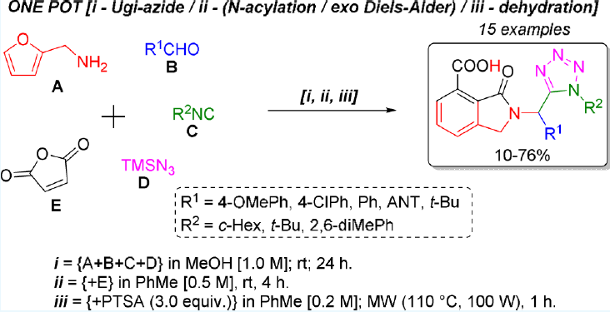
Fig1. Synthetic Strategy.

Recent Publications
- Rentería-Gómez A, Islas-Jácome A, Díaz-Cervantes E, Villaseñor-Granados T, Robles J, Gámez-Montaño R (2016) Synthesis of azepino[4,5-b] indol-4-ones via MCR/free radical cyclization and in vitro−in silico studies as 5-Ht6R ligands. Bioorg. Med. Chem. Lett. 26, 2333−2338.
- Aromí G, Barrios LA, Roubeau O, Gámez P (2011) Triazoles and tetrazoles: Prime ligands to generate remarkable coordination materials. Coord. Chem. Rev. 255, 485−546.
- Cárdenas-Galindo LE, Islas-Jácome A, Alvarez-Rodríguez NV, El Kaim L, Gámez-Montaño R (2014) Synthesis of 2-Tetrazolylmethyl- 2,3,4,9-tetrahydro-1H-β-carbolines by a One-Pot Ugi-Azide/Pictet−Spengler Process. Synthesis 46, 49−56.
- Unnamatla MVB, Islas-Jácome A, Quezada-Soto A, Ramírez-López SC, Flores-Álamo M, Gámez-Montaño R. (2016) Multicomponent One-Pot Synthesis of 3-Tetrazolyl and 3-Imidazo- [1,2-a]pyridin Tetrazolo[1,5-a]quinolines. J. Org. Chem. 81, 10576−10583.
- Rentería-Gómez A, Islas-Jácome A, Cruz-Jiménez AE, Manzano-Velázquez JC, Rojas-Lima S, Jiménez-Halla JOC, Gámez-Montaño R. (2016) Synthesis of 2‑Tetrazolylmethyl-isoindolin-1-ones via a One-Pot Ugi-Azide/(N-Acylation/exo-Diels−Alder)/Dehydration Process. ACS Omega, 1, 943-951



Rocío Gámez-Montaño* has got her PhD under guidance of Professor Raymundo Cruz-Almanza in UNAM, CDMX, México. After a post-doctoral fellow under guidance of Professor Jieping Zhu at Gif-Sur-Yvette, France, she was incorporated to University of Guanajuato, México, where is actually full-time Researcher-Professor (Class B). Her scientific interest includes design and developement of efficient synthesis of heterocycles and poly-heterocycles via MCR, in vitro and in silico studies of biological properties, applications in optics, as well as study of reaction mechanisms. Email: rociogm@ugto.mx

