Catalysis and Life-Cycle-Analysis of Current and Future Industrial Routes to CO₂ Utilization
Thomas Ernst Müller, RWTH Aachen University, Department Chemie, Worringerweg 2, 52074 Aachen, Germany

Abstract
The utilization of carbon dioxide (CO2) as an inexpensive and renewable C1 feedstock is of strategic importance for decreasing our dependence on fossil based raw materials (Ref. 1). In this context, the direct build-up of fuels, chemicals and polymers, at least partially, from CO2 is of particular interest. Various technologies are being discussed for implementation in the industry (Figure 1). The lecture will compare the current status of these technologies, the changes effected upon introducing CO2 as feedstock and evaluate the CO2 reduction potential based on the currently available life-cycle-analyses.
One recently commercialized process that involves the direct use of carbon dioxide as a feedstock is the production of organic carbonates by reaction of CO2 with epoxides (Ref. 2-4). Indirect routes for CO2 utilization are of equal relevance. Formaldehyde, commercially attained by partial combustion of methanol that, in a future economy, may be obtained from CO2, is a promising feedstock. Thus, oligomeric poly(acetalester) are generated readily from formaldehyde (Ref. 5). Such poly(acetalester) have intriguing properties rendering them inspiring compounds for fuel and polymer applications.
Motivated by the goal of expanding the CO2 technologies to further application fields, it seems essential to unravel highly effective strategies for activating the carbon dioxide molecule. The energy needed to overcome the thermodynamically low energy level of CO2 is thereby a crucial factor. Only when the energy level of the resulting intermediates is appropriate, the subsequent reaction of the activated CO2 molecule with the co-reagents will take place. The right choice of the catalyst is thus the key to CO2 conversion and directs the reaction pathway to the desired target products. The lecture concludes with discussing some of the most intriguing approaches for activating CO2.

Image

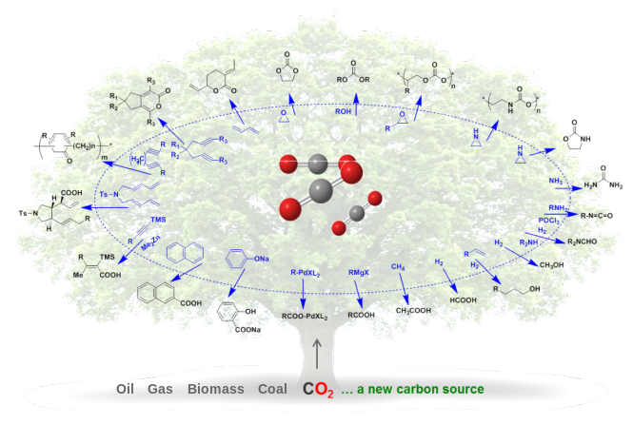
Figure 1: The utilization of carbon dioxide (CO2) as an inexpensive, renewable and abundant C1 feedstock is of strategic importance for decreasing our dependence on petroleum-derived raw materials. In
Recent Publications
- Markewitz P (2012) Worldwide innovations in the development of carbon capture technologies and the utilization of CO2. Energy & Environmental Science 5(6): 7281-7305.
- Pohl M (2016) Dynamics of Polyether Polyols and Polyether Carbonate Polyols. Macromolecules 49(23): 8995-9003.
- Subhani M A (2016) Transparent Films from CO2-Based Polyunsaturated Poly(ethercarbonate)s: A Novel Synthesis Strategy and Fast Curing. Angewandte Chemie International Edition 55(18): 5591-5596.
- Subhani M A (2016) Light-Mediated Curing of CO2-Based Unsaturated Polyethercarbonates via Thiol-ene Click Chemistry. Polymer Chemistry 7: 4121-4126.
- Castro-Osma J A (2016) Unprecedented Carbonato Intermediates in Cyclic Carbonate Synthesis Catalysed by Bimetallic Aluminium(Salen) Complexes. ChemSusChem 9: 791–794.
- Bizzarri C (2016) Oligomeric poly(acetalcarbonates) obtained by repolymerisation of paraformaldehyde. Green Chemistry 18(19): 5160-5168.

Biography
PD Dr. Thomas E. Müller is lecturer at RWTH Aachen University, Germany. He has received a PhD in Chemistry (1995) from Imperial College London. After positions at University of Sussex and TU Munich and visiting professor positions at NUS Singapore (2005) and University of Tokyo (2005), he accepted a position at Covestro in 2007. Since 2015 he concentrates on taking innovation to the chemical industry. He is associate editor of JCOU. His achievements include 80 papers and 75 patent applications, mainly in the fields of CO2 chemistry, catalyst development, and materials. His vision is to bridge the gap between fundamental research and industrial application.
Email: thomas.ernst.mueller@itmc.rwth-aachen.de

Notes/Comments:

