Carboranes and Metallacarboranes: Advances and New Perspectives

Narayan S. Hosmane, Department of Chemistry and Biochemistry, Northern Illinois University, DeKalb, IL 60115, USA.

Abstract (300 word limit)

Most of the carborane derivatives of the icosahedral (C₂B₁₀) or small cage (C₂B₄) systems are formed by varying the groups on the cage carbons. This is usually accomplished in the original carborane synthesis by reacting substituted acetylenes with either the B₁₀H₁₄ or B₅H₉ precursors. These reactions led directly to the “carbons adjacent” carboranes in which the carbon atoms occupy adjacent positions in the cage. The larger cages are obtained as closo-icosahedra, while the small cage, C₂B₄-carboranes, have nido- structures. There is another geometry of the small cages in which the carbon atoms are separated by a boron atom. Although these “carbons apart” or nido-2,4-(CR)₂B₄H₆ species are thermodynamically more stable and are more symmetric than the “carbons adjacent” isomers, they are not as well studied. ^{[1]} The main reason for the relative scarcity of information on the “carbons apart” systems lie in their method of preparation; they must be synthesized from their “carbons adjacent” analogues through sequential oxidative cage closure/reductive cage opening reactions. The historic perspective of the chemistry of carboranes and metallacarboranes with the latest findings in our research involving boron nanomaterials will be presented in detail.

Recent Publications (minimum 5)
[1] Hosmane, N. S.; Maguire, J. A. Organometallics, 2005, 24, 1356-1389; Satapathy, R.; Dash, B. P.; Maguire, J. A.; Hosmane, N. S. Dalton Trans., 2010, 39, 6613-6625; Gao, S.; Fu, R.; Hosmane, N. S. Pure Appl. Chem., 2015, 87, 123-134.

Image

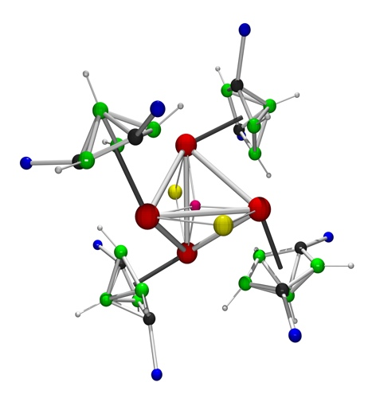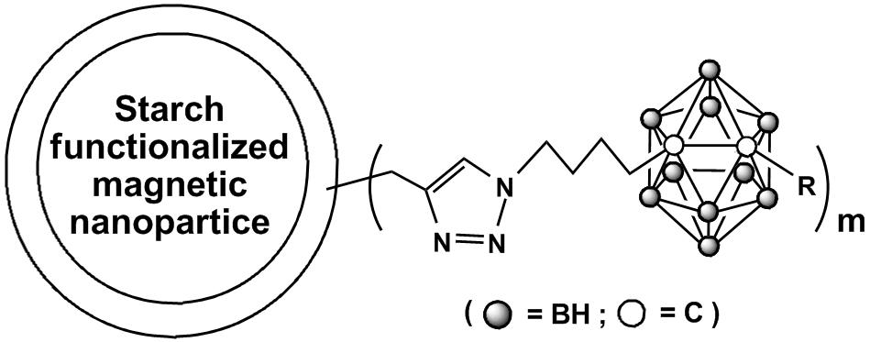

Biography (150 word limit)

Narayan S. Hosmane was born in Gokarn, Southern India, and is a B.S. and MS graduate of Karnatak University, India. He obtained a Ph.D. in Inorganic Chemistry in 1974 from the University of Edinburgh. After postdoctoral research in U.K. and in the USA (UVa), he joined Virginia Tech and then moved to SMU in 1982, where he became Professor of Chemistry in 1989. In 1998 he moved to Northern Illinois University as a Distinguished Research and Board of Trustees Professor. His international awards include but are not limited to the Alexander von Humboldt Foundation’s Senior U.S. Scientist Award twice; the BUSA Award for Distinguished Achievements in Boron Science; the Gauss Professorship of the Göttingen Academy of Sciences, Visiting Professor of the Chinese Academy of Sciences and Foreign Member of the Russian Academy of Natural Sciences. He has published over 330 papers in leading scientific journals and an author of five books on boron science and cancer therapies.
Email: hosmane@niu.edu

Notes/Comments:

