Multi-dimensional and Multi-functional Hierarchical Nanostructure for High Performance Sensing to Trace-Level Dopamine Molecules
Pengcheng Xu, PhD, State Key Laboratory of Transducer Technology, Shanghai Institute of Microsystem and Information Technology, Chinese Academy of Sciences, 865 Changning Road, Shanghai 200050, China
Xinxin Li, PhD, State Key Laboratory of Transducer Technology, Shanghai Institute of Microsystem and Information Technology, Chinese Academy of Sciences, 865 Changning Road, Shanghai 200050, China

Abstract (300 word limit)
For most of biochemical sensing applications, the ideal material are claimed to have multifunction such as the capability of molecular recognition, enrichment of analytes and anti-interference ability. To meet the multiple requirements, herein a novel nano-architecture with multi-dimension and highly favorable properties is hierarchical constructed from three nanoscale building blocks of graphene oxide (GO), ZnO nanowires and meal-organic frameworks (MOFs). To assemble the hierarchical nanostructure, one dimensional (1D) ZnO nanowires are firstly well-aligned grown on 2D GO nano-substrate to form a fuzzy-blanket-like nanostructure. The nanoporous ZIF-8 crystals (a subclass of MOFs) are subsequently grown on ZnO surface via a simple chemical vapor deposition (CVD) process. Figure 1 shows the SEM images of the prepared materials. In the obtained nanoarchitectures, GO and ZnO components are two typical active nanomaterials for electrochemical-based biochemical sensors, while nanoporous ZIF-8 crystals material is suitable for biochemical molecules capturing/enriching. Having been tuned into electrochemical sensors, the nano-architectures constructed from GO, ZnO nanowires and ZIF-8 crystals exhibit ultra-high response to dopamine (DA), an important neurotransmitters in the mammalian central nervous system. The limit of detection (LOD) of obtained sensor is estimated as 0.5 nM which is the desired concentration limit for current applications. Furthermore, the integration of different active components shows considerable anti-interference ability towards four typical electroactive coexisting molecules of cysteine, glutathione, ascorbic acid and uric acid which indicates a good selectivity of the developed sensing material.

Image
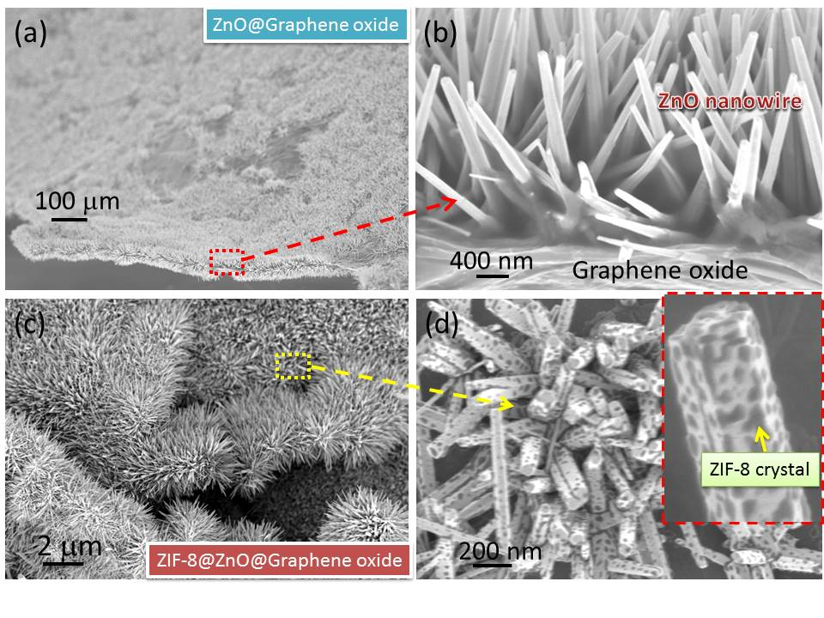
Figure 1: SEM of the multi-dimensional multi-functional material. (a)-(b) ZnO nanowire array in-situ grown on graphene oxide nanosheets (denoted as ZnO@GO). (c)-(d) ZIF-8 (zeolitic-imidazolate-framework) crystals in-situ grown on ZnO nanowires to form ZIF-8@ZnO@GO.
Recent Publications (minimum 5)
- Stassen I, et al, (2016) Chemical vapour deposition of zeolitic imidazolate framework thin films. Nature Materials 15: 304-310.
- Yeh Y-T, et al, (2016) Tunable and label-free virus enrichment for ultrasensitive virus detection using carbon nanotube arrays. Science advances 2: e1601026-e1601026.
- Labib M, Sargent EH, Kelley SO (2016) Electrochemical methods for the analysis of clinically relevant biomolecules. Chemical Reviews 116: 9001-9090.
- Chen Y, Xu P, Xu T, Zheng D, Li X (2017) ZnO-nanowire size effect induced ultra-high sensing response to ppb-level H₂S. Sensors and Actuators B-Chemical 240: 264-272.
- Xu T, Xu P, Zheng D, Yu H, Li X (2016). Metal-organic frameworks for resonant-gravimetric detection of trace-level xylene molecules. Analytical Chemistry 88: 12234-12240.

Biography (150 word limit)
Pengcheng Xu received his B.S. degree from Zhengzhou Institute of Light Industry, M.S. degree from Shanghai University and Ph. D. degree from University of Chinese Academy of Sciences. Now he is an associate professor at the State Key Laboratory of Transducer Technology, Shanghai Institute of Microsystem and Information Technology, Chinese Academy of Sciences. His present research covers advanced sensing materials (like nanowires, hyperbranched polymers and nanoporous materials), micro/nanofluidic chips and MEMS/NEMS-based chemical sensors. Since 2016, he has been appointed as a member of Youth Innovation Promotion Association CAS.

Email: xpc@mail.sim.ac.cn

Notes/Comments:

