Mechanistic study of alcohol oxidation by oxidized Cu^{II} salen-type complexes: Relationship between reactivity and the electronic structure of the complexes
Yuichi Shimazaki, PhD, Ibaraki University, JAPAN

Abstract
The redox chemistry of metal complexes has been widely developed in recent years, affording deep insights into the reaction mechanisms for many useful homogeneous catalytic reactions and enzymatic reactions at the active site of metalloenzymes. While studies on oxidative reaction intermediates are in progress, the oxidation state of the metal ions in the active species has not been fully understood until now. Detailed descriptions of the oxidation state of the intermediate are sometimes complicated, because the oxidation locus on oxidized metal complexes is often different from the “formal” oxidation site. Although “formal” and “experimental” oxidation numbers are identical in many cases, they are frequently used as synonyms, since the term of the physical or experimental oxidation state has not been accepted in some areas of chemistry. This practice leads to considerable confusion and presents an obstacle to the progress of the experimental determination of the intermediate.
Tetradentate Schiff-bases, such as salens, have received considerable attention as a ligand system due to their relative ease of synthesis, ability to form stable complexes with many metals in a variety of oxidation states, and versatility as catalysts for important organic transformations. Concurrent studies have investigated the electronic structure of oxidized metal salen systems, determining the factors that control the locus of oxidation in these complexes. Depending on the relative energies of the redox-active orbitals, metal complexes with pro-radical ligands can exist in a limiting description as a metal-ligand radical, [M^{n+}(L•)]^{n+}, or a high valent metal complex, [M^{(n+1)+}(L⁻)]^{n+}.
This presentation would discuss with recent advances in the chemistry related with the oxidation behavior of some metal–salen type complexes and their properties, especially focusing on comparison of their properties with those of the high valent metal–phenolate complexes which are iso-electronic with the phenoxyl radical complexes.

Image
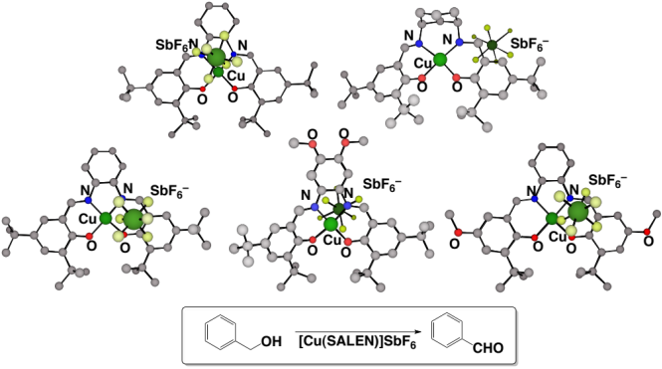
Figure 1. Crystal structures of one-electron oxidized Cu(II)-salen type complexes and the oxidation of benzyl alcohol by their oxidized complexes
Recent Publications (minimum 5)
- Shimazaki Y (2016) ‘Recent Advances in the Field of Phenoxyl Radical–Metal Complexes’ in Patai’s Chemistry of Functional Groups, edited by I. Marek. John Wiley & Sons, Ltd: Chichester, UK. DOI: 10.1002/9780470682531.PAT0851..
- Chiang L, Shimazaki Y, Storr T, et al (2016) ‘Electronic Structure Evaluation of an Oxidized Tris-Methoxy Ni Salen Complex’ Eur. J. Inorg. Chem. 49-55.
- Shimazaki Y, Yajima T, Yamauchi, O (2015) ‘Properties of the indole ring in metal complexes.’ J. Inorg. BioChem, 148, 105-115..
- Shimazaki Y, et al (2014) ‘Influence of Ligand Flexibility on the Electronic Structure of Oxidized Ni^{III}-Phenoxide Complexes’ Inorg. Chem., 53, 10195–10202.
5. Shimazaki Y, et al (2014) ‘Characterization of One-Electron Oxidized Copper(II)-Salophen-Type Complexes; Effects of Electronic and Geometrical Structures on Reactivities’. Dalton Trans., 43, 2283-2293.

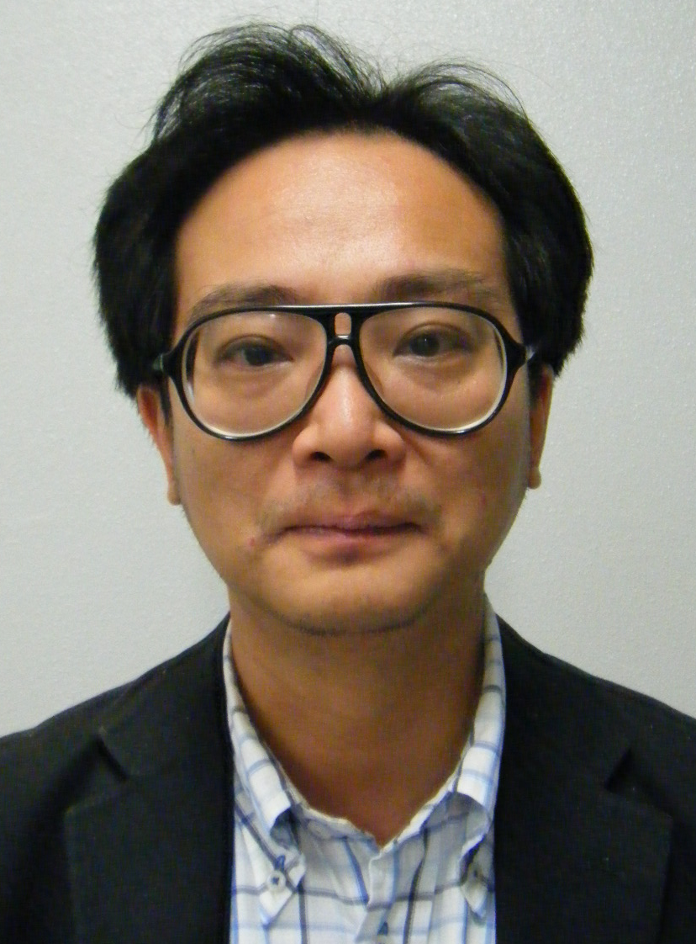Biography (150 word limit)
Yuichi Shimazaki was born in 1970 in Toyama prefecture, Japan. He received his Doctor’s degree in science from Nagoya University in 2000 under the supervision of Professor Osamu Yamauchi. He joined Professor Yoshinori Naruta’s group at Kyushu University as Assistant Professor and worked on the redox behavior of various metal porphyrin complexes as models of the active site of metalloenzymes. In 2008 he was promoted to Associate Professor at the College of Science, Ibaraki University. His research interests include the oxidation chemistry of the complexes of various metal ions, model studies of metalloenzymes, bioorganometallic chemistry, and weak interactions in metal-organic molecule systems.
Email: yshima@mx.ibaraki.ac.jp.

Notes/Comments:

