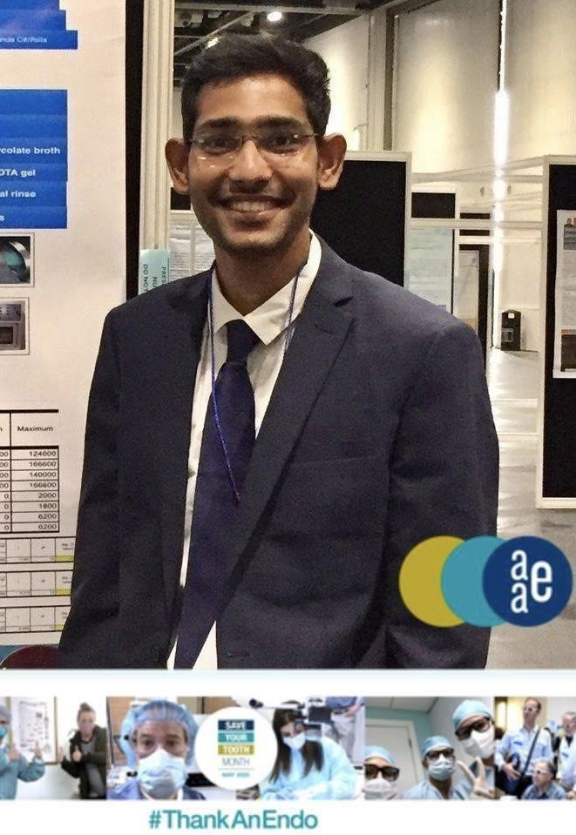

Title: ANALGESIC EFFECT OF PRE-EMPTIVE ORAL NSAIDS ON POST-ENDODONTIC PAIN LEVELS IN SINGLE VISIT ENDODONTICS -A SYSTEMATIC REVIEW.
Name: Dr Kavalipurapu Venkata Teja BDS, MDS Faculty Division of Endodontics, Department of Conservative Dentistry & Endodontics, Virtual Simulation Academy (VIRSA), Saveetha Dental College & Hospitals, Saveetha Institute of Medical & Technical Sciences, Saveetha University, Chennai, TamilNadu, India-600077.

ABSTRACT
Pre-emptive analgesia is an anti-nociceptive treatment that reduces postoperative pain by preventing altered afferent input. As most of the patients present with pain preoperatively have higher levels of released local inflammatory mediators. Thus, pretreatment analgesia decreases the establishment of central sensitization, a mechanism by which spinal neurons increase their response to the peripheral nociceptive impulse. This systematic review aims to compare and evaluate the postoperative pain levels and analgesic intake on NSAIDs' preoperative oral administration in single visit root canal treatment. According to PRISMA guidelines, the present review was done and was registered in the PROSPERO (Centre for Reviews and Dissemination University of York; ). Registration number - CRD42020195775. The research question was formulated based on the PICO strategy. A comprehensive electronic literature search was conducted across PubMed/Medline, Scopus and Cochrane Database independently by two reviewers. Articles published from January 1990 to May 2019 that focused on pre-emptive strategies in single visit root canal treatment were included in the present review. Based on specified inclusion and exclusion criteria's, the selected articles were subjected to quality assessment, and the risk of bias was evaluated. A total of 6 articles were included, out of which three were hand searched. The overall risk of bias of included studies was moderate, and the study limitations were high. Among the studies included, Ibuprofen was considered as the best drug of choice in single visit endodontics.

Biography:

Dr Teja Kavalipurapu finished his residency in endodontics in 2020. Currently, he’s working as a faculty in the division of endodontics in Saveetha dental college & hospitals in India. His clinical practice is limited to micro endodontics at GA Microscopic Dental Clinics, India. He has an extensive academic track record, attended more than 60 CDE, ten conferences & workshops, won 10 national & international awards, with 31 indexed publications & 2 patent copyrights to his credit. He has presented his research works at various national and international (IADR) conferences. His research interest is currently focused on evaluating the irrigation dynamics in the optimally shaped root canal system.

Research Areas of Interest & Review Areas:

- Irrigation dynamics
- Root canal irrigants
- Postoperative pain in endodontics
- Pain management

Presenting author details
Dr. Kavalipurapu Venkata Teja
BDS, MDS
Faculty Division of Endodontics
Department of Conservative Dentistry & Endodontics Virtual Simulation Academy (VIRSA)
Saveetha Dental College & Hospitals
Saveetha Institute of Medical & Technical Sciences Saveetha University
Chennai TamilNadu India-600077
Ph: +91-7397439814 ORCID:
https://orcid.org/0000-0003-0123-8873 Research Gate:
https://www.researchgate.net/profile/Kavalipurapu-Teja?ev=brs_highl Scopus: https://www.scopus.com/authid/detail.uri?authorId=57204679028 Category: Keynote speaker

