Effect of Double Antibiotic Paste and Calcium Hydroxide on stem cell viability and their attachment to irrigated dentin; an in vitro study
Samiya Riaz, BDS, Universiti Sains Malaysia, Malaysia Aung Thu Htun, BDS, MDSc, Universiti Sains Malaysia, Malaysia
Ahmad Azlina, BSc, MSc, PhD. Universiti Sains Malaysia, Malaysia

Abstract

Statement of the problem: Regenerative endodontics has emerged as a new treatment modality for immature permanent teeth with necrotic pulp. Conventional treatment procedures resulted with poor prognosis in terms of root maturation and apex closure due to loss of stem cells as a result of mechanical debridement. Regenerative endodontics preserves these stem cells by minimal or no instrumentation. Chemical irrigation followed by treatment with intracanal medicaments promotes ingress of stem cells. This results in renewal of pulp vitality and further root maturation. Ideally these medicaments should be Dental Pulp Stem Cells (DPSC) friendly and promote cell attachment to dentine. Objective: To compare the effects of Ca(OH)₂(Calcium hydroxide) and DAP (Double antibiotic paste) on DPSC attachment to irrigated radicular dentin. Methodology: 12 dental chips(4*4mm) were irrigated with 1.5% sodium hypochlorite followed by normal saline rinse. Group-1 dental chips (n=5) were treated with DAP 1mg/ml, group-2 (n=5) with commercial Ca(OH)₂ and group-3 (n=2) with no medicament as controls. After incubation of 4 weeks, the samples were rinsed with NaCl (normal saline) to remove the remnants of intracanal medicaments. DPSC from passage 7-8 were seeded onto the samples and allowed to attach to the dentinal surface. Presto blue viability assay was performed on day 1, 3 and 7. After 7 days, samples were prepared for SEM imaging and which were analysed to appreciate the attachment of stem cell to dentin. Results: Ca(OH)₂ treated samples showed. . better cell viability and attachment of DPSC compared to the DAP treated samples (P<0.05). SEM images showed significant showed widespread fibrous layer of cells attached overlapping each other. DAP treated samples showed insignificant number of attached cells Conclusion: Dentin conditioning with Ca(OH)₂ significantly promotes DPSC survival, proliferation and attachment to the dentinal surface.

Image

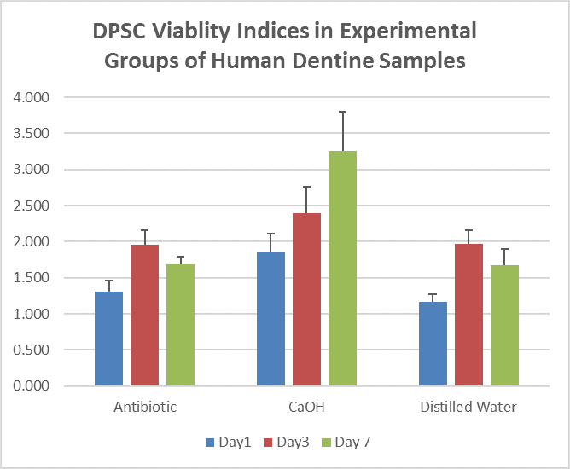

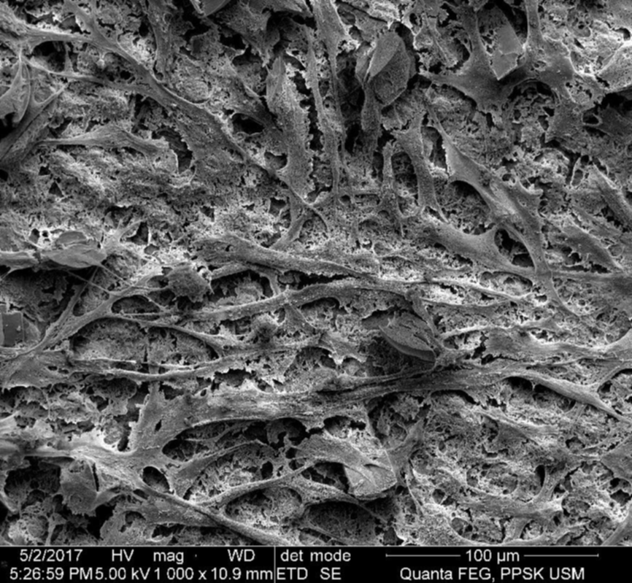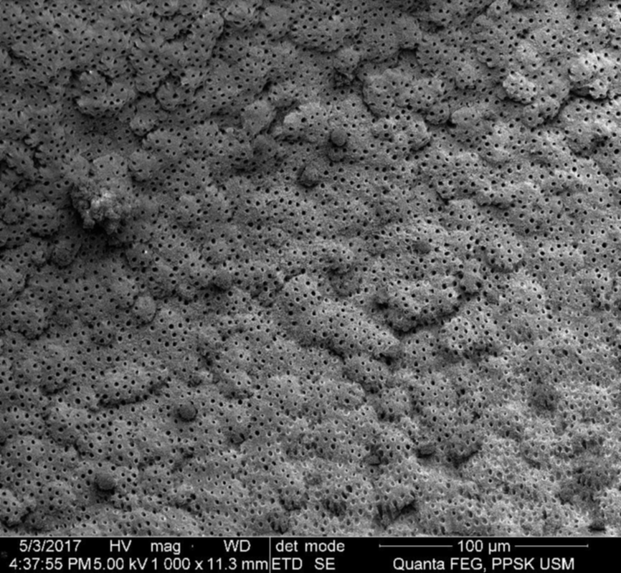
Figure 1. Ca(OH)2 treated samples Figure 2. DAP treated samples
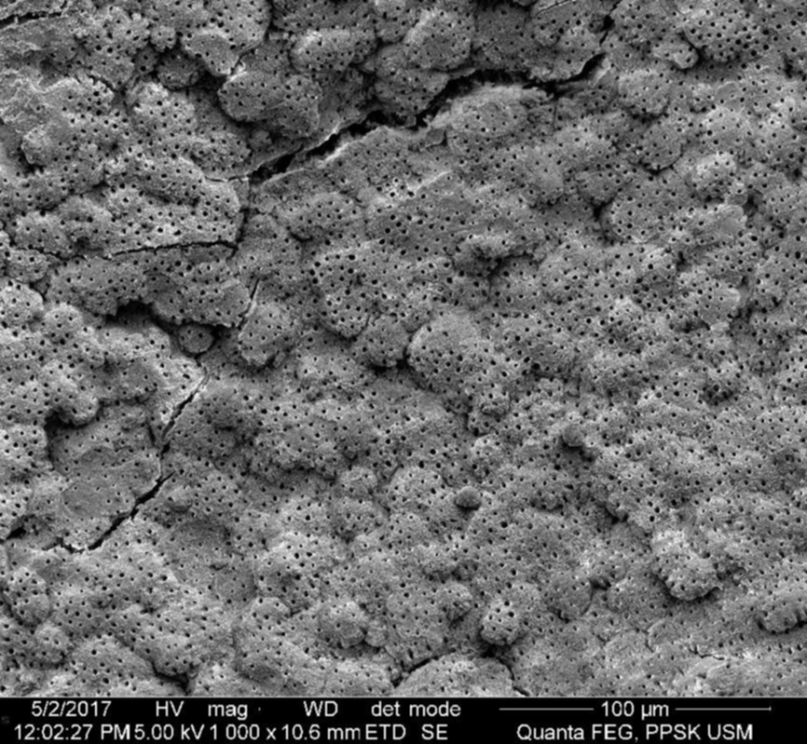
Figure 3. Samples with no treatment(normal saline)
Recent Publications (if any)
- Sabrah, A. H. A., Yassen, G. H., Spolnik, K. J., Hara, A. T., Platt, J. A. and Gregory, R. L. (2015) ‘Evaluation of Residual Antibacterial Effect of Human Radicular Dentin Treated with Triple and Double Antibiotic Pastes’, Journal of Endodontics, 41(7), pp. 1081–1084. doi: 10.1016/j.joen.2015.03.001.
- Kitikuson, P., Srisuwan, T. and Dent, D. C. (2015) ‘Attachment Ability of Human Apical Papilla Cells to Root Dentin Surfaces Treated with Either 3Mix or Calcium Hydroxide’, Journal of Endodontics. Elsevier Ltd, pp. 1–6. doi: 10.1016/j.joen.2015.08.021.
- Park, M. and Pang, S. (2015) ‘Effect of dentin treatment on proliferation and differentiation of human dental pulp stem cells’, Restorative Dentistry & Endodontics, 7658, pp. 1–9.
- Kim, K. W., Yassen, G. H., Ehrlich, Y., Spolnik, K., Platt, J. A. and Windsor, L. J. (2015) ‘The effects of radicular dentine treated with double antibiotic paste and ethylenediaminetetraacetic acid on the attachment and proliferation of dental pulp stem cells’, Dental Traumatology, 31(5), pp. 374–379. doi: 10.1111/edt.12181.
- Saoud, T. M. A., Mistry, S., Kahler, B., Sigurdsson, A. and Lin, L. M. (2016) ‘Regenerative Endodontic Procedures for Traumatized Teeth after Horizontal’, Journal of Endodontics. Elsevier Ltd, 42(10), pp. 1476–1482. doi: 10.1016/j.joen.2016.04.028.

 Biography
Samiya Riaz is a Masters student in Universiti Sains Malaysia, Department of Pediatric Dentistry. She graduated from de ’Montmorency college of Dentistry Pakistan in 2003. She is currently under the supervision of Dr. Aung Thu Htun and Dr. Ahmad Azlina. She has worked as a general dentist for more than 10 years and now wants to pursue her career in Academic side. Currently she is working on effects of different intracanal medicaments and their effects on stem cells in regenerative endodontics. She is also supervising the final year dental students in clinics after receiving USM Fellowship.
Email: dr_samiya80@yahoo.com
Contact number: +60-11-33108460

