High-Power High-Beam-Quality 330-nm Laser From a Frequency-Quadrupled Nd:YAG Laser
Shen-Jin Zhang¹, Zhi-Chao Wang¹, Bao-Shan Wang², Feng Yang¹, Feng-Feng Zhang¹, Nan Zong¹, Zhi-Min Wang¹,Yong Bo^{1,2}, Qin-Jun Peng², Da-Fu Cui², Zu-Yan Xu^{1,2}
¹Key Lab of Function Crystal and Laser Technology, Technical Institute of Physics and Chemistry(TIPC), Chinese Academy of Sciences(CAS), Beijing 100190, China
²Key Lab of Solid state Laser, TIPC, CAS, Beijing 100190, China

Abstract
We demonstrate a high-power high-beam-quality ultraviolet (UV) laser at 330 nm based on fourth-harmonic generation (FHG) of a diode-side-pumped 1319-nm Nd:YAG laser. A 23.2-W Q-switched Nd:YAG laser at 1319 nm with beam quality factor M²=1.15 was employed as the fundamental pump source. First, the output at 1319 nm was frequency doubled to 660 nm in an LBO crystal with an average output power of 11.3 W. Then, the SHG beam was frequency doubled again in another LBO crystal to obtain the FHG output at 330 nm. The maximum average output power at 330 nm was up to 7 W, and the beam quality factor M² was 1.45 with 1 kHz operation repetition rate and ~53 ns pulse width. A total conversion efﬁciency was 30.2% from infrared to UV. This is the ﬁrst 330-nm UV source generation from a diode-side-pumped frequency-quadrupled 1319-nm Nd:YAG laser. The UV 330 nm laser centered at 30, 272.51 cm⁻¹ (λ=330.333 nm) with a linewidth of Δυ=3.5 GHz is suitable to excite the ³S_{1/2}-⁴ P_{3/2} sodium transition, which can be applied in producing polychromatic laser guide star to increase the sky coverage using adaptive optics in large telescopes. Moreover, a vacuum UV laser at 165 nm with 6.8 mW was realized by frequency-doubling of the 330 nm laser, which is almost the shortest VUV wavelength through SHG with KBe₂BO₃F₂ (KBBF) crystal. An angle-resolved photoemission spectroscopy (ARPES) with thus higher photon energy (7.52 eV) VUV 165 nm laser may be able to reach larger momentum space and enhanced bulk sensitivity in probing the electronic structure of solids.

Image
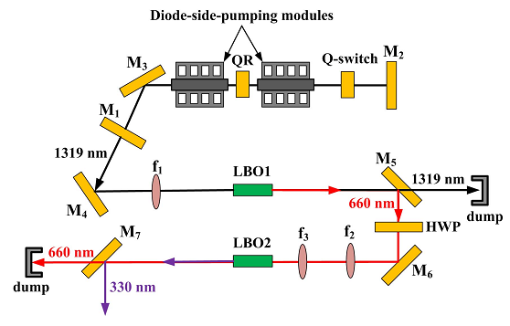
Recent Publications
- Ming Chen, Zhi-chao Wang, Shen-jin Zhang, Bao-shan Wang, Feng Yang, Guo-chun Zhang, et al. 2016. High-Power High-Beam-Quality 330-nm Laser From a Frequency-Quadrupled Nd:YAG Laser. Journal of Luminescence. 172; 254–257.
- Shi-Bo Dai, Ming Chen, Shen-Jin Zhang, Zhi-Min Wang, Feng-Feng Zhang, Feng Yang, Zhi-Chao Wang, Nan Zong, et al. 2016. 2.14 mW deep-ultraviolet laser at 165 nm by eighth-harmonic generation of a 1319 nm Nd:YAG laser in KBBF. Laser Phys. Lett; 13.
- Shen-jin Zhang, Da-fu Cui, Feng-feng Zhang, Zhi Xua, Zhi-min Wanga, Feng Yang, et al. 2014. High power all solid state VUV lasers. Journal of Electron Spectroscopy and Related Phenomena. 196;20–23
- Zhichao Wang, Baoshan Wang, Ming Chen, Feng Yang, Shenjin Zhang, Xiaowen Zhang, Yong Bo, et al. 2015.High-power 660.5 nm red laser from diode-side-pumped intracavity frequency-doubled Nd:YLF laser. Laser Phys. Lett. 12;125801.
- Ming Chen, Zhi-chao Wang, Shen-jin Zhang, Feng Yang, Feng-feng Zhang, et al.1319nm and 1356 nm dual-wavelength operation of diode-side-pumped Nd:YAG laser. 2015. Optics &Laser Technology. 79(2016)52–54.

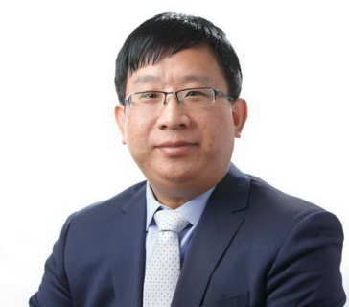Biography
Shen-Jin Zhang received the PhD degree from Xidian University, Xian, China in 2006. He is the deputy director of Key Lab of Function Crystal and Laser Technology, Technical Institute of Physics and Chemistry, Chinese Academy of Sciences. His research interests include nonlinear optics, UV & VUV laser and their applications. He has published more than 25 papers in reputed journals.
Email:zhangshenjin@163.com

Notes/Comments:

If I can’t attend the meeting, the abstract will not be published.

