Spectroscopic studies on Er³⁺-doped Al(PO₃)₃-BaF₂-SrF₂ fluorophosphate glasses
K. Linganna, Jung H. In, Sun H. Kim, Ju H. Choi
Optical Lens Research Center, Korea Photonics Technology Institute (KOPTI), 124 Cheomdan venchure-ro, 108 beon-gil 9, Buk-gu, Gwangju 61007, South Korea

Abstract
Statement of the Problem: For the past decades, erbium doped fiber amplifier (EDFA) has become a key element of modern telecommunication system due to Er³⁺ ion emission at 1.53 μm attributed to the ⁴I_{13/2} → ⁴I_{15/2} transition [1, 2]. The commercial EDFAs used in communication networks are made up of silica glass that has a relatively narrow bandwidth emission (∼35 nm) resulting in a narrow gain curve, which limits its applications to meet broadband transmission. Among different host matrices, fluorophosphate (FP) glasses have received great interest for laser and optical amplifier applications because of their characteristic properties [3, 4]. Therefore, Er³⁺-doped FP glasses can enlarge the emission cross-section and improve luminous efficiency because of the characteristic features of Er³⁺ ions and advantageous properties of mixed fluoride and phosphate glasses [5]. Hence, the present study carried out spectroscopic studies on Er³⁺-doped FP glasses for different concentrations of Er³⁺. Methodology: Er³⁺-doped fluorophosphate glasses were prepared by a conventional melt quenching technique and were characterized through spectroscopic techniques. Findings: From absorption, emission and decay measurements, the important spectroscopic properties such as bandwidths, emission cross-sections and lifetime were evaluated for significant 1.53 μm emission band. The emission cross-section and lifetime were found to be of the order of 2.0×10⁻²⁰ cm² and 10 ms, respectively. These desirable parameters are used to see the potentiality of the material for laser gain media. Conclusion & Significance: It was concluded that higher dopant Er concentration improved the 1.53 μm emission band characteristic properties. The results indicate that this glass composition can enable construction of short, highly efficient fiber or planar waveguide amplifiers.

Image
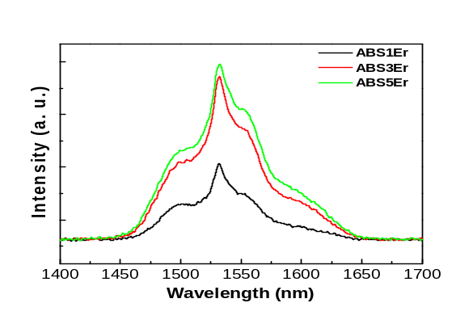
Figure 1. Near infrared emission spectra of Er³⁺-doped fluorophosphate glasses.

Recent Publications
- F. Cabello, S. Sanchez-Cortes, M. Jiménez de Castro (2014) Influence of the preparation conditions of erbium-doped bismuth germanate glasses on its optical response, J. Non-cryst. Solids 445-446:110–115.
- J. Zavadil, Z.G. Ivanova, P. Kostka, M. Hamzaoui, M.T. Soltani (2014) Photoluminescence study of Er-doped zinc–sodium–antimonite glasses, J. Alloys Compd. 611:111–116.
- Ju H. Choi, Frank G. Shi, Alfred Margaryan, Ashot Margaryan, Wytze van der Veer (2008) Novel alkaline-free Er³⁺-doped fluorophosphates glasses for broadband optical fiber lasers and amplifiers. J. Alloys Compd. 450:540-545.
- Ju H. Choi, Alfred Margaryan, Ashot Margaryan, Frank G. Shi (2008) Dependence of thermo-mechanical and mechanical properties of novel fluorophosphate glass on various rare earth dopants. J. Mater. Sci. 43:1109-1113.
- H. Ebendorff-Heidepriem, W. Seeber, D. Ehrt (1993) Spectroscopic investigations of the Er³⁺ fluorescence transitions at 540 nm and 1.5μm in fluoride phosphate and phosphate glasses, Glastech. Ber. 66:235–244.

Biography
Linganna K received M.Sc and Ph.D degrees from the Department of Physics, Sri Venkateswara University, Tirupati, Andhra Pradesh, India in 2006 and 2012, respectively. His research activities involve preparation and characterization of rare earth doped glasses and glass fibers fabricated by melt quenching technique and fiber drawing processes, respectively, for the development of photonic devices such as lasers, optical amplifiers, sensors and so on. He also gained experience on waveguide inscription in rare earth doped glasses indigenously developed at Sri Venkateswara University, Tirupati, India for integrated optics. So far, he visited UK, Mexico for his Doctoral and Post-Doctoral research work. For the past five years, he has been working as a Post-Doctoral researcher in South Korea. He published his research work in international reputed journals besides presented his work in various international and national conferences/workshops/symposia.
Email: lingannasvu@gmail.com

