Abstract (300 word limit)
Computational photography is at the junction of algorithms, sensors and modern optics. It aims to create new types of photographs and to allow photographers to acquire better images, new type of images or images we could never observe before.
Digital cameras count at each pixel sensor the number of photons emitted by the observed scene during an interval of time called exposure time. With a passive camera the only way to safely increase the signal to noise ratio (SNR) is to accumulate more photons by increasing the exposure time. Unfortunately, this also increases the chance of either the camera or the scene moving during the exposure process, resulting in motion blur that severely lessens the SNR of the image.
This talk is about a revolutionary camera concept called "flutter shutter". Flutter shutter cameras promised to increase the image quality (SNR) when photographing moving objects. Yet, these new camera designs raise theoretical, practical and numerical questions such as
What is the optimal camera design ? Can a flutter shutter indefinitely increase the SNR by an increased exposure time? Is the flutter shutter more efficient depending on the observations conditions (scene lighting, camera-scene velocity, …) ? What are the most suitable algorithms to treat the data acquired by these cameras ?

This talk gives a simple formalism that permits to answer the questions on these recent camera designs. (The theory is also proved to be valid for the "motion invariant photography": the only other competitor of the flutter shutter.)

Image (Left: observed image by a flutter shutter camera, Right: reconstructeed image by an algorithm)

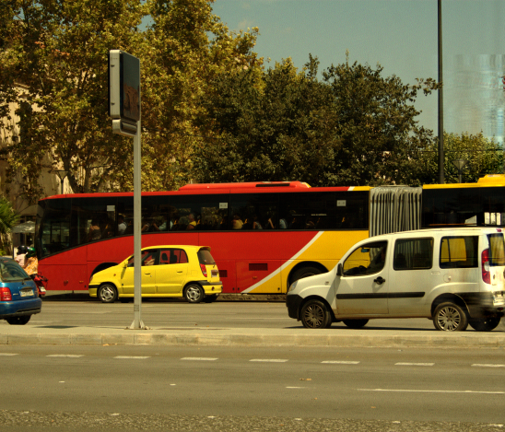

Recent Publications (minimum 5)
- Y. Tendero and S. Osher. "On a Mathematical Theory of Coded Exposure", Research in the Mathematical Sciences (RMSS), 2016.
- Y. Tendero and J.-M. Morel. "A Theory of Optimal Flutter Shutter For Probabilistic Velocity Models", SIAM journal on Imaging Sciences (SIIMS) 2016.
- Y. Tendero and J.-M. Morel. "On the Mathematical Foundations of Computational Photography - Does the Flutter Shutter Work Better at Night?", Journal of Mathematical Imaging and Vision (JMIV), 2015.
- Y. Tendero. "The Flutter Shutter Code Calculator", Image Processing On Line, 2015.
- Y. Tendero and J.-M. Morel. "An optimal blind temporal motion blur deconvolution filter", IEEE Signal Processing Letters, 2013.

Biography (150 word limit)
Yohann Tendero received his Ph.D. from CMLA/ENS-Cachan in 2012, and was a postdoc in the Department of Mathematics at the University of California, Los Angeles from 2012 to 2015. He is currently associate professor at Telecom ParisTech in the image processing group (TII/LTCI CNRS). See http://perso.telecom-paristech.fr/~ytendero/.
Email: yohann.tendero@telecom-paristech.fr

Presenting author details:
Full name: Yohann Tendero
University: Télécom ParisTech, Université Paris-Saclay, 75013, Paris, France
Associate prof
Country: France
Telephone: +33145817549
Email: yohann.tendero@telecom-paristech.fr
Track name: Track 9-7Computational optical sensing and imaging
Category: Invited speaker. I received the following email
Your contributions to the article ‘On the Mathematical Foundations of Computational Photography’ is quite impressive and allies with our conference theme, Enlightening the Inevitable Ascent in the Beam of Lasers, Optics & Photonics. In light of your renowned research, we are very glad to welcome you as an Invited speaker for the 5th International Conference and Exhibition on Lasers, Optics and Photonics which will be held during November 28-30, 2016 in Atlanta, USA.

Research interest: Computational photography, image processing and analysis, visual data acquisition systems, and image acquisition numerical chain designs.

Linked In account: https://www.linkedin.com/in/ytendero

Note: Please fill up the Red mark fields so that it would be easier for us to cite your details in the conference particulars. (Please do not forget to fix your photo above the title)

Notes/Comments:

